--­­­





Animal Detection System as Animo

The system is developed to make easier to identify animal by their characteristics and features.

Submitted By:

Karan Chaudhary

Level 5 (Semester 2)

University ID: 77297911

Submitted To:

Sukant Kumar Sahu

**Declaration**

I, Karan Chaudhary, declare that there has been no attempt to get a different grade or honor in the report titled Animal Recognition System. All of the information sources included in this report have the necessary citations and acknowledgments.

I also certify that I do not have any conflicts of interest or biases that would have corrupted this report's findings or conclusions.

**Acknowledgment**

I want to sincerely thank Mr. Sukant Kumar for all of his help and support during the creation of this report. The breadth and organization of the report were greatly influenced by his advice, knowledge, and helpful criticism.

**Abstract**

The Animal Recognition System is a rule-based expert system for the classification and identification of animals. Based on the features of the animal given by the user, the application applies a series of criteria and questions to identify the animal. The guidelines are divided into groups like mammal, bird, carnivore, herbivore, and ungulate, and each category includes distinctive qualities that are utilized to identify the species. The user is prompted with a series of questions regarding the traits of the animal, and the program uses the user's responses to classify and identify the animal. The user is given the option to try again or to exit the system if the application is unable to identify the animal. The program stores the answers utilizing the dynamic predicate of Prolog.

**Table of Contents**

**1. Introduction** **3**

**2. Objectives** 3-4

**3. Rationale** 4

**4. Literature Review 4-6**

**4. Pseudocode7**

**5. Methodology** 8

**6. Algorithm** 8

**7. Proposed Smart Framework** 9

**8. Complete Code**  10-13

**9. Queries** 14

**10. Future Work** 15

**11. Conclusion** 15

**12. References** 16

**Introduction**

Animals are a diverse category of living entities on the planet. They appear in a variety of shapes, sizes, and colors and inhabit a number of ecological niches. Animals, from the smallest insects to the greatest mammals, are an integral element of the natural world, playing critical roles in ecosystems and contributing to the planet's biodiversity. Humans have a long and complicated relationship with animals, utilizing them for food, clothing, transportation, labor, and companionship while also enjoying their beauty, power, and intelligence. As we continue to investigate and study the animal kingdom, we get a better understanding of these amazing animals, gaining new insights into their behavior, physiology, and evolution.

The animal recognition system is a program that uses traits and attributes to recognize different sorts of animals. This approach use a set of rules and logic to establish the categorization of the animal and to identify the individual species. The application asks the user a series of questions about the animal's characteristics and then compares the responses to the rules to arrive at a diagnosis. If the animal is recognized, the application will display its name. Otherwise, the user will be notified that the animal is not recognized. To establish the proper diagnosis, this animal recognition system employs the prolog programming language and includes a set of animal identification criteria and categorization rules.

Animal recognition is one of the most significant and crucial Computer vision domains. Animal identification is a problem that involves figuring out the species of an animal that has been seen in the picture using a list of well-known labels. The algorithms used to recognize animals typically perform a binary pattern classification challenge. That implies that a given input image is divided into blocks, each of which is then converted into a feature. A specific classifier is trained using characteristics of the animal that fits into a particular class. The classifier will then be able to determine if a sample belongs to a certain class when given a new input image (Pandey et al., 2020).

**Aim and Objectives**

The system's goal is to give an automated method for recognizing various species of animals based on their traits and attributes. This system's goals include the following:

1. The method tries to reliably and efficiently identify animals by employing a set of rules and logic that match the animal's traits with the characteristics of various animal species.
2. The method is intended to make the process of recognizing an animal easier. The user merely needs to answer a series of questions, and the machine will determine the diagnosis based on their replies.
3. The system gives information on many sorts of animals and their characteristics, which can help users learn more about the animal kingdom.
4. The method may be used as an instructional tool to teach people about various animal species and their features.
5. The technique may be used to aid in wildlife conservation by allowing for the rapid and precise identification of animals.

Overall, the animal recognition system seeks to provide an efficient and user-friendly solution for recognizing animals, improving knowledge about different sorts of animals, and helping to wildlife conservation initiatives.

**Rationale**

The animal recognition system is essential because it can be used to quickly and precisely identify a variety of animal species based on their distinctive characteristics and characteristics. This approach meets the requirements of a variety of experts, including zoologists, veterinarians, and conservationists, and enables them to quickly identify animals in a variety of settings, including the wild or in captivity. Professionals are better equipped to give specialized treatment, put in place efficient protection measures, and decide on conservation initiatives when they can accurately identify animals. Additionally, those who are interested in wildlife and want to learn more about various animal species can profit from using this system because it provides them with a thorough and user-friendly platform for research and learning.

In order to identify the animal, the Animal Recognition system uses a set of classification and diagnostic criteria that are dependent on the user's answers to a series of questions about the animal's characteristics. The goal of these inquiries is to learn more about the physical characteristics, habits, habitat, and other pertinent aspects of the animal. The system's rules are developed using data analysis and expert knowledge. The Animal Recognition system's mobility is among its many noteworthy benefits. The system can be used to identify animals in the field because it is portable and can be taken with you. Because of this characteristic, the system is perfect for usage in the outdoors where there may not be easy access to advanced tools or facilities.

**Literature Review**

Alli and Viriri (2013) presented a footprint-based animal identification system. The authors emphasize the importance of recognizing and tracking animals in the field for conservation efforts and wildlife management. This study's approach tries to identify individual animals based on their distinctive imprints, which can then be used to follow their movements and habits. The system comprises of a footprint image capture module, followed by a feature extraction module that extracts features from the footprints using the Discrete Wavelet Transform (DWT). To categorize the retrieved data and identify the animal, the classification module employs a support vector machine (SVM). Overall, the study proved that footprints may be used to identify animals in a reliable and non-invasive manner. The suggested approach identified individual animals based on their footprints with an accuracy of 86.7%.

J. L. Alty and G. Guida's work "The Use of Rule-Based System Technology for the Design of Man-Machine Systems" gives a detailed review of the use of rule-based systems in the design of man-machine systems. The article explores the potential advantages of employing rule-based systems in the design of such systems, such as the capacity to manage complicated and unpredictable data and the incorporation of expert knowledge into the design process. The authors also go through the different parts of a rule-based system, such as the knowledge base, inference engine, and user interface. Furthermore, the paper describes the challenges involved in designing and implementing rule-based systems in various applications, such as diagnosis and control systems. Overall, this work is a wonderful resource for scholars and practitioners in the area, providing unique insights into the usage of rule-based systems for the design of man-machine systems.

The paper "A review of automated feature recognition with rule-based pattern recognition" by Bojan Babic, Nenad Nesic, and Zoran Miljkovic gives an exhaustive study of automated feature recognition using rule-based pattern recognition approaches. The article examines the significance and use of automated feature recognition in a variety of domains, including engineering, manufacturing, and computer vision. The authors explore the merits and limits of rule-based pattern recognition algorithms in feature recognition, as well as the difficulties in building and implementing such systems. Furthermore, the paper provides a comprehensive overview of various rule-based pattern recognition algorithms and techniques used for feature recognition, such as fuzzy logic, neural networks, and genetic algorithms. The authors also explore potential research prospects in this topic, such as the use of machine learning and deep learning approaches in automated feature recognition. Overall, this study is a significant resource for scholars and practitioners in the area since it gives unique insights into the application of rule-based pattern recognition approaches in automated feature recognition.

The paper "Rule-Based Classification Based on Ant Colony Optimization: A Comprehensive Review" presents an overview of the usage of ant colony optimization (ACO) in rule-based classification systems. The authors describe the benefits of utilizing ACO in this situation, such as the capacity to handle big datasets and the possibility for better classification accuracy. They also detail the main components of a rule-based categorization system, such as the rule generation process and the inference engine. Furthermore, the paper provides examples of ACO-based rule classifiers in various applications, such as medical diagnosis and financial forecasting. Overall, this study provides excellent insights on the use of ACO in rule-based classification systems and is a great resource for scholars and practitioners in the field.

The rule-based event detection system proposed by Spampinato et al. (2013) is intended to identify events in video streams recorded by underwater cameras, such as the presence of particular fish species or the recurrence of particular behaviors. The study gives a summary of relevant work in event detection systems and draws attention to the shortcomings of current approaches, particularly in the underwater environment. On a real-world dataset, the authors assess their approach and show how well it can identify important events. The study hypothesizes that additional advancements in event detection systems may result from combining rule-based and machine learning techniques.

The article "Fuzzy Rule Based Image Reconstruction for PET" provides a novel method for image reconstruction in Positron Emission Tomography (PET) utilizing fuzzy rules. The technique was tested on both simulated and actual PET data and shown promise in terms of picture clarity, spatial resolution, and noise reduction when compared to traditional approaches. The proposed method may have important effects on medical research and diagnostics. To assess how well it performs on a bigger dataset and whether it can be applied to other imaging modalities, more study is required.

**Pseudocode**

DEFINE animal rules.

DEFINE the animal predicate to identify different animals based on their characteristics.

DEFINE rules for identifying cheetah, tiger, giraffe, zebra, ostrich, penguin etc.

DEFINE classification rules.

DEFINE criteria for categorizing creatures into groups like mammals, birds, carnivores, herbivores, and ungulates.

DEFINE what questions to ask.

DEFINE ask predicate to prompt the user with a question about an animal's features.

DEFINE how to verify user's response.

DEFINE the verb "undo" to revoke the most recent affirmative or negative statement.

DEFINE the search criteria

DEFINE searching predicate to check if the animal characteristics match any known animals in the rules

DEFINE start predicate.

DEFINE to greet the user and launch the animal identification procedure, use the start predicate.

DEFINE retry predicate.

DEFINE tryagain predicate to prompt the user if they want to try again or exit the system

CALL the start predicate to begin the animal identification process.

**Methodology**

The logic-based programming language Prolog, which is utilized in the animal identification system, enables the system to draw conclusions and inferences from the rules given. The collection of rules in the system is continually updated as new knowledge about animal traits becomes available. The search algorithm also uses a tree-searching technique to streamline the identification of an animal by reducing the options with each query. The system can recall the user's replies to earlier inquiries thanks to the use of assert and retract predicates, which enables it to produce identification results that are more precise and effective. A crucial tool for researchers and conservationists who need to swiftly and properly identify animals is the system's capacity to learn from past searches and adjust to new input.

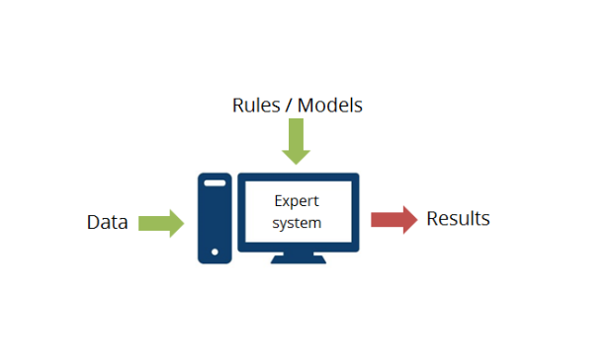

Expert systems

**Algorithm**

A rule-based algorithm is a method of making decisions that classifies data or makes predictions based on a set of if-then rules. The conditional statements that make up these rules specify the connection between the input variables and the appropriate output actions. The algorithm determines the right output or category when a new input is received by comparing the incoming data to the specified set of criteria. Rule-based algorithms are widely employed in different disciplines, including artificial intelligence, expert systems, and data analytics, due to their interpretability and transparency. They are especially useful and simple to maintain and update when the decision-making process can be articulated in a logical, rule-based manner.

The Animal Recognition system in uses a rule-based algorithm. It comprises of a collection of established laws and logical assertions that integrate several inputs into an output. A rule-based classifier is a technique for categorizing records that use a set of "if-then" rules (Qin et al., 2009). These if-then rule statements are utilized to construct the conditional statements that make up the whole knowledge base. In rule-based systems, two types of inference engines are used: forward chaining and backward chaining systems.

A forward chaining system processes the original facts first, then uses the rules to generate new conclusions based on those facts. In a backward chaining system, the hypothesis (or solution/goal) that we are attempting to attain is processed first, and we continue to hunt for rules that enable us to conclude that hypothesis. New sub-goals are set for validation as the processing progresses. Backward chaining systems are goal-driven, whereas forward chaining systems are data-driven (Mishra, Painuli & Nirvikar, 2016).

**Proposed Smart Framework**

The proposed system architecture for an animal recognition system is based on a Prolog program that identifies the animal using a mix of logical rules and human input. The approach begins with a list of animals to be examined, each with its own set of guidelines for identifying them based on characteristics like color, stripes, horns, hooves, and whether they consume meat or grass. The software provides guidelines for categorizing creatures as mammals, birds, carnivores, herbivores, or ungulates.

The "searching" predicate provides the system's primary functionality by attempting to match the animal with the rules and returning the result if a match is found. If the animal is not identified, the application invites the user to use the "tryagain" predicate to try again. The "ask" predicate is used to elicit a yes or no answer from the user in order to validate the animal's qualities, whereas the "verify" predicate is used to elicit inquiries regarding an animal's attributes.

The system design contains a dynamic database of "yes" and "no" replies to validate the animal's traits, as well as the ability to reverse prior responses. By showing the questions in a comprehensible style and requesting the user for their response, the system delivers a user-friendly interface. Overall, the suggested system design offers a flexible and efficient method of identifying animals based on their characteristics and classification. It implements a rule-based system that can manage a broad range of animals and features using Prolog's logical programming model.

**Complete Code**

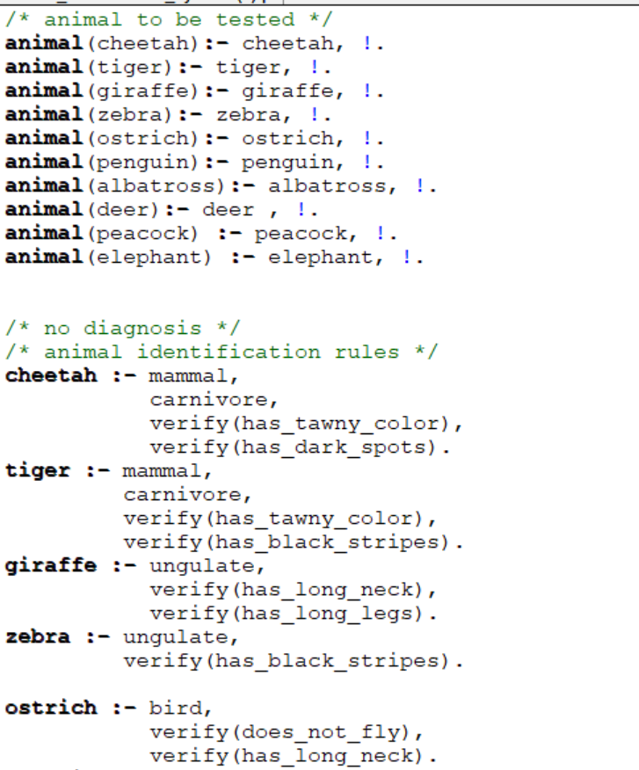

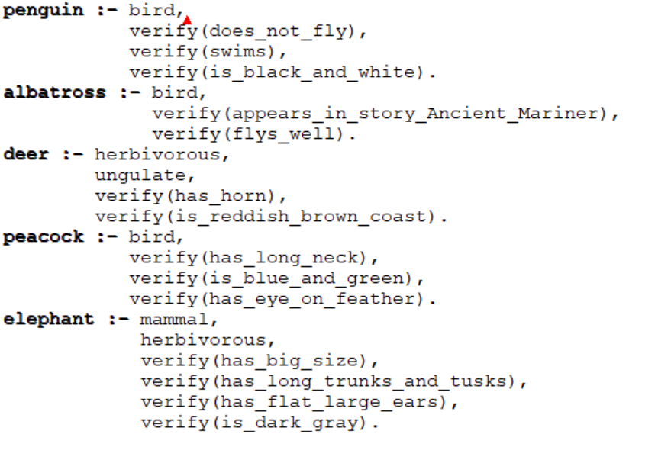

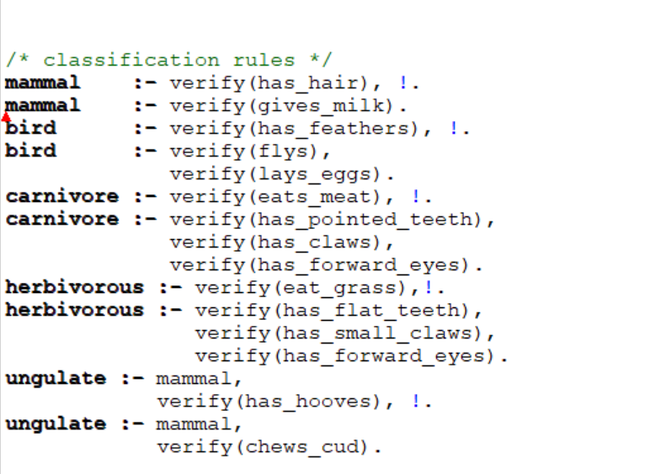

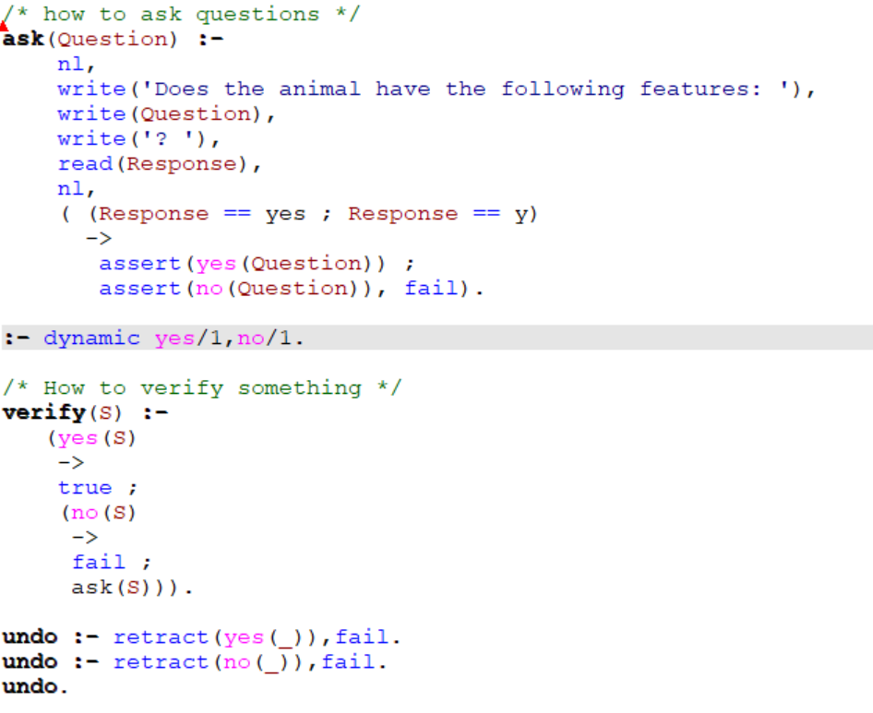

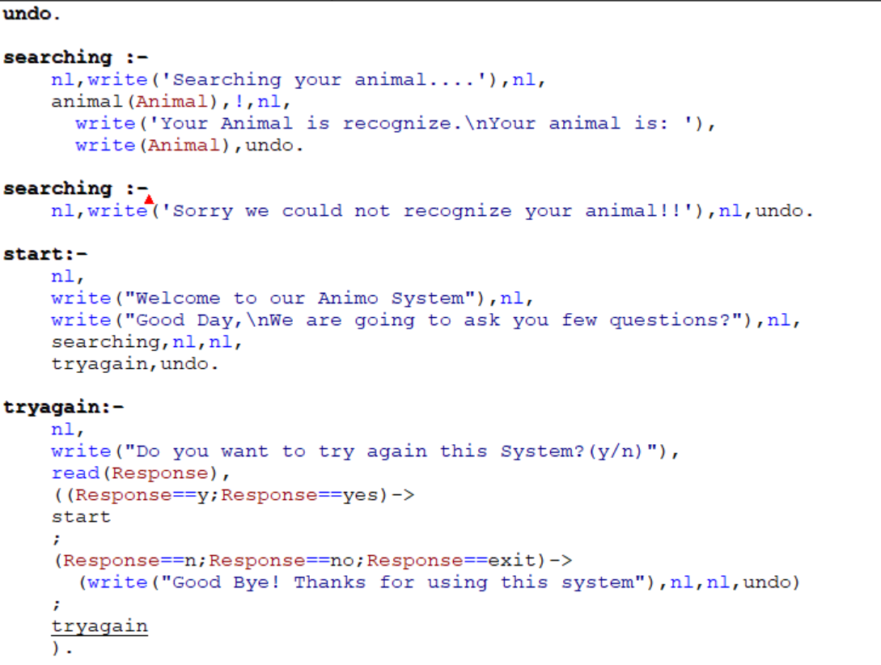

The code above is a Prolog program that uses a rudimentary expert system to identify animals based on their characteristics. It specifies a set of guidelines for recognizing various sorts of animals based on traits such as whether they have hair, feathers, or are herbivorous or carnivorous. The program use the built-in Prolog predicate'read' to read user replies to questions posed by the program, as well as the 'assert' and'retract' predicates to store and delete user responses to queries. The software also contains a'tryagain' predicate, which prompts the user to resume the animal identification process or quit the application based on their response. The software either output the detected animal or a message indicating that it could not be identified.

**Queries**

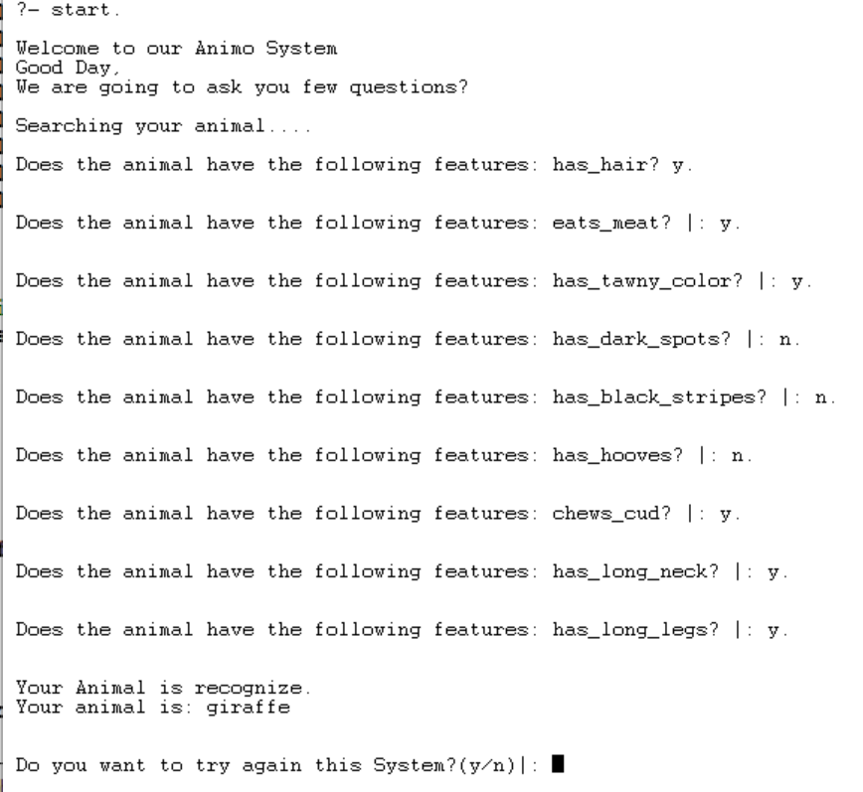

The Prolog program is run by calling the start predicate with the query?- start. It greets the user and inquires as to if they are prepared to respond to several questions in order to identify an animal. Then, a number of questions pertaining to the characteristics of the animal are posed, such as if it has hair, consumes meat, is tawny in color, has dark patches, has a long neck, etc. The application infers the animal that most closely fits the provided traits based on the user's replies using logical criteria. Here, a giraffe is the animal that most closely resembles the described characteristics. The application then prompts the user to continue or depart after recognizing the animal.

**Future Work**

The system for recognizing animals has room for improvement. More potent machine learning algorithms for accuracy and efficiency are among the future directions. Deep learning methods can help people recognize animals better, especially for less obvious qualities. Expanding the database and gathering additional data on attributes can better the system. More sophisticated algorithms and sensors would be needed to identify certain animal noises and actions. Accessibility can be improved with user-friendly interfaces and integration with mobile apps. Further progress can considerably help academics, conservationists, and animal aficionados.

**Conclusion**

In conclusion, the animal recognition system based on rule-based algorithms has demonstrated promising results in properly recognizing different species based on their physical attributes and categorization. The system's success is strongly reliant on the quality of the rule base and the accuracy of user replies to queries. While the system's rule-based approach has limitations in dealing with complex and fuzzy animal features, it can be improved by incorporating machine learning techniques to learn and adapt to new animal features and classifications. Overall, the animal recognition system has the potential to be beneficial in a variety of fields, including wildlife conservation, veterinary treatment, and animal research.

**References**

1. Alli, M. N., & Viriri, S. (2013). *Animal identification based on footprint recognition. 2013 International Conference on Adaptive Science and Technology.*
2. Alty, J. L. & Guida, G. (1985). The Use of Rule-Based System Technology for the Design of Man-Machine Systems.
3. Babic, B., Nesic, N., & Miljkovic, Z. (2008). *A review of automated feature recognition with rule-based pattern recognition.* Computers in Industry, 59, 321-337.
4. Hossain, S. K. M., Ema, S. A., & Sohn, H. (2022). *Rule-Based Classification Based on Ant Colony Optimization: A Comprehensive Review.* Applied Computational Intelligence and Soft Computing, 2022, 2232000.
5. Mishra, D., Painuli, D., & Nirvikar. (2016). *Rule Based Expert System for Medical Diagnosis-A Review*. International Journal of Engineering Technology, Management and Applied Sciences, 4(12), 167.
6. Pandey, R., Paudel, D., Sapkota, S., Bhandari, D., & Shrestha, R. (2020). *Animal Recognition System Based On Convolutional Neural Network.* NCE Journal of Science and Engineering, 1(1), ISSN: 2717-4794.
7. Qin, B., Xia, Y., Prabhakar, S., & Tu, Y. (2009). *A Rule-Based Classification Algorithm for Uncertain Data. In Proceedings of the IEEE 25th International Conference on Data Engineering* (ICDE) (pp. 1486-1489).
8. Li, C. J., Chen, C. H., & Huang, H. K. (2004). *Fuzzy Rule Based Image Reconstruction for PET.* In 2004 IEEE International Conference on Systems, Man and Cybernetics (pp. 2919-2923). IEEE.
9. Spampinato, C., Beauxis-Aussalet, E., Palazzo, S., Beyan, C., van Ossenbruggen, J., He, J., Boom, B., & Huang, X. (2013). *A rule-based event detection system for real-life underwater domain. Machine Vision and Applications,* 24(7), 1459-1476. Doi: 10.1007/s00138-013-0509-x.