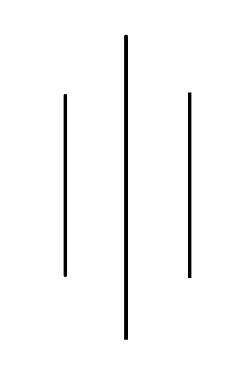

**Internet Technology**

**Submitted by: Karan Chaudhary**

**Submitted to:**

**Class: sec D (BSc.Hons Computing(IT), Level : 3) 2nd semester**

**Subject: IT**

**Github: https://github.com/Karan21-cyber/website_project**

**Project:**

**Wireframe 1: My Project PhotoREcreation**

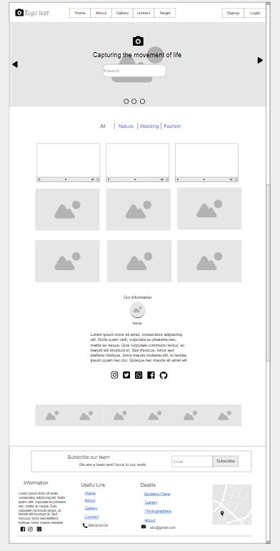

**WireFrame 2 : Café&Resturant**

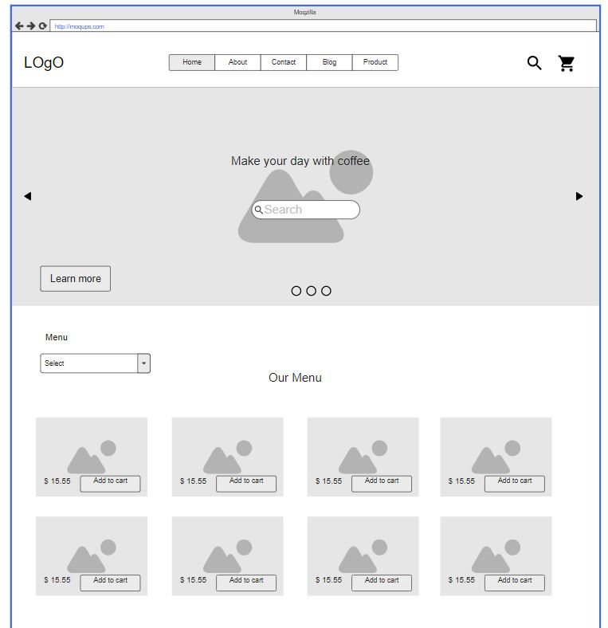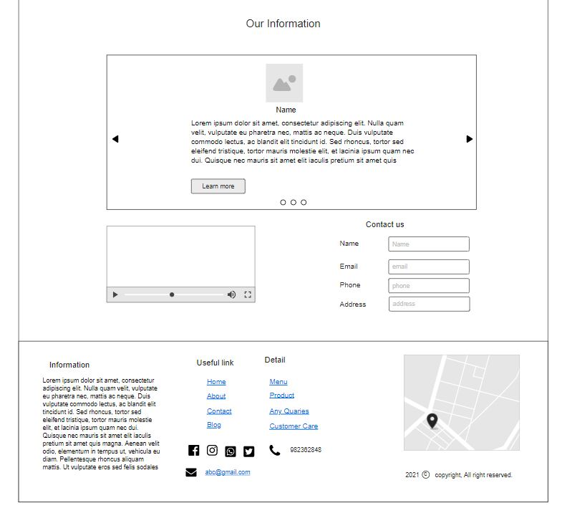

**WireFrame 3 : Institute**

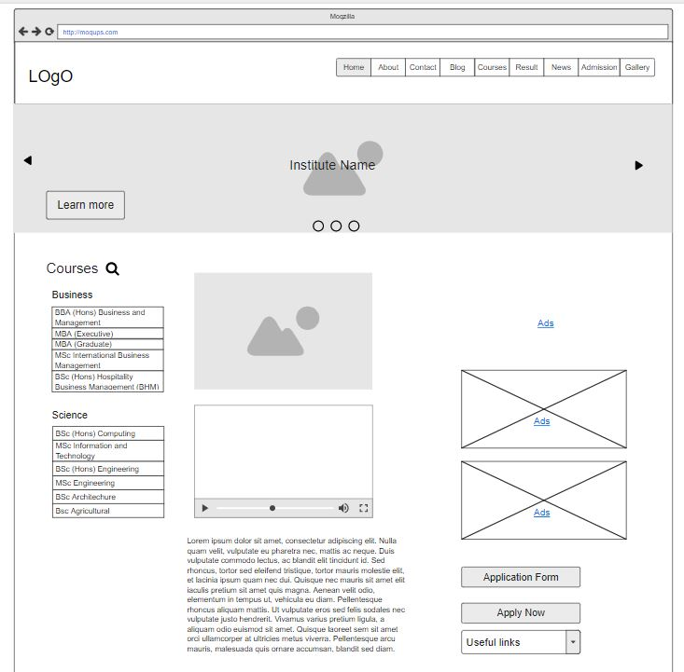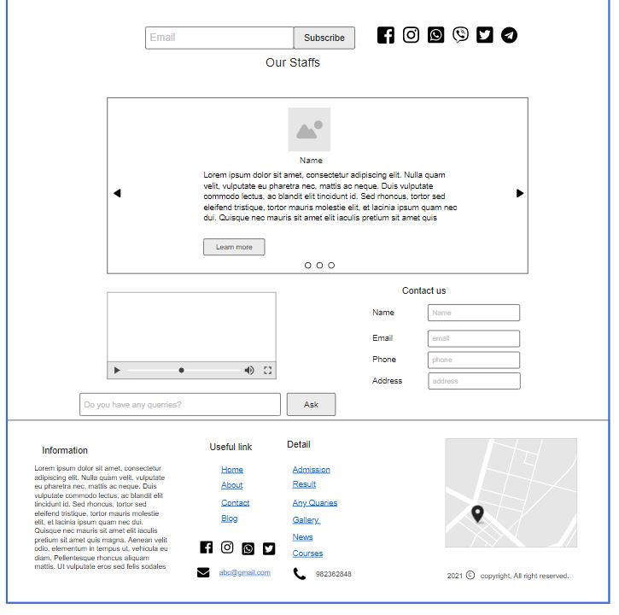

**WireFrame 4 : Portfolio**

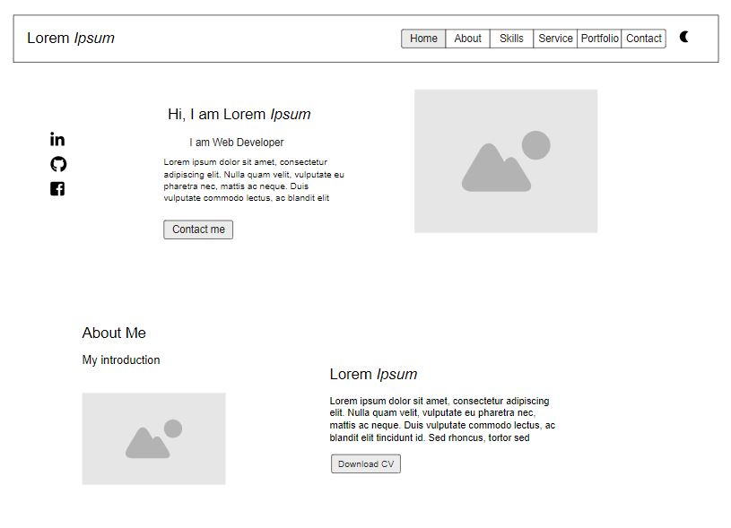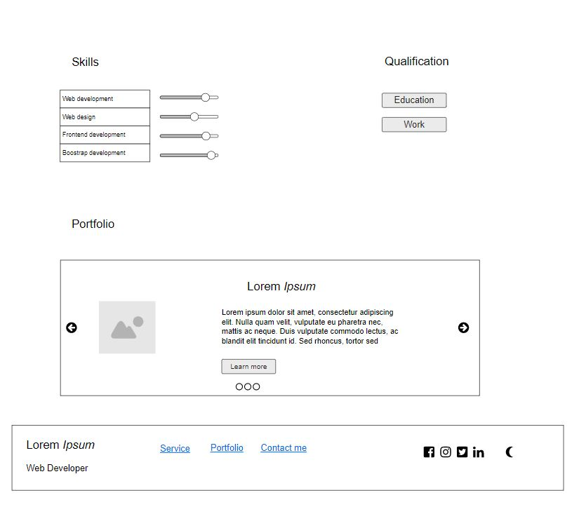

**Wireframe 5: Company**

