Analysis of Candidate Sites:
- Holden Crater:
- Type of Terrain: Large impact crater. It contains alluvial, sedimentary and clay deposits. Possibility of ancient lake beds.
- Information about the past: Indicates liquid water activity through the presence of clays. This possibility pushes the idea of supported microbial life.
- Accessibility: Challenging, steep crater walls and boulders.
- Relevance to Life Detection: Very high because clay preserves biosignatures very well.

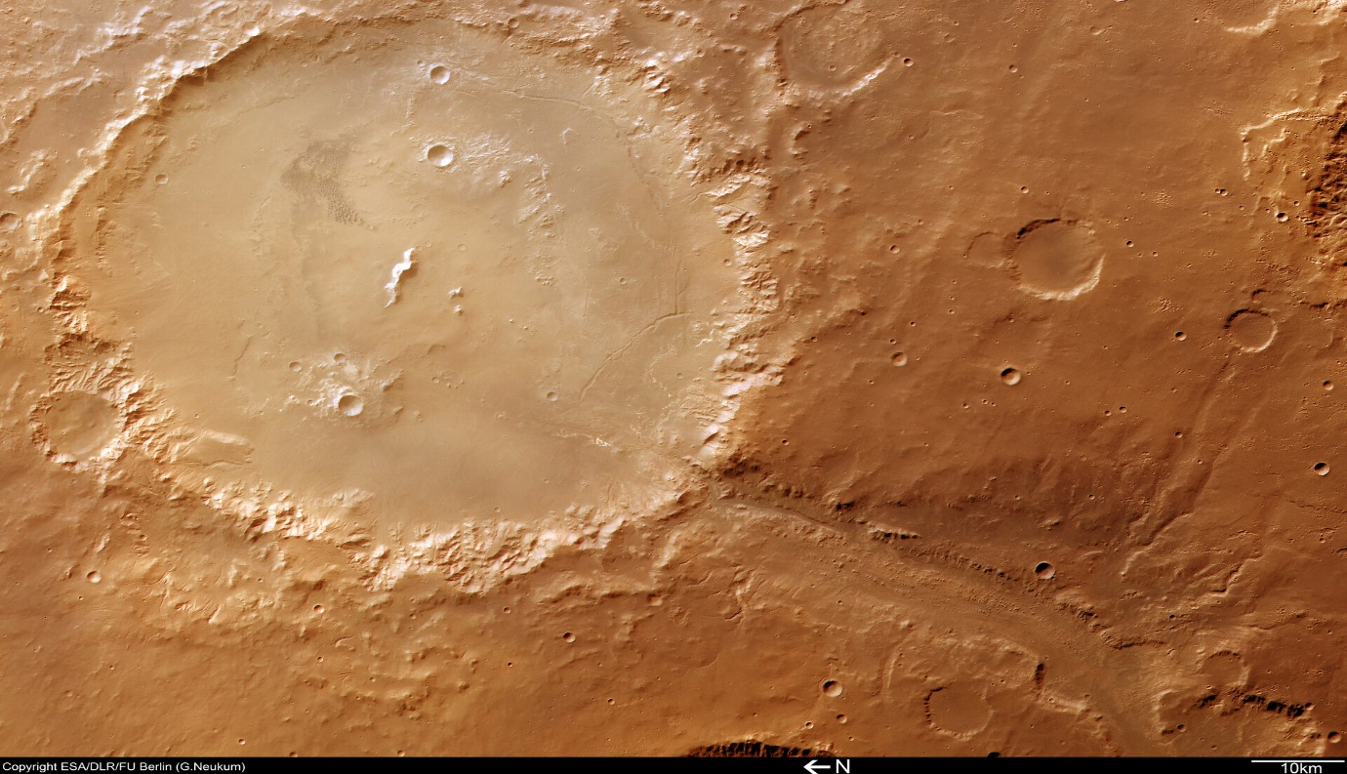

- Mawrth Vallis:
- Type of Terrain: Valley type; full of phyllosilicates or clay minerals.
- Information about the past: Suggests extensive water alteration. It is perhaps one of the oldest clay reserves on Mars.
- Accessibility: Large flat terrain with very few obstacles. Mostly open plains.
- Relevance to Life Detection: Extremely high as clay minerals are excellent at trapping and preserving organics.
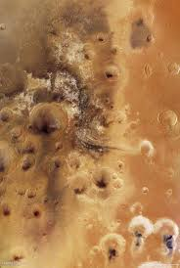

- Columbia Hills:
- Type of Terrain: Hills inside a crater. Also has volcanic and hydrothermal features.
- Information about the past: Possible hot-spring environment.
- Accessibility: Moderate. Hills and rocky terrain.
- Relevance to Life Detection: Good, considering hydrothermal environments are strong depictions of early microbial habitats.

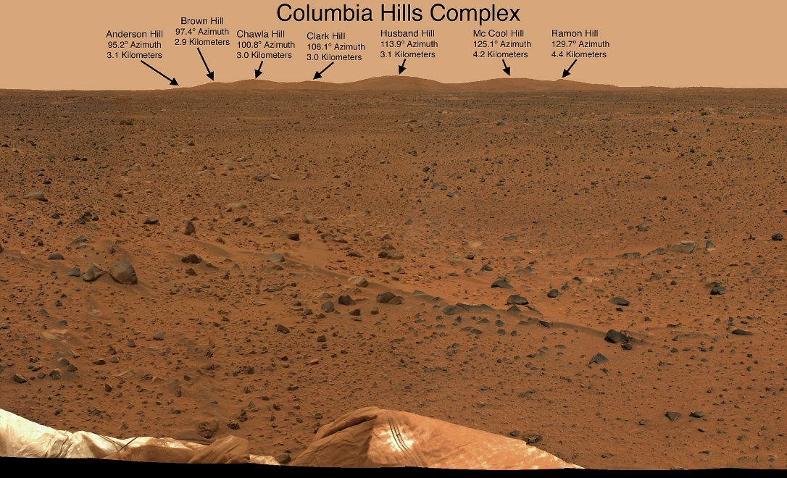

Choice of Site: Mawrth Vallis
Justification:
- It is rich in Phyllosilicates that indicates long-term water presence.
- It gives access to the oldest accessible materials.
- It is easier to access and traverse.
- It has amazing potential for biosignature preservation.
Rover Path Planning for Mawrth Vallis:
- Land in a flat plain south of the valley, from where clay-rich minerals are easily accessible.
- Move upslope to layered phyllosilicates. Do drilling and soil analysis for clay content.
- Traverse the valley channel edges to study erosion cuts.
Citations:
https://www.esa.int/Science_Exploration/Space_Science/Mars_Express/The_clays_of_Mawrth_Vallis
https://themis.asu.edu/feature/25
https://en.wikipedia.org/wiki/Columbia_Hills_(Mars)

Interpretation of given data:
- Chemical Test: Bradford- no color change observed. This suggests that there is no detectable protein, hence no strong evidence of CURRENT biological activity.
- Rock Image- It appears fragmented, and reddish in color. This suggests mechanical weathering. Angular fragments imply limited transport or mild erosion due to water.
- Gas Sensor Data-
- CO – 250ppm – Possible due to oxidation of organics or minerals.
- CO₂ – 5000ppm – Common on Mars due to volcanic activity.
- NO₂ – 15ppm – Very low, remote possibility of photochemical origin.
- Ethanol – 500ppm – Possibility of degrader organic matter.
- H₂ – 2000ppm – Produced from some rock reactions.
- NH₃ – 200ppm – Due to degradation of nitrogen compounds, possible biosignature!
- CH₄ – 5000ppm – Very significant, high chances of biotic presence.
- Propane – 3000ppm – Reduced hydrocarbons, possible ancient biological source.
- Iso-butane – 2500ppm – Reduces hydrocarbons, possible ancient biological source.
- Soil Image- Soil is reddish-brown in color. From Munsell Soil Color Chart, color notation: 5YR 4/4 is being noted. The reddish-brown indicates iron oxide presence. It also indicates an oxidizing, harsh environment, less favorable for preserving active organics.

Citations:
https://soils.uga.edu/files/2016/08/Munsell.pdf

Hypothesis: “Extinct Life”
Justification: High abundance of reduced hydrocarbons and ammonia suggests potential past biological activity. Negative Bradford test points out to no active biological activity. Eroded rock images points out to past water presence.

