PROJECT TITLE GOES HERE  Domain / Area: ____________ Semester / Year: ____________ | Ramaiah Institute of Technology  Team No: _______  Guide: ________________________  Team: Member 1 | Member 2 | Member 3 | Member 4

1 PROBLEM STATEMENT & RESEARCH GAP | 2 SYSTEM FLOW — INPUT · PROCESS · OUTPUT | 3 OUTCOMES & SCOPE

RESEARCH GAP  State in ONE clear sentence: what is missing from existing literature or tools that this project addresses? Cite the gap explicitly.  PROBLEM STATEMENT  Describe the exact problem being solved. Who is affected? Why is it critical to address it now? What are the real-world consequences if left unsolved? | INPUT ▶ PROCESS ▶ OUTPUT  Data, files, images, sensor feeds, API calls, user forms, logs, metadata… Algorithm, ML model, business logic, modules, tech stack, API integrations… Report, alert, prediction, PDF, dashboard, visual output, benchmarks… | OUTCOMES  List the concrete deliverables — what does the system produce? Predictions, reports, alerts, dashboards, metrics…  SCOPE & FUTURE EXTENSIONS  Describe constraints of the current system. What features or datasets are out of scope? What can be added in the next phase?

4 NOVELTY — EXISTING SYSTEM VS OUR APPROACH

ASPECT | EXISTING SYSTEM + LIMITATION | OUR APPROACH | NOVELTY / WHY BETTER
Algorithm / Model | Manual spreadsheet analysis or basic dashboards depend on fixed formulas and human interpretation. Forecasting, risk, anomaly detection, and recommendations are usually handled separately. | AI-CFO uses a multi-agent pipeline: KPI agent, ratio logic, forecast agent, anomaly agent, risk agent, recommendation agent, health agent, and auditor agent. | The system combines financial analytics and AI-style reasoning into one workflow, producing both numbers and business interpretation.
Forecasting | Existing SME analysis often uses simple trend assumptions or manual projections, which can fail when data is incomplete or volatile. | The forecast agent tries Prophet when available, falls back to ARIMA, and finally uses linear regression if advanced models fail. | Layered fallback improves robustness because the system can still generate usable forecasts even when one model or dependency is unavailable.
Risk & Decision Support | Traditional systems show financial values but often do not explain risk drivers or suggest next actions. | Risk is classified using profitability, expense load, volatility, forecast confidence, cashflow pressure, and anomaly signals. Recommendations are generated from the same signals. | The output is decision-oriented, not only descriptive. It gives risk level, reasons, and practical management actions.
Data / Dataset Handling | Manual analysis requires clean, consistently formatted spreadsheets and can break when date columns, missing months, or duplicate periods are present. | The preprocessing layer normalizes column names, accepts 'months' or 'date', aggregates duplicate months, interpolates missing monthly gaps, and converts numeric data safely. | The system reduces manual cleaning effort and makes the analysis pipeline more tolerant of real SME financial datasets.
User Interaction | Existing workflows require users to inspect formulas, charts, and reports manually. | Users upload a CSV and receive dashboard-ready KPIs, forecasts, anomalies, health score, recommendations, and auditor summary. | The platform converts raw finance data into executive-friendly insight in a single interaction.

5 ARCHITECTURE DIAGRAMS — SYSTEM ARCHITECTURE · DFD · ER · USE CASE

SYSTEM ARCHITECTURE DIAGRAM  [ Paste your architecture diagram image here — frontend → backend → database layers with tech stack labelled on each layer ]  DFD Level 0 / DFD Level 1 / Use Case Diagram (attach below) | ER DIAGRAM / FLOWCHART / CLASS DIAGRAM  [ Paste secondary diagram here — ER diagram with PKs, FKs, cardinality OR Flowchart / Sequence diagram based on system type ]  Label all entities, relationships, processes and data stores.

6 ALGORITHM & PROCESS STEPS | 7 TECHNOLOGY STACK

Algorithm & Process Steps  1. CSV Upload & Session  User uploads monthly SME finance data through the React interface; FastAPI receives the file for analysis.  2. Preprocessing  Column names are normalized, date/month fields are parsed, duplicate months are aggregated, missing gaps are interpolated, and numeric fields are cleaned.  3. KPI & Ratio Calculation  Revenue, expenses, profit, profit margin, average revenue, expense breakdown, and expense ratios are calculated.  4. Forecasting Agent  Revenue forecast is generated using Prophet when available, ARIMA as fallback, and linear regression as the final safe baseline.  5. Anomaly & Risk Agents  IsolationForest or rule-based checks detect unusual periods; risk is classified using profitability, volatility, forecast confidence, expense pressure, and cashflow signals.  6. Recommendations, Health Score & Auditor Summary  The system produces prioritized actions, a 0-100 health score, and an executive-style summary for dashboard display. | Technology Stack  Frontend  React, Vite, Tailwind CSS - used for CSV upload, dashboard cards, charts, navigation, and user interaction.  Backend  FastAPI, Python - exposes upload, analysis, session, result, and run-history APIs.  Database  SQLite with SQLAlchemy - stores analysis runs and compressed result payloads for later review.  Data Processing  Pandas, NumPy - cleans financial data, aggregates months, computes KPIs, ratios, and trend features.  ML / Analytics  scikit-learn IsolationForest, statsmodels ARIMA, optional Prophet, linear regression fallback - supports forecasting and anomaly detection.  AI Summary  Optional Google Gemini integration with structured rule-based fallback - generates executive-friendly auditor narration.  Deployment  Docker and Docker Compose - containerized frontend/backend setup for reproducible execution.

8 PERFORMANCE METRICS — COMPARISON WITH EXISTING SYSTEM

METRIC | EXISTING SYSTEM | OUR SYSTEM | IMPROVEMENT % | HOW MEASURED
Financial insight generation | Manual spreadsheet review; requires separate calculation and interpretation | Automated KPI, ratio, risk, forecast, anomaly, recommendation, and auditor outputs | To be measured | Compare time taken by manual Excel workflow vs AI-CFO upload-to-dashboard workflow
Data preprocessing coverage | Manual correction of column names, missing values, duplicate months, and date issues | Automated normalization, date handling, duplicate aggregation, monthly gap interpolation, and numeric conversion | To be measured | Test multiple CSV files with formatting issues and record successful processing rate
Forecast availability | Forecast may be absent if the chosen method fails or is not manually prepared | Prophet -> ARIMA -> Linear Regression fallback chain | To be measured | Count successful forecast generation across valid test datasets
Anomaly detection support | Manual detection through visual inspection or formula thresholds | IsolationForest-based anomaly detection with rule-based fallback | To be measured | Compare detected anomaly periods against labelled scenario datasets
Decision support completeness | Usually provides charts or formulas, but limited structured recommendations | Produces risk level, health score, anomaly explanation, strategic recommendations, and auditor summary | To be measured | Checklist-based evaluation: number of required output sections generated per test run

9 RESULTS — GRAPHS & VISUAL EVIDENCE

Graph 1 - Revenue vs Expenses Trend  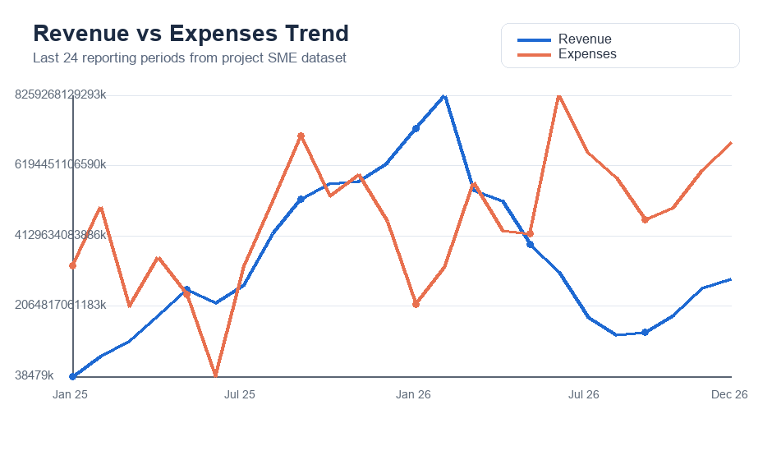  This chart compares monthly revenue against total expenses, showing whether business growth is supported by a controlled cost structure. | Graph 2 - Revenue Forecast Evidence  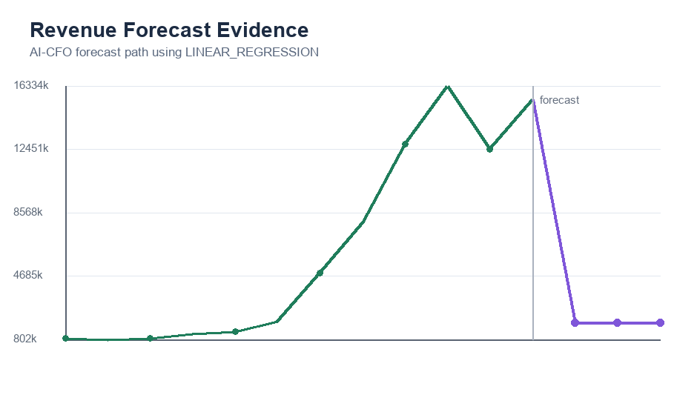  This graph shows the transition from historical revenue to the AI-CFO forecast period, demonstrating the system's planning-oriented output. | Graph 3 - Health Score Comparison  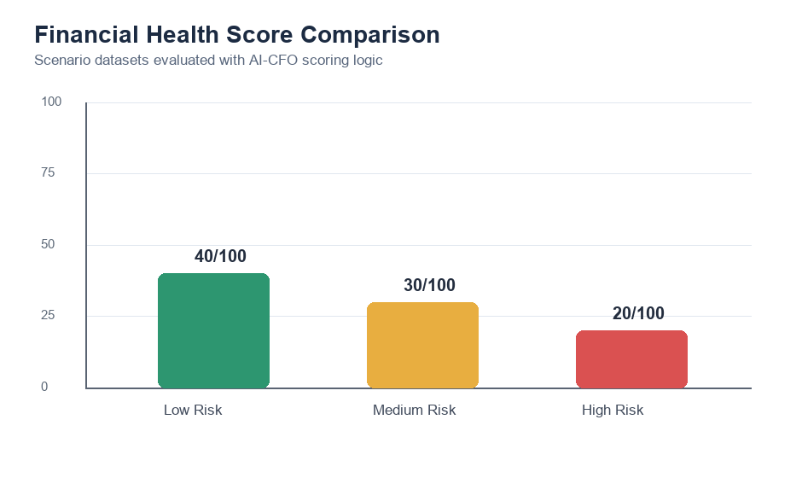  This comparison shows how the health scoring logic separates low, medium, and high-risk financial scenarios.

10 RESEARCH GAP RESOLUTION | 12 CONCLUSION & FUTURE SCOPE

GAP RESOLUTION  How our output closes it:  Explain how the solution developed addresses/closes the gap addressed earlier | CONCLUSION & FUTURE SCOPE  Conclusion:  Summarise what was built and what was achieved. Keep it 2–3 sentences.  Future Scope:  List 3–4 concrete extensions: larger datasets, real-time integration, mobile app, federated learning, multilingual support, etc.

Guide Signature

