REQUEST FOR PROPOSAL

OrderManager v3.1
Multi-Store Order Management Platform

────────────────────────────────────────

Developer RFP & Technical Specification
Project Overview • Requirements • Wireframes • Rebuild Guide
Field | Details
Document Type | Request for Proposal (RFP) & Technical Specification
Version | 3.1
Date Issued | February 7, 2026
Platform | React 18 Single-Page Application (Vite 5.x build)
Current Hosting | GoDaddy WordPress — Static subdirectory deployment
Current Status | In-Memory Demo / Production-Ready Frontend
Proposal Deadline | [TO BE FILLED]

Table of Contents

1. Project Overview

1.1 Business Context
Our company operates a chain of retail grocery/convenience stores across multiple locations. Each week, store managers must place purchase orders for inventory replenishment from centralized suppliers. Currently, this ordering process relies on informal communication (phone calls, WhatsApp messages, spreadsheets), which leads to missed orders, duplicate ordering, difficulty tracking what was ordered, and no consolidated view for management.
OrderManager was created to solve these problems by providing a structured, web-based platform where store managers submit orders on a defined schedule, and administrators can monitor, consolidate, and dispatch those orders to suppliers efficiently.

1.2 What the System Does
OrderManager is a multi-store order management web application that coordinates weekly purchasing across multiple retail locations and suppliers. The core workflow is:
- Store managers log in and see which order type is active today (Order A, B, or C, each on a fixed day of the week).
- Managers enter quantities for each item in their store’s catalog, referencing last week’s data as a guide.
- Managers submit their order (with a confirmation prompt to prevent accidental submission).
- Admin sees a real-time dashboard of which stores have submitted and which are pending.
- Admin reviews a consolidated cross-store matrix, then splits the order by supplier.
- Admin sends purchase orders to each supplier via email directly from the platform.
- Admin marks orders as processed, updating the status visible to all managers.

1.3 Who Uses the System
User Role | Count | Description | Key Capabilities
Admin | 1–2 | Business owner or operations manager with full system access | Monitor all stores, consolidate orders, dispatch to suppliers, manage items/users/settings, view reports
Manager | 1 per store | Store-level manager responsible for placing weekly orders | Place orders for their store, view order history, see custom order instructions from admin

1.4 Current State of the Application
A fully functional frontend prototype (v3.1) has been built and is included with this RFP. The prototype is a single React JSX file (~725 lines, 80KB) that implements every screen, workflow, and UI element described in this document. All data currently lives in-memory (resets on page refresh). The prototype is deployed as a static build in a subdirectory of our GoDaddy WordPress site.
What exists today: Complete UI, all workflows, role-based access, order scheduling, consolidated views, supplier splitting, email dispatch (via mailto:), reports, and admin settings.
What is needed: A persistent backend (database), server-side email sending, real SMS reminders, user authentication with password hashing, and optionally mobile-responsive improvements.

2. Purpose & Scope of This RFP

2.1 Purpose
This Request for Proposal invites qualified developers or development teams to review the existing OrderManager prototype, understand its complete functionality through this specification and the included wireframes, and propose an approach to rebuild or extend it into a production-ready application with persistent data storage.

2.2 Scope of Work
The selected developer will be expected to deliver the following:

2.2.1 Required Deliverables
- Production-ready web application implementing all features described in Sections 5–7
- Persistent data storage (database) replacing the current in-memory state
- Secure authentication system (password hashing, session management)
- Server-side email integration for supplier purchase orders
- SMS notification integration for order submission reminders
- Deployment to existing GoDaddy WordPress hosting environment (or recommended alternative)
- Source code with documentation and deployment instructions

2.2.2 Optional / Future Phase Deliverables
- Mobile-responsive layout optimization for tablet and phone use
- PDF/Excel export for reports and supplier orders
- Real-time multi-user concurrency support
- Integration with accounting or inventory management systems
- Progressive Web App (PWA) capabilities for offline order entry

2.3 Existing Assets Provided
The following materials are provided with this RFP:
Asset | Format | Description
OrderManager.jsx | React JSX (80KB) | Complete working prototype — all components, logic, styles, data
This RFP Document | DOCX | Full specification with wireframes, data models, and rebuild guide
ordermanager-deploy.zip | ZIP | Build-ready deployment package (Vite config, index.html, .htaccess)
DEPLOY-GUIDE.md | Markdown | Step-by-step GoDaddy deployment instructions

3. Screen Flow & Wireframes
The following diagrams illustrate the application’s navigation structure and key screen layouts. These wireframes represent the current working prototype and define the expected UI for the production build.

3.1 Application Screen Flow
This diagram shows how users navigate through the application after login, with separate paths for Admin and Manager roles.
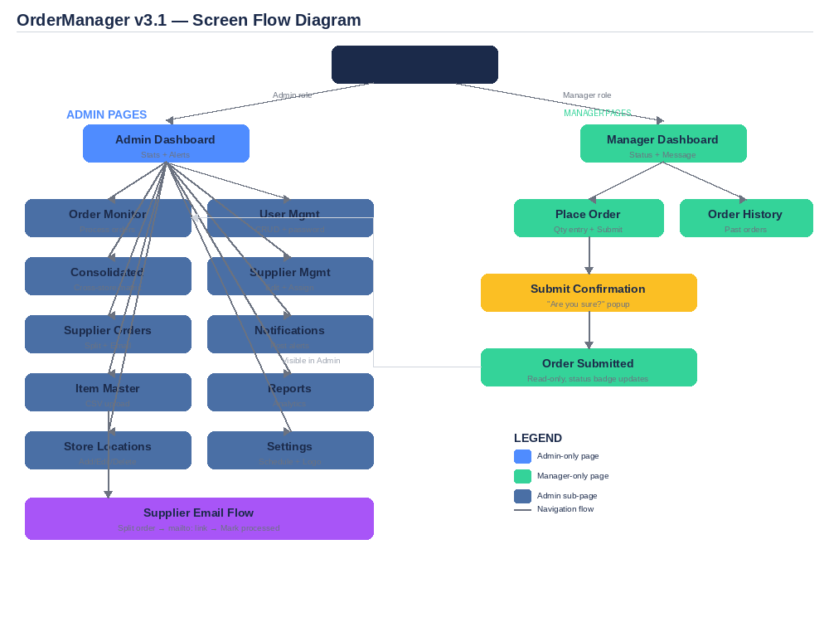
Figure 3.1: Complete application navigation flow showing Admin (11 pages) and Manager (3 pages) paths

3.2 Login Screen
The entry point for all users. Displays the company logo (customizable via Admin Settings), username/password fields, and demo account credentials for testing.
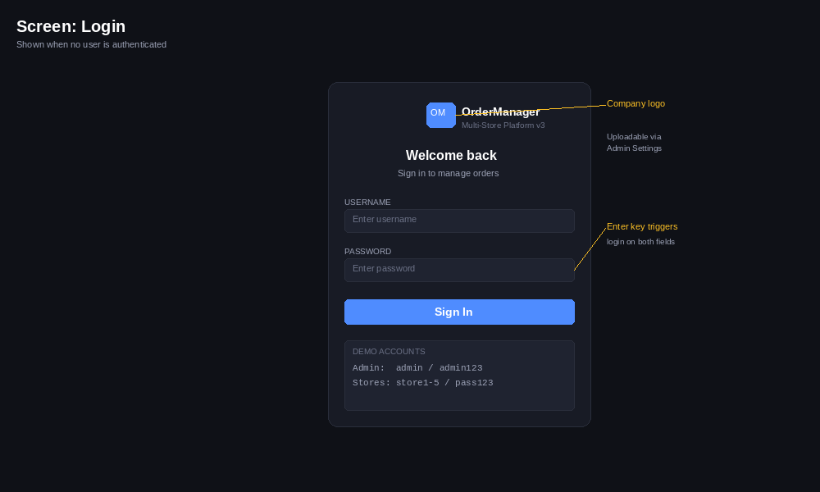
Figure 3.2: Login screen with custom logo area, credential fields, and demo account reference

3.3 Admin Dashboard
The admin’s home screen provides a high-level overview: store/item/order counts, pending submission alerts with SMS reminder indicators, active notifications, quick action buttons, and the current order schedule.
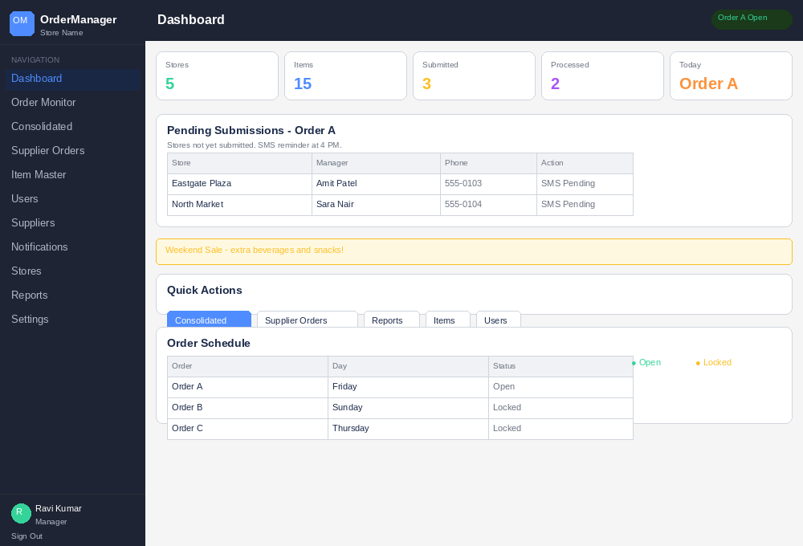
Figure 3.3: Admin Dashboard showing stat cards, pending alerts table, notifications, quick actions, and schedule

3.4 Manager Dashboard
The manager’s home screen shows their store context, today’s active order, and a context-aware status card that changes based on whether their order is pending, submitted, or processed.
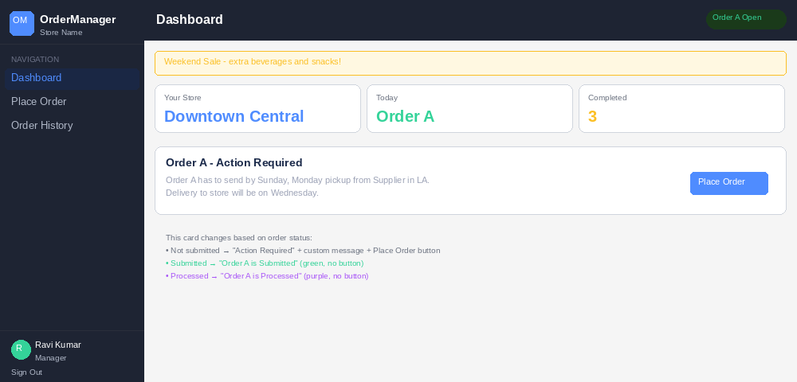
Figure 3.4: Manager Dashboard with store info, order status card, and state-dependent messaging

3.5 Place Order (with Submit Confirmation)
The core order entry screen with item table, sort controls, quantity inputs, last-week reference, and the confirmation popup that appears before final submission.
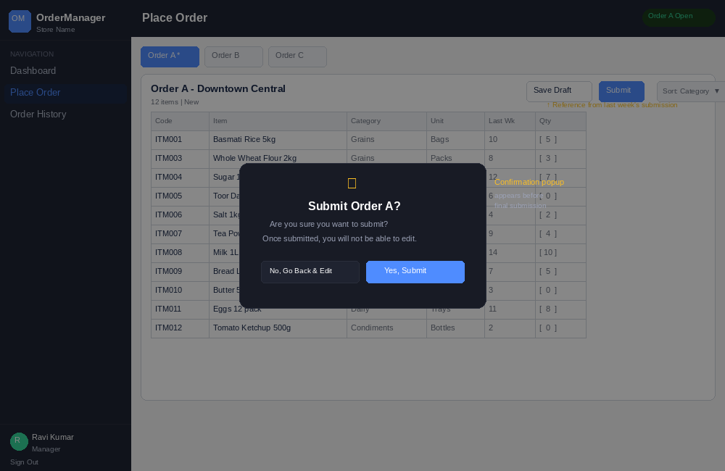
Figure 3.5: Order entry form with sort dropdown, item table, and submit confirmation popup overlay

3.6 Consolidated View
A matrix view showing all items (rows) across all stores (columns) with inline editing capability. The admin can click the edit icon on any store column to modify quantities directly.
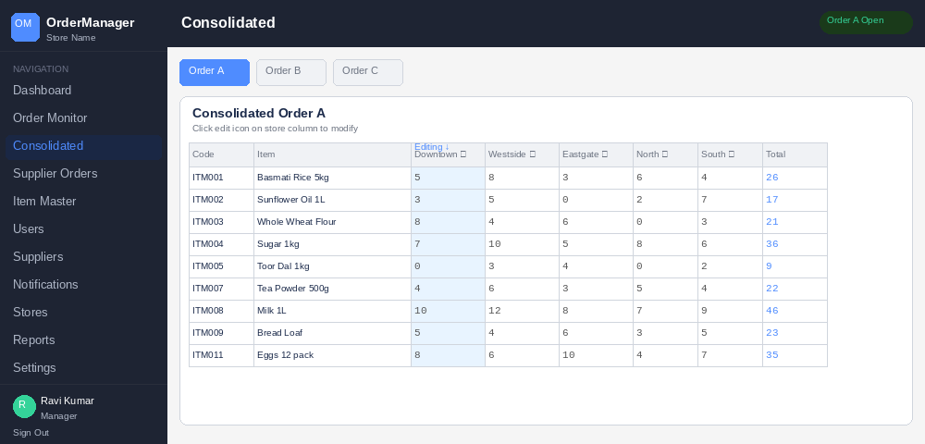
Figure 3.6: Cross-store consolidated matrix with inline editing and auto-calculated totals

3.7 Supplier Orders (Split & Email)
The consolidated order is automatically split by supplier based on item assignments. Each supplier gets a card with their items, quantities per store, and a Send Email button that opens the user’s email client with a pre-filled purchase order.
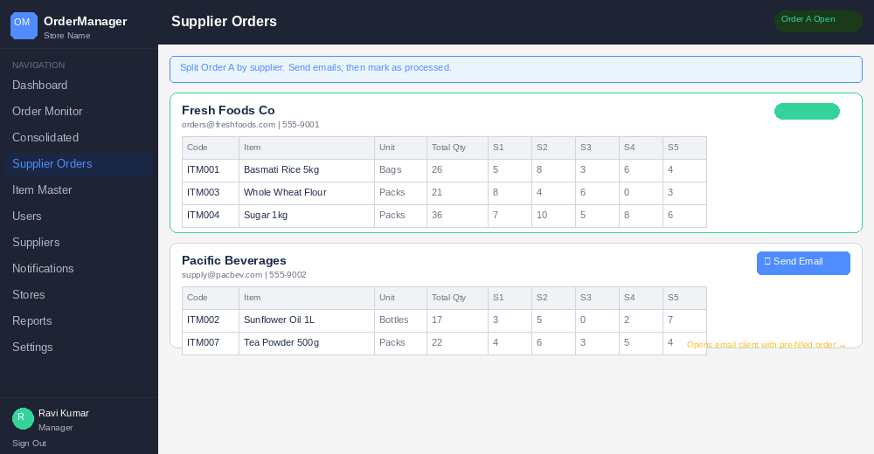
Figure 3.7: Supplier order split with per-supplier cards, email dispatch buttons, and sent confirmations

3.8 Settings
Admin configuration page for order schedule (day-of-week per order type), custom order messages, and company logo upload.
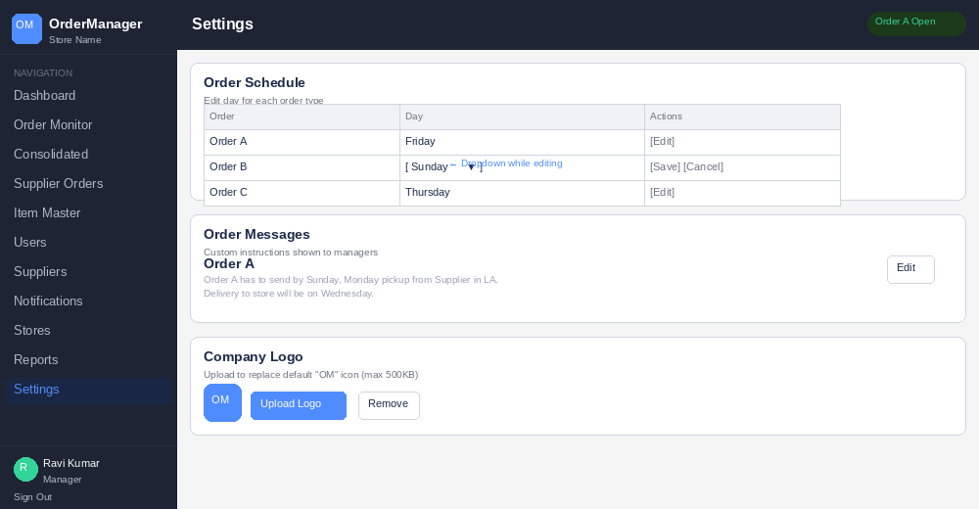
Figure 3.8: Settings page with editable schedule, custom messages, and logo upload/remove

3.9 Reports
Analytics dashboard with three report views: Top Items (ranked by quantity with visual bars), By Category (aggregated), and By Store (order counts by status).
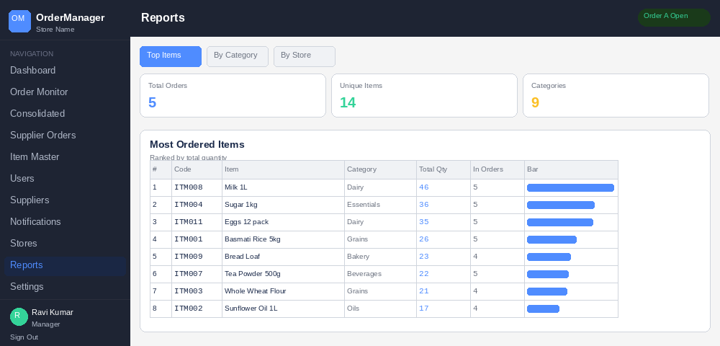
Figure 3.9: Reports page showing Top Items tab with bar visualization, summary stat cards, and ranked table

4. System Architecture

4.1 Current Technology Stack
Component | Technology | Version | Purpose
Frontend Framework | React | 18.x | UI rendering and state management
Build Tool | Vite | 5.x | Bundling and dev server
Language | JavaScript (JSX) | ES2020 | Application logic
Styling | Inline CSS Objects | N/A | All styles defined as JS object (var S)
Icons | Custom SVG Component | N/A | Hand-coded SVG paths (Ic component)
Hosting | GoDaddy WordPress | N/A | Static files in /orders/ subdirectory

4.2 File Structure
File | Purpose
src/OrderManager.jsx | Complete application (~725 lines): all 18 components, styles, data, logic
src/main.jsx | React entry point (mounts App to DOM #root element)
index.html | HTML shell with #root div and base CSS reset
vite.config.js | Build config — base path must match deployment subdirectory
.htaccess | Apache SPA rewrite rules for GoDaddy
package.json | Dependencies: react, react-dom, vite, @vitejs/plugin-react

4.3 State Management
All application state is managed via React hooks (useState, useCallback, useMemo, useRef) in the root App component and passed down via props. No external state library is used.
State Variable | Type | Description
user | Object | null | Currently logged-in user (null shows login screen)
page | String | Active page/route identifier
items | Array | Item master catalog (code, name, category, unit)
users | Array | All user accounts with credentials and roles
orders | Object (map) | All orders keyed by storeId_year-Wweek-type
notifs | Array | Admin-posted notifications/announcements
stores | Array | Store locations (id, name)
schedule | Object | Order schedule: {A: dayIndex, B: dayIndex, C: dayIndex}
orderMsgs | Object | Custom messages per order type for managers
suppliers | Array | Supplier records (id, name, email, phone, assigned items)
logo | String | null | Base64 data URL of uploaded company logo

4.4 Order Key Format
Format: storeId_year-Wweek-orderType — Example: S1_2026-W06-A
This composite key enables lookup by store, week, and order type, and naturally supports historical data through different week numbers.

5. Functional Requirements

5.1 Authentication & Login
Component: Login
- Username/password login with Enter-key support on both fields
- Custom company logo display (if uploaded) replacing default “OM” icon
- Error message for invalid credentials or disabled accounts
- Demo account reference box for testing
- Disabled/inactive users blocked from login

5.2 Order Schedule System
The system operates on three order types (A, B, C), each mapped to a day of the week:
Order | Default Day | Default Message
A | Friday | Order A has to send by Sunday, Monday pickup from Supplier in LA. Delivery to store on Wednesday.
B | Sunday | Order B has to send by Monday, Tuesday pickup from Supplier. Delivery to store on Thursday.
C | Thursday | Order C has to send by Friday, Saturday pickup from Supplier. Delivery to store on Monday.
Active Order Detection: Compares current day-of-week (0–6) against schedule. If today matches an order day, that order is “open.”
Locking: Non-active orders are locked for managers (read-only). Admin can edit schedules and messages in Settings.
Duplicate Prevention: Settings editor prevents assigning the same day to multiple order types.

5.3 Admin Dashboard
- Summary stat cards: Stores, Items, Submitted, Processed, Today’s active order
- Pending Submissions panel: Stores that haven’t submitted, with manager name and phone
- SMS Reminder indicators (4 PM on order day)
- Active notifications display
- Quick action buttons: Consolidated, Supplier Orders, Reports, Items, Users
- Order Schedule table with Open/Locked status

5.4 Manager Dashboard
- Store name, today’s active order, completed orders count
- Context-aware order status card:
  - Not submitted: “Action Required” with custom message + Place Order button
  - Submitted: “Order X is Submitted” (green, no button)
  - Processed: “Order X is Processed” (purple, no button)
- Topbar badge also reflects submitted/processed status

5.5 Place Order (Order Entry)
- Tab selector for Order A, B, C (active marked with asterisk)
- Locked order warning with scheduled day name
- Full item table: Code, Item, Category, Unit, Last Week qty, Current Qty input
- Sort dropdown: Category (default), Name, or Code
- Last Week reference column from previous week’s same order type
- Save Draft: Saves as “draft” status (editable)
- Submit: Confirmation popup (“Are you sure? Once submitted you cannot edit.”) Yes/No
- Submitted/processed orders become read-only

5.6 Order History (Manager)
- All orders for current store, sorted by date descending
- Columns: Order type, Date/Time, Status badge, Item count, View button
- View modal: Itemized breakdown with quantities

5.7 Order Monitor (Admin)
- Filter tabs: All, Order A, B, C
- Columns: Store, Order type, Date/Time, Status, Filled items, Action
- Individual Process button (submitted → processed)
- Bulk “Process Order X (All Stores)” when filtered

5.8 Consolidated View (Admin)
- Matrix: Items (rows) × Stores (columns) + Total column
- Tab selector for Order A, B, C
- Inline edit: Click pencil icon on store column to edit quantities
- Save/Cancel during edit; totals recalculate dynamically

5.9 Supplier Orders — Split & Email (Admin)
- Auto-splits consolidated order by supplier based on item assignments
- Per-supplier card: name, email, phone, item table with per-store breakdown
- Send Email button opens email client via mailto: with subject + itemized body
- “Email Sent” badge after sending
- “Mark All Processed” button once all suppliers emailed
- Unassigned Items section flags items not mapped to any supplier

5.10 Item Master (Admin)
- Searchable list (searches code, name, category)
- Sort dropdown: Category, Name, Code
- Add item modal: Code, Name, Category, Unit
- Delete item per-row
- CSV Upload: file → parser → preview (first 8 rows) → Merge/Replace → Confirm

5.10.1 CSV Format
Column Header (flexible) | Maps To | Required
code, sku | Item Code | No (auto-generates CSV0001...)
name, item, description | Item Name | Yes
category, cat, group | Category | No
unit, uom | Unit of Measure | No

5.11 User Management (Admin)
- User table: Name, Username, Phone, Role, Store, Status, Actions
- Create User: Name, Username, Password, Phone (all mandatory), Role, Store
- Enable/Disable toggle
- Password Reset modal (minimum 6 characters)

5.12 Supplier Management (Admin)
- Supplier table: ID, Name, Email, Phone, Item count, Actions
- Add Supplier: ID, Name, Email (required), Phone
- Edit Supplier: Modal to update Name, Email, Phone
- Assign Items: Checkbox-based item assignment modal
- Delete supplier

5.13 Notifications (Admin)
- Post new: Info or Promo type with text content (auto-dated)
- Display on both Admin and Manager dashboards
- Delete individually

5.14 Store Locations (Admin)
- Add new store: ID + Name (validates uniqueness)
- Inline edit store name
- Delete store (minimum 1 enforced)

5.15 Reports (Admin)
- Three tabs: Top Items, By Category, By Store
- Summary cards: Total orders, Unique items, Categories active
- Top Items: Ranked by total qty with visual bar chart
- By Category: Aggregated qty and unique item count
- By Store: Order counts by status (submitted, processed, draft)

5.16 Settings (Admin)
- Order Schedule: Edit day-of-week per order type (dropdown, duplicate validation)
- Order Messages: Edit custom instructions per order type (textarea)
- Company Logo: Upload image (max 500KB) to replace OM icon, or remove to revert
- Store listing (read-only reference)

6. Data Model & Default Configuration

6.1 Default Stores (5)
Store ID | Store Name
S1 | Downtown Central
S2 | Westside Mall
S3 | Eastgate Plaza
S4 | North Market
S5 | Southpoint Hub

6.2 Default Item Catalog (15 items)
Code | Name | Category | Unit
ITM001 | Basmati Rice 5kg | Grains | Bags
ITM002 | Sunflower Oil 1L | Oils | Bottles
ITM003 | Whole Wheat Flour 2kg | Grains | Packs
ITM004 | Sugar 1kg | Essentials | Packs
ITM005 | Toor Dal 1kg | Pulses | Packs
ITM006 | Salt 1kg | Essentials | Packs
ITM007 | Tea Powder 500g | Beverages | Packs
ITM008 | Milk 1L | Dairy | Packets
ITM009 | Bread Loaf | Bakery | Pieces
ITM010 | Butter 500g | Dairy | Packs
ITM011 | Eggs 12 pack | Dairy | Trays
ITM012 | Tomato Ketchup 500g | Condiments | Bottles
ITM013 | Mixed Spice Box | Spices | Boxes
ITM014 | Dish Soap 750ml | Cleaning | Bottles
ITM015 | Paper Towels 6 roll | Cleaning | Packs

6.3 Default Suppliers (3)
ID | Name | Email | Phone | Assigned Items
SUP1 | Fresh Foods Co | orders@freshfoods.com | 555-9001 | ITM001, 003, 004, 005, 006
SUP2 | Pacific Beverages | supply@pacbev.com | 555-9002 | ITM002, 007, 008, 012
SUP3 | Metro Supplies | orders@metrosup.com | 555-9003 | ITM009–015 (excl. 012)

6.4 Default Users (6)
Username | Password | Role | Store | Name | Phone
admin | admin123 | Admin | All Stores | System Admin | 555-0100
store1 | pass123 | Manager | S1 | Ravi Kumar | 555-0101
store2 | pass123 | Manager | S2 | Priya Sharma | 555-0102
store3 | pass123 | Manager | S3 | Amit Patel | 555-0103
store4 | pass123 | Manager | S4 | Sara Nair | 555-0104
store5 | pass123 | Manager | S5 | Vikram Singh | 555-0105

6.5 Seed Orders
The prototype initializes with last week’s Order A data (status: submitted) for all 5 stores with randomized quantities. This provides “Last Week” reference data when placing new orders.

7. UI/UX Specifications

7.1 Layout Structure
- Fixed sidebar (240px): Logo, navigation links, user info with avatar, sign-out button
- Top bar (52px): Page title, active order status badge, current day indicator
- Scrollable content area: Cards with max-height table containers and sticky column headers

7.2 Color System (Dark Theme)
Element | Color | Hex
Page background | Near-black | #0F1117
Card / sidebar | Dark charcoal | #181B25
Borders | Dark gray | #2A2E3B
Input / table header bg | Slate | #1F2330
Primary text | Light gray | #E8EAF0
Secondary text | Medium gray | #9BA1B5
Muted text | Dim gray | #6B7186
Primary accent | Blue | #4F8CFF
Success | Emerald | #34D399
Warning | Amber | #FBBF24
Danger | Red | #F87171
Processed status | Violet | #A855F7

7.3 Status Badge System
Status | Color | Usage
Open / Active / Enabled | Green #34D399 | Active order, submitted, enabled user
Locked / Draft / Pending | Yellow #FBBF24 | Locked order, draft status
Processed | Purple #A855F7 | Admin-processed order
Error / Disabled | Red #F87171 | Disabled user, SMS pending, delete
Info / Count | Blue #4F8CFF | Item counts, role badges

7.4 Toast Notifications
Fixed-position toast at top-right, auto-dismissed after 2.5 seconds. Green for success, red for errors. Triggered by toast(message, isError) callback.

8. Key Functions Reference
Core utility functions defined at the top of OrderManager.jsx:
Function | Purpose | Returns
activeType(schedule) | Checks if today matches any order day | “A” / “B” / “C” or null
weekNum(date) | ISO week number calculation | Integer (1–52)
dateKey(type) | Current week order key | "2026-W06-A"
lastWeekKey(type) | Previous week order key | "2026-W05-A"
sortItems(array) | Sort items by category then name | Sorted array
fmtDT(isoString) | Format ISO date to locale string | "2/6/2026 2:30 PM"
parseCSV(text) | Parse CSV text to item objects | Array of {code, name, category, unit}

9. Component Map
Every React component with its route, props received, and description:
Component | Route | Key Props | Description
App | Root shell | (manages all state) | Sidebar, topbar, routing, all state hooks
Login | /login | users, onLogin, logo | Authentication form
AdminDash | dashboard (admin) | orders, users, items, notifs, aot, schedule, stores | Admin stats, alerts, quick actions
MgrDash | dashboard (mgr) | user, orders, notifs, aot, schedule, orderMsgs | Manager order status card
OrderEntry | order-entry | user, items, orders, setOrders, aot, schedule | Quantity entry + submit confirm
OrderHistory | history | user, orders, items | Past orders with detail viewer
OrderMonitor | orders | orders, setOrders, items, stores, aot | All submissions + process controls
Consolidated | consolidated | orders, setOrders, items, aot, stores | Cross-store matrix + inline edit
SupplierOrders | supplier-orders | orders, setOrders, items, stores, suppliers | Split by supplier + email
ItemMaster | items | items, setItems | Item CRUD + CSV upload + sort
UserMgmt | users | users, setUsers, stores | User CRUD + password reset
SupplierMgmt | suppliers | suppliers, setSuppliers, items | Supplier CRUD + item assign + edit
NotifMgmt | notifications | notifs, setNotifs | Post/delete notifications
StoreMgmt | stores | stores, setStores | Store CRUD
Reports | reports | orders, items, stores | Top items, by category, by store
Settings | settings | schedule, orderMsgs, logo, setters... | Schedule, messages, logo config

10. Deployment & Build Guide

10.1 Prerequisites
- Node.js v18 or higher
- GoDaddy File Manager or FTP access

10.2 Build Steps
- Unzip ordermanager-deploy.zip
- cd ordermanager-deploy && npm install
- Edit vite.config.js — set base to target directory (e.g., '/orders/')
- npm run build (creates dist/ folder)
- Upload dist/ contents + .htaccess to public_html/orders/ on GoDaddy
- Access at: yourdomain.com/orders/

10.3 Update Procedure
- Replace src/OrderManager.jsx with the new version
- Run npm run build
- Upload new dist/ contents to GoDaddy (overwrite)

11. Known Limitations & Production Requirements

11.1 Current Limitations (to be resolved by developer)
Limitation | Current Behavior | Required Production Behavior
Data persistence | In-memory; resets on refresh | Database storage (Firebase, Supabase, PostgreSQL, or similar)
Email sending | Opens mailto: link in user’s email client | Server-side email via SendGrid, AWS SES, or similar
SMS reminders | Visual “SMS Pending” badge only | Actual SMS via Twilio or similar at 4 PM if not submitted
Authentication | Plain-text password comparison | Hashed passwords (bcrypt), JWT/session tokens
Multi-user | Single session at a time | Concurrent access with real-time or near-real-time sync
File architecture | Single 725-line JSX file | Multi-file component structure for maintainability

11.2 Recommended Future Enhancements
- PDF/Excel export for reports and supplier orders
- Mobile-responsive layout for tablet/phone use in stores
- Progressive Web App (PWA) for offline order entry
- Integration with accounting or inventory systems
- Barcode/QR scanning for item lookup
- Order approval workflow (manager → supervisor → admin)

12. Proposal Requirements

12.1 What to Include in Your Proposal
Proposals should address each of the following areas:
- Technical Approach: Describe your proposed technology stack for the backend (database, API framework, hosting). Explain how you will integrate with or replace the existing React frontend.
- Architecture Diagram: Provide a high-level diagram of the proposed production system (frontend, backend API, database, email service, SMS service).
- Timeline & Milestones: Break the project into phases with estimated delivery dates. Suggested phases: (a) Backend setup + authentication, (b) Core order workflow, (c) Admin features + reports, (d) Email/SMS integration, (e) Deployment + testing.
- Cost Estimate: Provide a fixed-price or time-and-materials estimate broken down by phase. Include any ongoing hosting or service costs (e.g., Twilio, SendGrid, database hosting).
- Team & Experience: Describe relevant experience with React, Node.js or similar backend, database design, and deploying to shared hosting environments.
- Maintenance Plan: Describe post-launch support (bug fixes, minor enhancements, uptime monitoring).
- Portfolio: Include 2–3 examples of similar projects (multi-user web apps with role-based access).

12.2 Evaluation Criteria
Criteria | Weight | Description
Technical Approach | 30% | Quality of proposed architecture, technology choices, and scalability plan
Timeline & Delivery | 20% | Realistic schedule with clear milestones and communication plan
Cost | 20% | Competitive pricing with transparent breakdown
Experience | 20% | Demonstrated experience with similar projects and technologies
Maintenance | 10% | Post-launch support plan and long-term partnership potential

12.3 Submission Instructions
Field | Details
Deadline | [TO BE FILLED]
Format | PDF or Word document
Email To | [TO BE FILLED]
Subject Line | RFP Response — OrderManager v3.1
Questions | Send questions to [TO BE FILLED] by [DATE]

13. Configuration Guidance — Testing & Production
This section provides practical guidance on how the email, SMS, and data storage features work today in the prototype, how to test them, and what is needed to configure them for production use.

13.1 Email — Sending Purchase Orders to Suppliers

13.1.1 Current Behavior (Prototype)
The app uses mailto: links. When Admin clicks “Send Email” on the Supplier Orders page, it opens the computer’s default email client (Outlook, Gmail app, Apple Mail) with the supplier’s email address, subject line, and itemized order details pre-filled. The admin then clicks Send manually in their email client.
How to test now: Simply click the “Send Email” button on any supplier card in the Supplier Orders page. Your email client will open with the purchase order content. You can verify the recipient, subject, and body content before sending.

13.1.2 Production Configuration
For production, the developer should replace mailto: links with server-side email sending via an API service. Recommended options:
Service | Free Tier | Cost Beyond Free | Setup Complexity
SendGrid (Twilio) | 100 emails/day | Starting at $19.95/mo for 50K emails | Low — REST API, good documentation
Amazon SES | None (pay-per-use) | ~$0.10 per 1,000 emails | Medium — requires AWS account + domain verification
Mailgun | 100 emails/day (trial) | Starting at $35/mo | Low — REST API
Resend | 100 emails/day | $20/mo for 50K emails | Very low — modern developer-friendly API
Recommended for your scale: SendGrid Free Tier. With 5 stores and 3 suppliers, you would send at most ~15 supplier emails per week, well within the 100/day free limit.
Testing in sandbox mode: All services above offer a sandbox/test mode where emails only go to verified addresses (your own email). This lets you test the full workflow without accidentally emailing real suppliers. The developer should set up sandbox mode first, verify everything works, then switch to production mode at go-live.

13.1.3 What the Developer Needs to Implement
- Create a backend API endpoint (e.g., POST /api/send-supplier-email)
- Integrate the chosen email service SDK/API
- Format the purchase order as a professional HTML email template
- Add email delivery status tracking (sent, failed, bounced)
- Configure sender domain and SPF/DKIM records for reliable delivery

13.2 SMS — Order Submission Reminders

13.2.1 Current Behavior (Prototype)
The app displays a visual “SMS Pending” badge on the Admin Dashboard next to stores that have not yet submitted their order. This is a UI placeholder only — no actual text messages are sent.
How to test now: Log in as admin and check the Pending Submissions panel on the Dashboard. If any stores haven’t submitted for today’s active order, you’ll see the “SMS Pending” badge. This confirms the detection logic works correctly.

13.2.2 Production Configuration
The standard SMS service for web applications is Twilio:
Item | Cost | Notes
Twilio Phone Number | ~$1.15/month | One number needed as the sender for all messages
Per SMS (US) | ~$0.0079/message | About 1 cent per text message sent
Free Trial Credit | $15.50 | Enough for ~1,900 test messages
Monthly estimate (5 stores) | ~$2–5/month | Assuming 3 order days/week, ~15 reminder texts maximum
How testing works with Twilio: During Twilio’s free trial, SMS can only be sent to phone numbers you manually verify in the Twilio dashboard. This means you can register your own phone number, test the full reminder flow, and confirm messages are received — all without any risk of texting real staff members before you’re ready.

13.2.3 What the Developer Needs to Implement
- Create a Twilio account and purchase a phone number
- Build a scheduled job (cron or cloud function) that runs at 4 PM on each order day
- The job checks which stores have not submitted for the active order type
- For each non-submitted store, send an SMS to the manager’s phone number
- SMS content example: “Reminder: Order A for Downtown Central is due today. Please submit via OrderManager.”
- Log SMS delivery status for admin visibility

13.3 Data Storage — Database Configuration

13.3.1 Current Behavior (Prototype)
All data (users, items, orders, suppliers, settings) is stored in JavaScript variables in the browser’s memory. When the page is refreshed, all data resets to the hardcoded defaults. This is by design for the prototype/demo phase.

13.3.2 Production Database Options
For production, the developer must set up persistent storage. Here are the recommended options ranked by ease of setup for your use case:
Option | Type | Free Tier | Monthly Cost | Best For
Firebase (Google) | NoSQL (Firestore) | 1GB storage, 50K reads/day | Free for your scale | Fastest setup, real-time sync, no server needed
Supabase | PostgreSQL | 500MB, 50K monthly users | Free for your scale | Full SQL database with built-in auth
GoDaddy MySQL | MySQL (relational) | Included with hosting | $0 additional | Keeping everything on GoDaddy, no new accounts
PlanetScale | MySQL (serverless) | 5GB, 1B row reads/mo | Free for your scale | Scalable MySQL without managing servers
Neon | PostgreSQL (serverless) | 512MB, 3GB transfer | Free for your scale | Modern PostgreSQL with branching
Recommended: Firebase or Supabase for simplest setup with free tier. However, if you prefer keeping everything under your GoDaddy account, the MySQL database included with your hosting plan works perfectly and costs nothing extra. Check your GoDaddy cPanel under “Databases” to verify availability.

13.3.3 Data Volume Estimate
Your application’s data needs are very modest:
Data Type | Estimated Records | Growth Rate | Storage Estimate
Users | 6–20 | Rarely changes | < 1 KB
Items | 15–200 | Occasional additions | < 10 KB
Stores | 5–15 | Rarely changes | < 1 KB
Suppliers | 3–10 | Rarely changes | < 1 KB
Orders (per week) | 15 (5 stores × 3 types) | ~780/year | ~500 KB/year
Notifications | 5–20 active | Periodic | < 5 KB
Total after 1 year |  |  | < 1 MB
Even after several years of operation, your total data would remain well under 10MB — easily within every free tier listed above.

13.4 Licensing & Compliance

13.4.1 Software Licenses
No special software licenses are required. All recommended technologies (React, Node.js, MySQL, PostgreSQL, Firebase) are either open-source or offered as managed services with free or pay-as-you-go pricing. There are no per-seat, per-user, or enterprise licenses needed for an application of this size.

13.4.2 Service Account Requirements
The developer will need accounts created for the following services (all free to start):
Service | Account Needed | Cost | Purpose
Email service | SendGrid or Amazon SES | Free tier | Sending purchase order emails to suppliers
SMS service | Twilio | $15 trial credit, then ~$2–5/mo | Sending order reminder texts to managers
Database (if cloud) | Firebase, Supabase, or similar | Free tier | Storing application data persistently
GoDaddy cPanel | Already have | Included | Hosting + optional MySQL database

13.4.3 Data Privacy Considerations
Since this is an internal business tool storing employee names, phone numbers, and order data:
- No special data privacy regulations apply for a US-based internal business tool with employee data
- Ensure your GoDaddy hosting has SSL/HTTPS enabled (included with most GoDaddy plans) so all data is encrypted in transit
- The developer must implement password hashing (bcrypt) — passwords should never be stored in plain text
- Implement session-based or JWT authentication for secure login
- Regular database backups should be configured (automated daily recommended)
- If you ever expand to store customer personal data or payment information, PCI compliance and additional privacy requirements would apply — but this is not needed for the current scope

13.5 Estimated Monthly Operating Costs (Production)
For your scale (5 stores, 6 users, 3 suppliers, 3 order days per week):
Service | Monthly Cost | Notes
GoDaddy Hosting | Already paid | Your existing WordPress hosting plan
SSL Certificate | $0 | Included with GoDaddy hosting
Database (Firebase/Supabase free tier) | $0 | Well within free limits for years
OR GoDaddy MySQL | $0 | Included with your hosting plan
Email (SendGrid free tier) | $0 | ~15 emails/week is far under 100/day limit
SMS (Twilio) | $2–5 | ~$1.15/month phone number + ~$0.50–$1.00 in messages
Domain (if separate) | $0 | Using existing domain
Total Additional Cost | $2–5/month | Beyond your existing GoDaddy hosting
Bottom line: Your production operating cost above what you already pay for GoDaddy hosting would be approximately $2–5 per month, almost entirely from Twilio SMS charges.

────────────────────────────────────────────────────────────
End of Document
OrderManager v3.1 — Developer RFP & Technical Specification

