**PROJECT: The Catering**

**Developers**: Karan Bhatt, Manav Desai, Vishal Jhaveri

**Project Managers**: Karan Bhatt, Manav Desai, Vishal Jhaveri

**Team**: Karan Bhatt, Manav Desai, Vishal Jhaveri

**CATEGORY:** Web Application

**PURPOSE:**

The purpose of making “The Catering” is to provide luxurious and easily available catering service in Surat as well as nearby cities providing the best food and amenities at affordable price.

**SCOPE :**

Anyone in the surat district can book the services available.

* **24/7** support from anywhere.

**INTENDED AUDIENCE AND INTENDED USE :**

**Companies, Public, kids, etc.**

**Commercial Use, Parties, Weddings, Functions, Private dinners, etc.**

**PROBLEM STATEMENT :**

Nowadays Everything is going online but when it comes to catering services it is still offline in the cities and even many quality tests are made to decide the best. To solve this problem, with the help of our website anyone can order the services online without worrying about the quality of the food.

**OVERVIEW :**

“The Catering” Is the one-stop shop for all the necessary requirements for any catering needs to complete a wonderful event.

* “The Catering” provides a wide collection of catering packages.
* “The Catering” has the most reliable and fast delivery services.
* Most valuable customers are rewarded with special Awards that can reduce the billing cost.
* Premium memberships are available for special offers.
* Orders are customizable according to one’s need.
* Easy Selection of services according to the events.
* A la carte section is available to add selected individual dishes.
* All the types of affordable packages are available according to events.
* Fresh Seasonal Ingredients are used for the preparation of food that gives exquisite culinary bites.
* Bestseller section helps selecting or best product to valuable customers.
* Blogs containing additional information regarding how to plan parties, information of foods and their dietary information.

**ADVANTAGES OF** **“The Catering”:**

* Easy to use.
* Regularly Updated.
* Lots of variety among foods.
* Best in class services.
* High Security to user data.
* Load speed is high.
* Get regularly updates about new posts via email newsletter.
* **24/7** support.
* User Friendly.
* Lots of Awards
* Fast delivery
* Easy tracking

**FUNCTIONAL REQUIREMENTS :**

|  |  |
| --- | --- |
| **ID** | **Title & Description** |
| **FR1** | **Title :** Admin  **Desc :** Admins can access cpanel of website and can update, delete or add functionality as per need.   * Required Username and Password to authenticate in admin dashboard. |
| **FR2** | **Title :** Home  **Desc :** Home page where all categories, packages, customer care, etc services are located. |
| **FR3** | **Title :** Bestsellers  **Desc:** Shows all the recent bestseller products which are used most. |
| **FR4** | **Title :** Individual packs  **Desc :** Services like breakfast, lunch, dinner, etc are available with different food types. |
| **FR5** | **Title :** Events  **Desc :** Packages according to different events are available which contains customisable orders and filtering. |
| **FR6** | **Title :** About  **Desc :** Contain detail of website and team. |
| **FR7** | **Title :** Contact  **Desc :** User can contact via contact form or from social media links to us. |
| **FR8** | **Title :** Email Newsletter  **Desc :** Send notification to user when new stuff is posted in website.   * For that user have to subscribe via newsletter by giving his/her email and confirm it. |
| **FR9** | **Title :** Cart  **Desc :** Consists of items to be purchased and their billing information |
| **FR10** | **Title :** Supplies  **Desc :** Additional amenities and supplies required for events. |
| **FR11** | **Title :** Account  **Desc :** User account creation, updation, deletion, Membership Information and list of awards |
| **FR12** | **Title :** Blog  **Desc :**Ideas about parties , dietary information, etc. |
| **FR9** | **Title :** Footer  **Desc :** This area contain quick links like privacy policy, terms & condition, recent posts, social media links and email-newsletter. |

**NON-FUNCTIONAL REQUIREMENTS :**

**Security :** Prevents malware attacks. To assure that the user credentials are safe and sound, which should not be attacked by the intruder.

**Performance :** “The Catering” website should run at a smoother pace with minimum lags.

**Reliability :** The site should run properly even if any problem arises.

**Maintainability :** The Catering” is maintain by experts technician, so that it is sure that they can fixed any component failure or system failure in certain amount of time. Also regular updates and provisions of user feedback, and a proper acknowledgement to be provided to the users.

**Availability :** User can access site if system is fail because our administrative has created backup for site.

Portability:- The website will work smoothly on different end devices.

**Storage :** User information is stored in database for an easier retrieval.

**Access :** Only authorized user can enter into “The Catering” admin dashboard by proving his/her authentication using correct username and password.

**Learnability :** Site should be so interpretable that even the layman can understand the interface of “The Catering”

**SOFTWARE REQUIREMENTS :**

**Front-end** : Django, HTML, CSS

**Back-end** : Django, SQLite

**Technology** : Django web server

**Operating System** : Windows XP, Windows 7/8//10, Ubuntu – Linux, Mac Os

**HARDWARE REQUIREMENS :**

**Processor** : Dual core i3 or more

**RAM** : 2 GB

**Hard Disk** : 10 GB

**Aim:To perform function oriented diagram: DFD and Structured chart.**

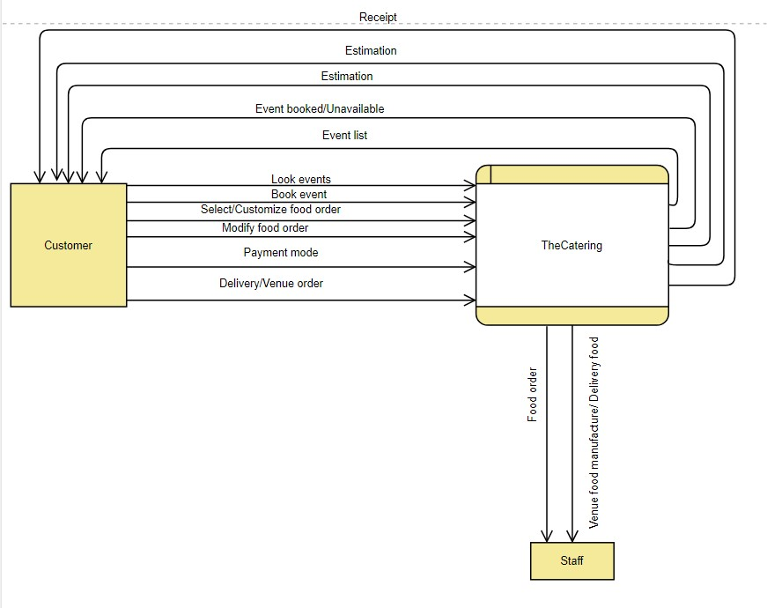

**Level 0 DFD**

**Level 1 DFD**

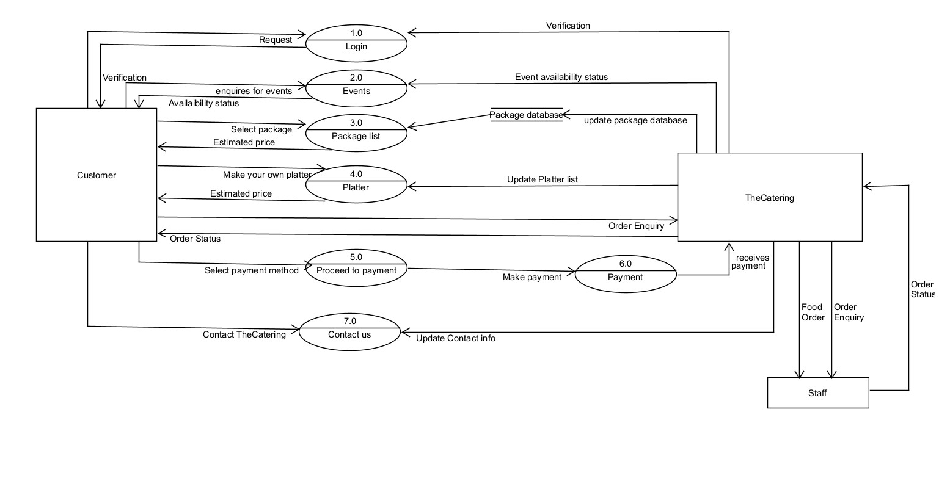

**Practical 4**

**Aim:To perform the user’s view analysis: Use case diagram.**

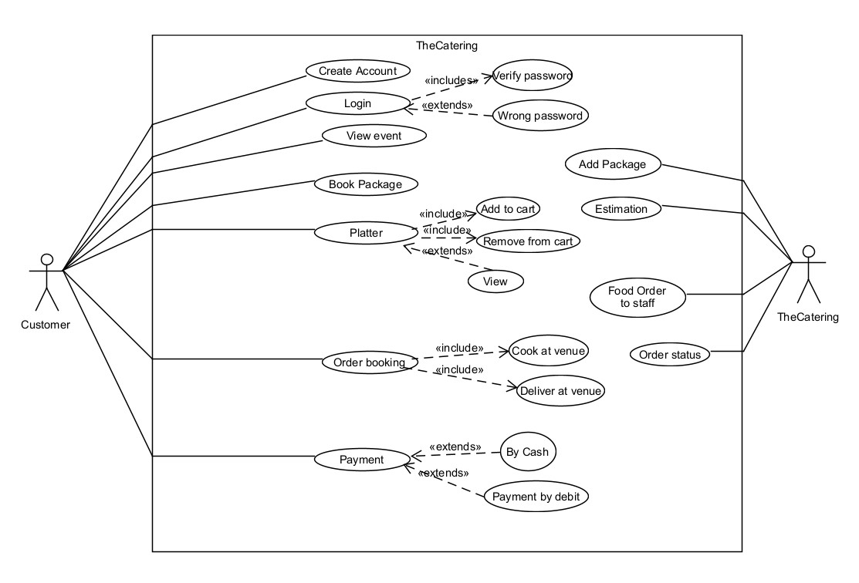

**Practical 6**

**Aim:To draw the behavioural view diagram: Sequence diagram, Activity**

**diagram.**

**Sequence Diagram:**

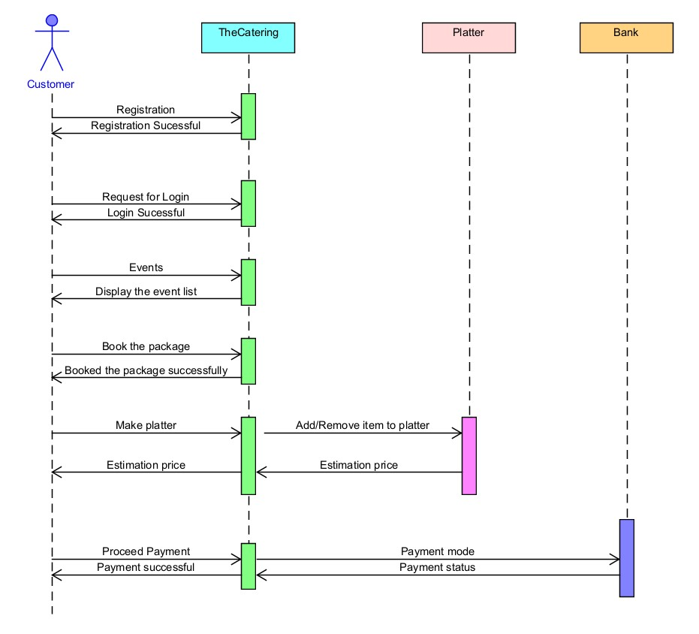

**Logical ER Diagram**

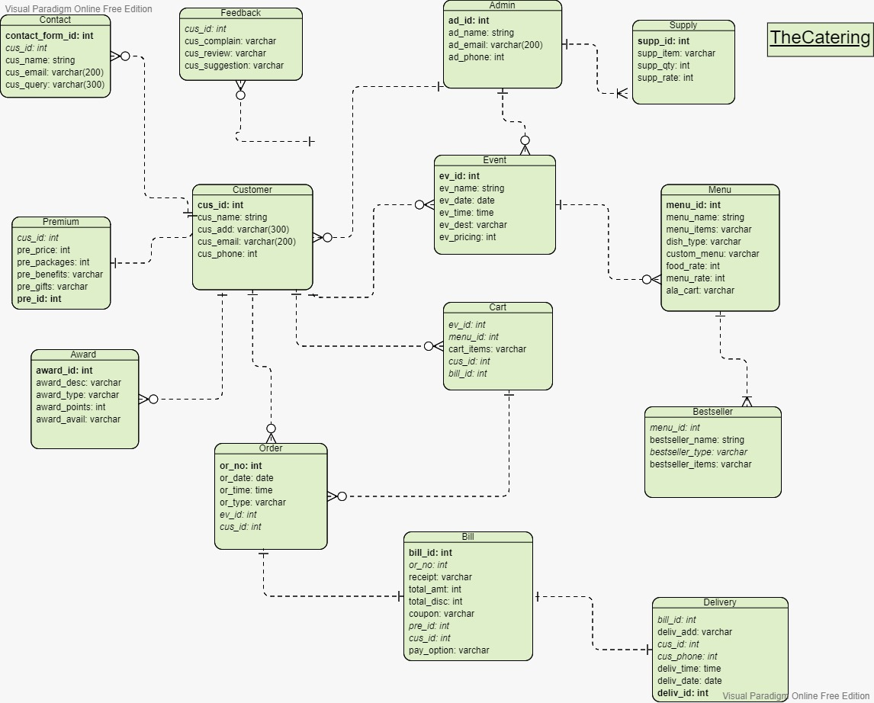

**Relational ER Diagram**

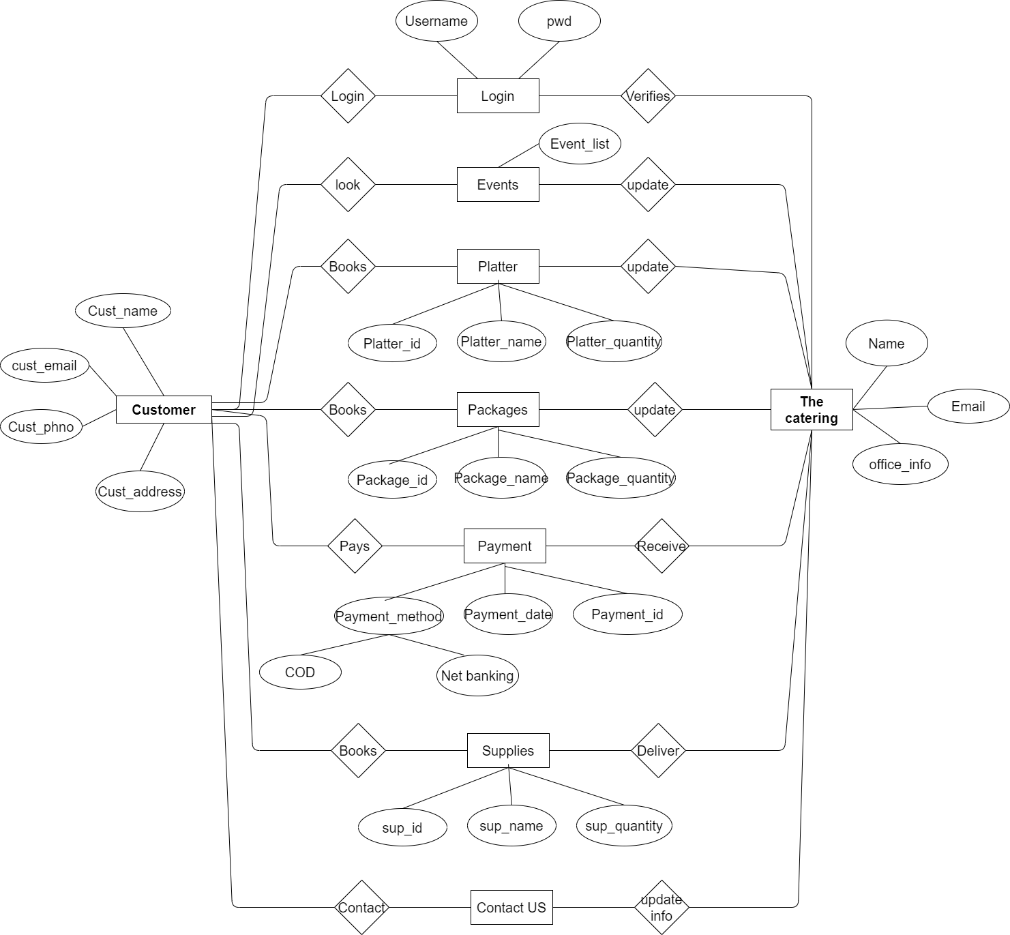

**Activity diagram from user side**

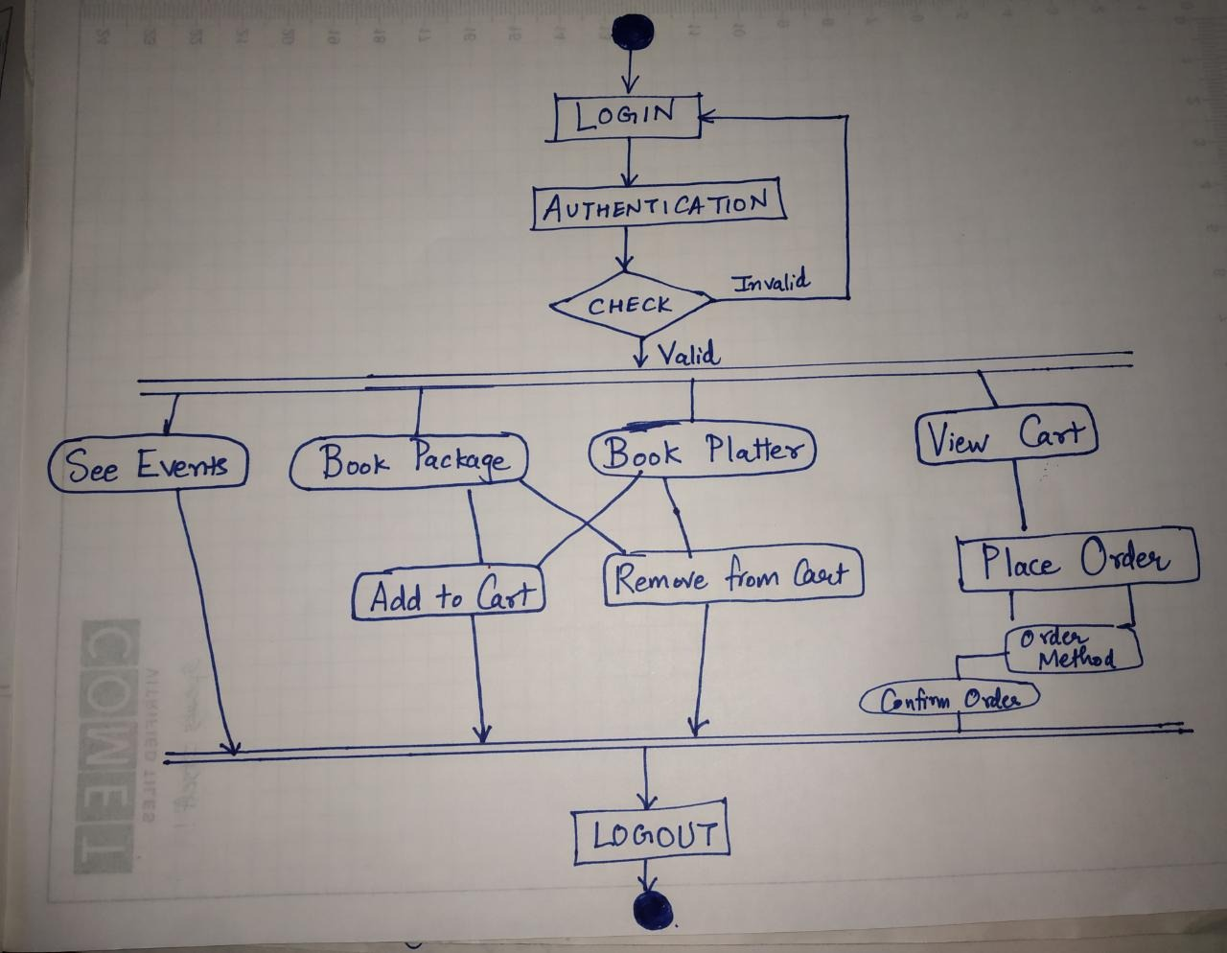

**Activity Diagram from admin side**

