Code-

## Experiment 1a HelloWorld

NAME:- KARAN DUBEY

CLASS:- B.E – 4

ROLL NO:- 04

BATCH:- A

import javax.microedition.midlet.*; import javax.microedition.lcdui.*; public class Hello extends MIDlet implements CommandListener

{

private Display display ;

private TextBox textBox ; private Command quitCommand; public

void startApp()

{

display = Display.getDisplay(this);

quitCommand = new Command("Quit", Command.SCREEN, 1); textBox = new TextBox("Welcome", "first midlet code, Really happy it works", 40, 0); textBox .addCommand(quitCommand); textBox .setCommandListener(this); display .setCurrent(textBox );

}

public void pauseApp()

{

}

public void destroyApp(boolean unconditional)

{

}

public void commandAction(Command choice, Displayable displayable)

{

if (choice == quitCommand)

{

destroyApp(false); notifyDestroyed();

}

}

}

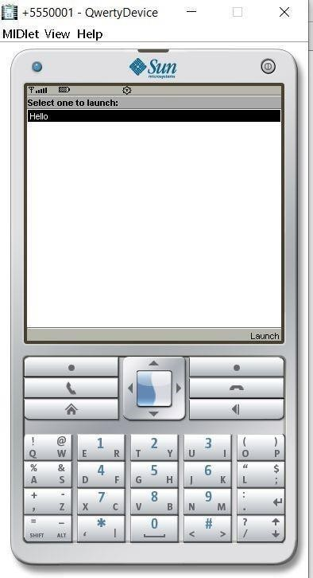 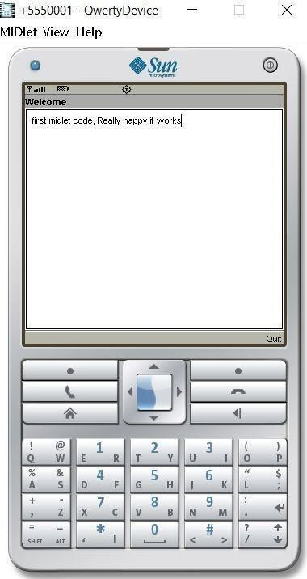

## Experiment 1b

Form Navigation & Design

#### Source Code:

import javax.microedition.midlet.*; import javax.microedition.lcdui.*;

public class FormNavigation extends MIDlet implements CommandListener

{

private Form f1,f2; private TextField tf1,tf2; private Display display; private Command cmd = new

Command("Navigate",Command.OK,0); private Command exit_cmd = new Command("Exit",Command.EXIT,0); public void startApp()

{

tf1 = new TextField("Enter your name : ","",10,TextField.ANY); f1 = new Form("My Form 1"); f1.append(tf1);

f1.addCommand(cmd);

f1.setCommandListener(this); display = Display.getDisplay(this);

display.setCurrent(f1);

}

public void pauseApp(){}

public void destroyApp(boolean unconditional){} public void commandAction(Command c,Displayable d) {

if(c==cmd)

{

tf2 = new TextField("Your name :

",tf1.getString(),10,TextField.ANY); f2 = new Form("My Form 2"); f2.append(tf2); display.setCurrent(f2);

}

if(c==exit_cmd){ destroyApp(false); notifyDestroyed();

}

}

}

OUTPUT:

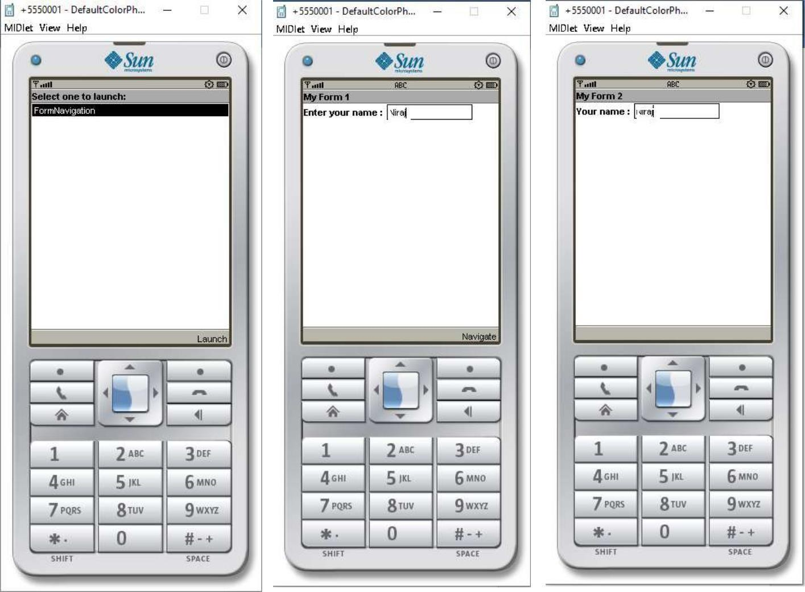

**Rohan**

**Rohan**

## Experiment 1c Immutable Image

Code:-

import javax.microedition.lcdui.*; import javax.microedition.midlet.*; public class ImmutableImage extends MIDlet implements CommandListener

{

private Command exitCommand = new Command("Exit", Command.EXIT, 1); private Display display; private Form form; private Image image; private

ImageItem imageItem; public void startApp()

{ display = Display.getDisplay(this); form = new Form("Immutable Image"); try { image = Image.createImage("/image.png"); form.append(image); display.setCurrent(form);

}

catch(java.io.IOException error){}

form.addCommand(exitCommand); form.setCommandListener(this);

} public void pauseApp() {} public void destroyApp(boolean unconditional)

{} public void commandAction(Command c, Displayable s)

{ if (c == exitCommand) { destroyApp(false);

notifyDestroyed();

}

}

}

Output:

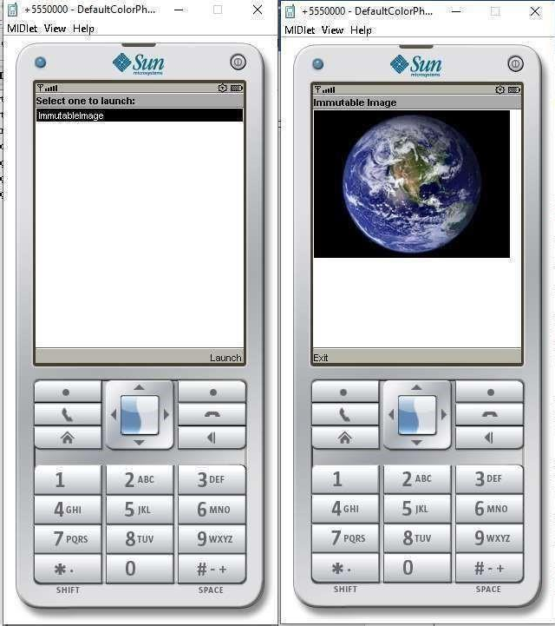

### Experiment 1d Mutable Image

import javax.microedition.midlet.*; import javax.microedition.lcdui.*;

public class DrawRectengle extends MIDlet { public void startApp () {

Display.getDisplay (this).setCurrent (new DrawingDemoCanvas ());

}

public void pauseApp () {}

public void destroyApp (boolean forced) {}

}

class DrawingDemoCanvas extends Canvas { public void paint (Graphics g) {

g.setColor (255, 0, 0);

g.fillRect (0, 0, getWidth (), getHeight ()); g.setColor (0, 0, 255);

g.fillRect (20, 30, 200, 80);

} }

# OUTPUT:

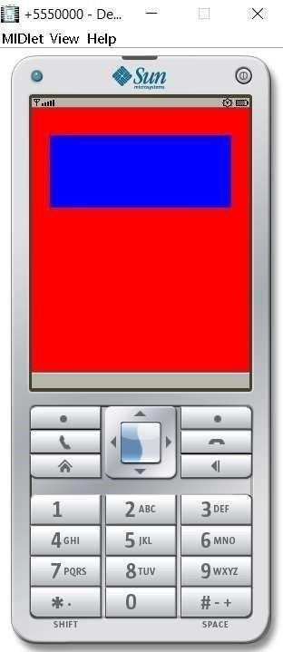

## Experiment 1e Ticker

#### Source Code:

import javax.microedition.lcdui.*; import javax.microedition.midlet.*;

public class TickerProgram extends MIDlet implements CommandListener

{

private Command exitCommand = new Command("Exit", Command.EXIT, 1 );

private Display display; public void startApp()

{ display = Display.getDisplay(this);

TextBox t = new TextBox("Hello", "Welcome to MIDP Programming",

256, 0);

Ticker aTicker = new Ticker("ticker"); t.setTicker(aTicker); t.addCommand(exitCommand); t.setCommandListener(this);

display.setCurrent(t);

}

public void pauseApp() {} public void destroyApp(boolean unconditional) {} public void commandAction(Command c, Displayable s)

{

if (c == exitCommand) { destroyApp(false); notifyDestroyed();

}

}

}

**OUTPUT:**

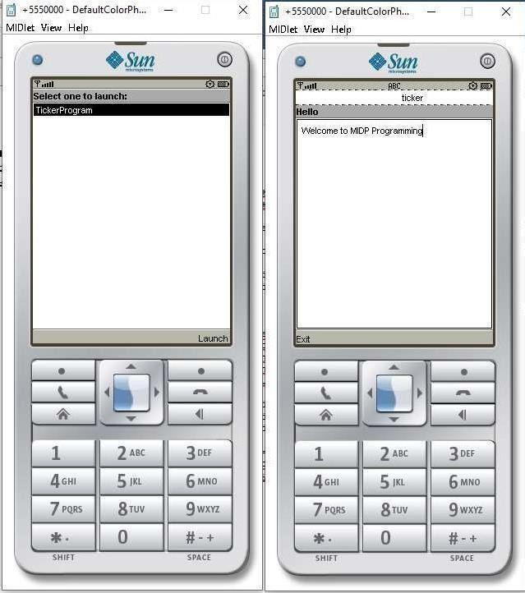

## Experiment 1f

Interactive Gauge/Non Interactive Gauge

import javax.microedition.lcdui.*; import javax.microedition.midlet.*;

public class gauge extends MIDlet implements CommandListener{ private Form form; private Display display; private Command back; private String label1, label2;

private Gauge gauge1, gauge2;

public gauge(){ label1 = new String("This is the Interactive and Non- Interactive Gauge"); gauge1 = new Gauge("Interactive- Values Will

Change.", true, 7, 40); gauge2 = new Gauge("Graph",false,100,40);

}

public void startApp(){

Form form = new Form("GaugeExample"); back = new Command("Exit", Command.EXIT, 0); display = Display.getDisplay(this);

form.append(label1); form.append(gauge1); form.append(gauge2);

form.addCommand(back); form.setCommandListener(this); display.setCurrent(form);

}

public void pauseApp(){}

public void destroyApp(boolean unconditional){ notifyDestroyed();

}

public void commandAction(Command c, Displayable s){ String label = c.getLabel(); if (label.equals("EXIT")){ destroyApp(false);

}

}

}

# OUTPUT:

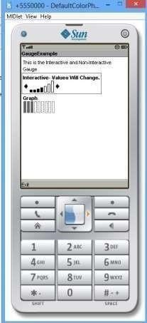

### Experiment 1g Date and Time Display

import java.util.*;

import javax.microedition.lcdui.*; import javax.microedition.midlet.MIDlet; public class Datetime extends MIDlet

{

private Display display; protected void startApp()

{

display = Display.getDisplay(this); Form form = new Form("Demo");

DateField timeOnly = new DateField("Time", DateField.DATE_TIME,TimeZone.getTimeZone("IST")); form.append(timeOnly); display.setCurrent(form);

}

protected void pauseApp() {}

protected void destroyApp(boolean unconditional) {}

}

