NAME:- DUBEY KARAN SANJEEV

CLASS:- B.E – 4

ROLL NO:- 04

BATCH:- A

MADT Practical CDMA

# Source Code:

ak=[0 1 0 0 1 1];

figure(1) bar(ak) bk=[1 1 0 1 0 1];

figure(2) bar(bk) ad=1; bd=0; d=size(ak);

for n=1:d(2)

if ak(n)==0 ak(n)=-1;

endif bk(n)==0

bk(n)=-1;

end end if bd==0 bd=-1;

end if ad==0 ad=-1;

end as=ad*ak;

figure(3) bar(as) bs=bd*bk; figure(4) bar(bs) c=as+bs; figure(5) bar(c) x=c*ak';

if x>0 disp("1 is sent by A.") else disp("0 is sent by A.")

end y=c*bk';

if y>0 disp("1 is sent by B.") else disp("0 is sent by B.")

end

Output:

>>cdma 1 is sent by A.

1. is sent by B

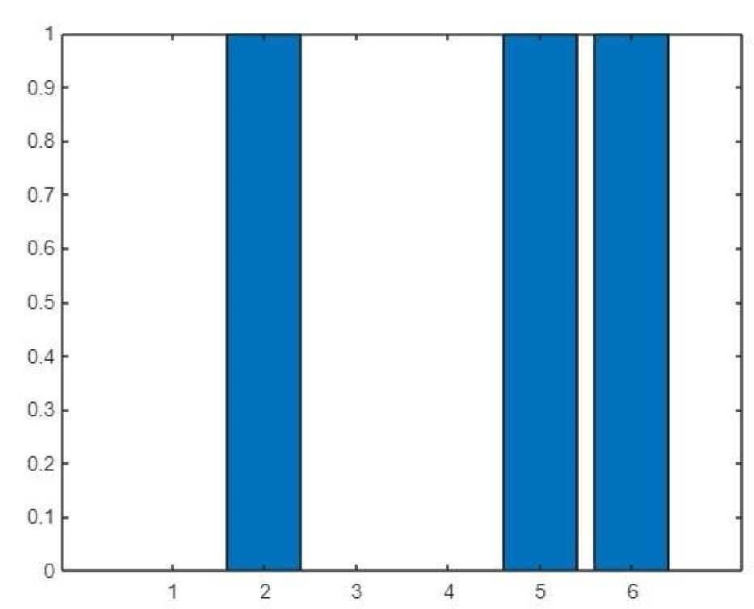**Figure**

1. **(ak)**

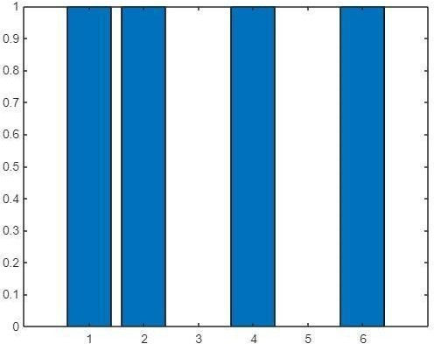

**Figure 2 (bk)**

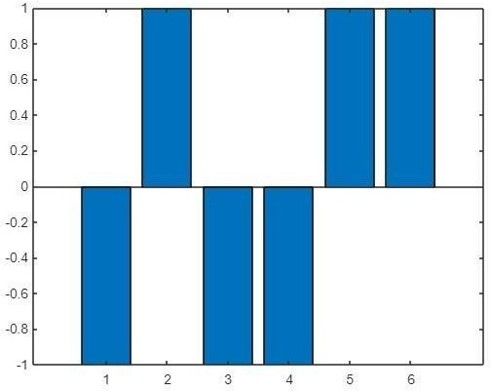

**Figure 3 (as=ad*ak)**

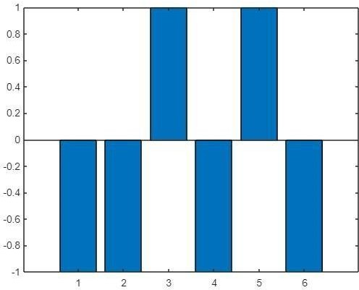

**Figure 4 (bs=bd*bk)**

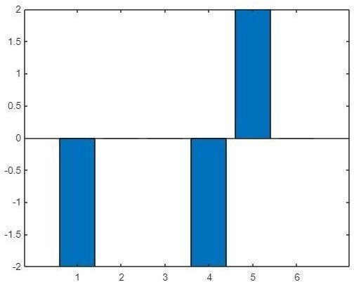

**Figure 5 (c=as+bs)**