## NAME:- DUBEY KARAN SANJEEV

## CLASS:- B.E – 4

## ROLL NO:- 04

## BATCH:- A

## Experiment 2a Basic Arithmetic Calculator

import javax.microedition.lcdui.*; import javax.microedition.midlet.*; import java.io.*; public class calculator extends MIDlet implements CommandListener { private Form form; private Display display;

private TextField

input1, input2; private Command add, sub,

mul,div; private StringItem item;

public calculator()

{

} public void startApp()

{ display =

Display.getDisplay(this); Form form = new Form("Calculator"); item = new StringItem("Answer = ",

"");

input1 = new TextField("First Number:", "", 30, TextField.NUMERIC); input2 = new TextField("Second Number:", "", 30, TextField.NUMERIC);

form.append(input1); form.append(input2); add = new Command("Addition",

Command.OK, 1); sub = new Command("Subtraction", Command.OK, 1); mul

= new Command("Multiplication", Command.OK, 1); div = new

Command("Division", Command.OK, 1); form.addCommand(add); form.addCommand(sub); form.addCommand(mul); form.addCommand(div); form.append(item);

form.setCommandListener(this);

display.setCurrent(form);

}

public void pauseApp() { }

public void destroyApp(boolean uncondn)

{

notifyDestroyed(

); } private void calculate()

{int one=Integer.parseInt(input1.getString());

int two= Integer.parseInt(input2.getString()); int result=one+two; item.setText( result +

""

);

} private void calculate1(

) { int one

=

Integer.parseInt(input1.getString()); int two = Integer.parseInt(input2.getString()); int result

= one - two; item.setText(result + "");

} private void calculate2()

{ int one = Integer.parseInt(input1.getString()); int two = Integer.parseInt(input2.getString()); int result

= one * two; item.setText(result + "");

} private void calculate3()

{ int one =

Integer.parseInt(input1.getString()); int two = Integer.parseInt(input2.getString()); int result

= one / two; item.setText(result + "");

}

public void commandAction(Command c, Displayable d)

{

String label = c.getLabel(); if (label.equals("Addition"))

{

calculate();

}

else if (label.equals("Subtraction"))

{

calculate1();

}

else if (label.equals("Multiplication"))

{ calculate2(); form.append("The Answer is:");

}

else if (label.equals("Division"))

{ calculate3(); form.append(" The Answer

is:");

}

} }

# OUTPUT:

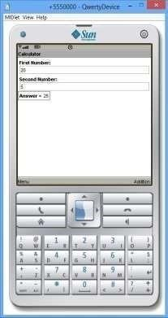 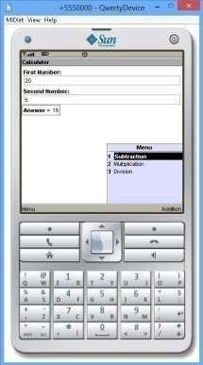

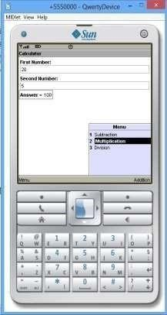 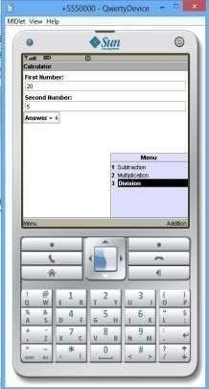

## Experiment 2b Loan Calculator (CI)

import javax.microedition.lcdui.*; import javax.microedition.midlet.*;

public class LoanEMICalculator extends MIDlet implements CommandListener

{

Display d; Form f;

TextField t1,t2,t3; Command calculate,exit; public void startApp() { d=Display.getDisplay(this); f= new Form("Loan EMI Calculator"); t1=new TextField("Principal Amount : ","",100,TextField.NUMERIC); t2=new TextField("Interest Rate (in ppa) : ","",100,TextField.NUMERIC); t3=new TextField("Tenure (in months) : ","",100,TextField.NUMERIC); exit=new Command("Exit",Command.EXIT,0); calculate=new Command("Calculate",Command.OK,1);

f.append(t1);

f.append(t2);

f.append(t3); f.addCommand(calculate); f.addCommand(exit); f.setCommandListener(this);

d.setCurrent(f); } public void pauseApp() { } public void destroyApp(boolean unconditional) {} public void commandAction(Command c,Displayable

d)

{

if(c==calculate)

{

float principal,interest,tenure,emi;

principal=Float.parseFloat(t1.getString()); interest=Float.parseFloat(t2.getString()); tenure=Float.parseFloat(t3.getString()); emi=(principal*(1+((interest/100)*(tenure/12))))/tenure; f.append("EMI

= "+emi+"\n");

} if

(c == exit)

{

destroyApp(false); notifyDestroyed();

}

}

}

# Output:

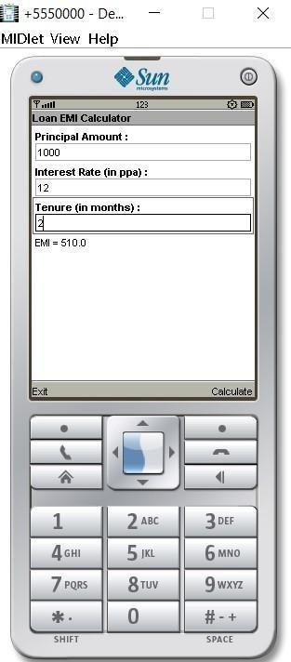

Inocme tax Calculator

CODE: import javax.microedition.lcdui.*; import javax.microedition.midlet.*; public class incomecacli extends MIDlet implements CommandListener { Display d; Form f; TextField t1; Command calculate,exit; public void startApp() { d=Display.getDisplay(this); f= new Form("Enter Your Annual Income To Chek IncomeTax"); t1=new TextField("Annual Income :","",100,TextField.NUMERIC); exit=new Command("Exit",Command.EXIT,0); calculate=new Command("Calculate",Command.OK,1); f.append(t1); f.addCommand(calculate); f.addCommand(exit); f.setCommandListener(this); d.setCurrent(f);

} public void pauseApp() {} public void destroyApp(boolean unconditional) {} public void commandAction(Command c,Displayable d) { if(c==calculate) { float income,tax; income=Float.parseFloat(t1.getString()) ;

f.append("Income Tax = "+(income*0.05)+"\n"); } if (c == exit) { destroyApp(false); notifyDestroyed(); } } }

# Output:

