NAME:- DUBEY KARAN SANJEEV

CLASS:- B.E – 4

ROLL NO:- 04

BATCH:- A

**Experiment 6**

Develop an application that makes use of database.

# Source Code:

**Dependencies**

dependencies {

implementation fileTree(dir: 'libs', include: ['*.jar']) implementation 'androidx.appcompat:appcompat:1.0.2' implementation 'androidx.constraintlayout:constraintlayout:1.1.3' testImplementation 'junit:junit:4.12'

androidTestImplementation 'androidx.test.ext:junit:1.1.0' androidTestImplementation 'androidx.test.espresso:espresso-core:3.1.1'

//add these libraries

//support design

implementation "com.android.support:design:29.0.2"

//card view

implementation "com.android.support:cardview-v7: 29.0.2"

//recyclerview

implementation "com.android.support:recyclerview-v7: 29.0.2"

//room implementation "android.arch.persistence.room:runtime: 1.1.1" annotationProcessor "android.arch.persistence.room:compiler: 1.1.1" testImplementation

"android.arch.persistence.room:testing: 1.1.1"

}

# Activity_main.xml

<?xml version="1.0" encoding="utf-8"?>

<RelativeLayout xmlns:android="[http://schemas.android.com/apk/res/android"](http://schemas.android.com/apk/res/android) xmlns:app="[http://schemas.android.com/apk/res-auto"](http://schemas.android.com/apk/res-auto) xmlns:tools="[http://schemas.android.com/tools" a](http://schemas.android.com/tools)ndroid:layout_width="match_parent" android:layout_height="match_parent" android:padding="8dp" tools:context=".MainActivity">

<androidx.recyclerview.widget.RecyclerView android:id="@+id/recyclerview_tasks" android:layout_width="match_parent" android:layout_height="match_parent" />

<com.google.android.material.floatingactionbutton.FloatingActionButton android:id="@+id/floating_button_add"

android:layout_width="wrap_content" android:layout_height="wrap_content"

android:layout_alignParentBottom="true" android:layout_alignParentRight="true" android:layout_margin="8dp" android:backgroundTint="@color/colorPrimaryDark" android:src="@drawable/ic_add"

android:tint="@color/colorLight" app:fabSize="normal"

/>

</RelativeLayout>

# Recyclerview_tasks.xml

<?xml version="1.0" encoding="utf-8"?>

<RelativeLayout xmlns:android="[http://schemas.android.com/apk/res/android"](http://schemas.android.com/apk/res/android) android:orientation="vertical" android:layout_width="match_parent" android:layout_height="wrap_content">

<androidx.cardview.widget.CardView android:layout_width="match_parent" android:layout_height="wrap_content" android:layout_marginBottom="3dp">

<LinearLayout android:layout_width="match_parent" android:layout_height="wrap_content" android:orientation="vertical" android:padding="7dp">

<TextView android:id="@+id/textViewStatus" android:layout_width="match_parent" android:layout_height="wrap_content" android:layout_marginBottom="5dp" android:background="@color/colorPrimaryDark" android:text="Completed" android:textAppearance="@style/Base.TextAppearance.AppCompat.Medium

"

android:textColor="@color/colorLight" android:textStyle="bold" />

<TextView android:id="@+id/textViewTask" android:layout_width="match_parent" android:layout_height="wrap_content" android:text="Go Bring Eggs" android:textAppearance="@style/Base.TextAppearance.AppCompat.Headline"

/>

<TextView android:id="@+id/textViewDesc" android:layout_width="match_parent" android:layout_height="wrap_content" android:text="Bring

6 eggs from super market" android:textAppearance="@style/Base.TextAppearance.AppCompat.Medium" />

<TextView android:id="@+id/textViewFinishBy" android:layout_width="match_parent" android:layout_height="wrap_content" android:text="5pm today"

android:textAppearance="@style/Base.Text Appearance.AppCompat.Medium" />

</LinearLayout>

</androidx.cardview.widget.CardView> </RelativeLayout>

**Task.java** package com.example.first_application; @Entity public class Task implements Serializable

{

@PrimaryKey(autoGenerate = true) private int id;

@ColumnInfo(name = "task") private String task;

@ColumnInfo(name = "desc") private String desc;

@ColumnInfo(name = "finish_by") private String finishBy; @ColumnInfo(name = "finished") private boolean finished;

public int getId() { return id;

}

public void setId(int id) { this.id = id;

}

public String getTask() { return task;

}

public void setTask(String task) { this.task = task;

}

public String getDesc() { return desc;

}

public void setDesc(String desc) { this.desc = desc;

}

public String getFinishBy() { return finishBy;

}

public void setFinishBy(String finishBy) { this.finishBy

= finishBy;

}

public boolean isFinished() { return finished;

}

public void setFinished(boolean finished) { this.finished

= finished;

}

}

**TaskDao.java(Interface)** package com.example.first_application;

@Dao

public interface TaskDao {

@Query("SELECT * FROM task") List<Task> getAll();

@Insert void insert(Task task);

@Delete

void delete(Task task);

@Update

void update(Task task);

}

**Appdatabase.java** package com.example.first_application;

@Database(entities = {Task.class}, version = 1) public abstract class AppDatabase extends RoomDatabase { public

abstract TaskDao taskDao();

}

# Databaseclient.java

package com.example.first_application; public

class DatabaseClient { private Context mCtx; private static DatabaseClient

*mInstance*;

//our app database object private

AppDatabase appDatabase; private DatabaseClient(Context mCtx) { this.mCtx = mCtx;

//creating the app database with Room database builder, MyToDos is the name of the database appDatabase = Room.*databaseBuilder*(mCtx, AppDatabase.class, "MyToDos").build();

}

public static synchronized DatabaseClient getInstance(Context mCtx) { if (*mInstance* == null) { *mInstance* = new DatabaseClient(mCtx);

}

return *mInstance*;

}

public AppDatabase getAppDatabase() { return appDatabase;

}

}

## Addtaskactivity

package com.example.first_application;

public class Addtaskactivity extends AppCompatActivity { private EditText editTextTask, editTextDesc, editTextFinishBy;

@Override

protected void onCreate(Bundle savedInstanceState) { super.onCreate(savedInstanceState); setContentView(R.layout.*activity_addtaskactivity*);

editTextTask = findViewById(R.id.*editTextTask*); editTextDesc = findViewById(R.id.*editTextDesc*); editTextFinishBy = findViewById(R.id.*editTextFinishBy*);

findViewById(R.id.*button_save*).setOnClickListener(new View.OnClickListener() { @Override

public void onClick(View view) { saveTask();

} });

}

private void saveTask() { final String

sTask =editTextTask.getText().toString().trim();

final String sDesc =editTextDesc.getText().toString().trim();

final String sFinishBy = editTextFinishBy.getText().toString().trim();

if (sTask.isEmpty()) { editTextTask.setError("com.example.first_application.Task required"); editTextTask.requestFocus();

return;

}

if (sDesc.isEmpty()) { editTextDesc.setError("Desc required"); editTextDesc.requestFocus(); return;

}

if (sFinishBy.isEmpty()) { editTextFinishBy.setError("Finish by required"); editTextFinishBy.requestFocus(); return;

}

class SaveTask extends AsyncTask<Void, Void, Void> {

@Override

protected Void doInBackground(Void... voids) {

//creating a task Task task = new Task(); task.setTask(sTask); task.setDesc(sDesc); task.setFinishBy(sFinishBy) ; task.setFinished(false);

//adding to database DatabaseClient.*getInstance*(getApplicationContext()).getAppDatabase() .taskDao()

.insert(task); return null;

}

@Override

protected void onPostExecute(Void aVoid) { super.onPostExecute(aVoid); finish(); startActivity(new Intent(getApplicationContext(), MainActivity.class));

Toast.*makeText*(getApplicationContext(), "Saved", Toast.*LENGTH_LONG*).show();

}

}

SaveTask st = new SaveTask(); st.execute();

}

}

# Taskadapter.java

package com.example.first_application; public class TasksAdapter extends

RecyclerView.Adapter<TasksAdapter.TasksViewHolder> {

private Context mCtx; private List<Task> taskList;

public TasksAdapter(Context mCtx, List<Task> taskList)

{ this.mCtx

= mCtx; this.taskList

= taskList;

}

@Override

public TasksViewHolder onCreateViewHolder(ViewGroup parent, int viewType) {

View view = LayoutInflater.*from*(mCtx).inflate(R.layout.*recyclerview_tasks*, parent, false); return new TasksViewHolder(view);

}

@Override

public void onBindViewHolder(TasksViewHolder holder, int position) { Task t = taskList.get(position); holder.textViewTask.setText(t.getTask()); holder.textViewDesc.setText(t.getDesc()); holder.textViewFinishBy.setText(t.getFinishBy());

if (t.isFinished()) holder.textViewStatus.setText("Completed"); else holder.textViewStatus.setText("Not Completed");

}

@Override

public int getItemCount() { return taskList.size();

}

class TasksViewHolder extends RecyclerView.ViewHolder implements View.OnClickListener { TextView textViewStatus, textViewTask, textViewDesc, textViewFinishBy; public TasksViewHolder(View itemView) { super(itemView);

textViewStatus = itemView.findViewById(R.id.*textViewStatus*); textViewTask = itemView.findViewById(R.id.*textViewTask*); textViewDesc = itemView.findViewById(R.id.*textViewDesc*); textViewFinishBy = itemView.findViewById(R.id.*textViewFinishBy*); itemView.setOnClickListener(this);

}

@Override

public void onClick(View view) {

Task task = taskList.get(getAdapterPosition());

Intent intent = new Intent(mCtx, Updatetaskactivity.class); intent.putExtra("task", task);

mCtx.startActivity(intent);

}

}

}

## MainActivity.java

package com.example.first_application;

public class MainActivity extends AppCompatActivity {

private FloatingActionButton buttonAddTask; private RecyclerView recyclerView;

@Override

protected void onCreate(Bundle savedInstanceState) { super.onCreate(savedInstanceState); setContentView(R.layout.activity_main); recyclerView =

findViewById(R.id.recyclerview_tasks); recyclerView.setLayoutManager(new LinearLayoutManager(this));

buttonAddTask = findViewById(R.id.floating_button_add); buttonAddTask.setOnClickListener(new View.OnClickListener() {

@Override

public void onClick(View view) {

Intent intent = new Intent(MainActivity.this, Addtaskactivity.class); startActivity(intent);

}

});

getTasks();

}

private void getTasks() { class GetTasks extends AsyncTask<Void, Void, List<Task>> {

@Override

protected List<Task> doInBackground(Void... voids) { List<Task> taskList = DatabaseClient

.getInstance(getApplicationContext())

.getAppDatabase()

.taskDao()

.getAll(); return taskList;

}

@Override

protected void onPostExecute(List<Task> tasks) { super.onPostExecute(tasks); TasksAdapter adapter = new TasksAdapter(MainActivity.this, tasks); recyclerView.setAdapter(adapter);

}

}

GetTasks gt = new GetTasks(); gt.execute();

}

}

## Updatetaskactivity

package com.example.first_application;

public class Updatetaskactivity extends AppCompatActivity {

private EditText editTextTask, editTextDesc, editTextFinishBy; private CheckBox checkBoxFinished;

@Override

protected void onCreate(Bundle savedInstanceState) { super.onCreate(savedInstanceState); setContentView(R.layout.*activity_updatetaskactivity*);

editTextTask = findViewById(R.id.*editTextTask*); editTextDesc = findViewById(R.id.*editTextDesc*); editTextFinishBy = findViewById(R.id.*editTextFinishBy*);

checkBoxFinished = findViewById(R.id.*checkBoxFinished*); final Task task = (Task) getIntent().getSerializableExtra("task"); loadTask(task);

findViewById(R.id.*button_update*).setOnClickListener(new View.OnClickListener() { @Override

public void onClick(View view) {

Toast.*makeText*(getApplicationContext(), "Clicked", Toast.*LENGTH_LONG*).show(); updateTask(task);

}

});

findViewById(R.id.*button_delete*).setOnClickListener(new View.OnClickListener() { @Override public void

onClick(View view) {

AlertDialog.Builder builder = new AlertDialog.Builder(Updatetaskactivity.this); builder.setTitle("Are you sure?");

builder.setPositiveButton("Yes", new DialogInterface.OnClickListener() { @Override public void onClick(DialogInterface dialogInterface, int i) { deleteTask(task);

}

});

builder.setNegativeButton("No", new DialogInterface.OnClickListener() { @Override

public void onClick(DialogInterface dialogInterface, int i) {

}

});

}

}

});

AlertDialog ad = builder.create(); ad.show();

private void loadTask(Task task) { editTextTask.setText(task.getTask()); editTextDesc.setText(task.getDesc()); editTextFinishBy.setText(task.getFinishBy()); checkBoxFinished.setChecked(task.isFinished());

}

private void updateTask(final Task task) { final String sTask = editTextTask.getText().toString().trim(); final String sDesc = editTextDesc.getText().toString().trim(); final String sFinishBy = editTextFinishBy.getText().toString().trim();

if (sTask.isEmpty()) { editTextTask.setError("Task required"); editTextTask.requestFocus(); return;

}

if (sDesc.isEmpty()) { editTextDesc.setError("Desc required"); editTextDesc.requestFocus(); return;

}

if (sFinishBy.isEmpty()) { editTextFinishBy.setError("Finish by required"); editTextFinishBy.requestFocus(); return;

}

class UpdateTask extends AsyncTask<Void, Void, Void> {

@SuppressLint("WrongThread") @Override

protected Void doInBackground(Void... voids) { task.setTask(sTask); task.setDesc(sDesc); task.setFinishBy(sFinishBy); task.setFinished(checkBoxFinished.isChecked()); DatabaseClient.*getInstance*(getApplicationContext()).getAppDatabase() .taskDao()

.update(task); return null;

}

@Override

protected void onPostExecute(Void aVoid) { super.onPostExecute(aVoid); Toast.*makeText*(getApplicationContext(), "Updated", Toast.*LENGTH_LONG*).show(); finish();

startActivity(new Intent(Updatetaskactivity.this, MainActivity.class));

}

}

UpdateTask ut = new UpdateTask(); ut.execute();

}

private void deleteTask(final Task task) { class DeleteTask extends AsyncTask<Void, Void, Void> {

@Override

protected Void doInBackground(Void... voids) { DatabaseClient.*getInstance*(getApplicationContext()).getAppDatabase() .taskDao()

.delete(task); return null;

}

@Override

protected void onPostExecute(Void aVoid) { super.onPostExecute(aVoid); Toast.*makeText*(getApplicationContext(), "Deleted", Toast.*LENGTH_LONG*).show(); finish();

startActivity(new Intent(Updatetaskactivity.this, MainActivity.class));

}

}

DeleteTask dt = new DeleteTask(); dt.execute();

}

}

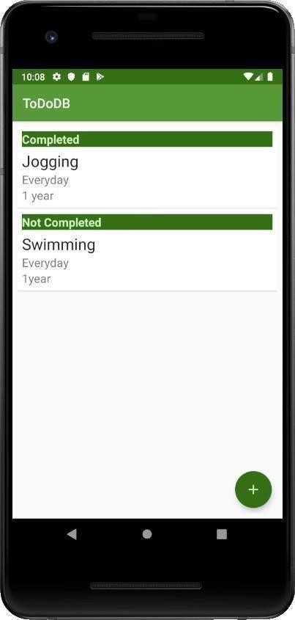Output

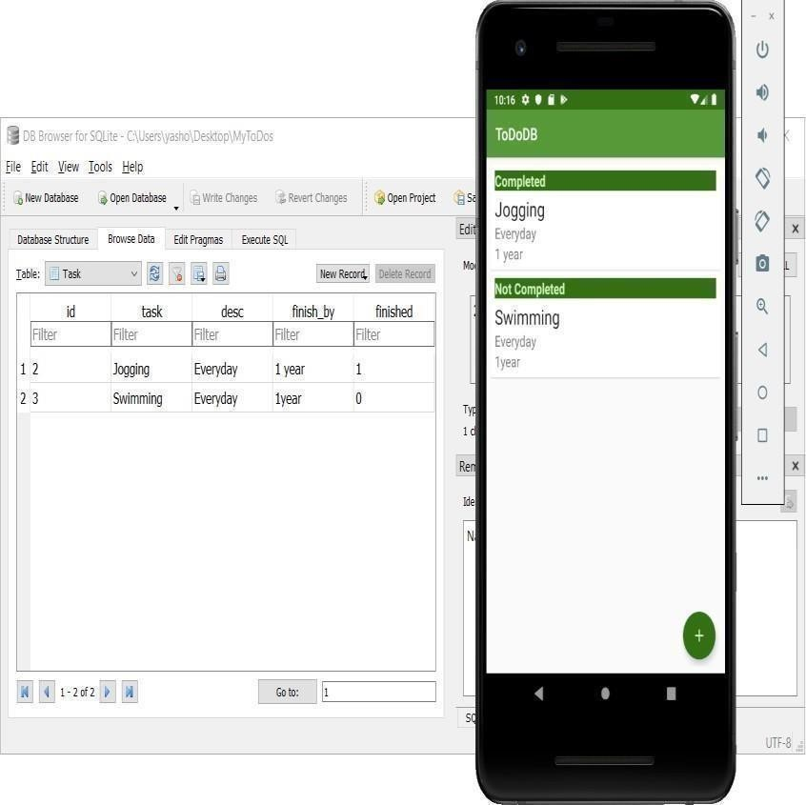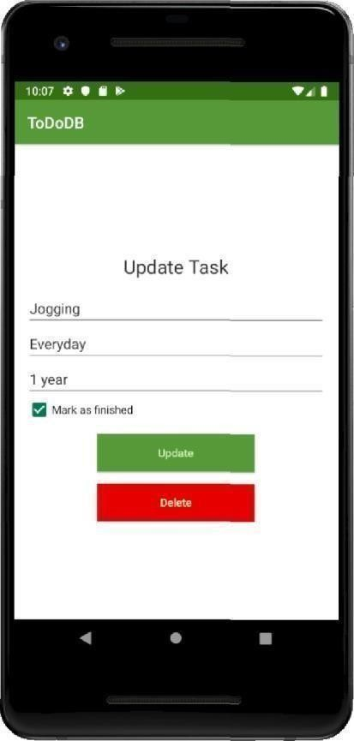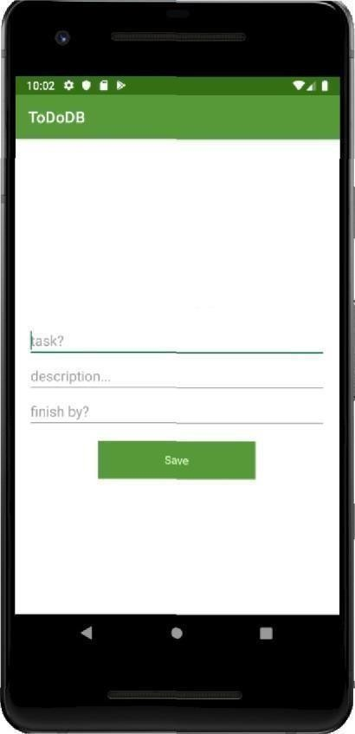

AddaTask