SPOTIFY CLONE USING CSS ONLY:

Link for icons: <https://cdnjs.com/libraries/font-awesome>

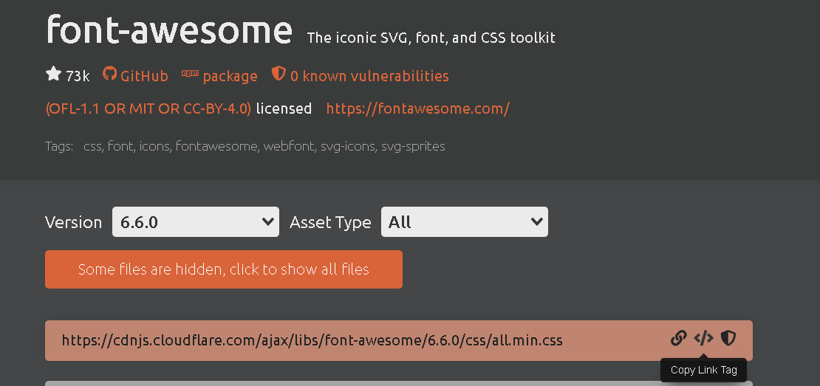

<link rel="stylesheet" href="https://cdnjs.cloudflare.com/ajax/libs/font-awesome/6.6.0/css/all.min.css" integrity="sha512-Kc323vGBEqzTmouAECnVceyQqyqdsSiqLQISBL29aUW4U/M7pSPA/gEUZQqv1cwx4OnYxTxve5UMg5GT6L4JJg==" crossorigin="anonymous" referrerpolicy="no-referrer" />