DATABASE

DDL->Data definition language->create,alter,drop,truncate

DML->Insert ,update,delete

DCL-> Grant,reworke

TCL->commit,rollback,savepoint

DQL->

\l->all database

\c->connecting database

\dt ->tables inside the database

Create database -> CREATE DATABASE database_name;

Create table -> CREATE TABLE table_name(var datatype);

Print table->SELECT * FROM table_name;

Alter table name-> ALTER TABLE old_table_name RENAME TO new_name;

Add colum-> ALTER TABLE table_name ADD column_name datatype;

Drop column -> ALTER TABLE table_name drop column_name;

Drop table ->DROP TABLE table_name;

Tuncate table->TRUNCATE TABLE table_name;

Insert data into table -> INSERT INTO table_name VALUES(values);

Update the value -> UPDATE table_name SET column_name=insert_value where unick_colum = unick_value;

Delete row ->DELETE FROM table_name WHERE unick_colum=unick_value;

Order data->SELECT * FROM student_data ORDER BY age (asc/desc);

Printing the limited row -> SELECT * FROM table_name LIMIT 3;

Find the null valu -> SELECT * FROM table_name WHERE colum_name ISNULL;

LIKE -> S%,%S,

* SELECT * FROM table_name WHERE column_name LIKE ‘d%’;
* SELECT * FROM table_name WHERE column_name LIKE ‘%d’;

BETWEEN ->RANGE

IN

* SELECT * FROM table_name WHERE colum_name IN('VIJAY','karan');

WHERE ->CONDITION

Sum()

found(Avg(),3)->for decimal value

Min()

Max()

Count()

Group by()->having Is important when using the group by()

**JOINS:**

Joins are used to connect the two tables .

Types:

Inner join -> 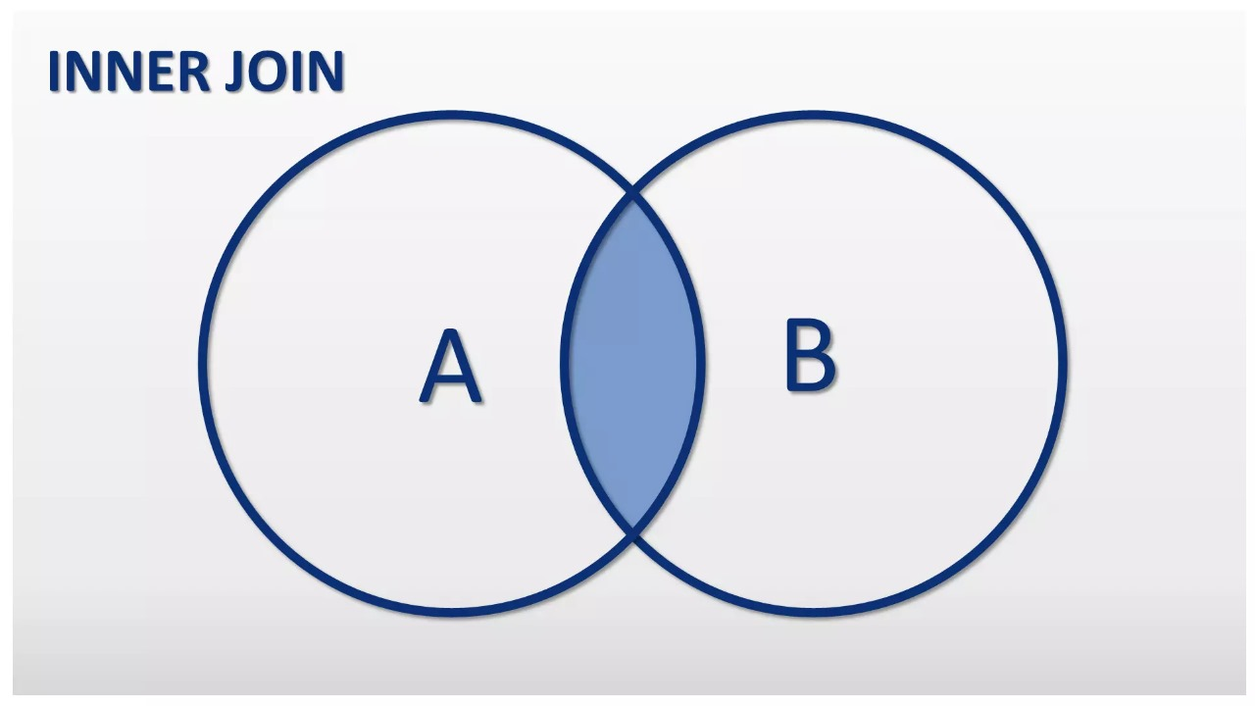

takes the commom fields.

Outer join - >

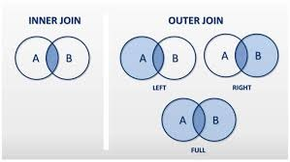

left outer join , right outer join

Self join->

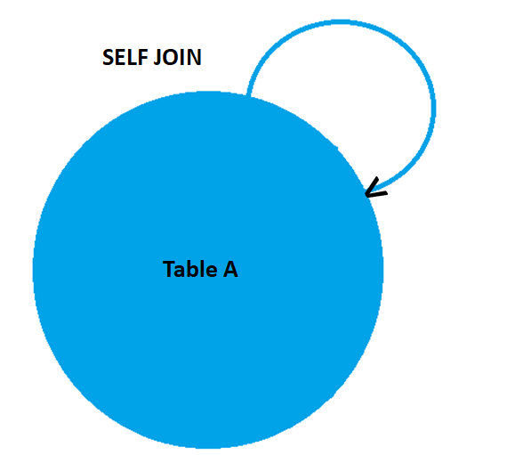

**Inner join:**

SELECT * FROM 1sttable_name JOIN 2ndtable_name on 1sttable_name.colum_name = 2ndtable_name.colum_name;

(same syntex for all the joins )

**Ranking :**

|  |  |  |  |  |  |
| --- | --- | --- | --- | --- | --- |
| Sal id | Dep | sal | Rank | | |
| 1 | It | 7000 | 1 | 1 | 1 |
| 2 | It | 7000 | 1 | 2 | 1 |
| 3 | It | 5500 | 3 | 3 | 2 |
| 4 | Hr | 6000 | 1 | 1 | 1 |
| 5 | Hr | 5000 | 2 | 2 | 2 |

**Sysntex:**

select (emp_id,dep,sal),RANK() OVER(PARTITION BY dep ORDER BY sal DESC) AS rank

FROM aids; ->for the type 1

select (emp_id,dep,sal),DENSE_RANK() OVER(PARTITION BY dep ORDER BY sal DESC) AS denserank FROM aids; ->for the type 3

select (emp_id,dep,sal),row_number() OVER(PARTITION BY dep ORDER BY sal DESC) AS rowmum FROM aids; ->for the type 2