**AWS EventBridge**

AWS EventBridge is a serverless event bus service provided by Amazon Web Services (AWS) that allows you to route events between AWS services, your own applications, and third-party SaaS applications. Event bus that helps in integrating different applications. It is fully managed and pay what you use model.

**How does AWS EventBridge work:**

1. AWS EventBridge works by routing events between different AWS services, applications, and third-party SaaS applications. The event bus is the central component of EventBridge, which provides a way to route events from different sources to different targets.
2. An event source is a service or application that generates events, and an event target is a service or application that receives events. You can set up rules in EventBridge to route events from an event source to one or more event targets.
3. When an event is generated by an event source, it is sent to the EventBridge event bus. If the event matches one or more rules that you’ve defined, EventBridge forwards the event to the corresponding event targets.
4. Aws Servies
5. Custom applications
6. Third party saas provider

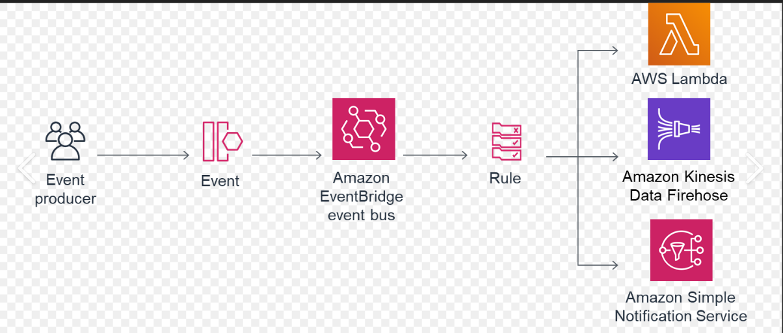

**Event Sources/Producer:**

Event sources in the Aws EventBridge are the origin or stating points from where events are generated and send in to the EventBridge service.

**Event:**

An event is a real-time change in a system, data, or environment. These changes can be either in your application or in a aws service or a SaaS partner service.

**Event Buses:**

To receive an event from event sources, you need to configure an event bus in aws account. These event bus can be of several types:

**Default Event bus**:

Created by default and receives events from any aws service.

**Custom Event bus:**

Receive events from custom applications you create and must be created manually.

**Partner Event bus**:

Receives events from saas partner applications and must be created manually.

**Rules:**

Amazon EventBridge rules are powerful way to route events to a target and trigger and action based on the event pattern or schedule defined in the rule.

* Event Pattern: Event pattern in eventbridge is used to filter events and select which events should be send to the targets.
* Schedule: We can create scheduled events that trigger specific actions at specified times and intervals.

**Targets:**

A target is a resource or endpoint that evenbridge send an event to the event matches the event pattern defined for a rule. Its support json format events. Its include several aws services like Amazon EC2 instance, Lambda functions, Amazon SNS etc.

**Prons:**

* **Scalability:**

As a serverless service, EventBridge can automatically scale with the number of events, accommodating both low and high event volumes without the need for manual intervention.

* **Simplified integration:**

complexity of connecting multiple services. EventBridge facilitates seamless integration between various AWS services, SaaS applications, and custom applications, reducing the complexity of connecting multiple services.

* **Event Filtering:**

EventBridge supports filtering of events, allowing you to control which events are sent to specific targets, reducing the amount of processing required by the target service.

* **Real-time processing:**

Event-driven architectures built with EventBridge can respond to events in real-time.

* **Security:**

EventBridge provides built-in security features such as AWS Identity and Access Management (IAM) for access control and AWS Key Management Service (KMS) for encrypting sensitive data.

* **Cost-Effective:**

its use for pay-as-you-go pricing model.

**Cons:**

* **Complexity of Events:**

defining how events should look and what information they carry can be tricky, especially when connecting multiple services or external apps.

* **Vendor Lock-In:**

Using AWS EventBridge might make it harder to switch other cloud provider because your system become tightly connected to AWS.

* **Event Delivery Guarantees:**

Theres no guarantee that events will be delivered exactly once, so you need to handle potential duplicate or lost events.

* **Latency:**

There might be a small delay before events are processed, which could affect real-time or super-fast applications.

**How AWS EventBridge impact on SaaS application**

Aws EventBridge into a SaaS application can have a significant impact, enhancing the application architecture, scalability, responsiveness, and flexibility.

* **Real-time Event-Driven Architecture:**

EventBridge enables real-time communication between different parts of the application, making it more responsive and dynamic.

* **Decouple Components:**

The application components become loosely coupled , leading to improve maintainability and scalability.

* **Seamless Integrations:**

EventBridge allow easy integration with other aws services and third party systems, enhancing the application functionality.

* **Scalability:**

AWS Eventbridge automatically scales and handle workloads.

* **Cost-Effectiveness:**

Follow a pay-as-you go pricing model, optimizing costs for event processing.

* **Event-Based Workflows:**

Enables the creation of event-based workflows, streamlining business processes.

* **Security and Compliance:**

EventBridge ensures data security and supports various compliance certification fir regulatory requirements.