**CLOUDFORMATION**

Aws Cloudformation is IAC(infrastructure as a code) tool.it is used for automation and deploy. we will manage the infrastructure of aws resources. It uses a template to written yml and json format to create aws resources .cloudFormation take care of creating ,deleting, updating aws resources.

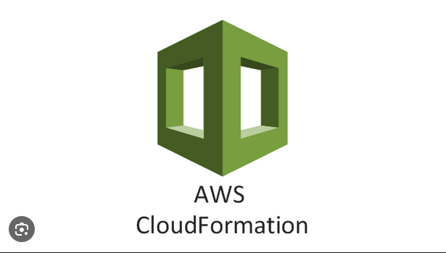

**Stack:**

Aws cloudFormation stack is a collection of aws resources that are created, updated, delete a single unit. It represent the overall infrastructure.

**Template:**

Template is just a test file written in json or yml format that define.you can say that template is just a blueprint of resources or set of instruction.in this template we have write the code which aws resources will be created.

**Section:**

**Format Version**: in this format version we define the which format version we are use

**Description:** we define the description of resources

**Parameters:** define input value passed to the template

**Mapping:** Allow you to define key-value mapping that can be used to select different resources.

**Resources:** we define which resources we are created

**Output:** specify the value that should be returned when the stack is created or updated such resource ids, endpoints.