**Stackset**

Stackset in Aws CloudFormation you create a template that describe how to build your aws resources like server, database, storage. then you use the stackset magic to deploy that blueprint to multiple aws accounts and regions simultaneously.

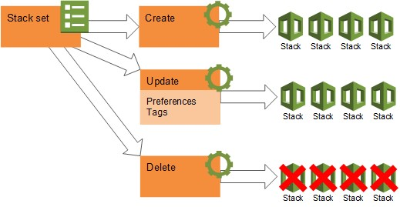

**Stack set operations**

**Create StackSet**:

Create a blueprint (template) for building multiple sets of LEGO structures (AWS resources) in different rooms (AWS accounts and regions).

**Update StackSet**:

Make changes to the blueprint, like adding more LEGO pieces or changing their color, and apply those changes to all the LEGO structures in all the rooms.

**Delete StackSet**:

Remove the blueprint and demolish all the LEGO structures in all the rooms, cleaning up the deployed resources from the specified AWS accounts and regions.

d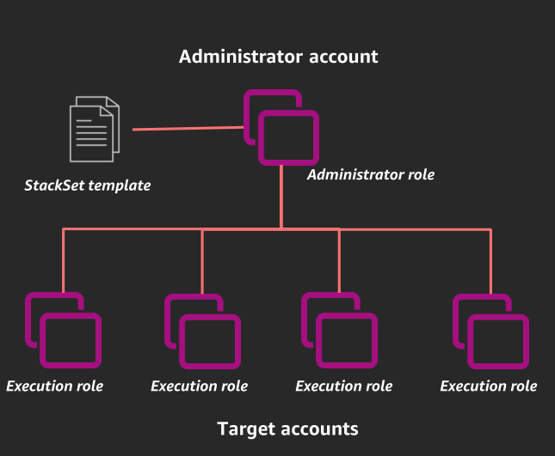

**Note:** [According to the AWS documentation, you can create up to **100 StackSets per account and region**](https://medium.com/superluminar/a-look-at-the-aws-cloudformation-stackset-resource-18ae0d89dfc6). According to AWS documentation, if we provision a CloudFormation template to three AWS accounts and in five different regions, we have a single StackSet but fifteen Stack resources.

**Administrator account:**

[In AWS CloudFormation StackSets, an administrator account is the AWS account in which you create stack sets](https://docs.aws.amazon.com/AWSCloudFormation/latest/UserGuide/stacksets-concepts.html).

**Target Account:**

[A target account is the account in which you create individual stacks that belong to a stack set](https://docs.aws.amazon.com/AWSCloudFormation/latest/UserGuide/stacksets-concepts.html).