**cloudTrail**

1. Cloudtrail is enabled on your aws account when you create it.
2. When activity occurs in you aws account, that activity is recorded in a cloudtrail event.
3. You can easily view recent events in the cloudtrail console by going to event history.
4. Event history allow you to view,Search,and download the past 90 days of activity your aws account.

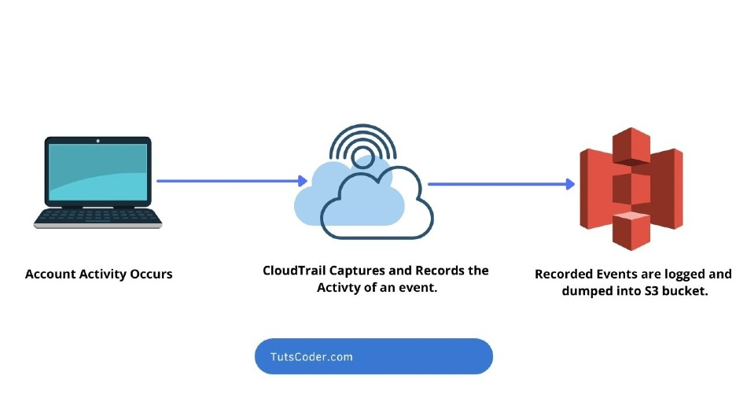

**Events:**

**Management Events:**

Management events provide information about management operation that are performed on resources in your aws account. These are also known as control plane operations.

Configuring security(for example, AWS identity and access management AttachRolePolicy API operations).

**Data Events:**

Data events provide information about the resources operations performed on or in a resources. These are also known as data plan operations. Data events are often high-volume activities. the following data types are recorded.

Amazon s3 object-level API activity (for example getobject, deleteObject ,and putObject API operations) on buckets and objects in buckets

**Insight events:**

Cloudtrail insight events capture unsual API call rate or error rate activity in your aws account. If you have insight event enabled, and cloudtrail detects unsual activity, insight events are logged to thw destination for your trail.

**CloudTrail Creation:**

Search cloudTrail: