**Index**

**Cloudwatch**

1. CloudWatch is a service used to monitor your AWS resources and applications that you run on AWS in real time. CloudWatch is used to collect and track metrics that measure your resources and applications.
2. Amazon CloudWatch is a fantastic service that watches over your cloud resources, collects important data, and helps you keep everything running smoothly and happily in the cloud!.

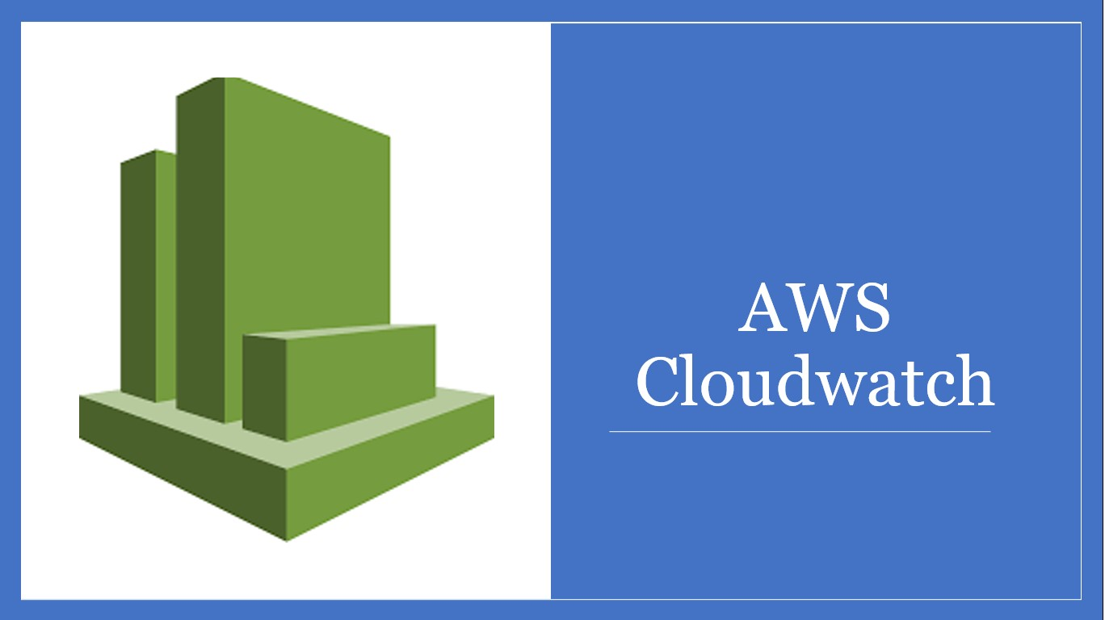

**Concepts of CloudWatch:**

1. **Metrics:**

CloudWatch collects and stores performance data in the form of metrics. Metrics can be used to monitor resource utilization, track application performance, and identify trends and anomalies.

1. **Alarms:**

CloudWatch Alarms can be set up to monitor metrics and take automated actions based on defined thresholds. Alarms can be configured to notify you via email, SMS, or other methods when a threshold is breached.

1. **CloudWatch Logs:**

With the help of this feature, users can collect and store logs for various AWS services like AWS EC2, S3 Bucket, etc, or for specific applications.

1. **CloudWatch Events:**

CloudWatch Events allow you to trigger actions in reaction to changes in your resources or applications.

1. **CloudWatch Dashboard:**

CloudWatch provides fully customizable dashboards where you can add widgets with metrics and log data. This gives you a single view of the health and performance of your applications.

**Working:**

First create Ec2 instance:

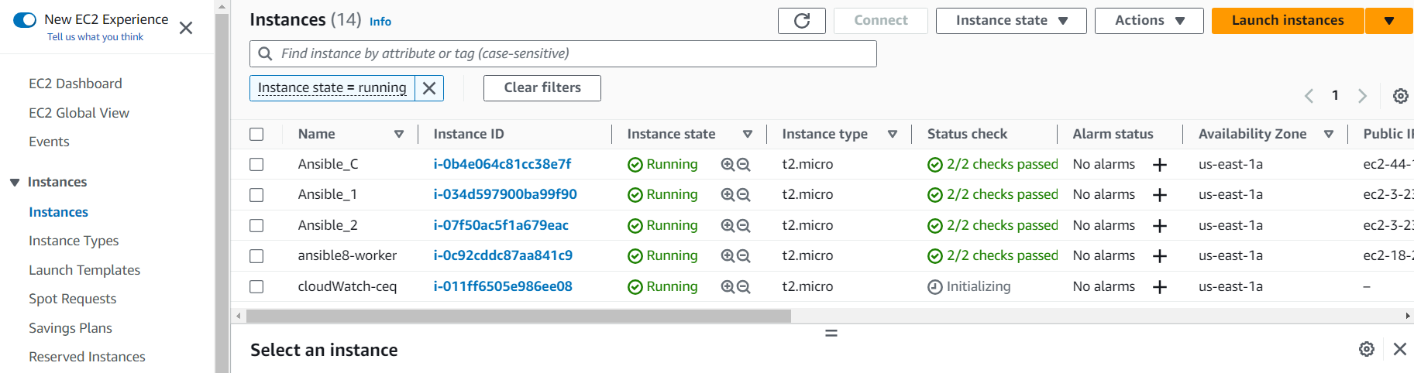

Go to the CloudWatch:

Then go to the Dashboard:

Create Dashboard:

Add The Widget:

Add Metric Graph:

Then save this

**Create Alarms:**

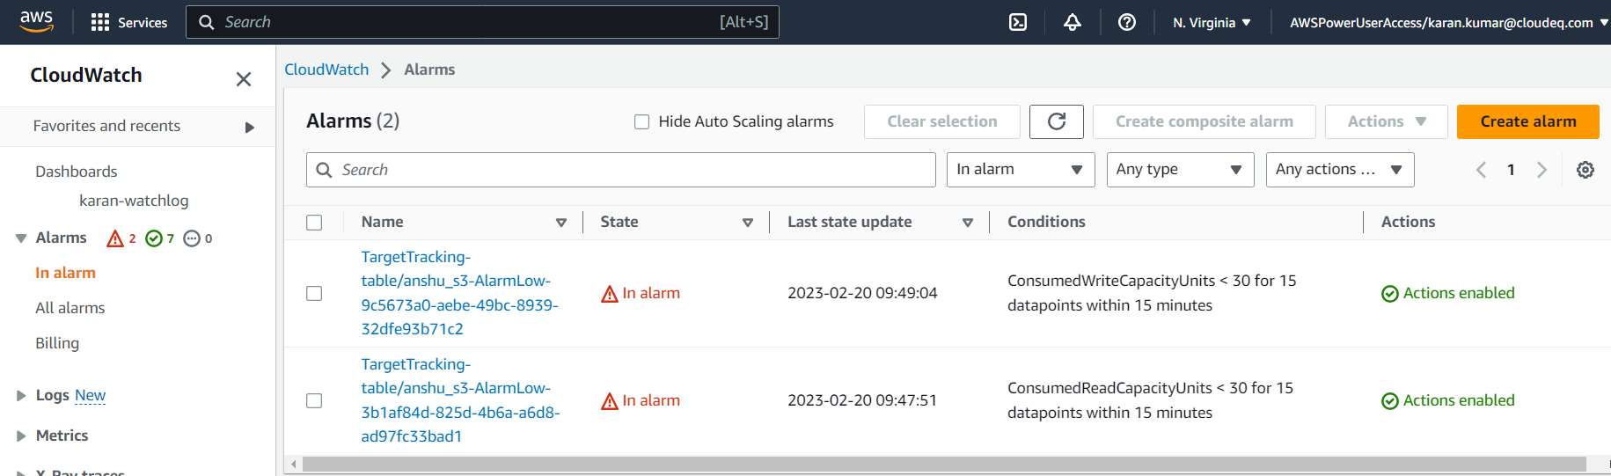

Select Metrics:

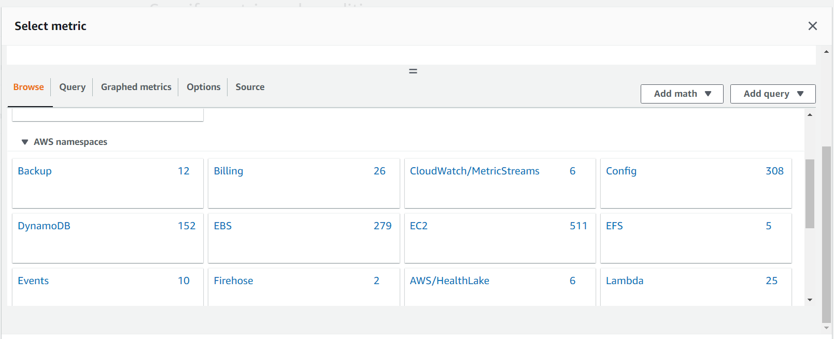

Select pre-instance metrics:

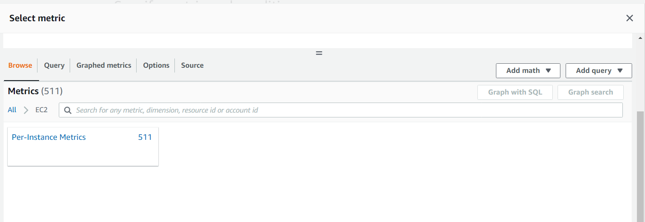

Select metrics:

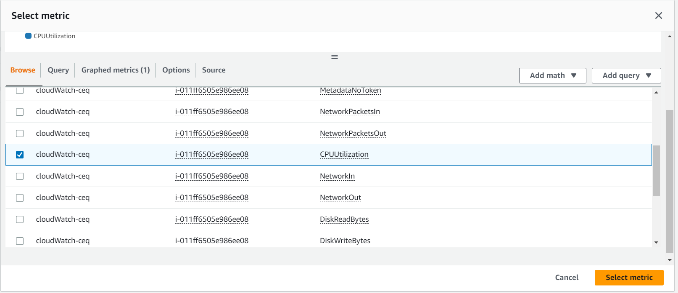

Specifay the conditions:

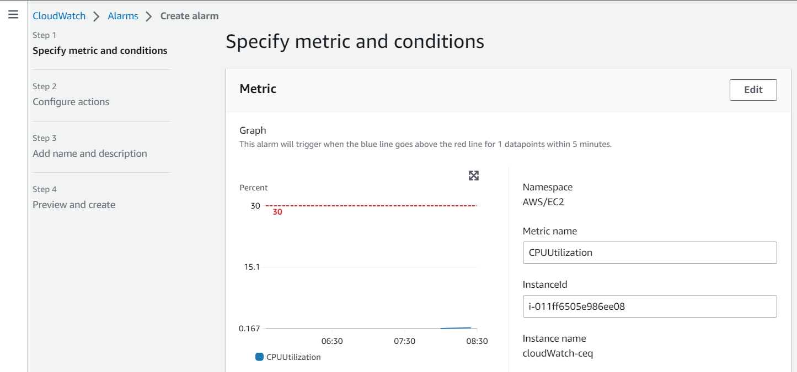

Configure Condition:

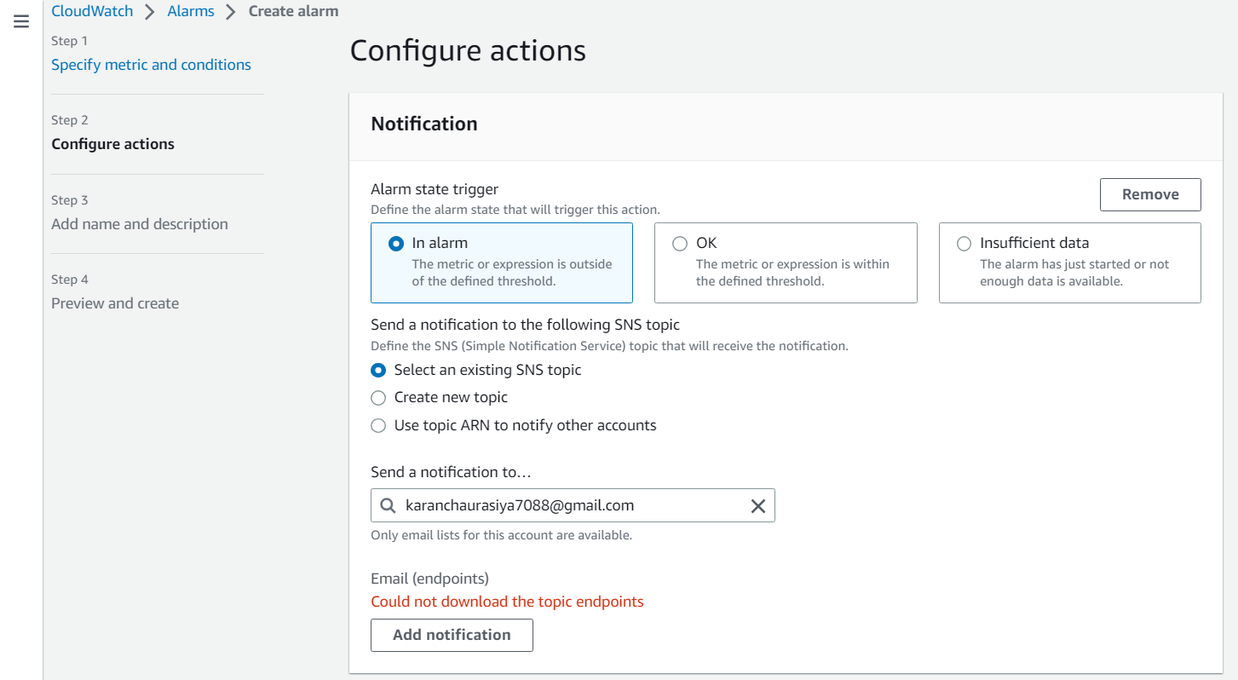

Add name and description:

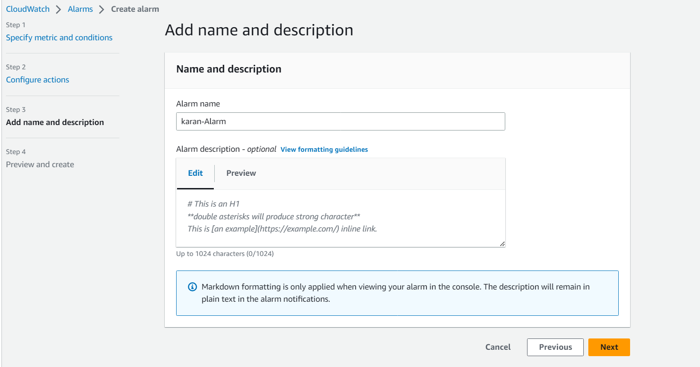

Preview and create:

View Alarm:

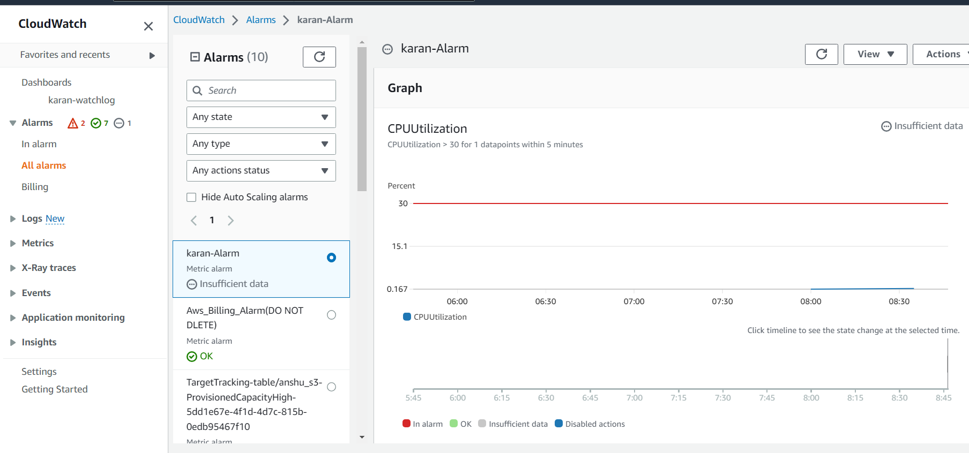

Amazon SNS:

