**Index**

|  |  |  |
| --- | --- | --- |
| **s.no** | **content** | **Page.no** |
| **1** | Cloud development on Azure:  What is Azure? Datacenters, services, and resources:   * + - Azure:     - Azure Services:     - **Datacentres:**     - Resources | **2** |
| **2** | Provisioning, accessing, and managing resources on Azure:   * + Provisioning Resources on Azure:   + Accessing Resources on Azure:   + Managing Resources on Azure: | **3-4** |
| **3** | Subscriptions, resource groups, and regions:  1.Subscriptions:  2.Resource Groups:  3.Regions: | **4-5** |

**Cloud development on Azure**

**What is Azure? Datacenters, services, and resources:**

**Azure:**

Azure is Microsoft's cloud computing platform that provides a vast range of services and resources for building, deploying, and managing applications and services in the cloud.it offers a flexible and scalable infrastructure.

**Azure Services:**

**Compute Service:**

it includes the Microsoft Azure Cloud Services, Azure Virtual Machines, Azure Website, and Azure Mobile Services, which processes the data on the cloud with the help of powerful processors.

**Data Services:**

this service is used to store data over the cloud that can be scaled according to the requirements. It includes Microsoft Azure Storage (Blob, Queue Table, and Azure File services), Azure SQL Database.

**Application Services:**

It includes services, which help us to build and operate our application, like the Azure Active Directory, Azure Media services

**Network services:**

**It helps you to connect with the cloud and on-premises infrastructure, which includes Virtual Networks and the Azure traffic Manager.**

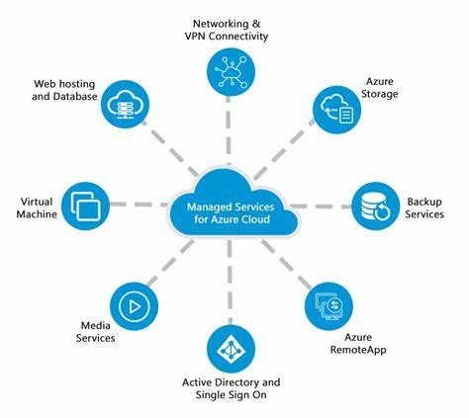

**Datacentres:**

1. **A datacenter is simply a building that contains the physical server. Not just one server, many many physical servers which are connected over a network.**
2. **These data centres are located all over the globe and organised into azure regions.**
3. **Azure has over 60 regions worldwide and is available in 140 countries/regions.**



**Resources:**

The resource is nothing but an Azure service such as app service, Azure storage, azure active directory, etc. It means whenever you create a new resource, you are actually creating the azure service.

**Provisioning, accessing, and managing resources on Azure**

**Provisioning Resources on Azure:**

Provisioning on Azure refers to the process of creating and configuring essential resources needed for your application or service to operate in the cloud. These resources encompass a wide range of components such as virtual machines, storage accounts, databases, and networking elements.

You communicate with various method including Azure portal, Azure CLI, Azure PowerShell.

**Accessing Resources on Azure:**

Once resources are provisioned, you can access and use them to run your applications, store data, and deliver services. Accessing resources often involves using APIs, connection strings, or endpoints provided by Azure services.

**Managing Resources on Azure:**

Managing resources includes tasks like monitoring, scaling, updating, and securing your applications and services. Azure provides various tools and services to manage resources efficientlylike a azure monitor and azure security center.

**Subscriptions, resource groups, and regions**

1. **Subscriptions:**
   * Think of a subscription as your ticket to access and use Azure services.
   * With a subscription, you can create and manage various resources in Azure, such as virtual machines, databases, and web apps.
   * Each subscription has its own billing and access control, so you can keep track of what you're using and who has permission to use it.
2. **Resource Groups:**

* Resource groups are like containers that help you organize and manage your resources in Azure.
* You can group resources together based on projects, applications, or departments, making it simpler to manage and track them.

1. **Regions:**
   * You can say thar regions are group off datacentres.
   * Each region is a specific location where Azure datacentres and resources are located.