**Assigment-Batch7**

**Karan Kumar(CEQ539)**

**Step 1:**

**First Create two virtual Machine in Azure portal**

**Step 2:**

**Create load balancer**

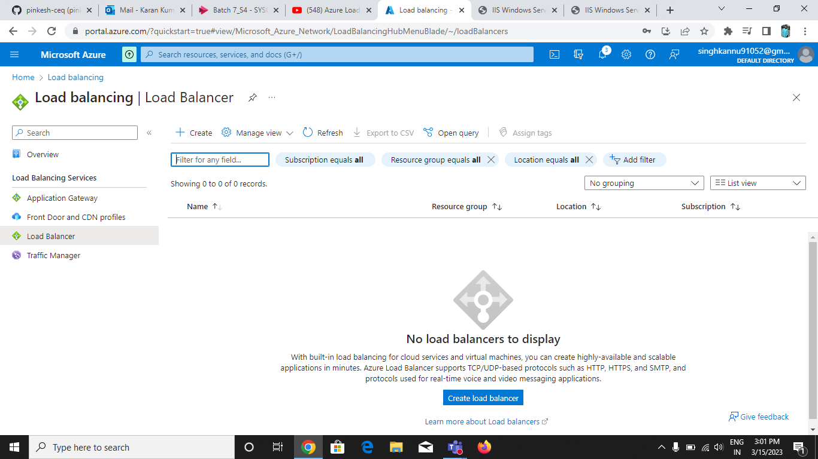

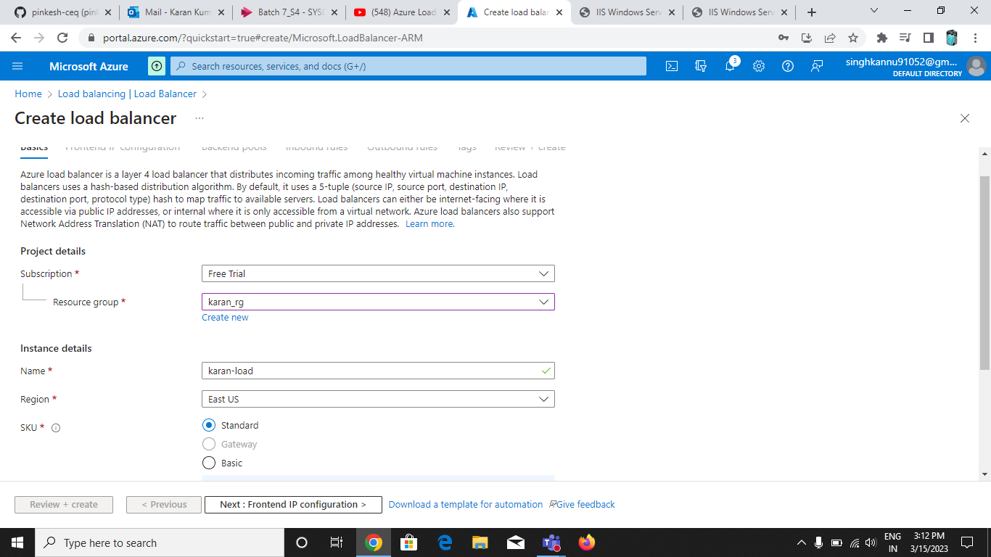

**Add Fronted IP Configuration:**

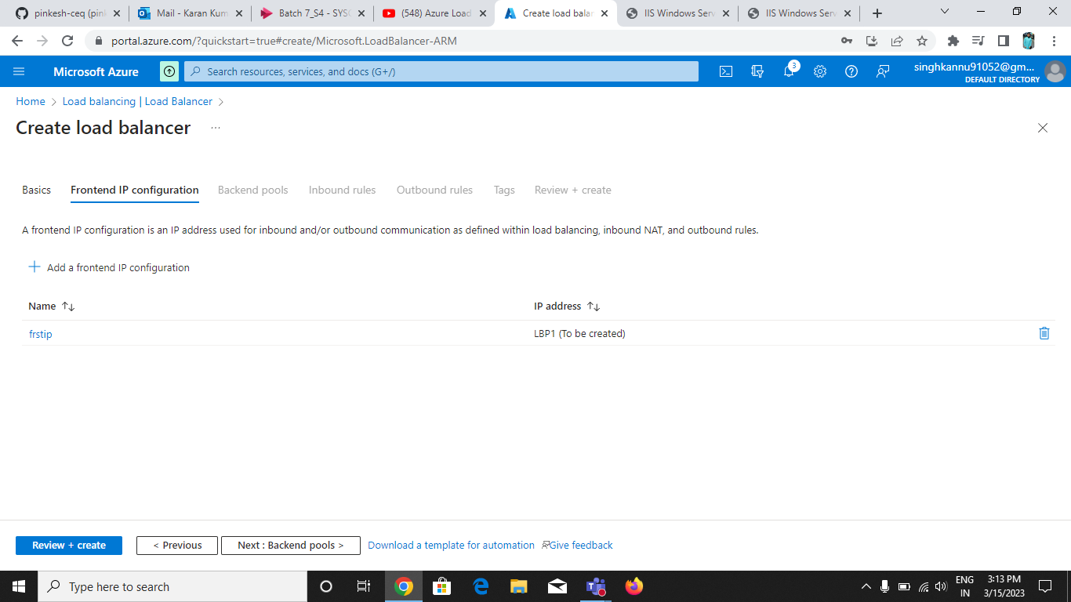

**Add on Backend pools:**

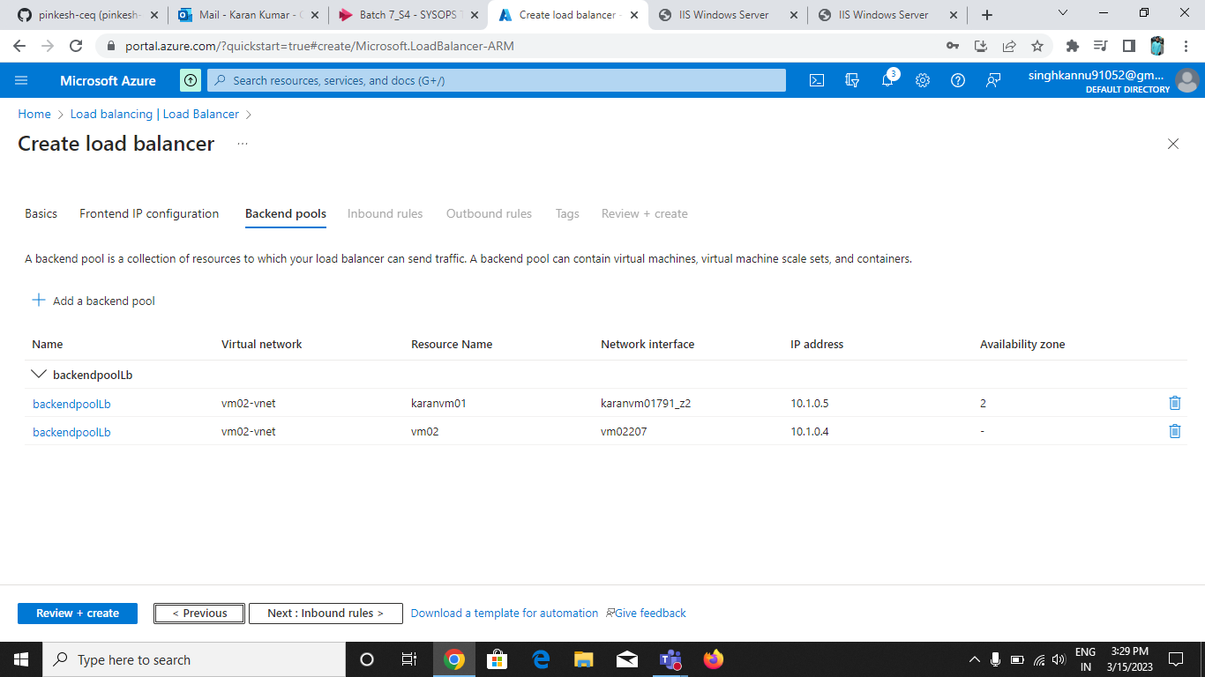

**Include Inbound Rules:**

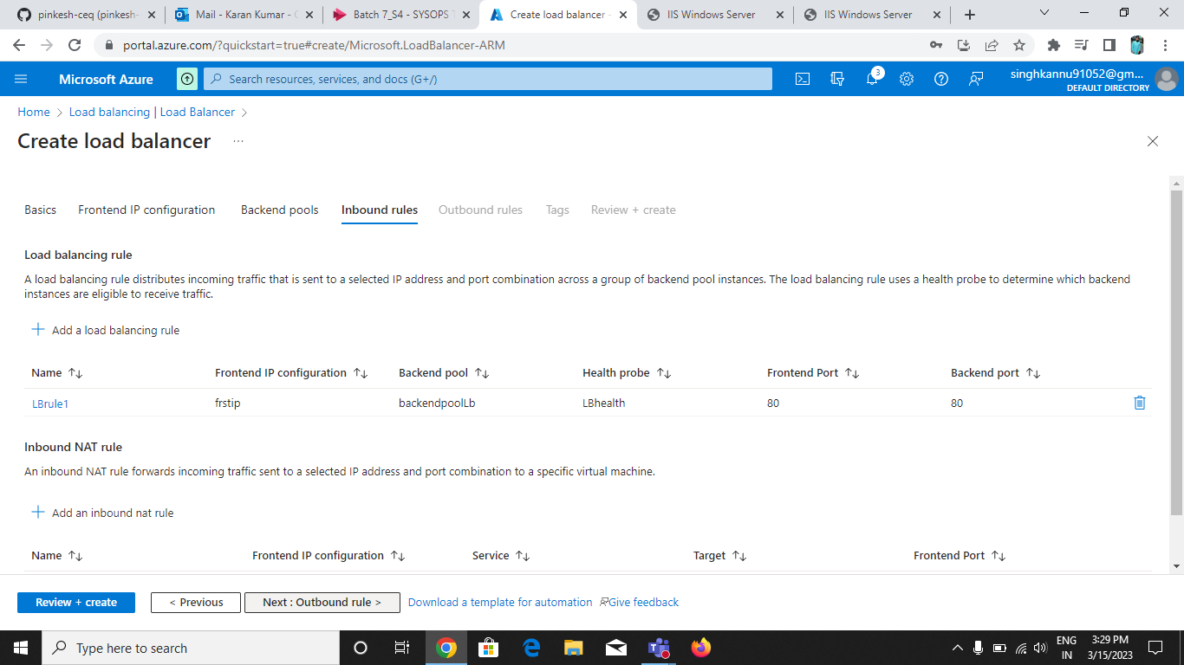

**Validation Done:**

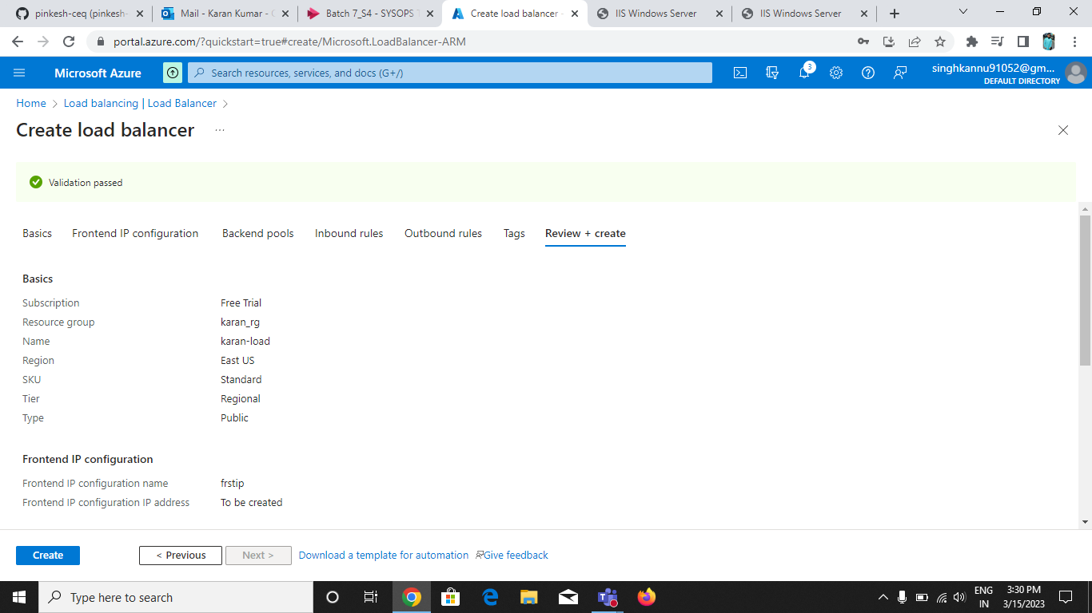

**Create load Balancer is done and deployment also done for load balancer:**

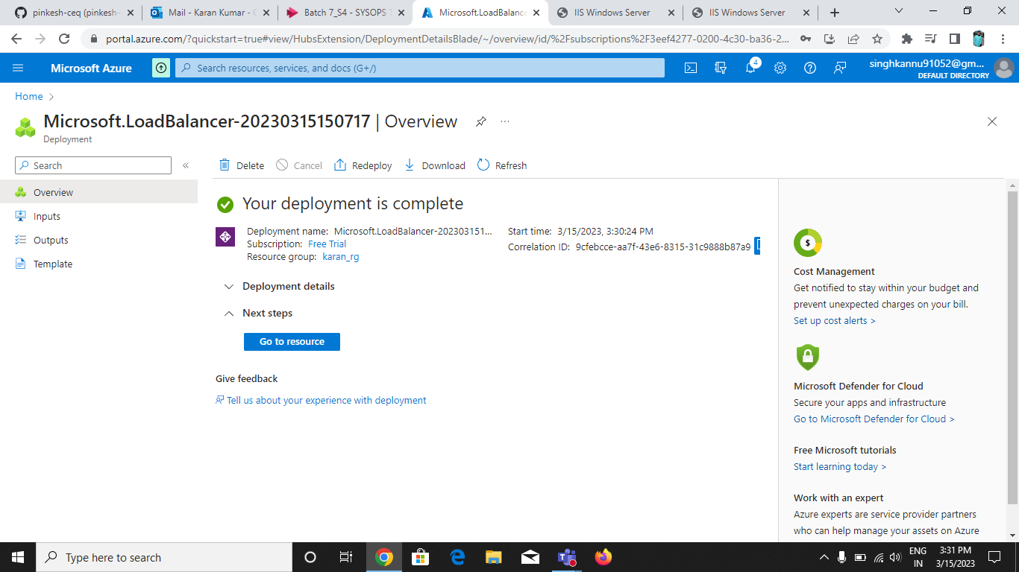

**Fronted IP Configuration Done:**

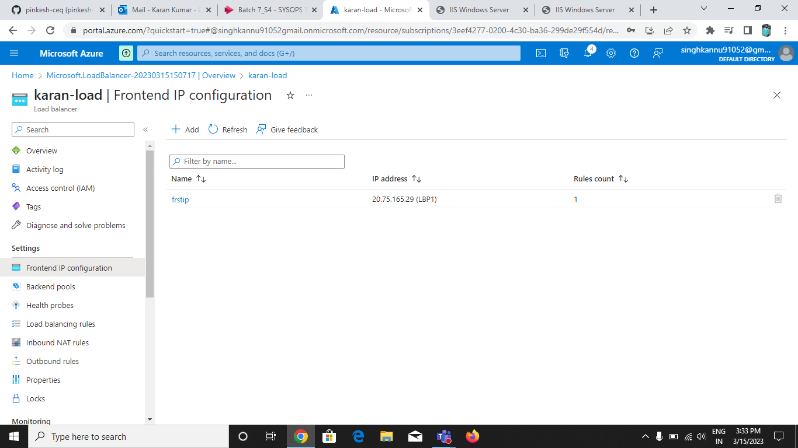

**Backend Pools Done:**

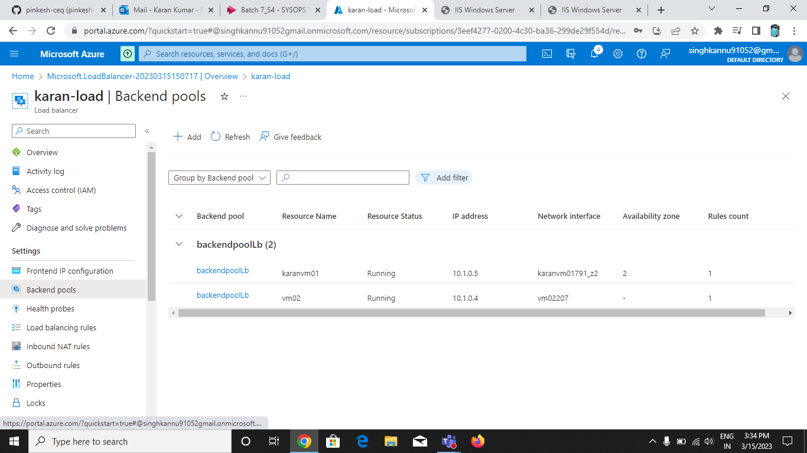

**Health Probes done:**

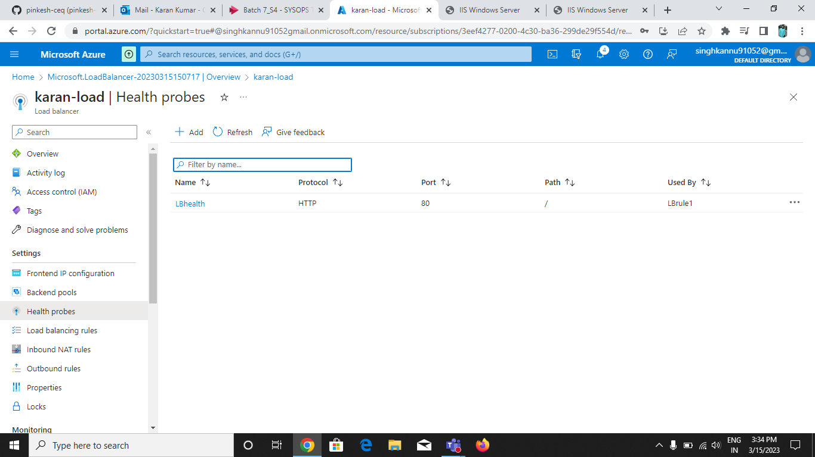

**Load Balancer:**

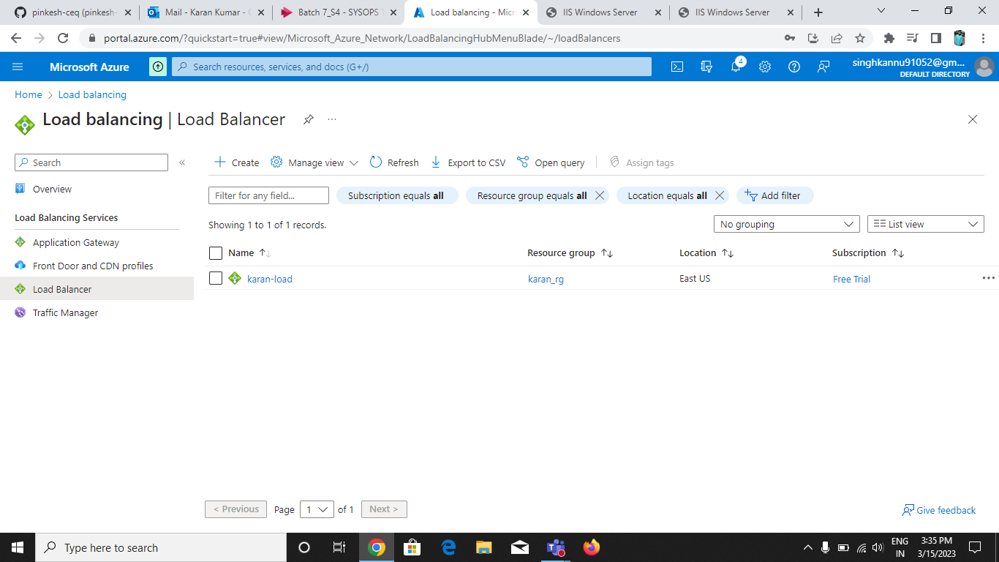

**The Result is :**

**First server is:-**

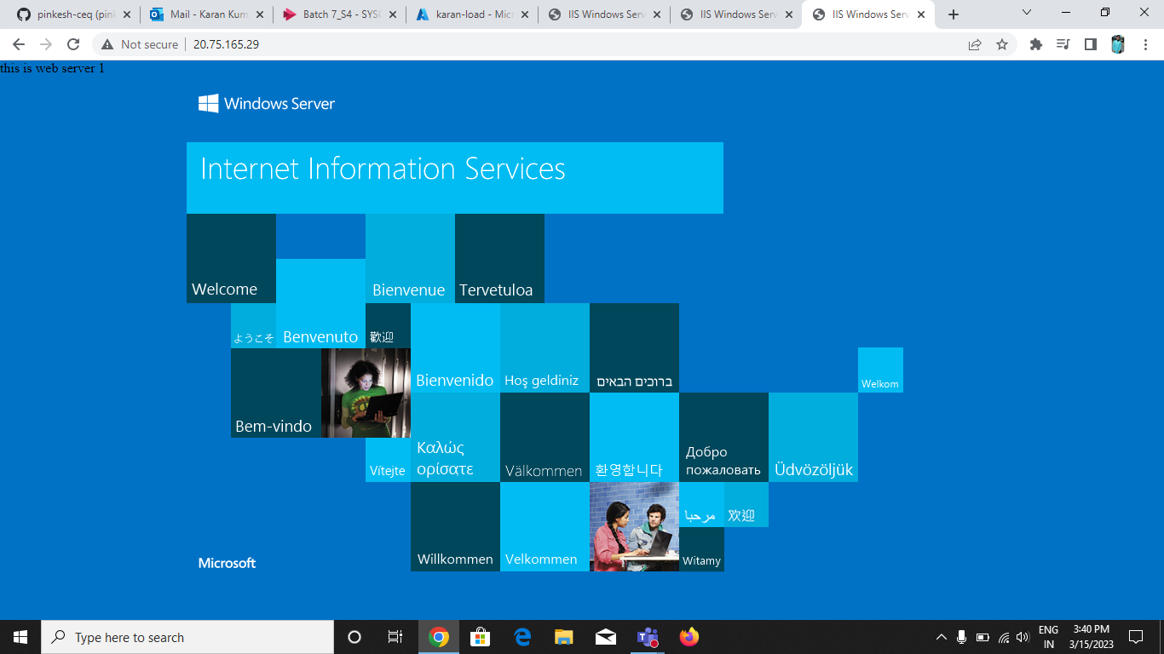

**Second Server is:**

