

**A PROJECT REPORT ON ONLINE**

**J o b P o r t a l WEBSITE**

Submitted by:

Mihir Prajapati (22032211205)

Karan Parmar (22032211123)

Guided by: Prof.**Falguni Suthar**

Submitted To:

Acharya Motibhai Patel Institute Of Computer Studies Ganpat University, Kherva 384012.

Acharya Motibhai PatelInstitute Of Computer Studies Ganpat University, Kherva 384012.

CERTIFICATE

TO WHOM SO EVER IT MAY CONCERN

This is to certify that the following students of **BCA Semester V** have completed their project work title “**ONLINE Job Portal** ” satisfactorily fulfill the requirement for subject **U35A5SDP-I** in BCA Semester V in the year 2023-2024.

|  |  |  |
| --- | --- | --- |
| **No** | **Name** | **Enrollment No** |
| 1. | Mihir Prajapati | 22032211205 |
| 2. | Karan Parmar | 22032211123 |

**Internal Guide Program Co- ordinator**

**Principal**

Prof. Falguni Suthar Dr. Savan Patel Dr. Nirbhay Chaubey

## Acknowledgement

An acknowledgment should be an expression of Genuine gratitude and not a set of platitudes. Here with we pen down the thank fullness. We own to all those who made this endeavor ours successful.We do not want to miss the opportunity to thanks all those who had helped us either directly or indirectly, through their constant and guidance, which helped, put in our best.

We are thankful to **Prof. Falguni Suthar** for help in our project as a project coordinator and project guide.

Our project at AMPICS. We are thankful to AMPICS for providing usan opportunity to work on their premises, guidance & cooperation during the project.

All other staff member of AMPICS institute of Computer Studies, kherva. Who support & guide us greatly during the tenure of the project and for this us sincere thanks to all of them. At last but not least we must say that the quality of the guidance, co-operation and inspiration provided by the member of AMPICS, kherva. We can’t be expressed in words.

## Preface

Welcome to project report developed by **Mihir Prajapati** and **Karan Parmar, Group No 04** undertaken at AMPICS located at **Ganpat University**, **Kherva.**

The project report has been made to make ease of understanding of the website developed for full time project fulfillment in BCA SEM-V.Where project report contains the documentation of project and project presentation.

Here in word document the documentation has been developed including the following things. Intro-page, college certificate (for made project), index, project profile, existing system, need for new system, minimum requirement, system flow- chart, DFD up to first level, entity relationship diagram.

The other thing is process description that includes brief description of process. Process algorithm, Admin Side Input Design, Customer Side Input Design, and at the last Post Implementation Review, Future Enhancement, and Bibliography that gives the reference books and references sites.

|  |  |  |
| --- | --- | --- |
| **Title Page No.** | | |
| **1.** | Project Profile | 1 |
| **2.** | Existing System | 2 |
| **3.** | Need for new system | 3 |
| **4.** | H/w & S/W requirements | 4 |
| **5.** | Flow Chart | 5 |
| **6.** | Data-flow-diagram | 7 |
| **7.** | Data Dictionary | 10 |
| **8.** | E R Diagram | 13 |
| **9.** | Process Description | 14 |
| **10.** | Brief Description of user | 15 |
| **11.** | Process Algorithm | 16 |
| **12.** | User side design | 17 |
| **13.** | Recruiter side design | 23 |
| **14.** | Testing | 29 |
| **15.** | Future Enhancement | 30 |
| **16.** | Bibliography / References | 31 |

# Project Profile

|  |  |
| --- | --- |
| **Project Title** | **Job Portal web Application** |
| **Objective** | For Provide Job portal To Public |
| **Front End Tool** | ReactJs,DaisyUi,TailwindCSS |
| **Back End Tool** | NodeJS |
| **Editor** | Visual Studio Code |
| **Operating System** | Windows 10, 11, 12 |
| **Application Type** | Website |
| **Developed For** | Acharya Moti Bhai Patel Institute of Computer  Studies |
| **Team Member** | Mihir Prajapati(22032211205)  Karan Parmar(22032211123) |
| **Project Guide** | Prof. Falguni Suthar (Internal Guide) |
| **Group No** | 04 |

**Existing System**

* Job details are stored in paper work
* Maintenance is a huge problem
* Updating , Changes in details is a big task
* **Limited Accessibility :** without an online presence, applicant can
* only access the rental service by physically visiting the rental location

# Need for new System

* Maintenance is easy and performance is good.
* Mainly the system has automated the transportation process. As data is maintained electronically , it’s easy for a person to update the details, Which has overcome the tedious updating in previous system.
* **Customer Convenience :** In an increasingly digital world
* **24/7 Availability :** our online platform can operate 24/7 , allowing applicant to apply jobs at any time day or night

**H/W & S/W Requirement(recommended)**

* + **Server side:**

## HARDWARE:

* **Processor : Intel core i3 OR above**
* **Ram : 4GB or above**
* **Hard – Disk : 256GB or above**

## SOFTWARE:

* **Database System : MongoDB**
* **Operating System : Windows 7 or above**
  + **Client side:**

## HARDWARE:

* **Processor : Intel core i3 or above**
* **Ram : 2GB or above**
* **Hard-Disk : 256GB or above**

## SOFTWARE:

* **Browser : chrome or Any browser**
* **Operating System : windows or any OS**

# Flowchart

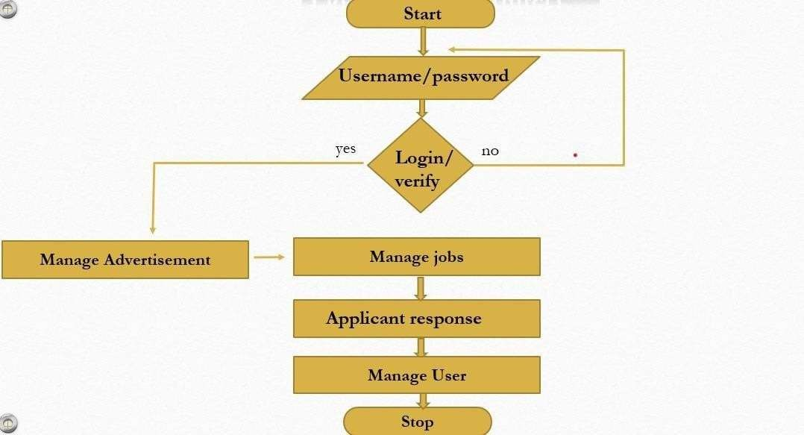

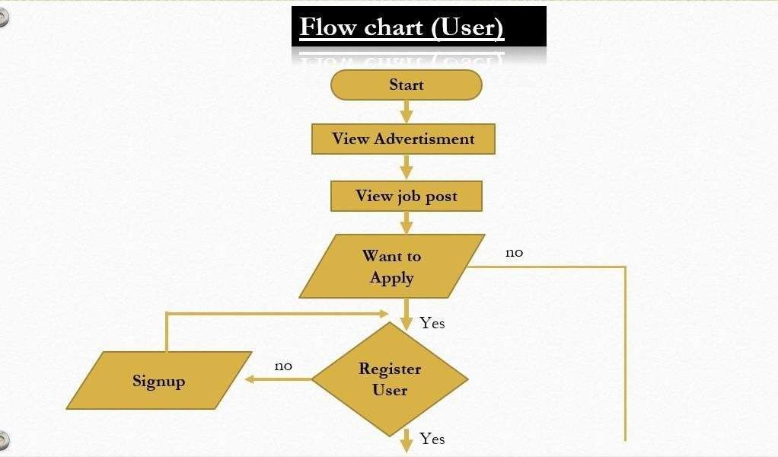

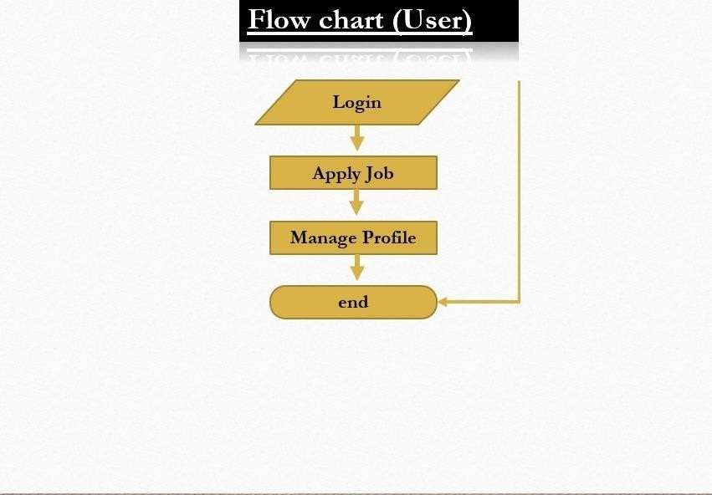

**Data Flow Diagram**

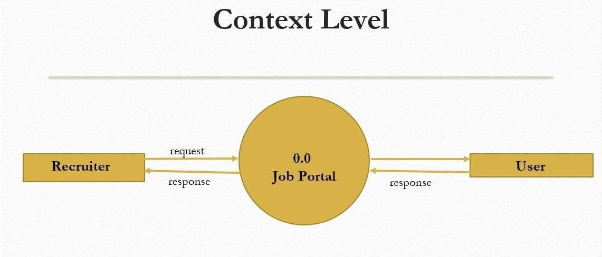

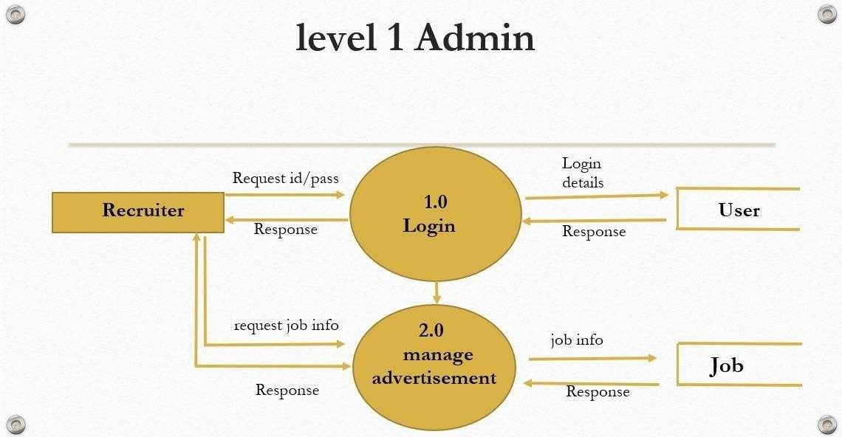

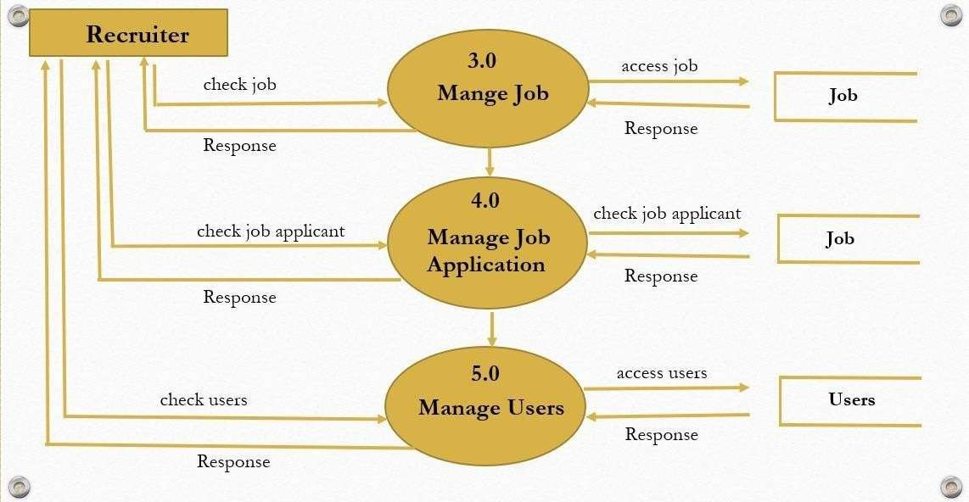

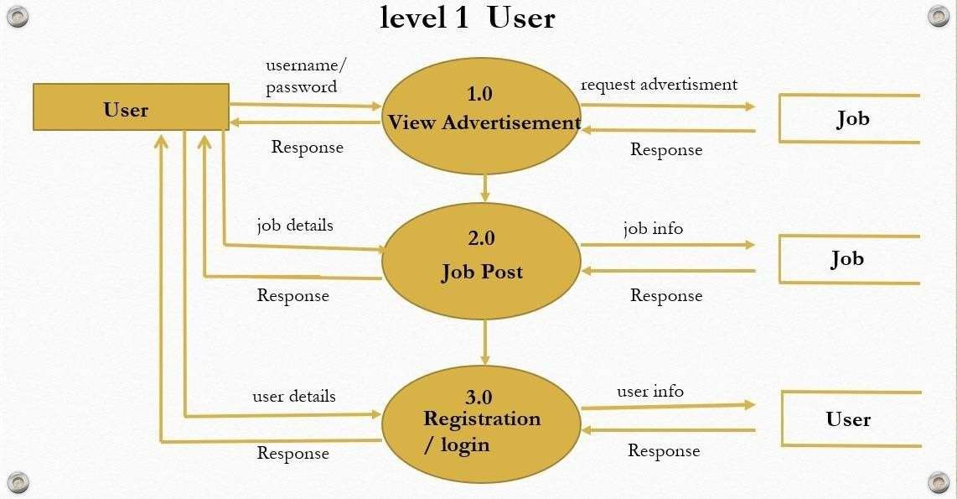

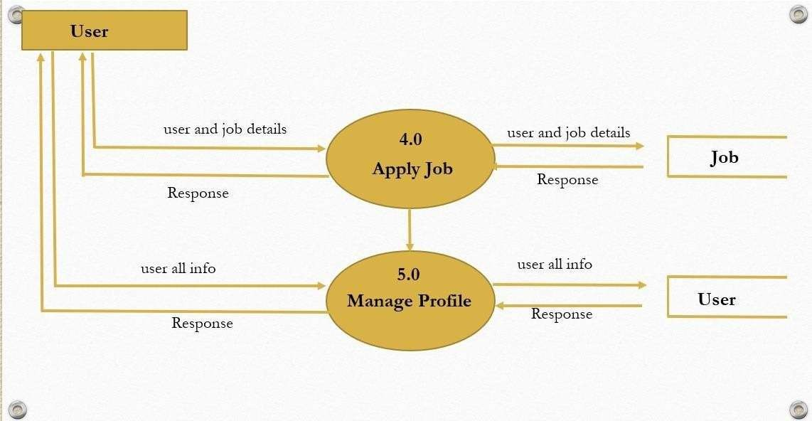

# Data Dictionary

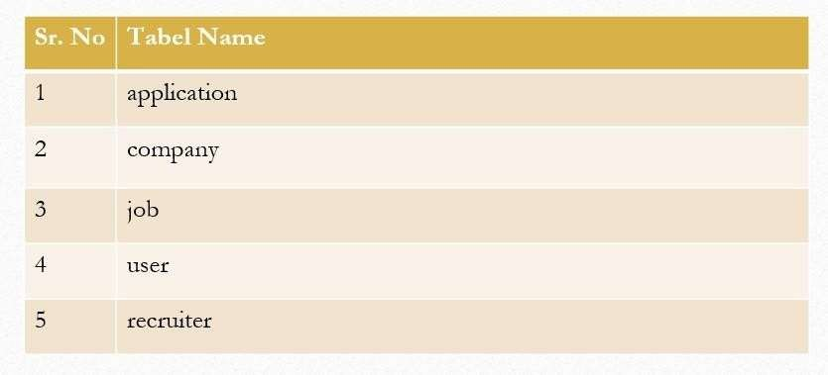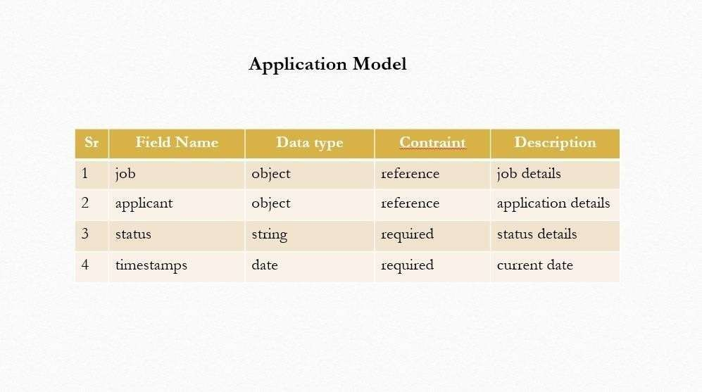

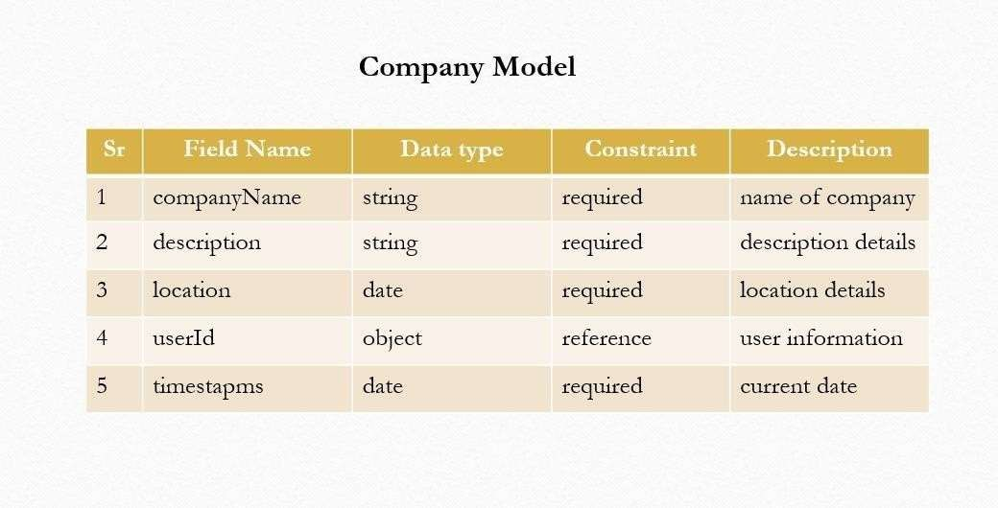

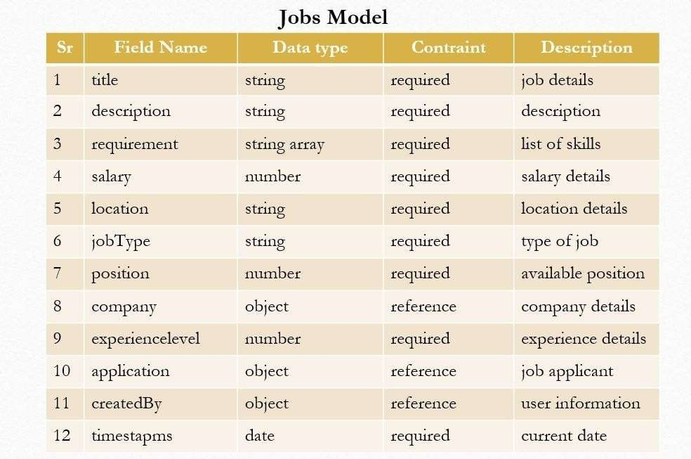

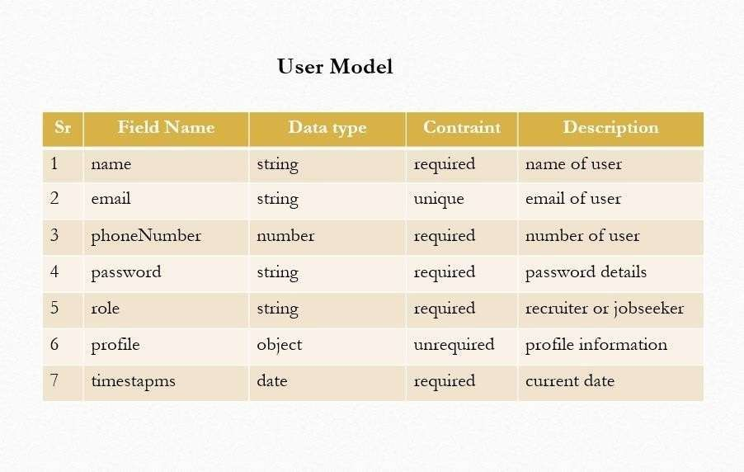

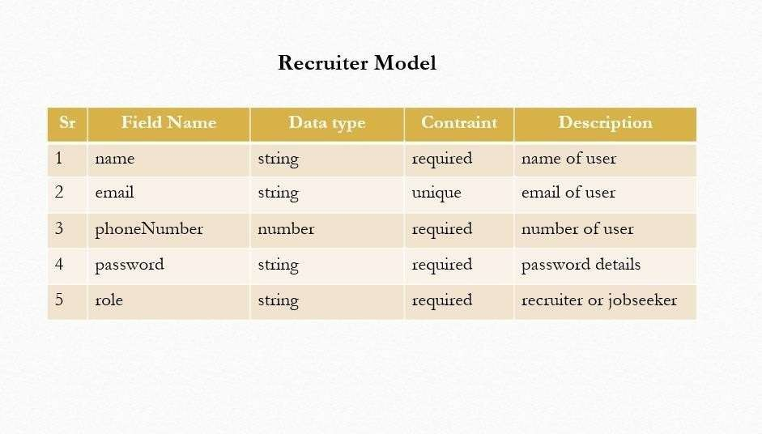

**Entity Relationship Diagram**

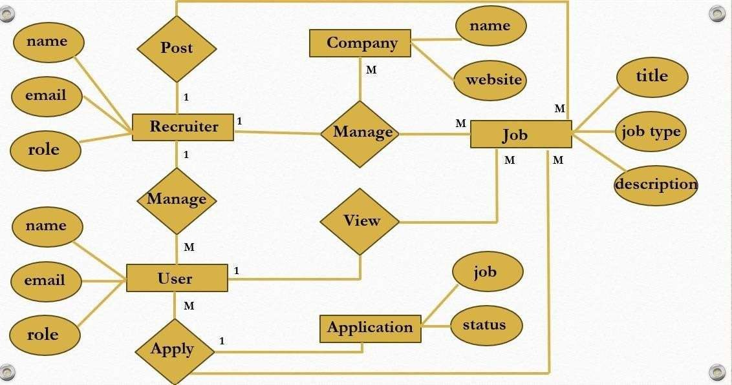

# Process Description of Recruiter

## Register :-

Recruiter Firstly Enter Name,Phone number, Profie photo ,Email & Password. and then go into next process.

1. **Login** :-

Recruiter Enter Email & Password then the check into the LOGIN then they pass the information into next Process.

## Company dashboard :-

After Login Admin navigate company dashboard.in company Dashboard page admin can see all company that they add.

## Add Company :-

Admin enter detail of company that display into company dashboard and job page.

## Job post :-

After company add then admin post the job into Job page that user can display company.

## Applicant :-

The **Applicant** section allows the admin to view details about users who have interacted with or displayed interest in their company listings.

## Response:-

The Response section provides functionalists for recruiter to communicate with applicants and manage their responses effectively.

# Brief Description of User

## User Registration and Login:

* + **Registration**:
    - Users can sign up by providing their name,profile photo,email, number, and password.
    - An email verification step may be included for security.
  + **Login**:
    - Users can log in using their registered email and password.
    - Support for "Forgot Password" to reset their credentials.

## Profile Management:

* **Users can create and update their profiles by providing**:
  + Personal details (e.g., name,bio, contact info).
  + Professional details (e.g skills educational).
  + Uploading a resume or CV for application purposes.

## Job Search and Application:

* **Browse Job Listings**:
  + Users can search for jobs using filters such as location, salary, job type (Hybrid/Full time/WOF) or company name.
* **View Job Details**:
  + Users can view detailed descriptions of job roles, requirements, and company profiles.
* **Apply for Jobs**:
  + Users can submit applications directly through the portal by clicking the "Apply" button. Option to attach their uploaded resume.

# Process Algorithm

* **Recruiter Side:**

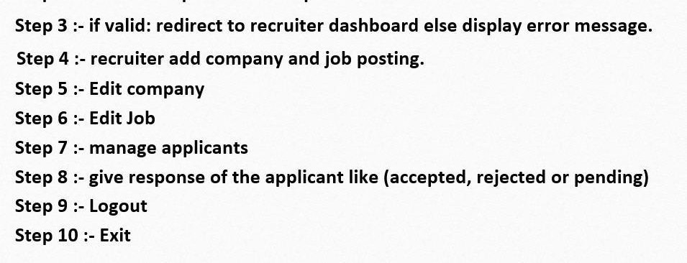

* **User Side:**

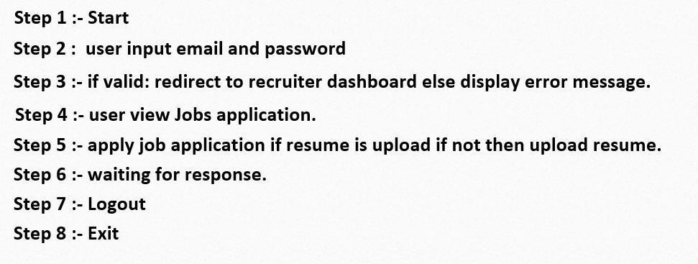

## Input Design (User)

**Home Page**

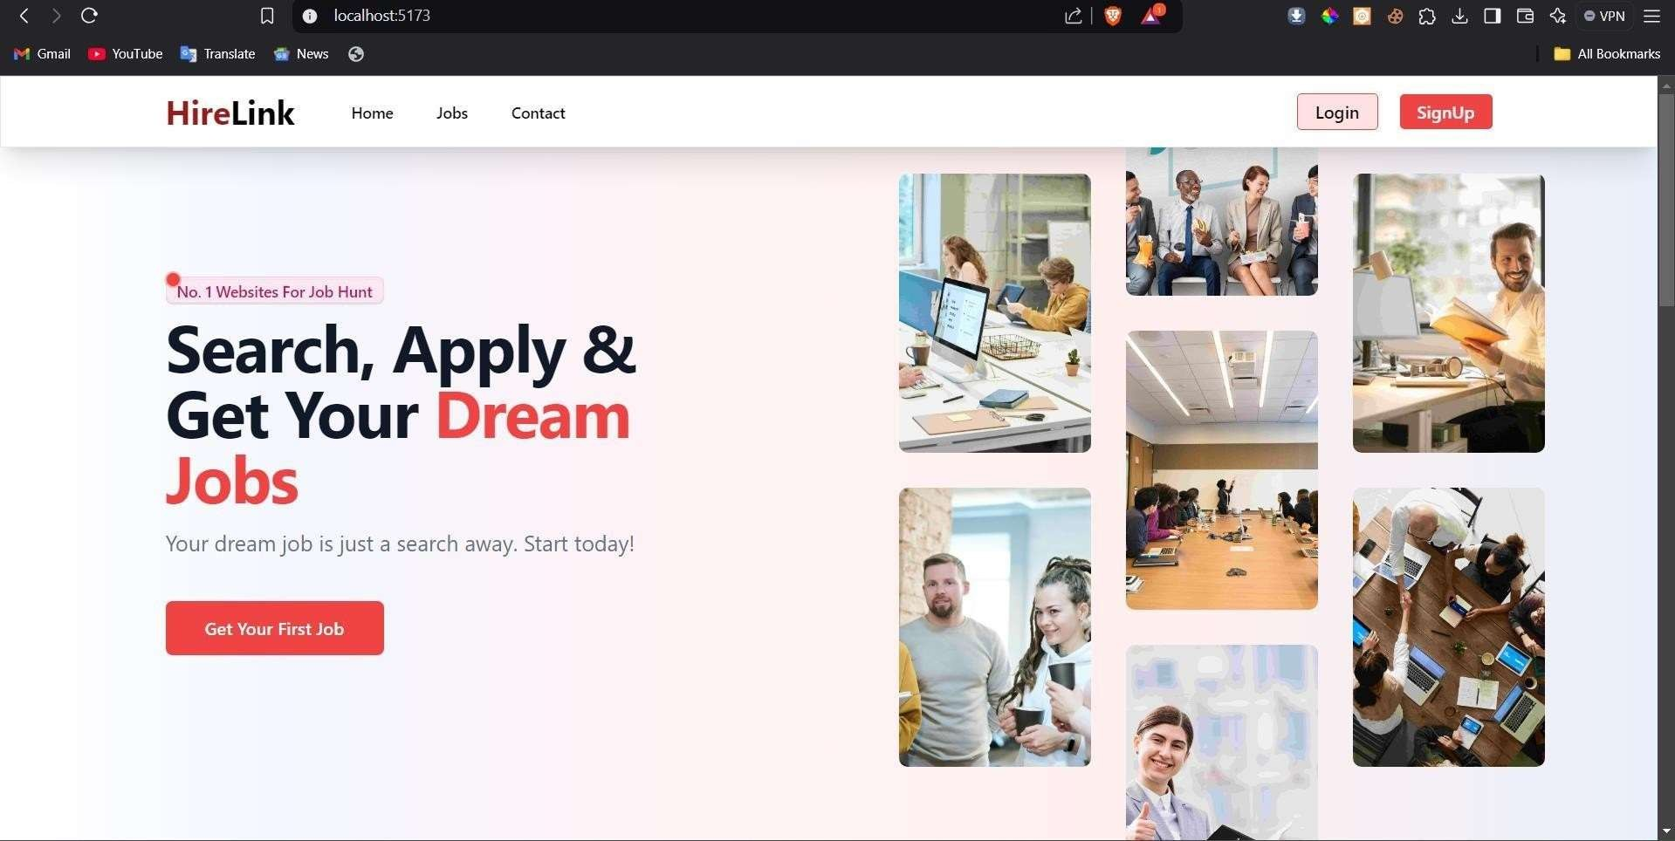

**Home Page search**

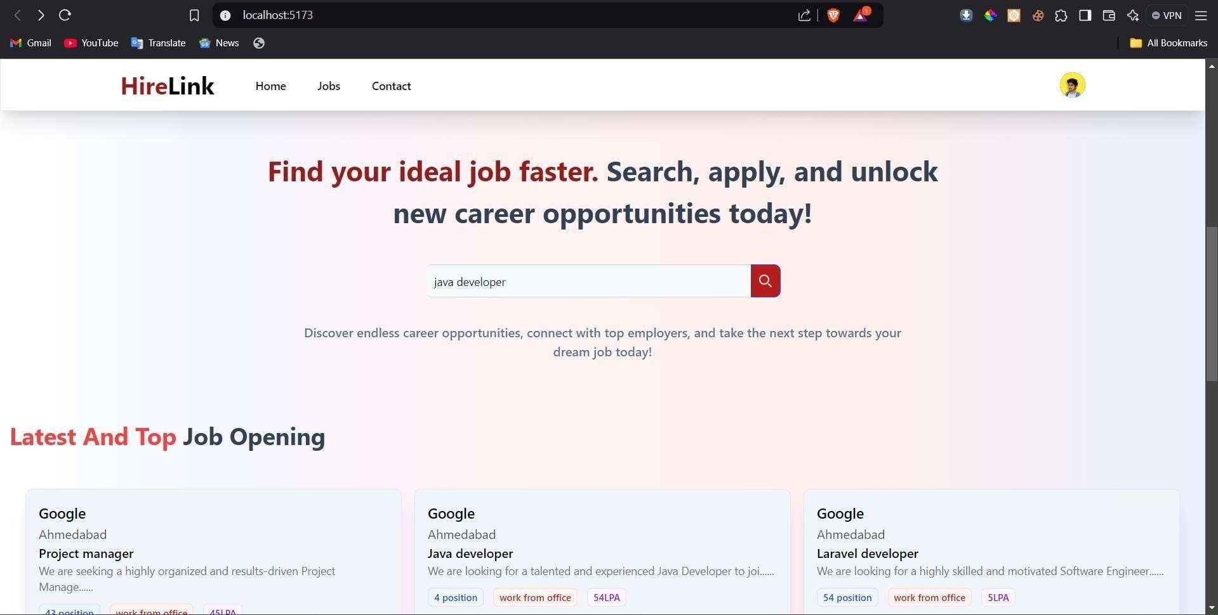

**Home Page latest job opening**

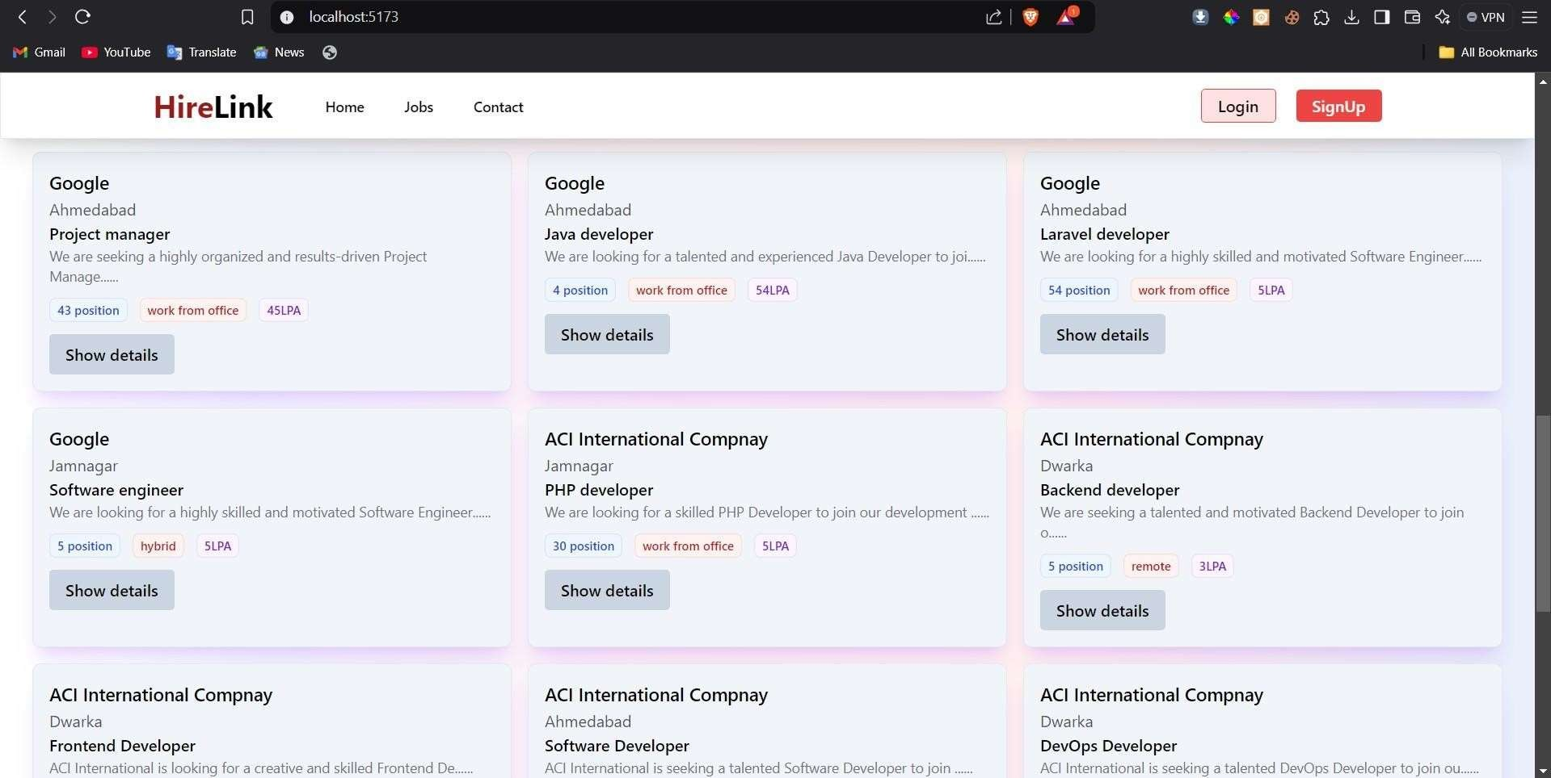

**Jobs Page**

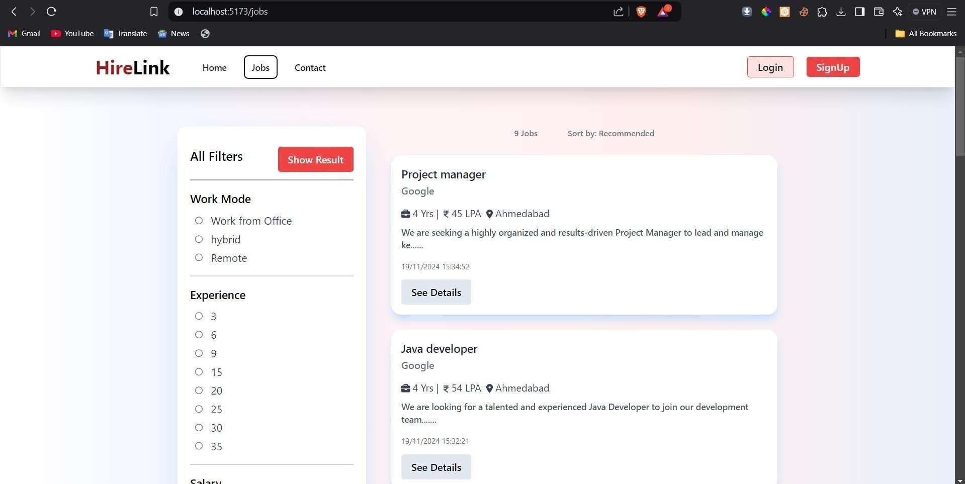

**register page choice**

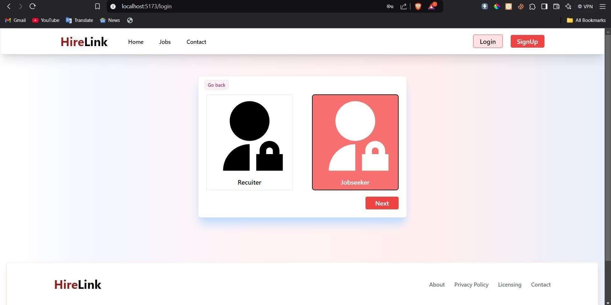

**Jobs post page**

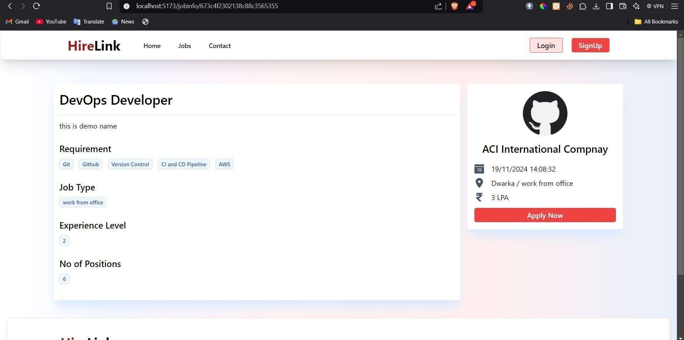

**register for user**

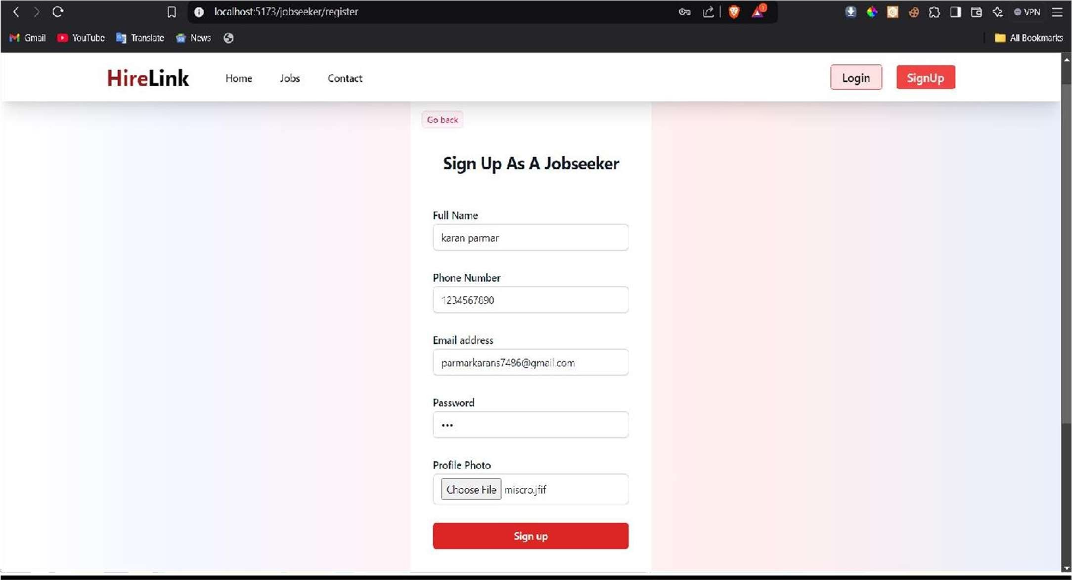

**login for user**

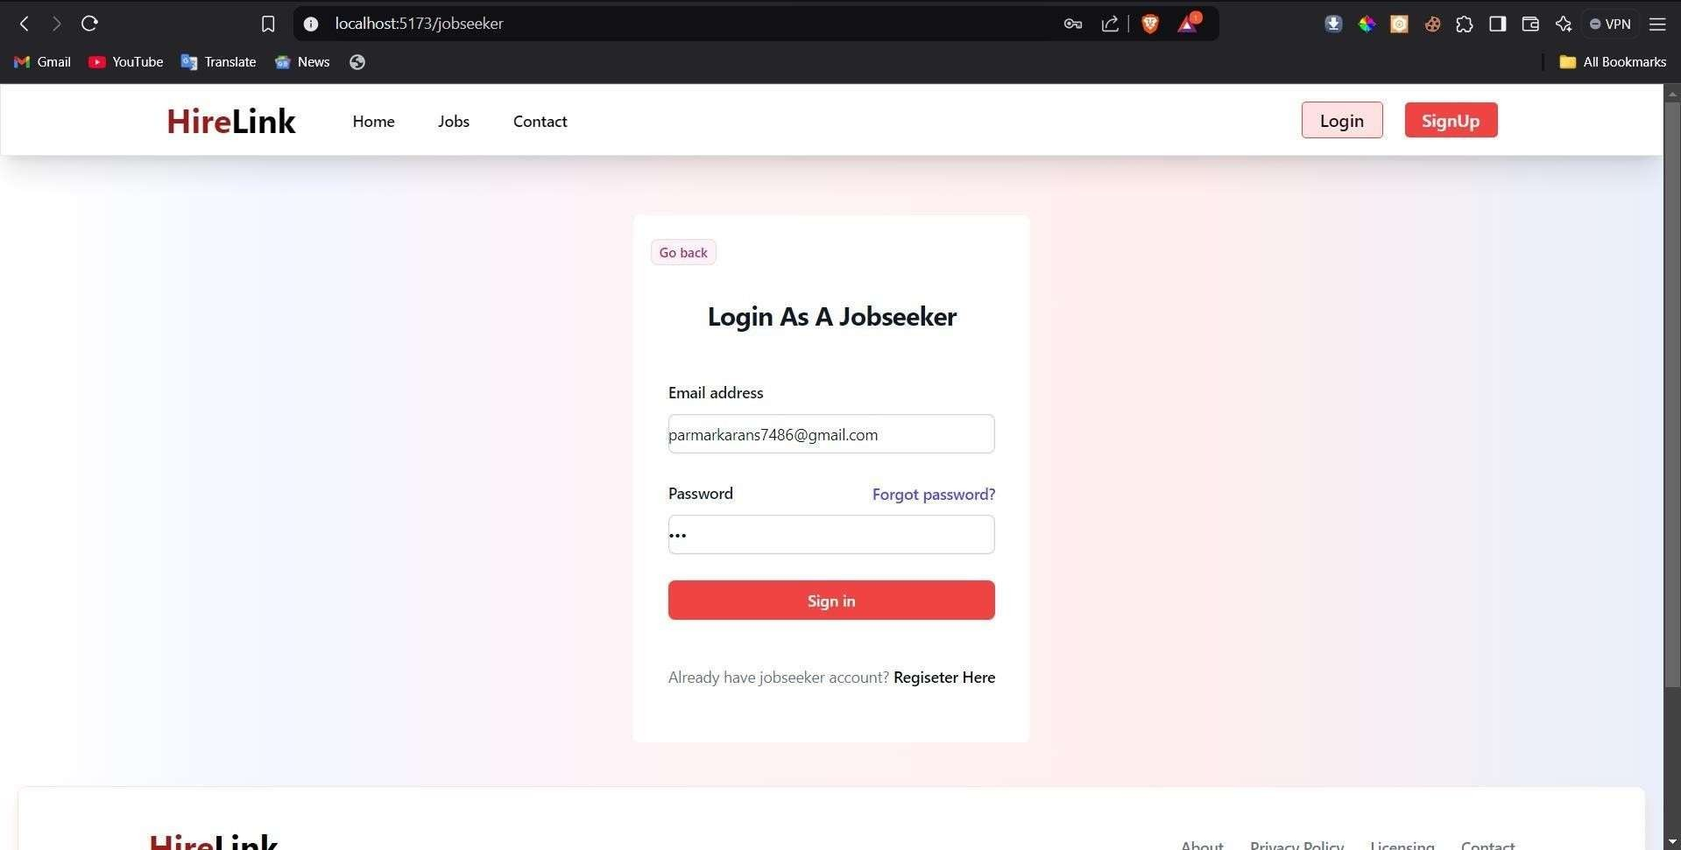

**forget password page for user**

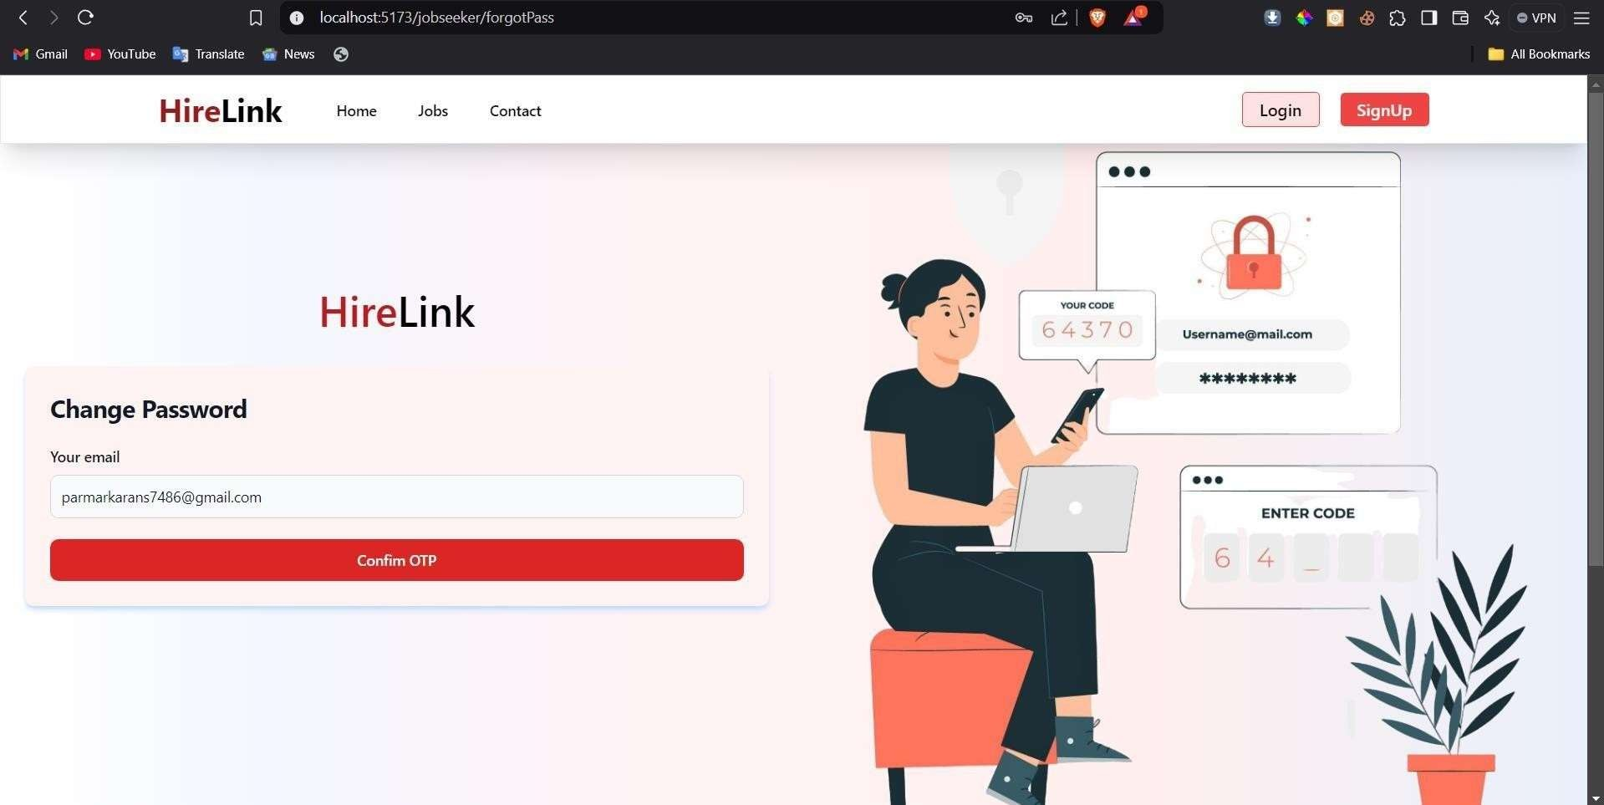

**profile page**

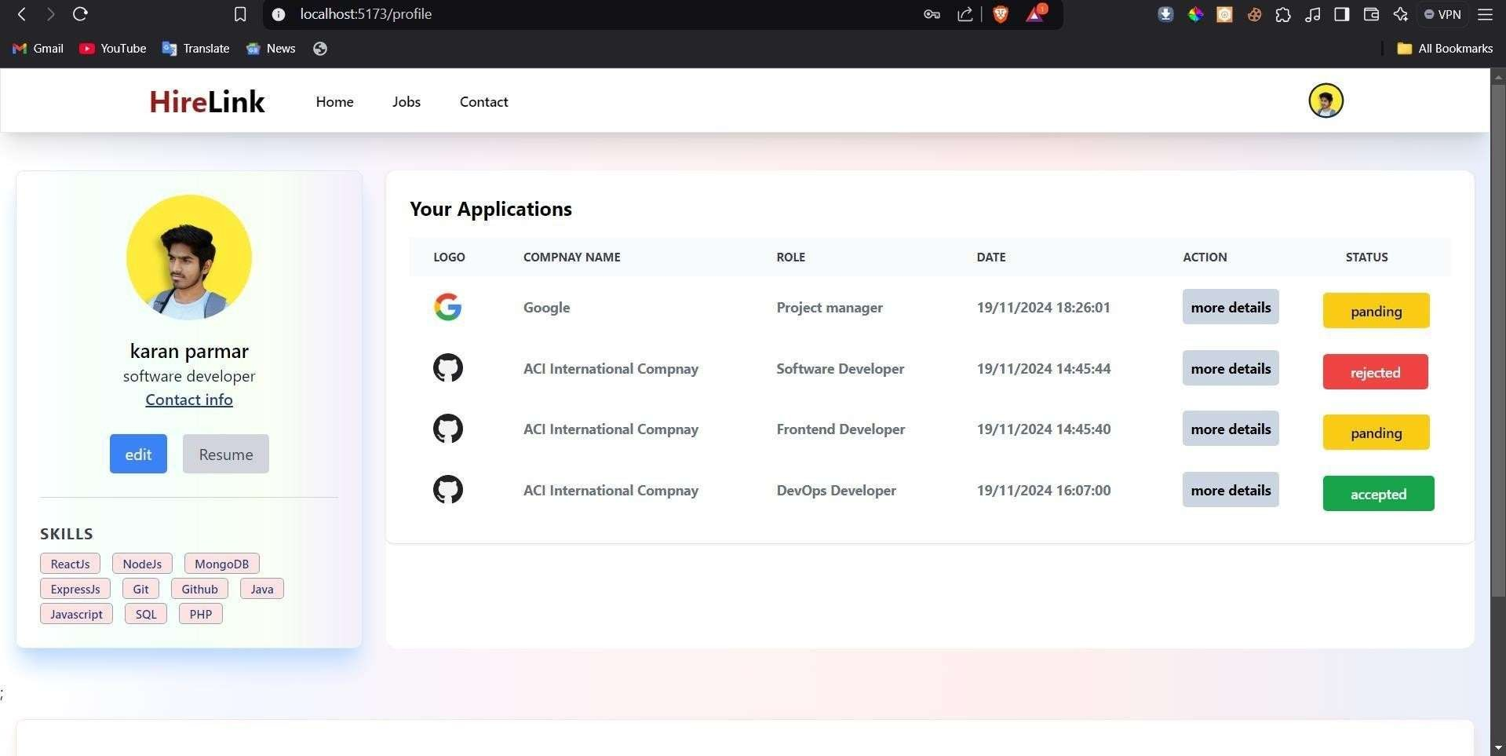

**update profile page**

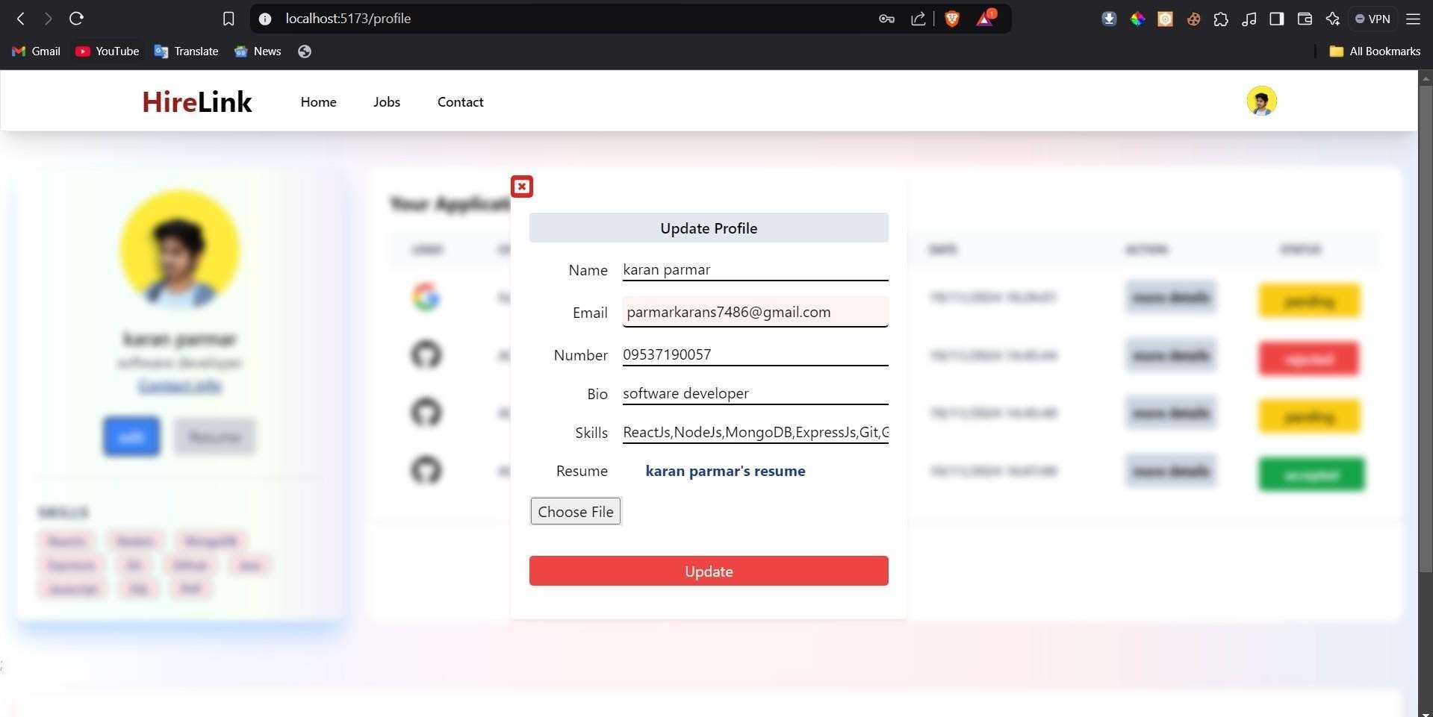

## Input Design (Recruiter)

**Recruiter selection**

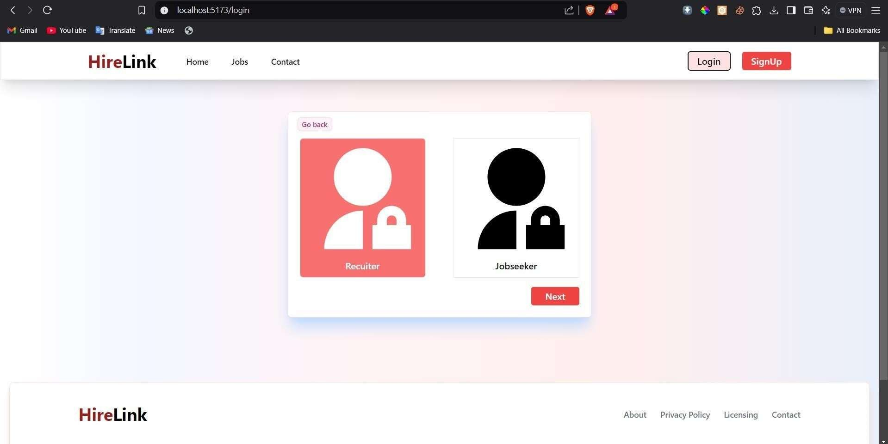

**Recruiter login**

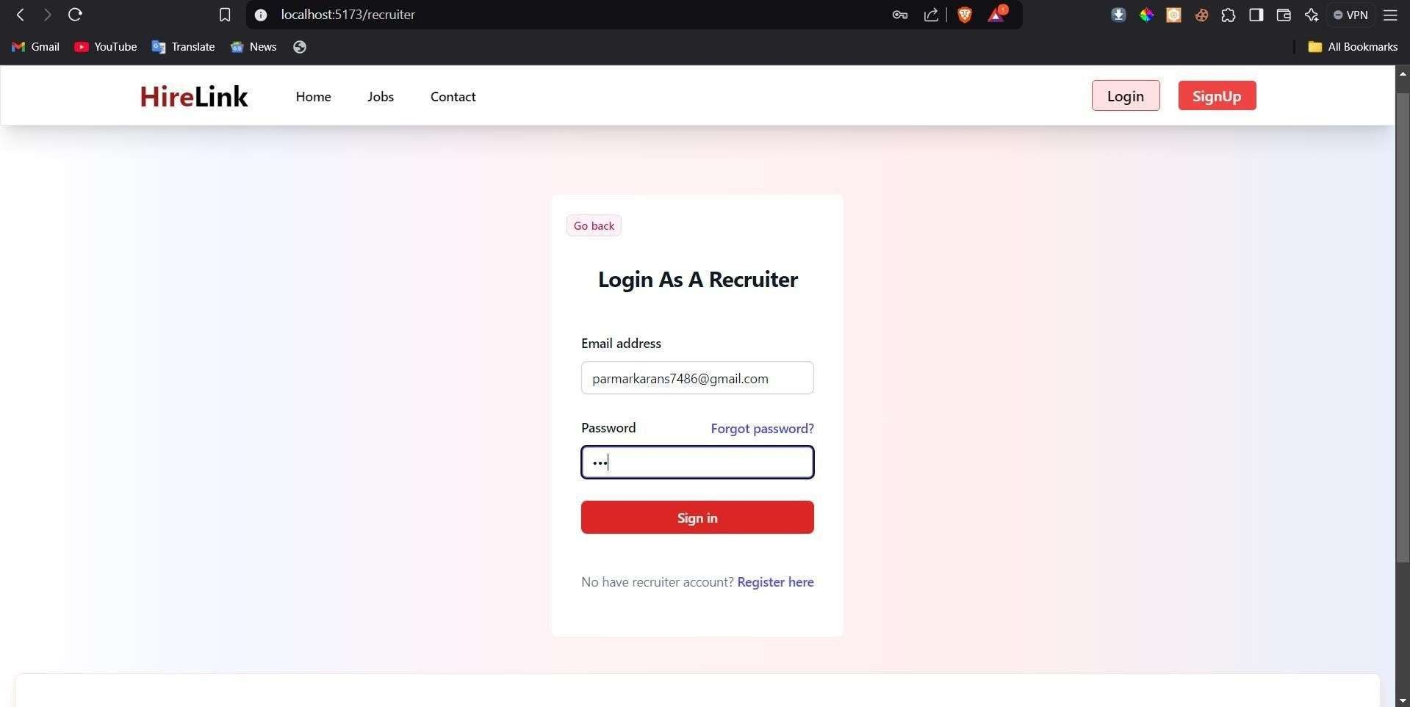

**Recruiter register**

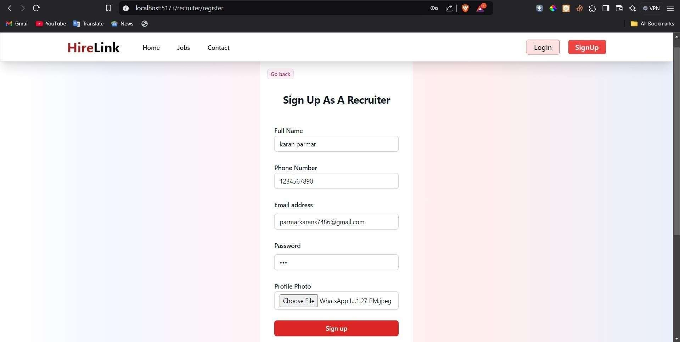

**Recruiter dashboard**

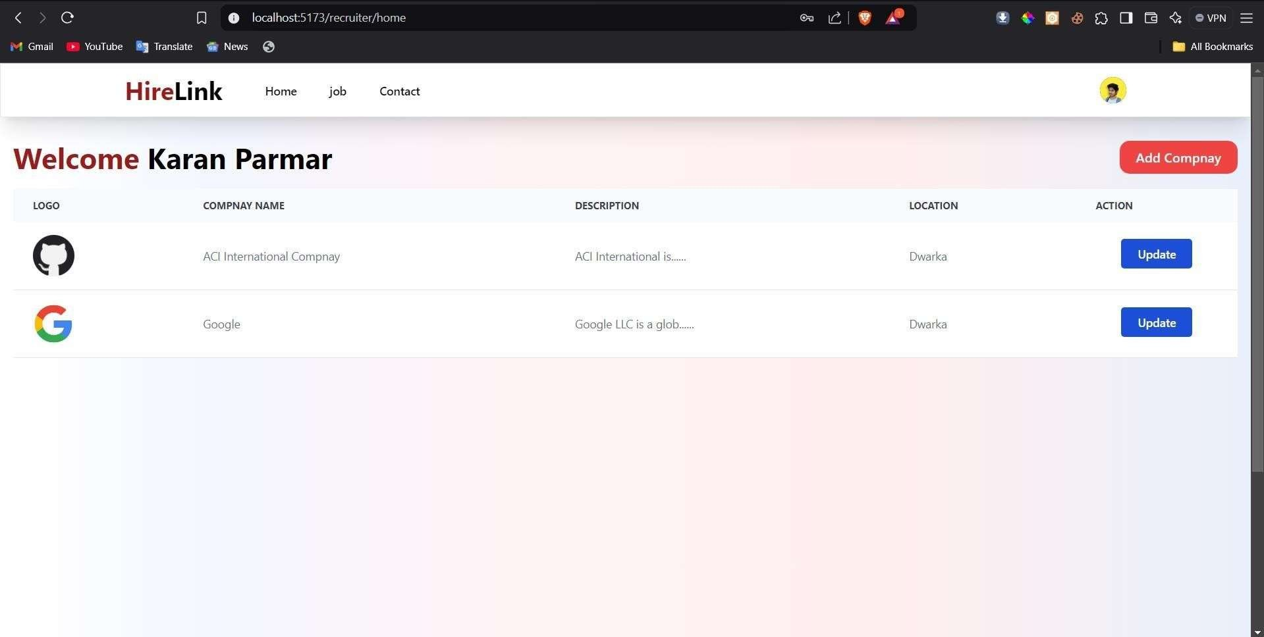

**company register**

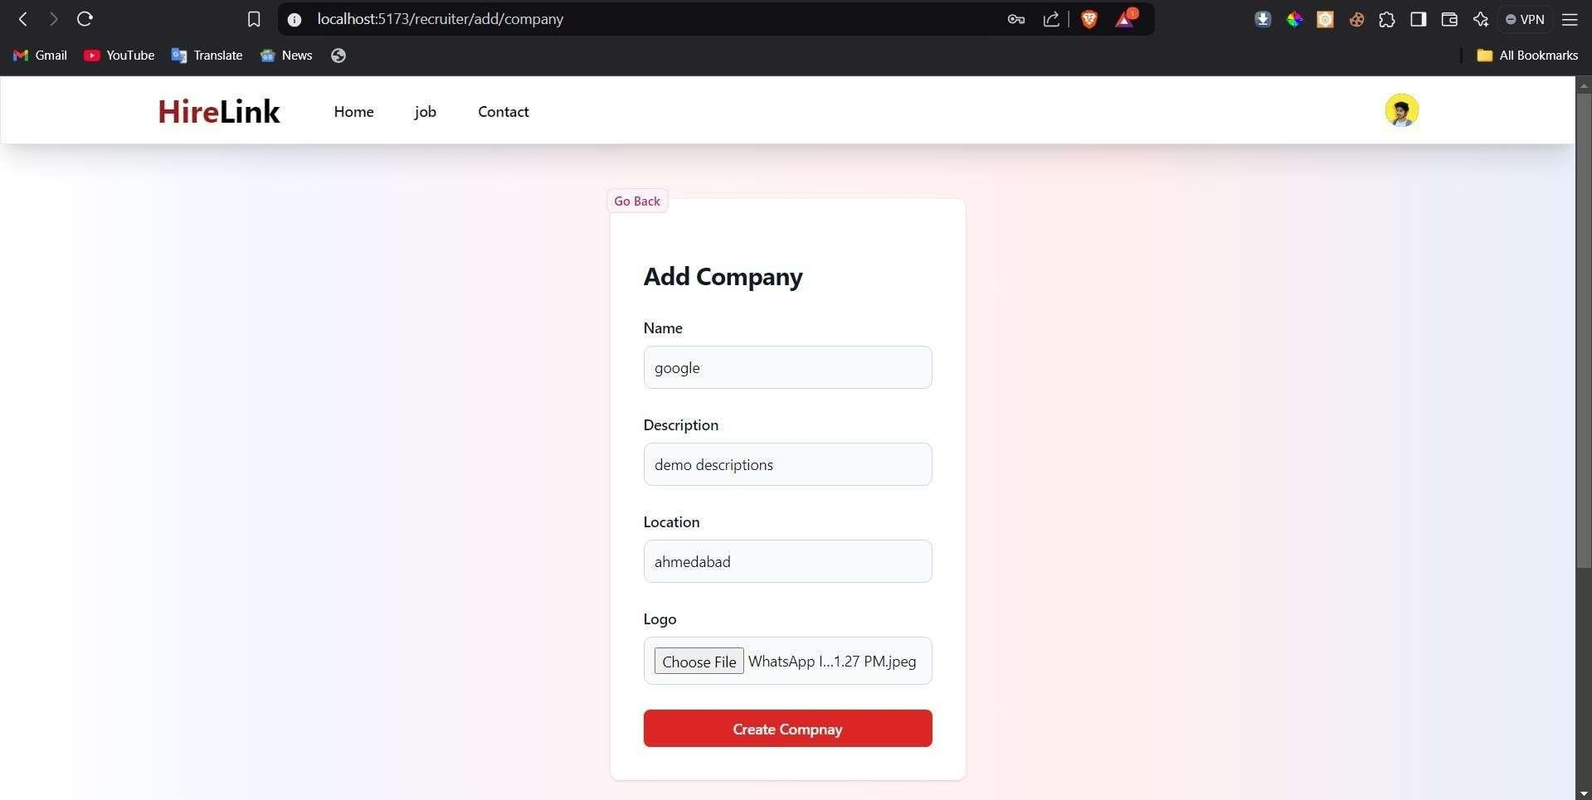

**company update**

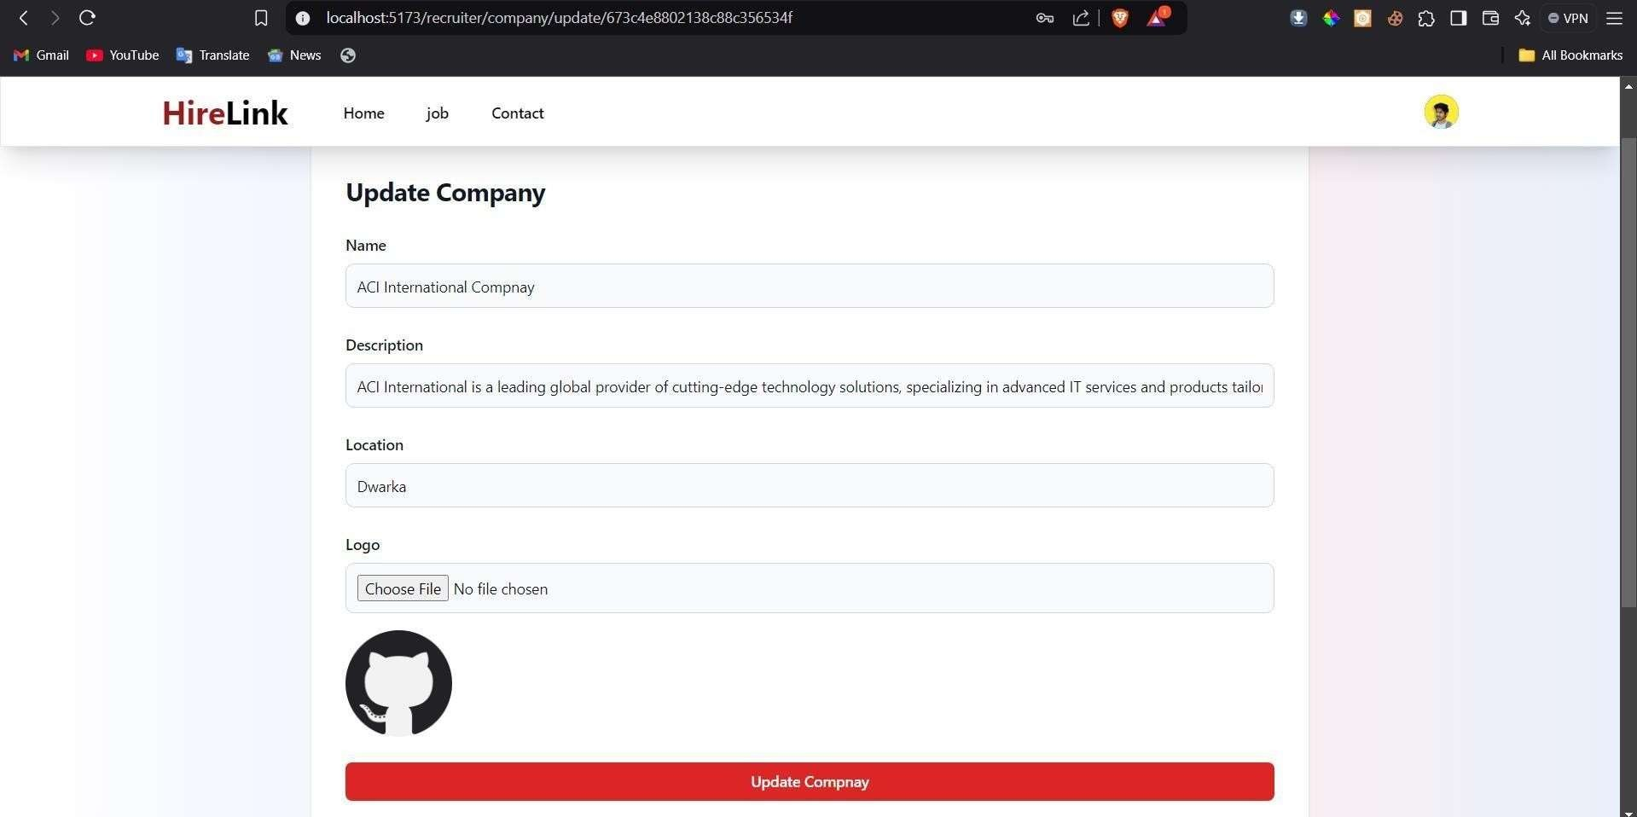

**job page**

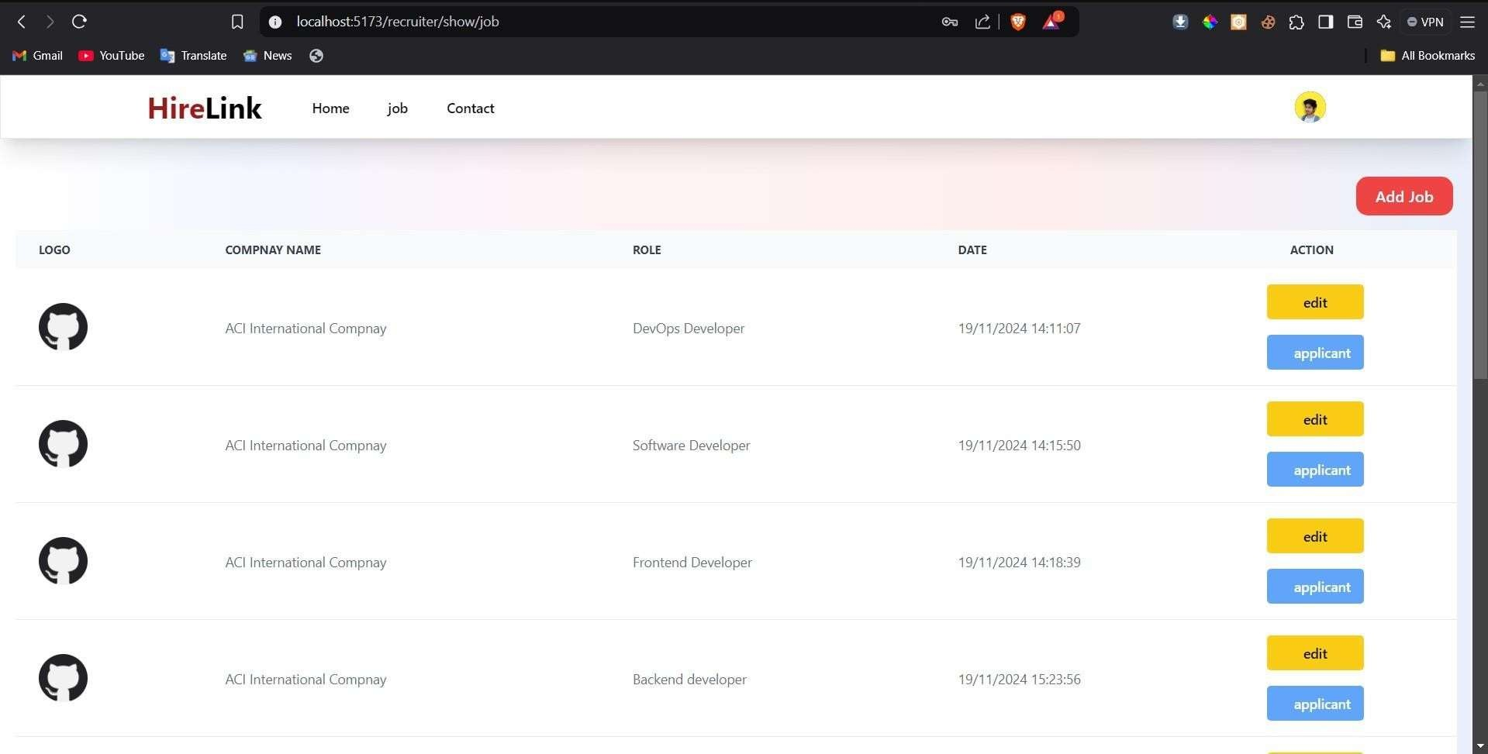

**add job**

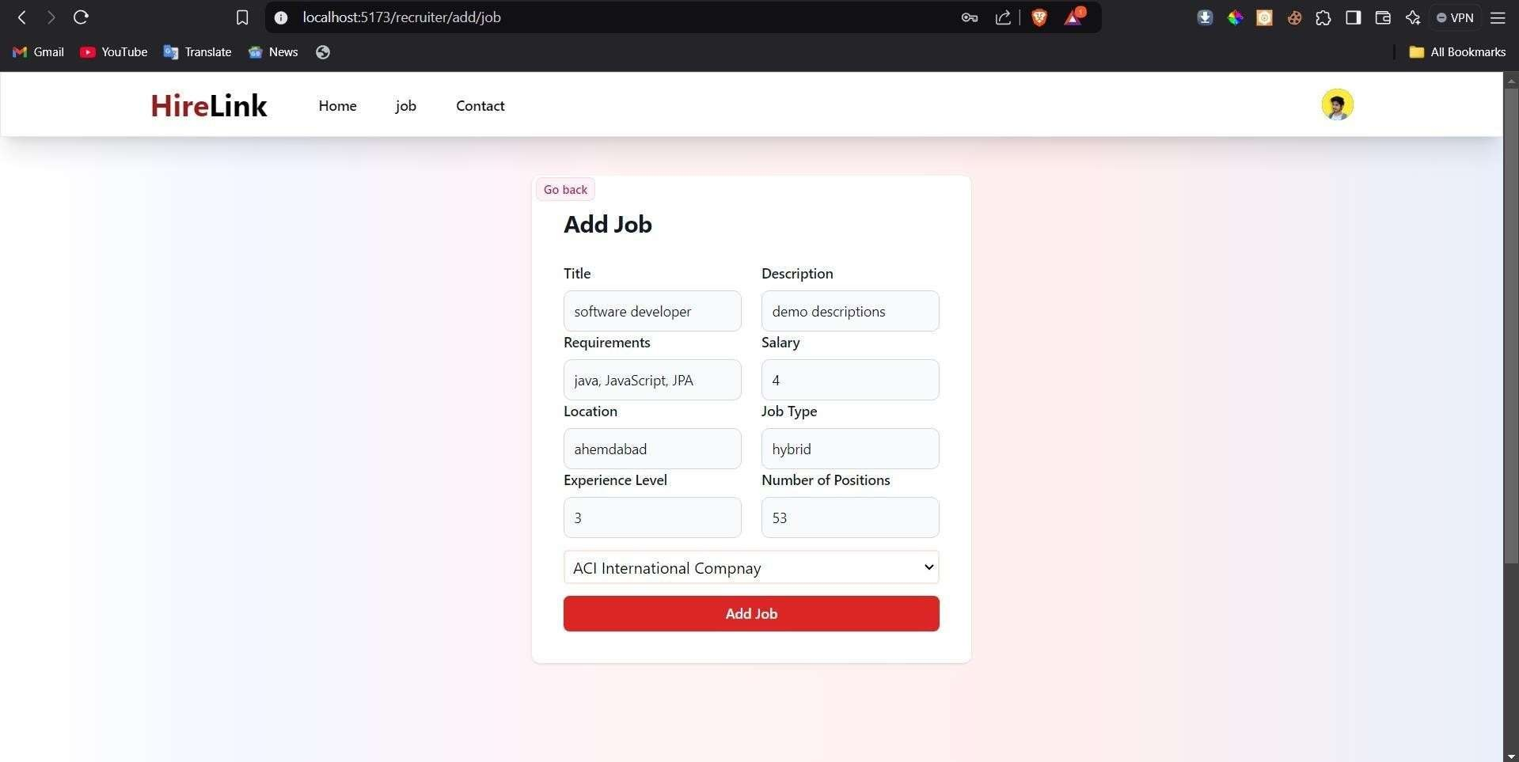

**update job**

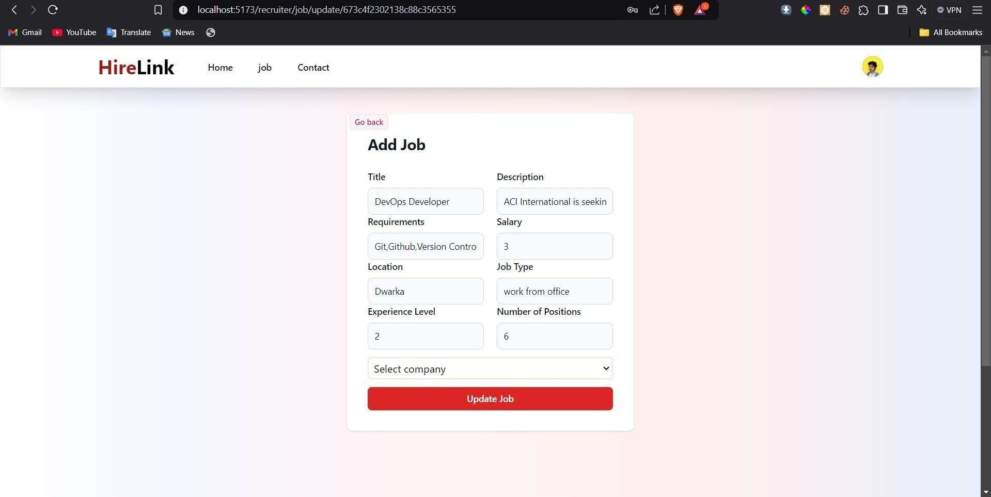

**job applicant page**

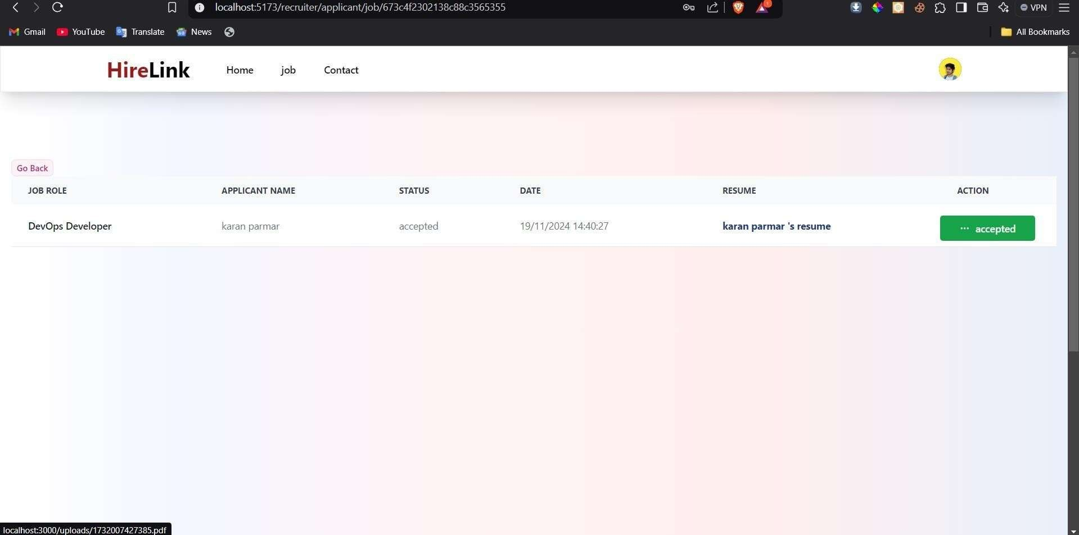

**job applicant response**

ss

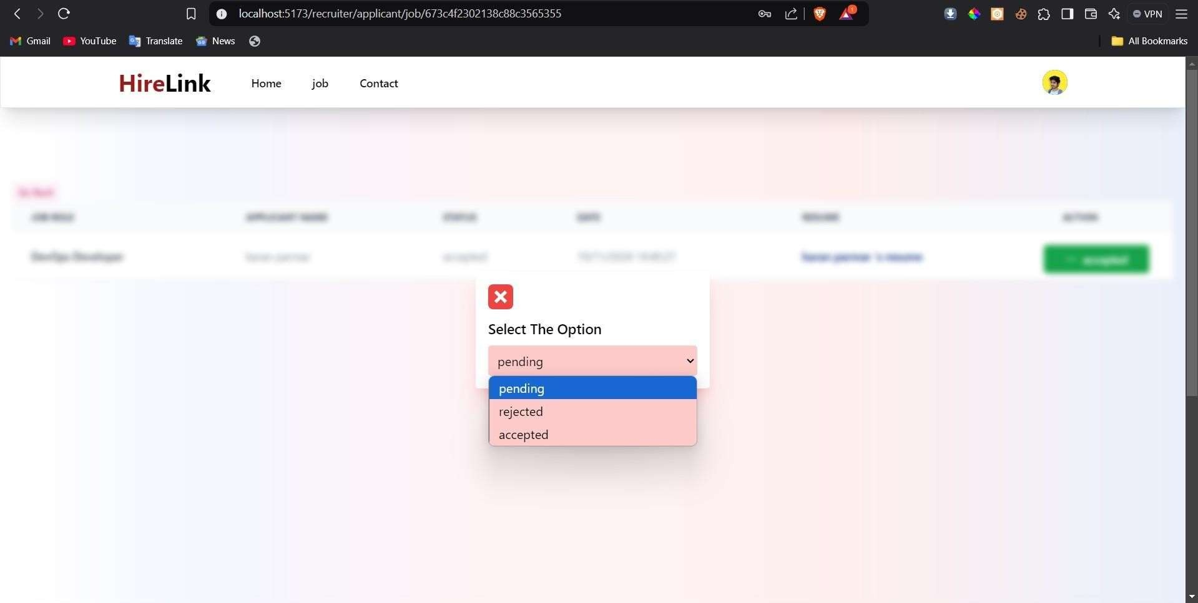

**Testing**

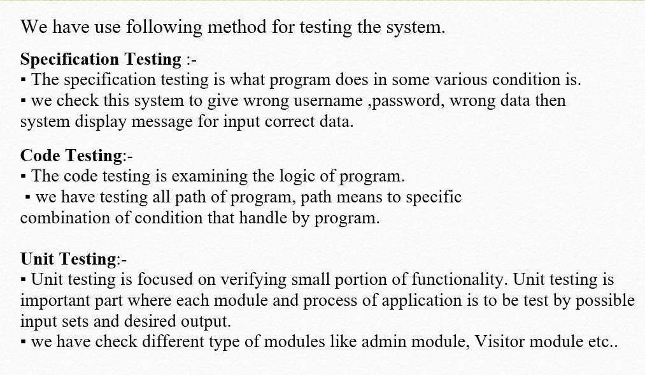

**Future Enhancement**

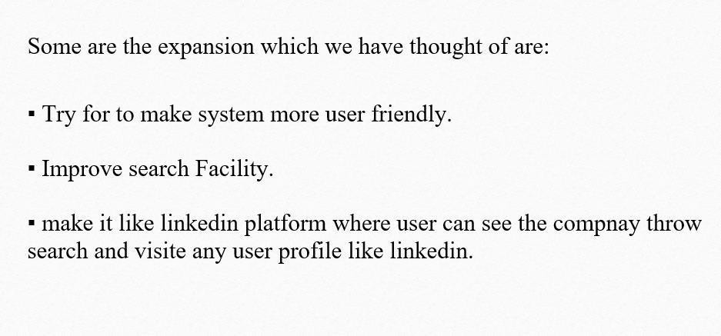

# Bibliography

* **Websites** [www.google.com](http://www.google.com/) [www.W3School.com](http://www.W3School.com/) [www.stakoverflow.com](http://www.stakoverflow.com/) geeksforgeeks

Pro MERN stack

MERN stack development express

