**Karan Agarwalla – 180050045**

**Problem 1**

**Problem 1.1**

=

Now,

Now we proved in class that is a valid kernel for . Also, if K1 and K2 are valid kernels then K1K2 and aK1+bK2 are valid kernels for a>=0, b>=0. As is a valid kernel, then by first of the results is a valid kernel. Then is valid kernel as it is a positive linear combination of valid kernels.

If is a valid kernel then is also a valid kernel. Let then where . Hence is a valid kernel.

In our case . Therefore is a valid kernel.

**Problem 1.2**

**(b)**

(ii)

The best value of as it has minimum number of mistakes.

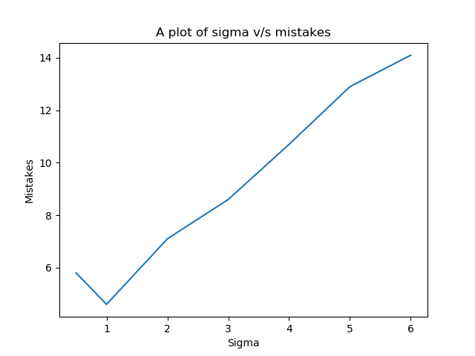

(iii) The number of mistakes decreases initially then increases further. At low values of (low spread) overfitting occurs causing more mistakes. As increases (high spread) underfitting occurs causing more mistakes.

**(c)** (ii)

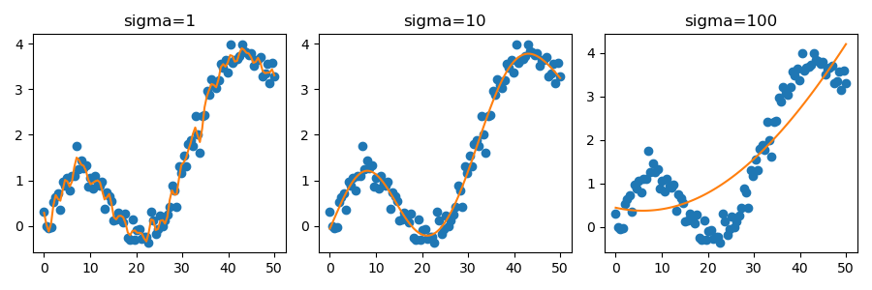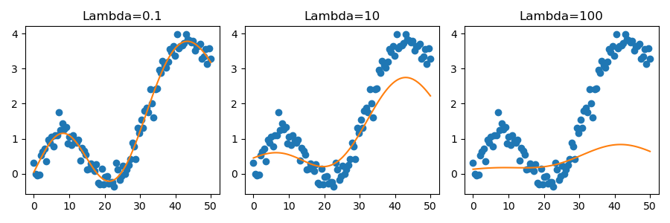

We observe overfitting at lower values of (low spread) and underfitting at higher value of (high spread). The spread is determined by of the distribution. One observes that at the curve tries to overfit the data and at it underfits the data.

Also, higher the value of higher is the regularisation term resulting in underfitting of data. Also, as value of increases, the curvature of the curve decreases (determined by ratio of maximum and minimum eigenvalues).

**Problem 2**

**Problem 2.1**

(i) Given:

To show:

Proof:

Since

Consider

Hence is a positive definite kernel.

(ii) Given:

To show:

Proof:

If K1 and K2 are valid kernels then is a valid kernel for . Let and . Then where .

If K1 and K2 are valid kernels then is a valid kernel for . Let and . Then where is vector of size where . Then where division is integer division.

Define .

is a valid kernel as it is multiplication of valid kernels and hence, by second property it is a valid kernel.

Then is positive linear combination of valid kernels, hence is a valid kernel.

**Problem 2.2**

is a polynomial kernel with d = 4.

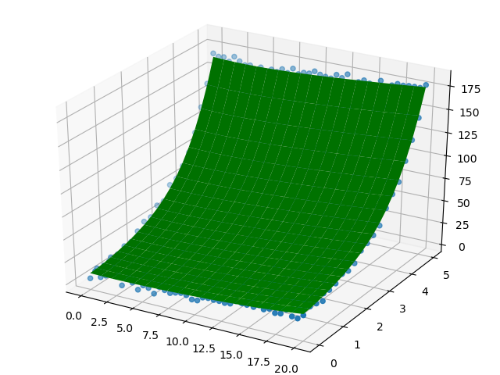

Error of the fit: 6935.36888

**Problem 3**

**Problem 3.1**

Given:

To show:

Proof: Let us show that one of the required hyperplanes is the perpendicular bisector plane between the two cluster centers and . Now consider

Then by definition of clustering, if then it lies in cluster 1 else it lies in cluster 2. Also is the perpendicular bisector plane.

By property of planes, we know if and only if two points lie on the same side of plane,

Now for all points in cluster 1, all points in cluster 1 lie on same side of plane defined by . A similar argument holds for cluster 2. Now for two points in cluster 1 and cluster 2, say they lie on opposite sides of the plane. Hence the plane defined by is one such plane where and .

**Problem 3.2**

(ii)

|  |  |  |
| --- | --- | --- |
|  |  |  |
|  |  |  |
|  |  |  |

With increase in number of cluster centers, we observe increase in detail in the image. This can be seen from the fact that with increase in number of cluster centers, the more related pixels can be assigned to a cluster, resulting in better detail.

(iii) The pixels are assigned the color of their respective centroid. So with increase in number of cluster centroids, number of colors in the final image increases resulting in more detail.

Therefore the number of clusters needed to adequately represent the image would depend on the number of distinct colors that are available and the spread with respect to them. Also if colors that are similar with respect to their values but are distinct in what we see in the image are nearby in the image, there is a good chance that they are assigned the same cluster which might not be desirable.

In the third image, k = 2 does a good job of clustering the image which might be useful for various tasks. There are less number of widely distinct colors in the image resulting in better depiction. Take for example, first image. It has plenty of colors and also a lot of similar colors closeby. Thus more number of clusters is needed to represent such an image. The second image has a blue gradient which would not be captured by lower values of k as such hues would be represented by a single blue hue(can be noticed when k = 2).