**Azure Load Balancer**

**Load Balancing:**

* Load balancing refers to efficiently distributing incoming network traffic across a group of backend virtual machines (VMs) or virtual machine scale sets (VMSS).
* Azure Load Balancer is a cloud service that distributes incoming network traffic across backend virtual machines (VMs) or virtual machine scale sets (VMSS).
* Azure Load Balancer operates at layer 4 of the Open Systems Interconnection (OSI) model.

**Public (External) Load Balancer:**

* A public load balancer distributes traffic from the internet to your virtual machines.
* Public Load Balancers have a Public IP address, allowing external access.
* They are ideal for web servers, APIs, and applications accessible to the public.
* Example: If you have a website hosted on multiple virtual machines, a public load balancer can distribute traffic across them.

**Private (Internal) Load Balancer:**

* Private load balancers handle traffic within the virtual network itself.
* Private load balancers, uses a private IP address within the virtual network.
* They are ideal for Internal services, backend applications.
* Example:  Distributes traffic to backend services like databases or internal APIs.

**Configuring External Load Balancer:**

**STEP-1:**

* Create a new Resource group LB-Demo-RG.
* Then go to virtual networks console and create a virtual network (LB-VNet) in the resource group of IP address space 10.0.0.0/16 and create a subnet (Subnet-1) of IP address space 10.0.1.0/24.
* We will create two virtual machines named as VM-external-01 and VM-external-02 in the Subnet-1 and allow SSH port access and HTTP access to the VM from the internet (all Public IPs).
* To add security rule to the VMs go to NSG console and select the NSG of the VM and click on Create a new rule and then add an inbound rule.

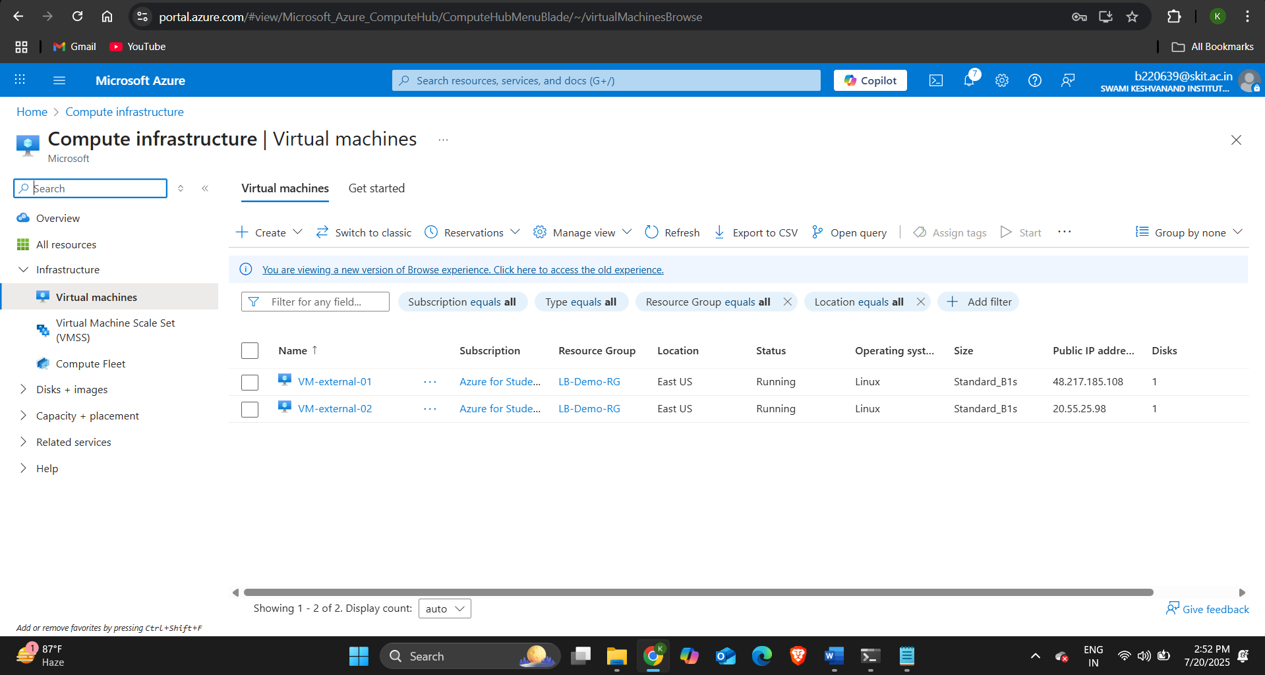

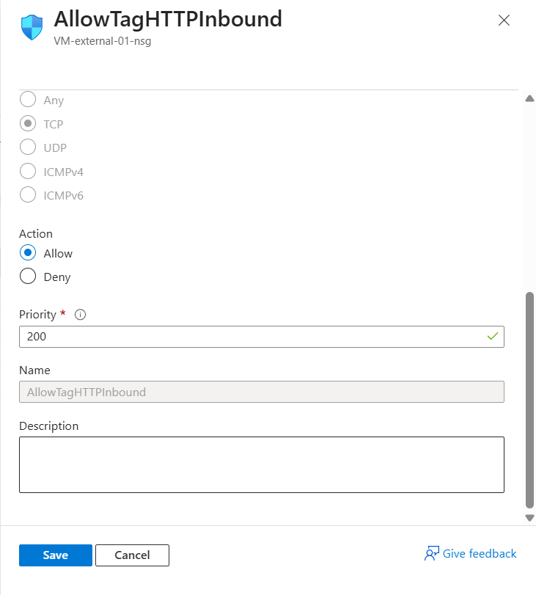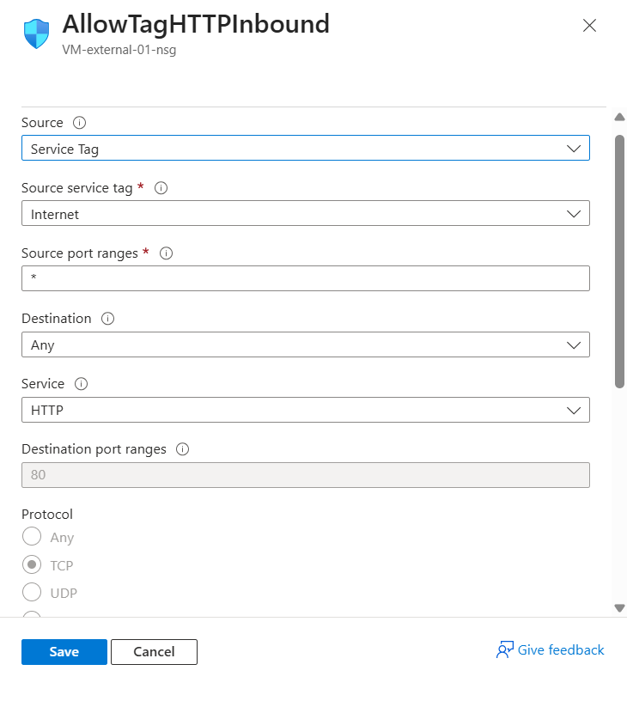

**STEP-2:**

* Since external load balancer have a Public IP address so we will create a public IP address for it.
* Go to Public IP addresses console then click on create and assign the same resource group as VMs.
* 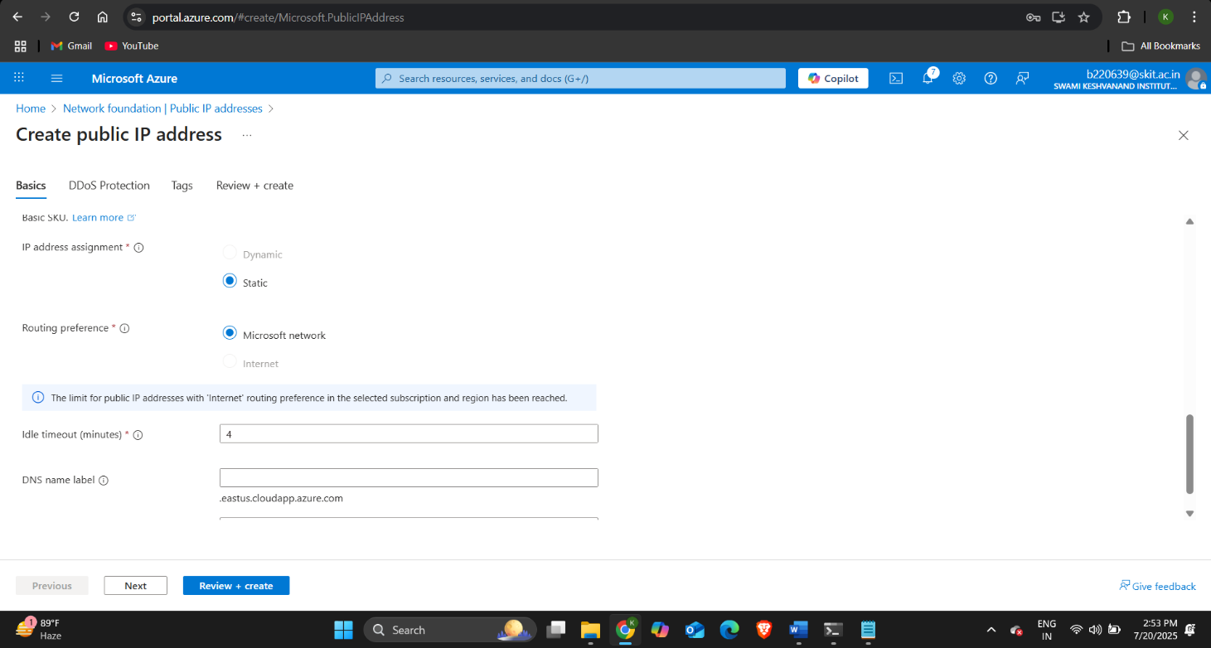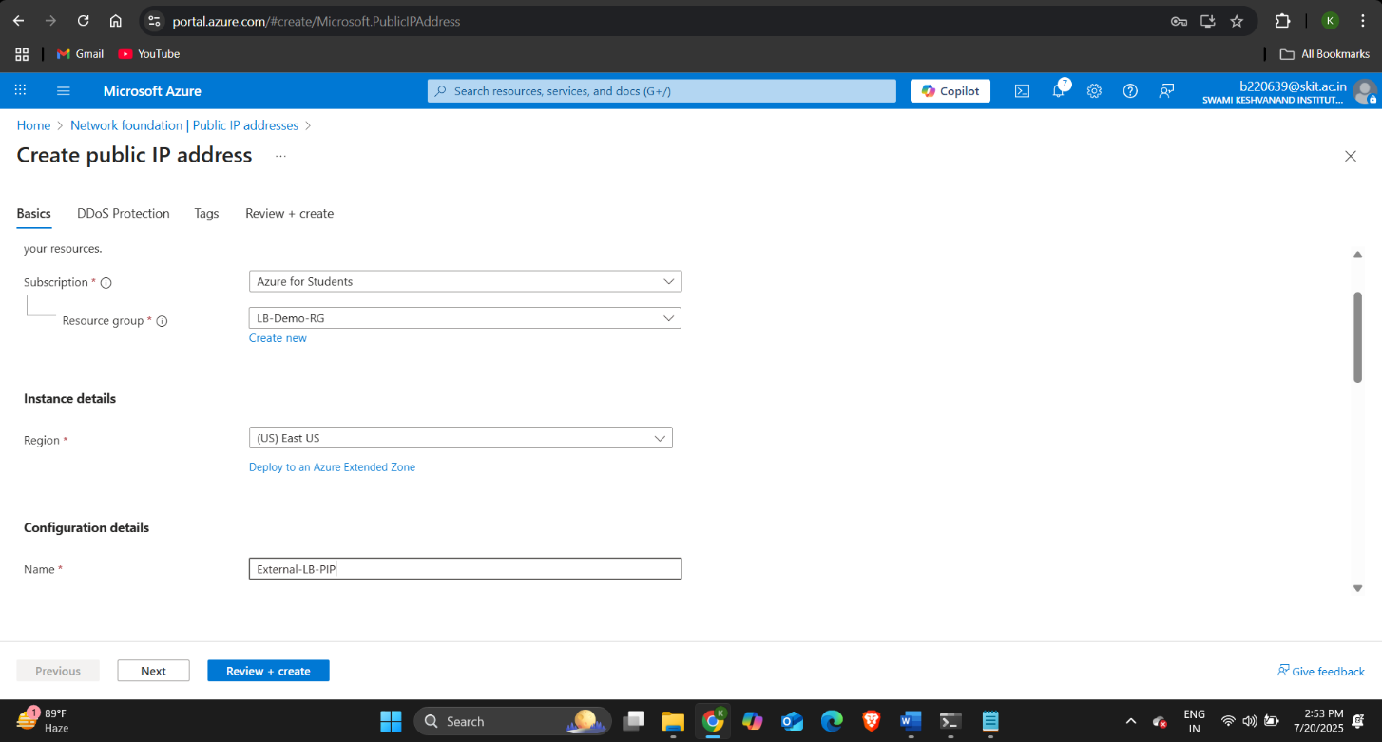Specify the name as External-LB-PIP and IP address assignment as Static and then click on Review + create and then create.

**STEP-3:** Configure Web servers in the VMs.

* SSH into the two VMs and install apache2 web server in each VM using the commands:

sudo apt-get update

sudo apt-get install

sudo apt install apache2 -y

cd /var/www/html/

echo “This is external VM-01”> /var/www/html/index.html

**STEP-4: Create external load balancer.**

* In the azure portal go to load balancer console and click on create and then select standard load balancer and then do the below configurations:

Resource Group: LB-Demo-RG

Name: External-LB

Region: East US

SKU: Standard

Type: **Public**

Public IP address: Select External-LB-PIP

* Then click on review + create and then click on create.

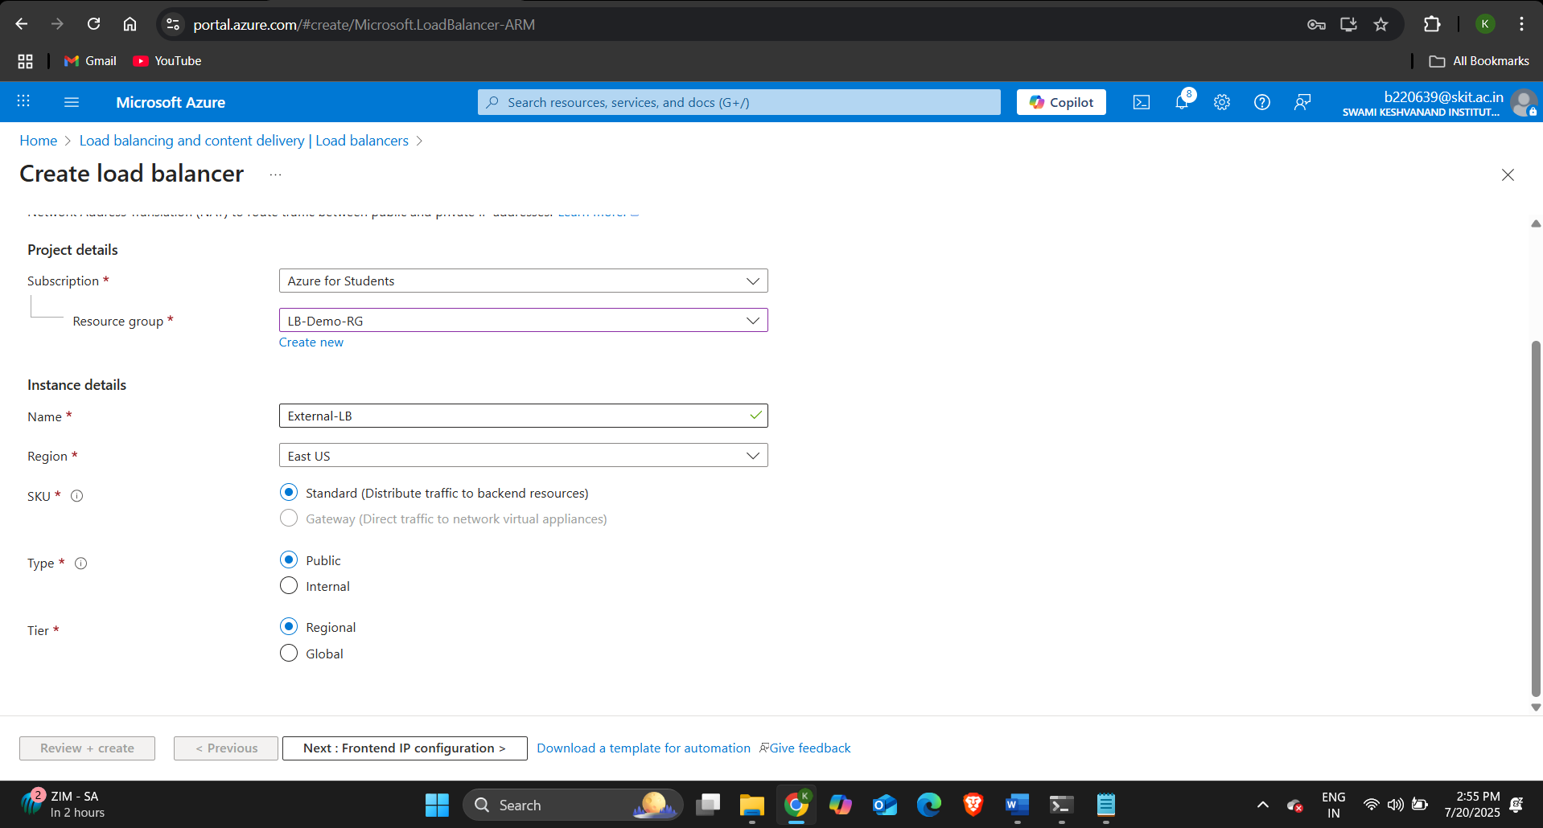

**STEP-5:** Configure Frontend-IP configuration and backend pool.

* Specify the name as External-LB-PIP and in the Public IP address field select the Public IP address External-LB-PIP and click on save and then go to backend pools.
* Do the below configurations:

Name: External-LB-BackendPool

Virtual Network: LB-VNet

Backend Pool Configuration: NIC

* Then click on add and select both the VMs VM-external-01 and VM-external-02 and then click on add.

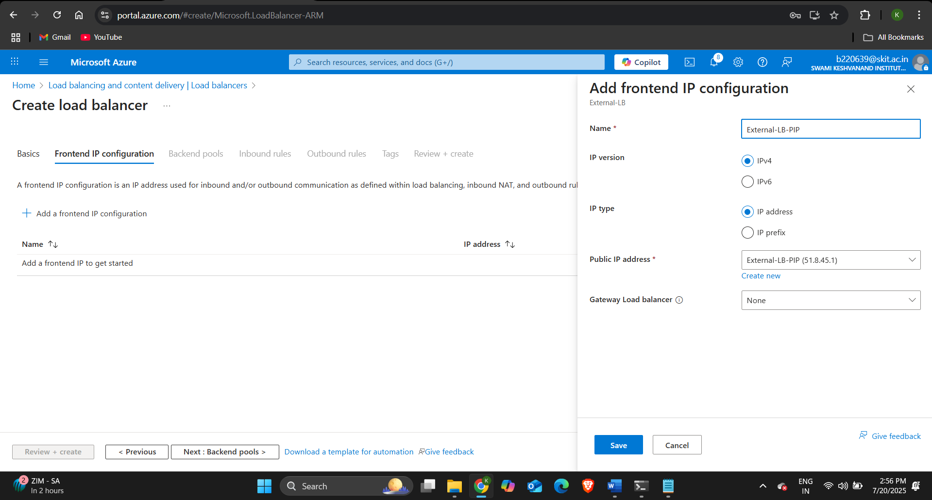

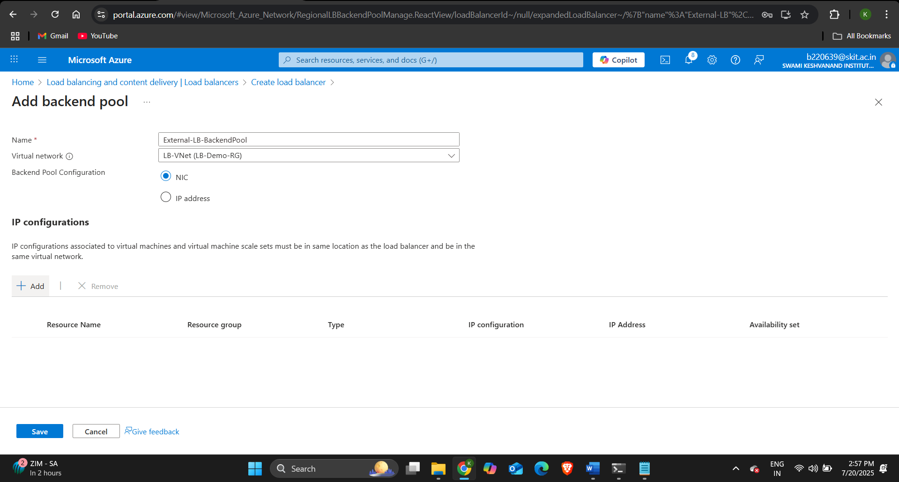

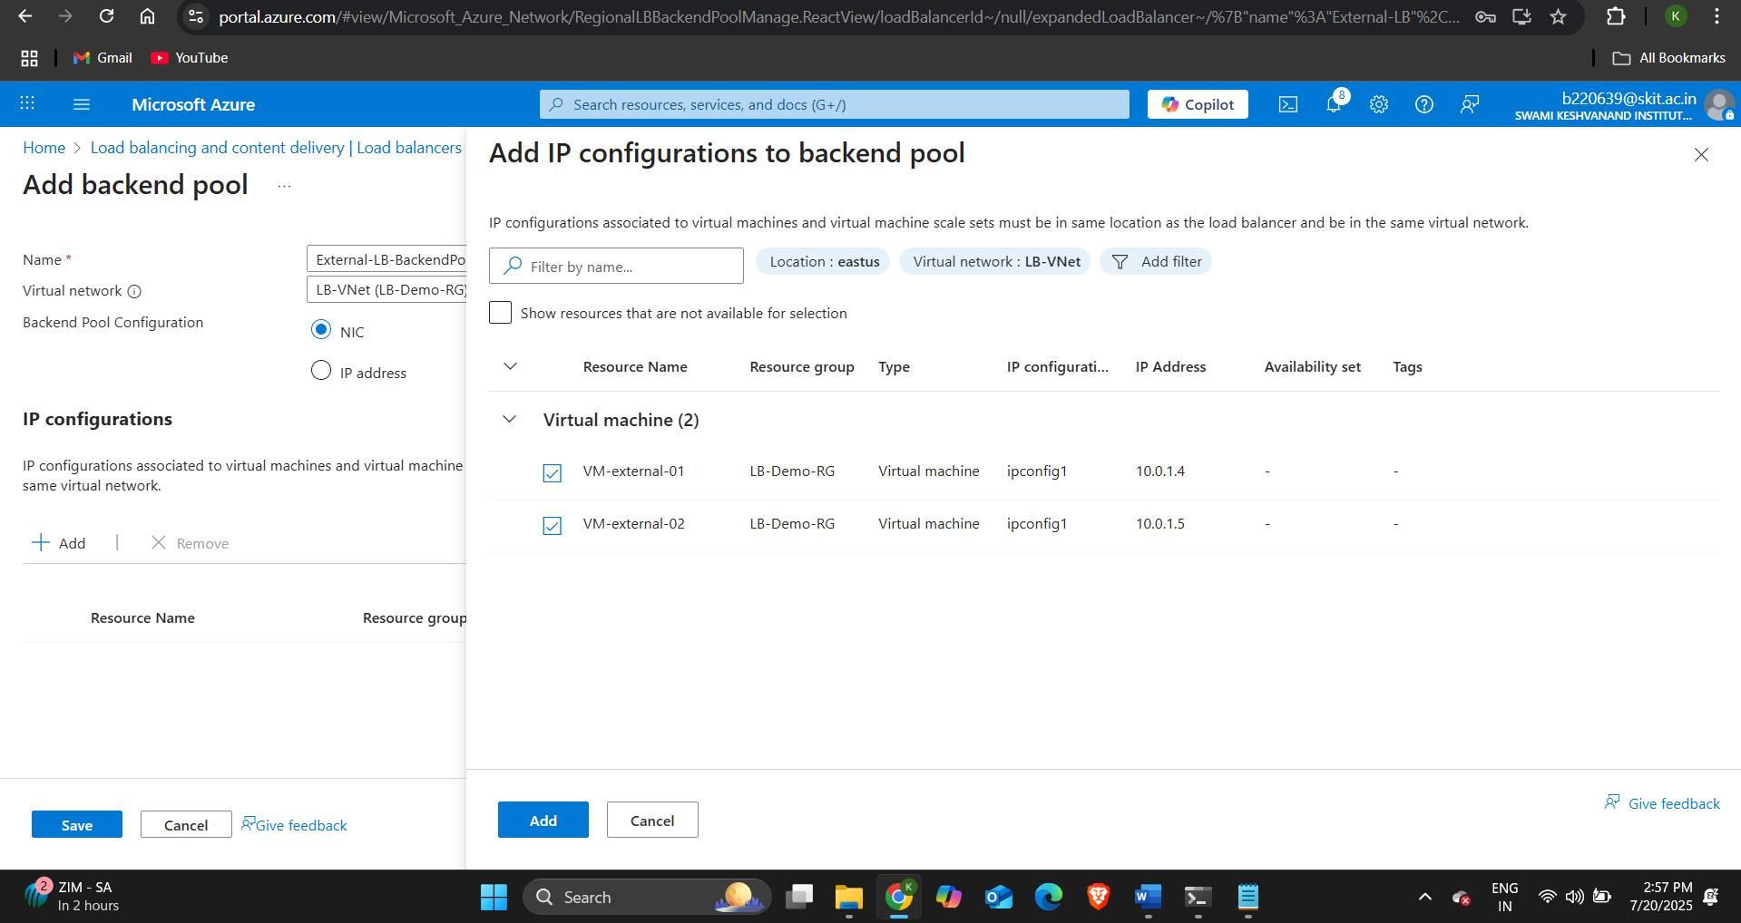

* Then go to inbound rules and under load balancing rule click on Add a load balancing rule.
* We will allow HTTP traffic on the load balancer so do the below configuration:
* Name: http-rule
* Frontend IP: Select External-LB-PIP
* Protocol: TCP
* Port: 80
* Backend Port: 80
* Backend Pool: External-BackendPool
* Session Persistence: None (Round Robin)
* Idle timeout: Default and then click on Save.
* In the Health probe section click on Create New.
* Specify the name as http-probe.
* Protocol: TCP
* Port: 80
* Interval: 5 seconds
* Unhealthy Threshold: 2
* 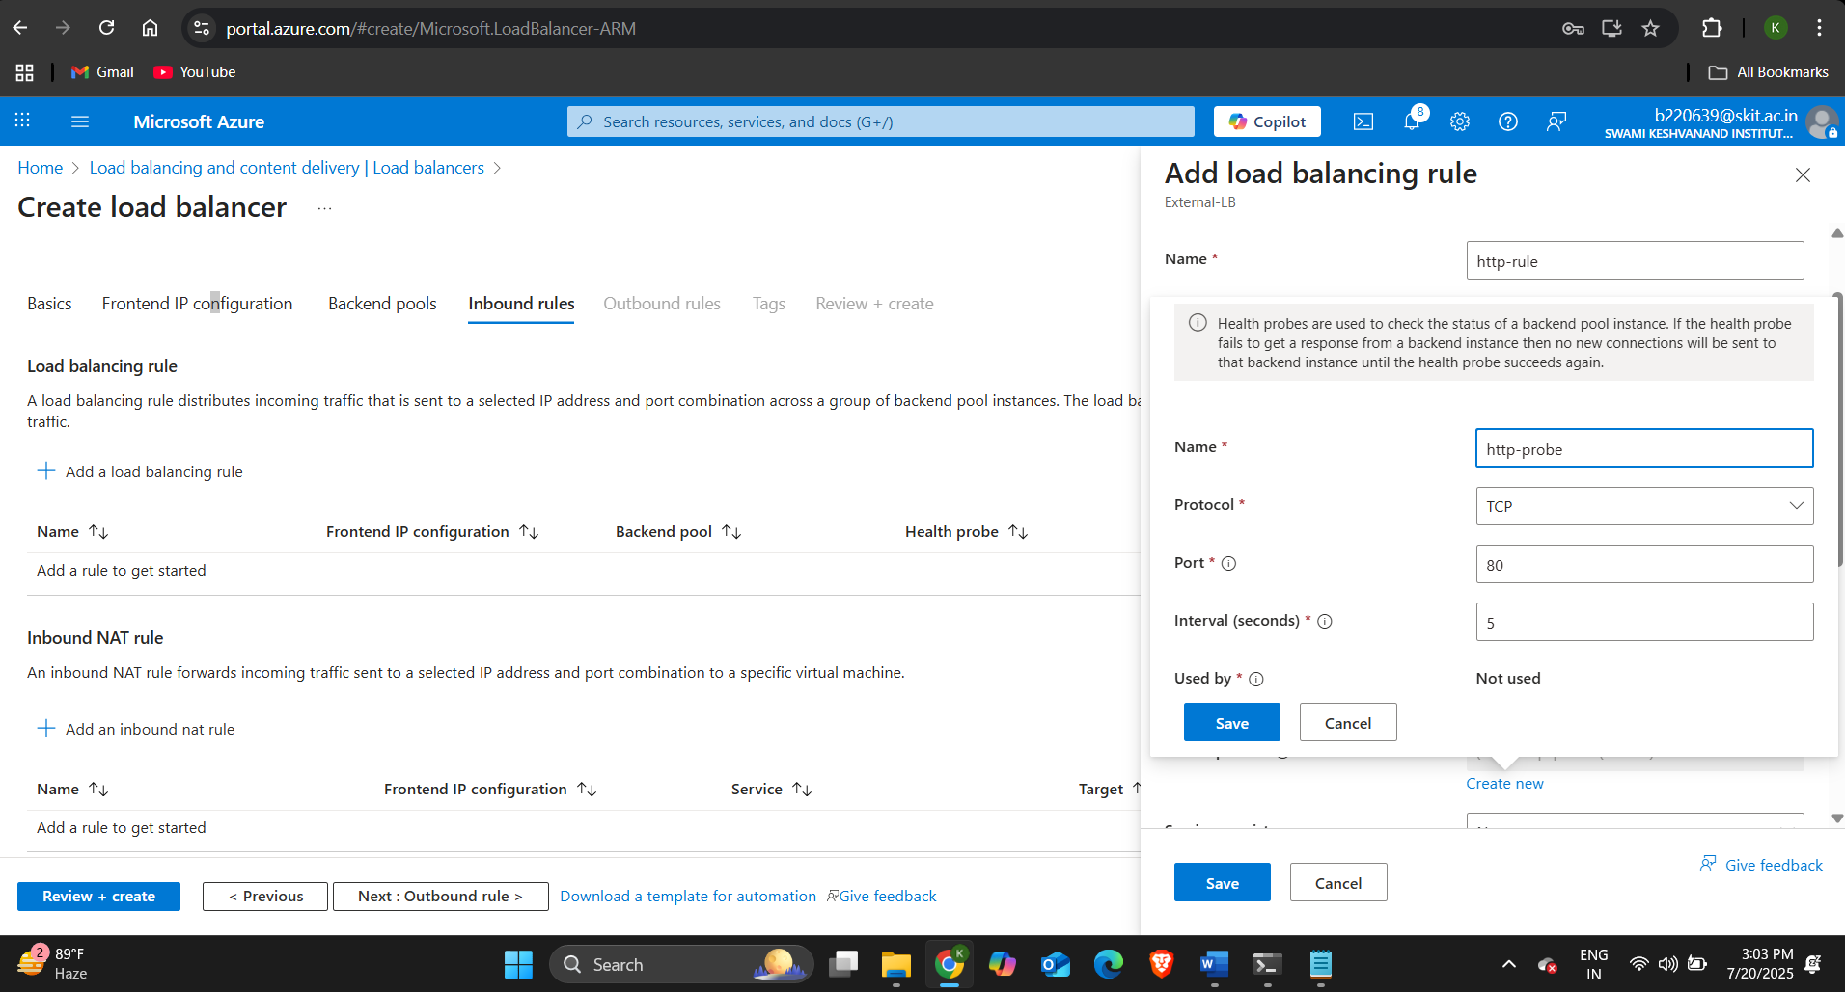The load balancer continuously sends request to the VMs attached to the load balancer on the Port 80 and the VMs sends back response and if the VM doesn’t respond within 2 seconds more than 2 times then the load balancer considers it as Unhealthy and doesn’t send the network traffic to the VM.

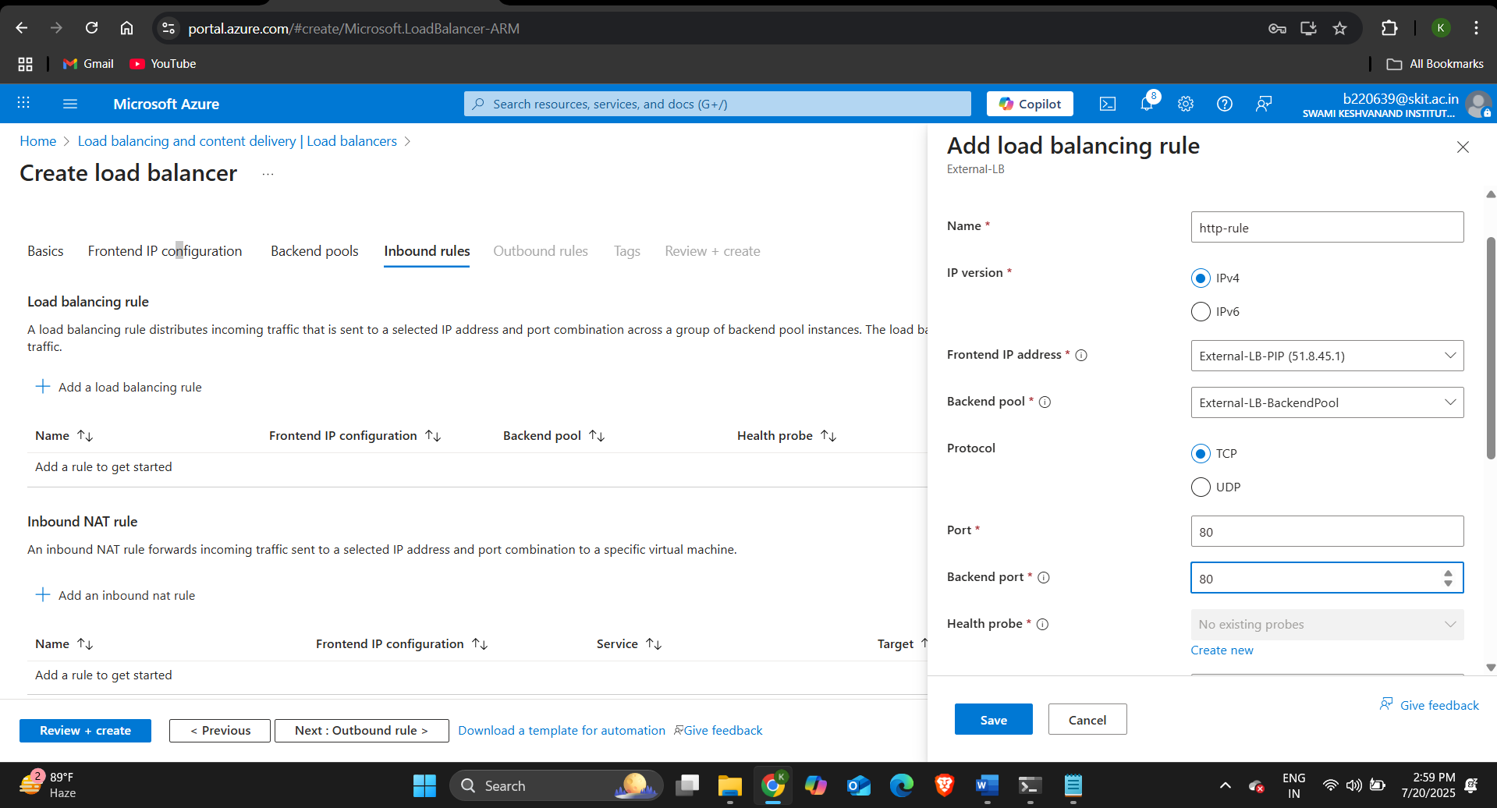

**STEP-6:** Verify External Load Balancer:

* Copy the Public IP address of the external load balancer and open it on the browser.





* **We can see that the external load balancer is distributing the network traffic to both the VMs.**

**Configuring Internal Load Balancer:**

STEP-1:

* Create three virtual machines- test-VM, VM-internal-01, and VM-internal-02 in subnet-1 of Virtual network LB-VNet and allow port 22 (SSH) for these VMs. And install apache2 web server in these VMs.

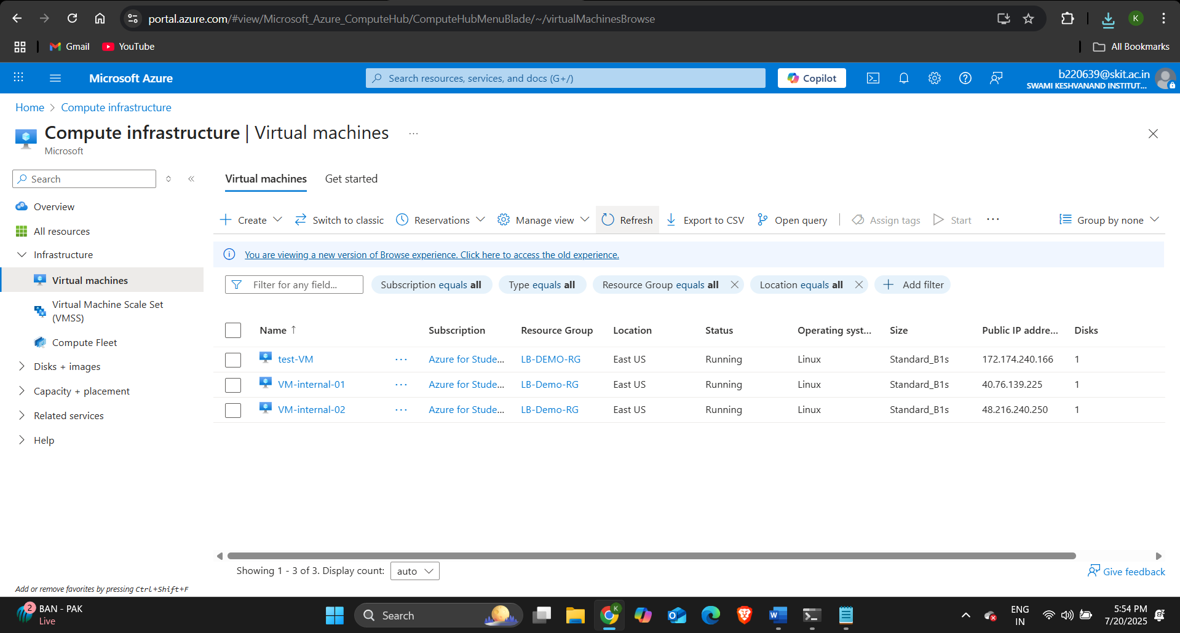

**STEP-2:** Create Internal Load Balancer:

* Go to load balancers console and click on create and select Standard Load Balancer.
* Do the below configurations:
* Resource Group: LB-Demo-RG
* Name: Internal-LB
* Region: East US
* SKU: Standard
* Type: **Internal**
* Virtual Network: LB-VNet
* Subnet: Subnet-1
* Private IP address: Static → e.g. 10.0.1.10
* Then click on review + create and then on create.

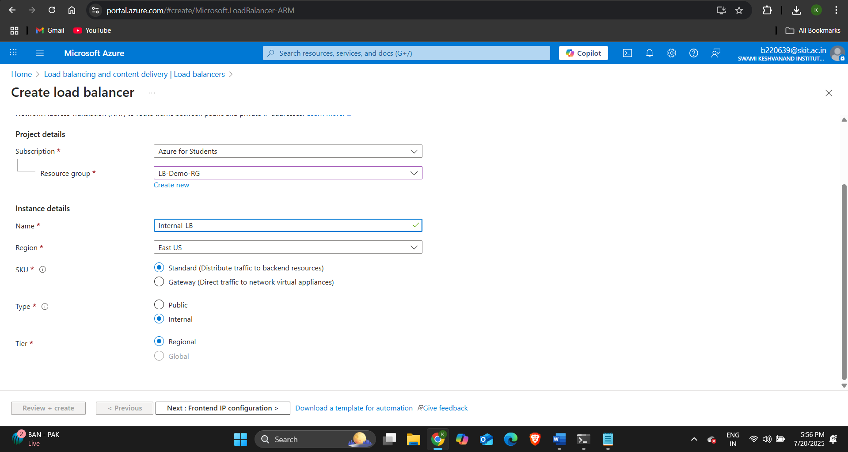

STEP-3: Configure Frontend-IP configuration and backend pool.

* Specify the name as Internal and select the subnet as Subnet-1 in the IP address field enter 10.0.1.10 and click on save and then go to backend pools.
* Do the below configurations:

Name: Internal-LB-BackendPool

Virtual Network: LB-VNet

Backend Pool Configuration: NIC

* Then click on add and select both the VMs VM-internal-01 and VM-internal-02 and then click on add.

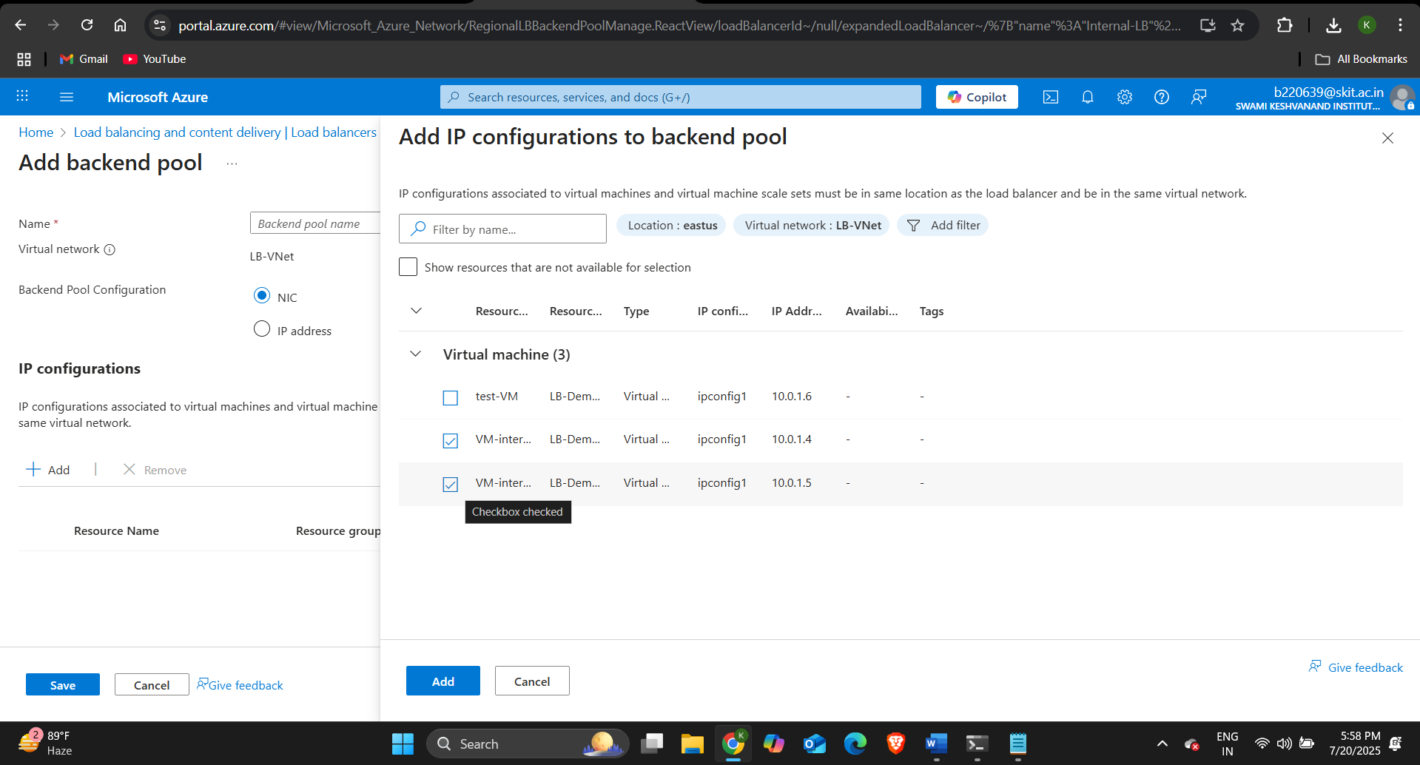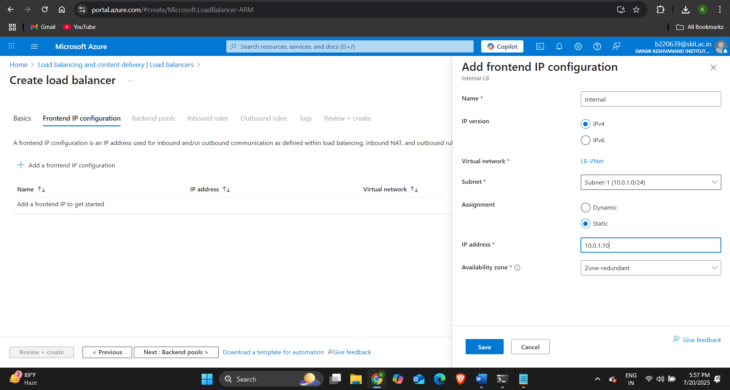

* Then go to inbound rules and under load balancing rule click on Add a load balancing rule.
* We will allow HTTP traffic on the load balancer so do the below configuration:
* Name: internal-http-rule
* Frontend IP: Internal (Private IP)
* Backend Pool: Internal-BackendPool
* Protocol: TCP
* Port: 80
* Backend Port: 80
* Session Persistence: None
* In the health probe section click on Create New and configure it as:
* Specify the name as internal-http-probe.
* Protocol: TCP
* Port: 80
* Interval: 5 seconds
* Unhealthy Threshold: 2

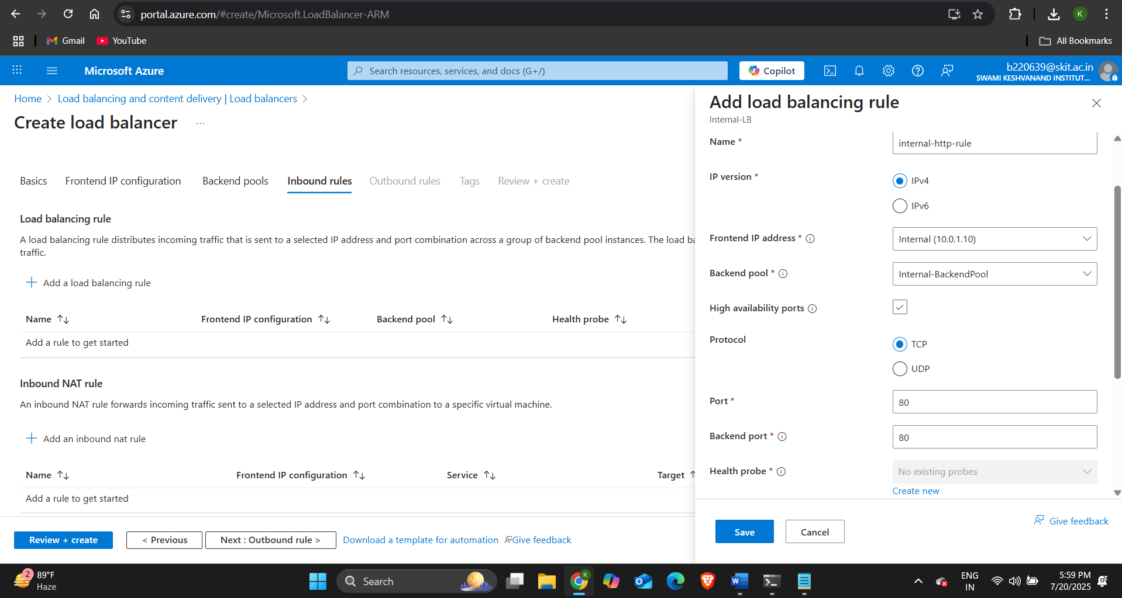

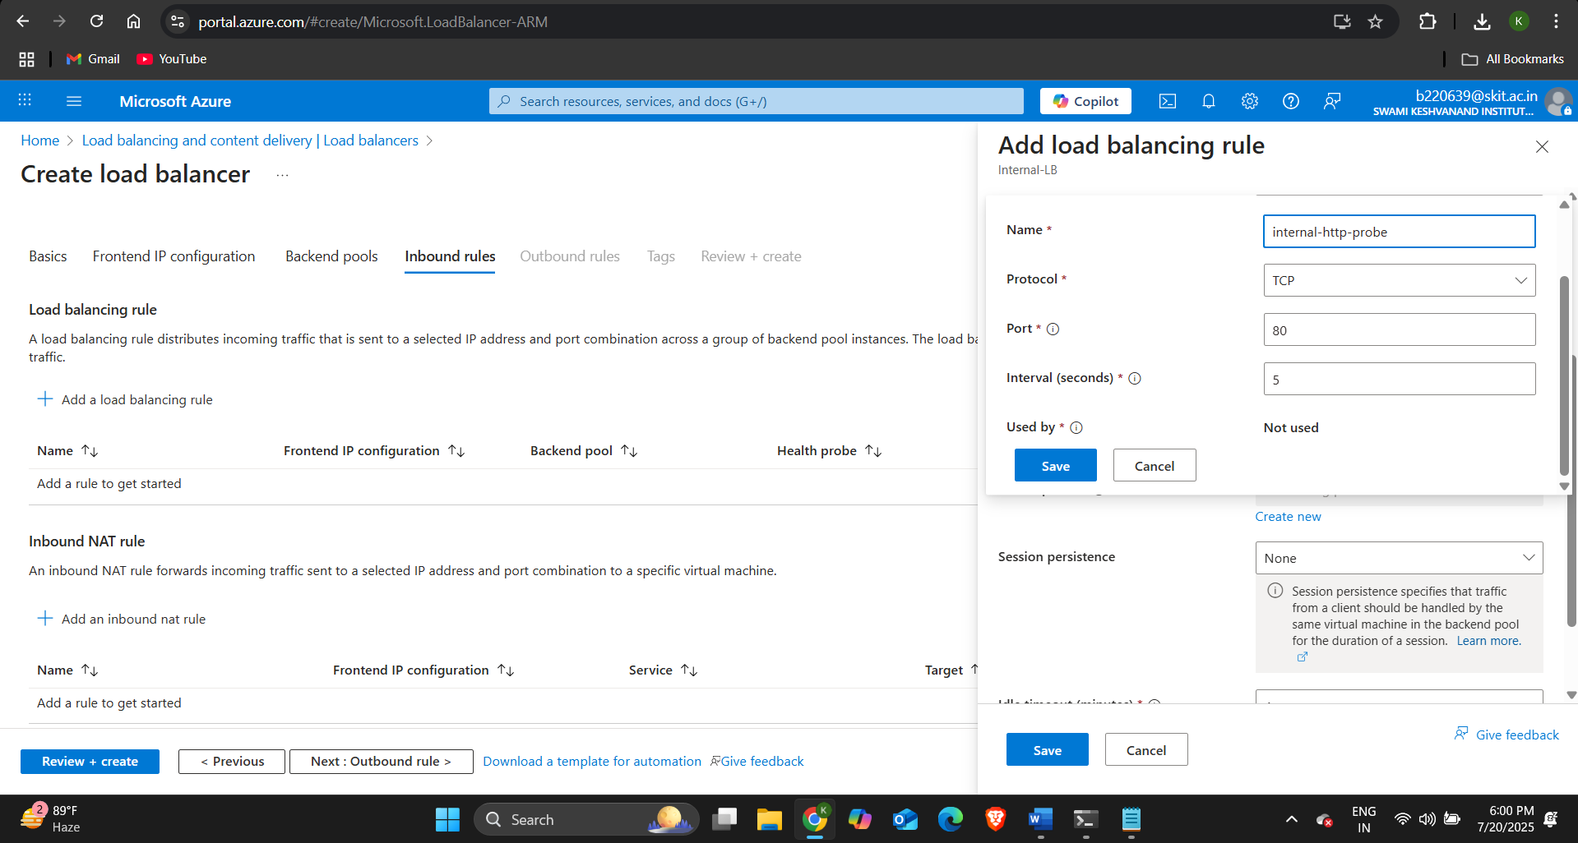

* Then click on review + create and then on create.

**STEP-4:** Configuring security rules for the VMs.

* For health probe check we will allow HTTP traffic from Internal Load Balancer to the VMs.
* We will allow the virtual network traffic to access the VMs through HTTP.
* Go to the Virtual machines and select the VM-internal-01 and under Networking section go to Network Settings and configure it as given below.
* We will configure the same rules for the Vm-internal-02 VM as well.

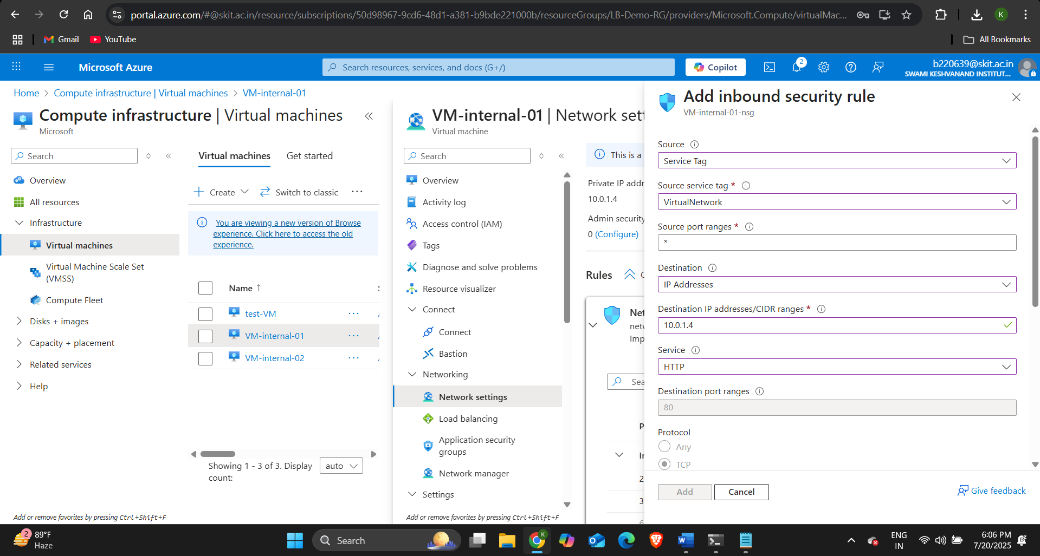

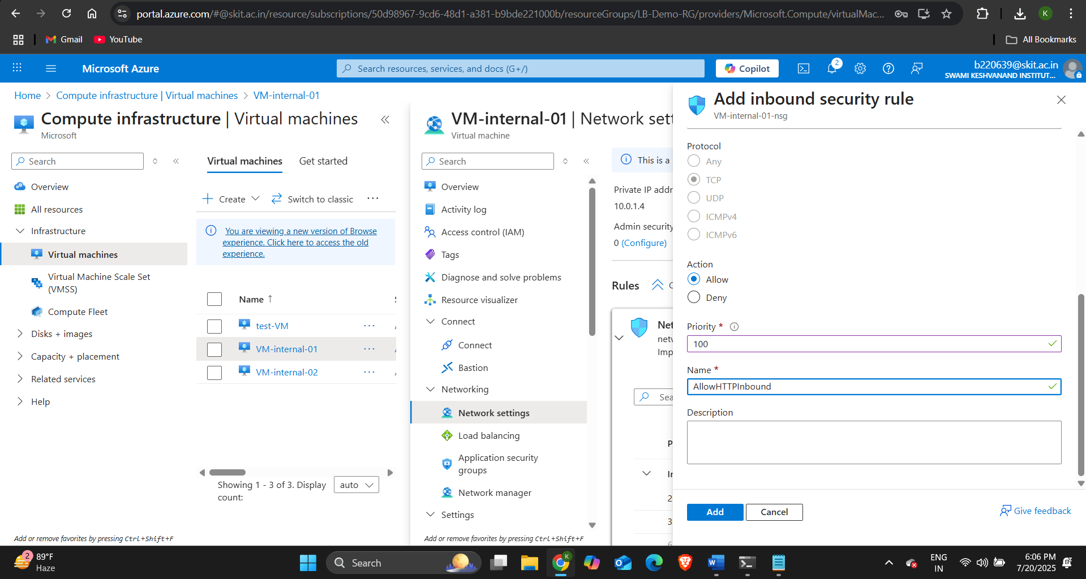

STEP-5: Verify Internal Load Balancer:

* Connect to the test-VM by SSH.
* And using the command: curl http://10.0.1.10 (Private IP of Internal Load Balancer)
* 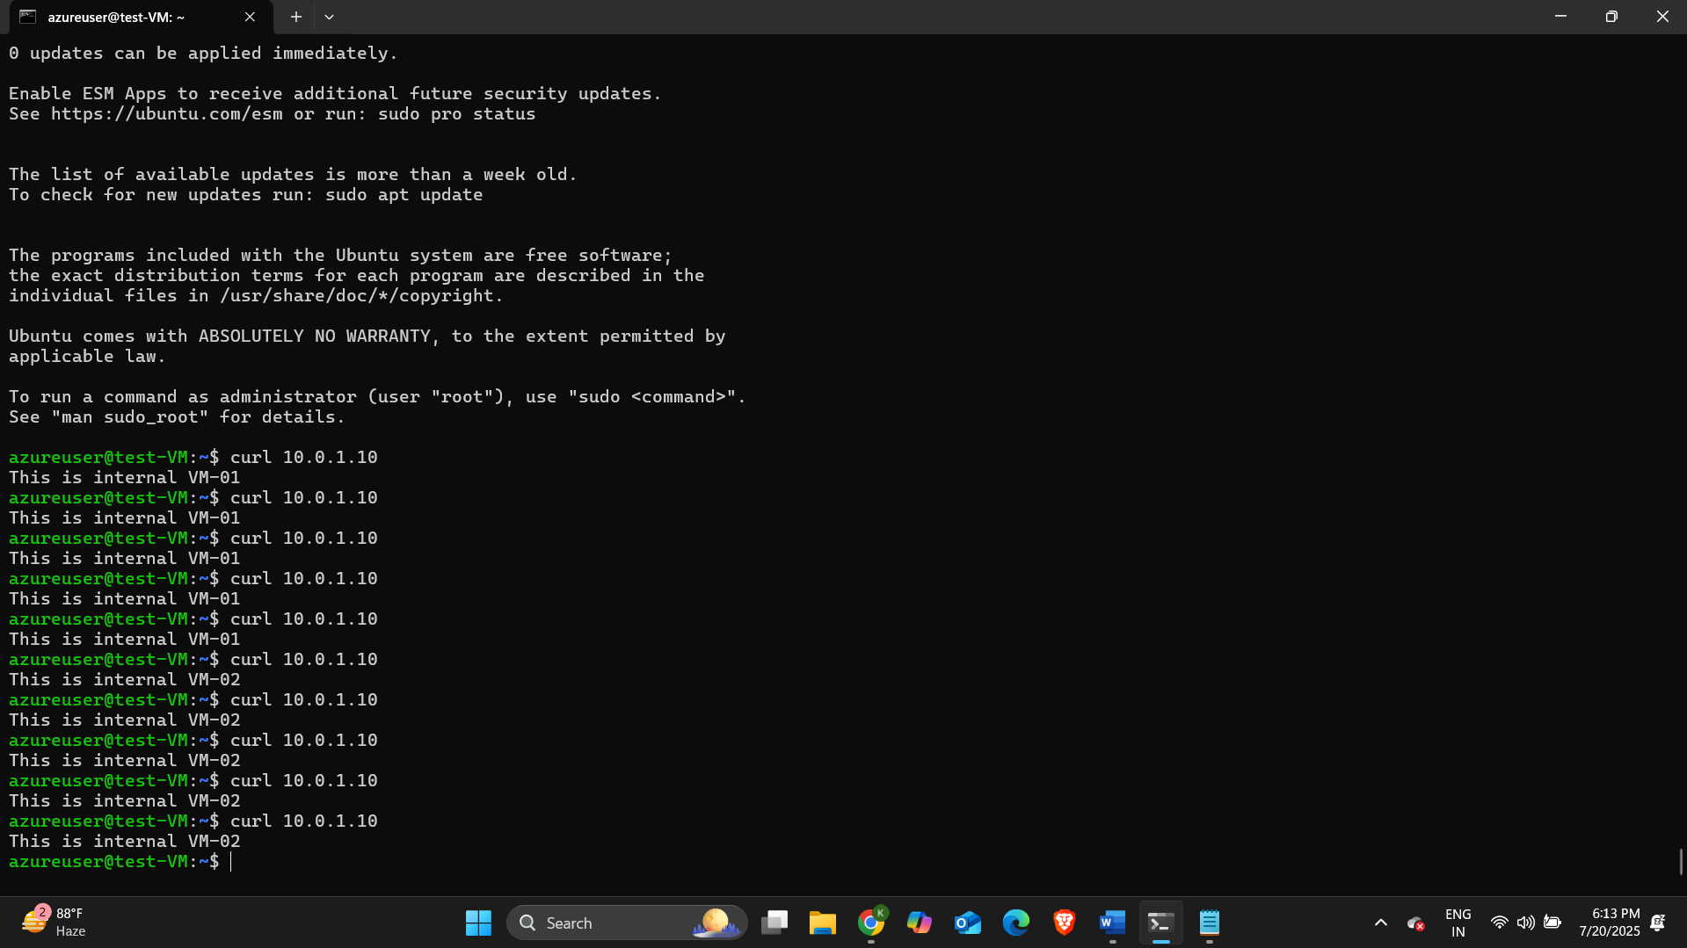You will see alternating responses from backend VMs.
* The traffic is distributed to both the VMs.