

**Software Engineering Assignment**

**MODULE: 1**

**SE – Overview of IT Industry**

1. What is software? What is software engineering?
2. Explain types of software
3. What is SDLC? Explain each phase of SDLC
4. What is DFD? Create a DFD diagram on Flipkart
5. What is Flow chart? Create a flowchart to make addition of two numbers
6. ****What is Use case Diagram? Create a use-case on bill payment on paytm.

**Sumbitted To**

Chinmayee Shukhla

**Assignment-1**

1. **What is software? What is software engineering?**

**🡪Software:-**

* The software is basically a set of instructions or commands that tell a computer what to do. In other words, the software is a computer program that provides a set of instructions to execute a user’s commands and tell the computer what to do.
* Software is a set of instructions, data or programs used to operate computers and execute specific tasks.
* It is opposite of hardware, which describes the physical aspects of a computer.
* Software is a generic term used to refer to applications, scripts and programs that run on device.

**🡪 Software engineering:-**

* Software engineering is an engineering-based approach to software development.
* A software engineering is a person who applies the engineering design process to design, develop, test, maintain computer software.
* The term programmer is sometimes used as a synonym, but may emphasize software implementation over design and can also lock connotations of engineering education or skills.

**2) Explain types of software.**

🡪 the two main categories of software are application software and system software.

**1)Application software:-**

* An Application is software that fulfills a specific need or performs tasks.
* Applications software is a computer software package that performs a specific function for a user, or in some cases, for another app.
* Example of applications software:- Instagram ,whatsapp, snapchat, facebook exe….

**2)System software:-**

* System software is a designed to run a computer’s hardware and provides a platform for applications to run on top of.
* These software programs are designed to run a computer’s application programs and hardware.
* Example of system software:-calendar, calculator, clock, compass, exe….

**3) What is SDLC? Explain each phase of SDLC**

**🡪SDLC:-**

* SDLC stands for software development life cycle.
* SDLC is focused on software development, while PDLC is focused on product development.
* SDLC consists of various phases, such as planning, design, coding, testing, and deployment, while PDLC includes additional phases, such as market research, product planning, and marketing.

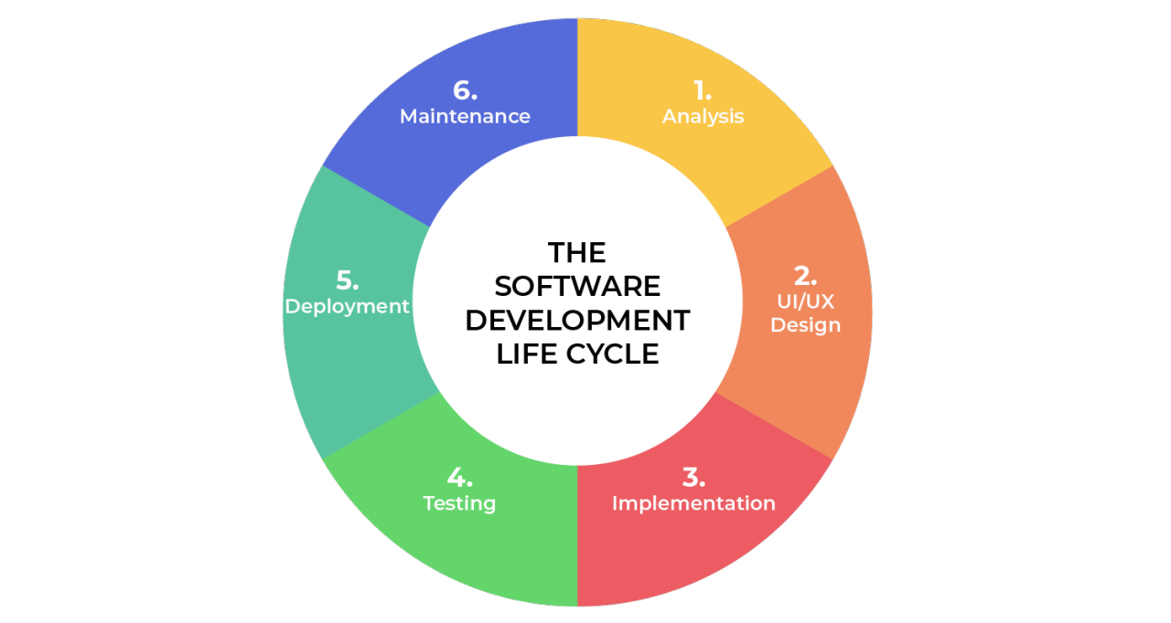

**Phases of SDLC**

**1)planning :**

* The first phase of the SDLC is the project planning stage where you gathering business requirements from your client or stakeholders.
* This phase is when you evaluate the feasibility of creating the product, revenue potential, the cost of production, the needs of the end-users, etc…

**2) analysis :**

* The analysis stage includes gathering all the specific details required for new system as well as determining the first ideas for prototypes.
* This phase involves gathering information about the software requirements from stakeholders, such as customers, end-users, and business analysts.

**3) Design:**

* The second of the software development life cycle phases is often done concurrently with the first.
* This phase is necessary for the developers. They will first outline the details for the overall application long side specific aspects, such as; use interface, system interface, network and network requirements and database

**4) Coding:**

* Computer programming or coding is the composition of sequences or instructions, called programs, that computers can follow to perform tasks.
* It involves designing and implementation algorithms, step-by-step specifications of procedures, by writing code in one or more programming languages.

**5) Testing:**

* Different types of testing occur during this phase, such as a code quality, unit testing, integration testing, performance testing and security testing.

**6) Maintenance:**

* Maintain software functionality, make upgrades to the coding, and ensure any repairs needed to the software are completed.
* The customer is responsible for maintaining the software by upgrading it when advised.

**4) What is DFD? Create a DFD diagram on flipkart.**

* DFD is the abbreviation for the data flow diagram.
* The flow of data of a system or a process is represented by DFD.
* It also gives insight into the inputs and outputs of each entity and the process itself.
* DFD does not have control flow and no loops or decision rules are present.

**DATA FLOW DIAGRAM ON FLIPKART**

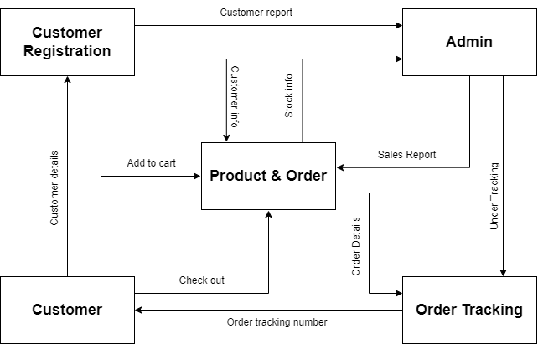

**5) What is flow chart? Create a flowchart to make addition of two numbers**

* Flowchart is a type of diagram that represents a workflow or process.
* A flowchart can also be defined as a diagrammatic representation of an algorithm, a step-by-step approach to solving tasks.
* The flowchart shows the steps as boxes of various kinds, and their order by connecting the boxes with arrows.

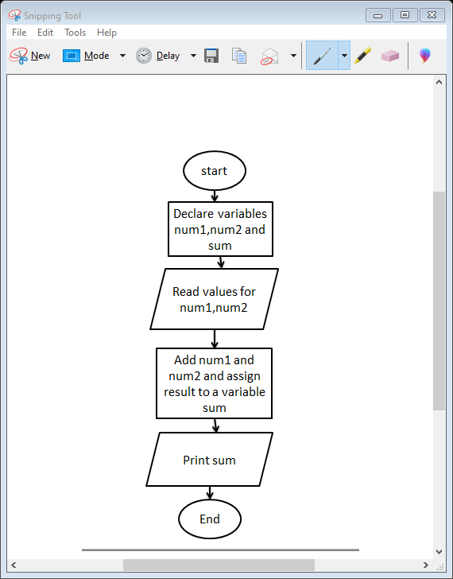

Fig 1.0: flowchart to make addition of two numbers

**6) What is use case diagram? Create a use case on bill payment on paytm.**

* Use-case diagrams the high-level functions and scope of a system.
* These diagrams also identify the interactions between the system and its actors.
* The use cases and actors in use-case diagrams describe what the system does and how the actors use it, but now how the system operators internally.

Use case on bill payment on paytm.

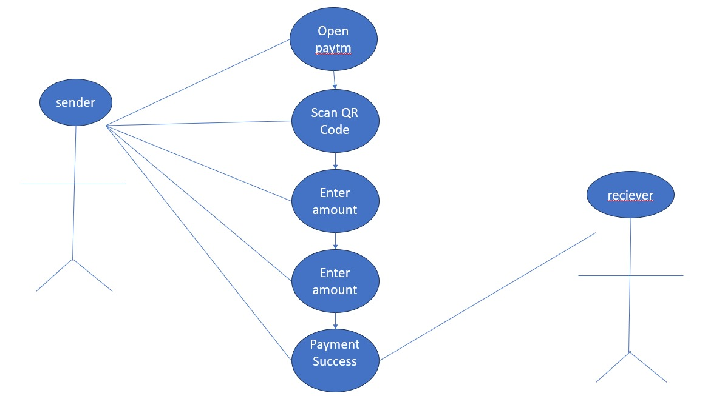

**Submitted By :- Beriya Karan v.**