ALY6030 - Data Warehousing and SQL
CRN: 71719
Module 5 Assignment
By: Karan Kaushal Daiya
Northeastern University: College of Professional Studies

Introduction:
In this assignment, we will be working with Microsoft SQL Server. This assignment will elaborate the installation step, Microsoft SQL Server uses and coding in T-SQL query language. Basically, it is a relational database administration system created by Microsoft. As a database server, it is a program item with the essential work of storing and retrieving data as asked by other computer program applications which may run either on the same computer or on another computer across a network. Here, I am using MAC Operating System so I have to use Azure Machine Learning Service. However, SQL Server is available for Windows, Linux and Docker operating system.

List of Chapters:
Introduction:
Transform your powerful data with SQL Server 2019
What you should know
Get Started with SQL Server:
What is SQL Server?
Understand the editions of SQL Server
Install SQL Server
Chapter Quiz
Work with the server:
Configure and start the server
Log into the server
Locate SQL Server documentation
Chapter Quiz
SQL Server Management Studio:
Tour the SSMS interface
Install a sample database
Create a new database on the server
Understand SQL datatypes
Create a data table
Join tables together with keys
Chapter Quiz

Write Transact-SQL commands:
Create a SELECT statement
Use functions to calculate values
Write an UPDATE statement
Add data with an INSERT statement
Create a view of the data
Quiz
Conclusion:
Next steps

Introduction
Topics that are progressing to be investigated and learned in this instructional exercise and tools being utilized are talked about. Moreover, a few applications and uses of SQL Server 2019 are talked about. Moreover, there is an essential presentation about the instructor Adam Wilbert.
Chapter 1: Get Started with SQL Server
Here in the very first chapter, SQL server and its roles are introduced. It is a relational database management system and can be introduced on a local computer. Establishment of a SQL Server is called an instance and a single occurrence can hold many databases beneath it. Meaning we are able to make numerous databases beneath one establishment of SQL Server and only one server can run multiple databases at a time. Moreover, this chapter talks approximately distinctive adaptations of SQL Server and how to induce a free form and introduce it. It is pleasant knowing around the possibilities of SQL Server and here the pro is that multiple instances of SQL Server can be run at a same time on a machine. Also, SSMS-SQL Server Management Studio may be an exceptionally valuable tool for GUI based work.
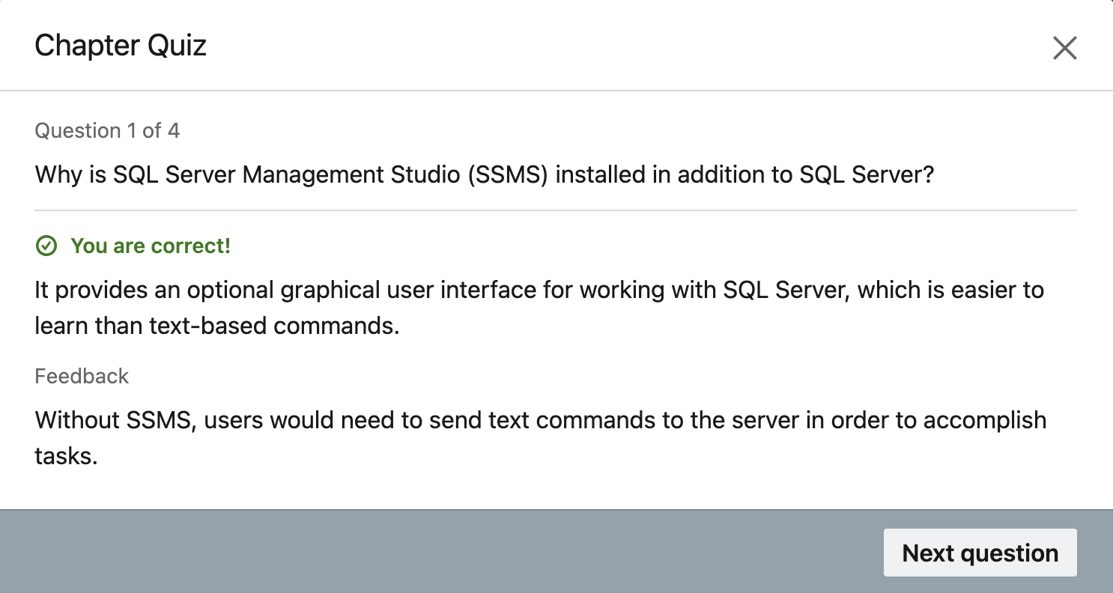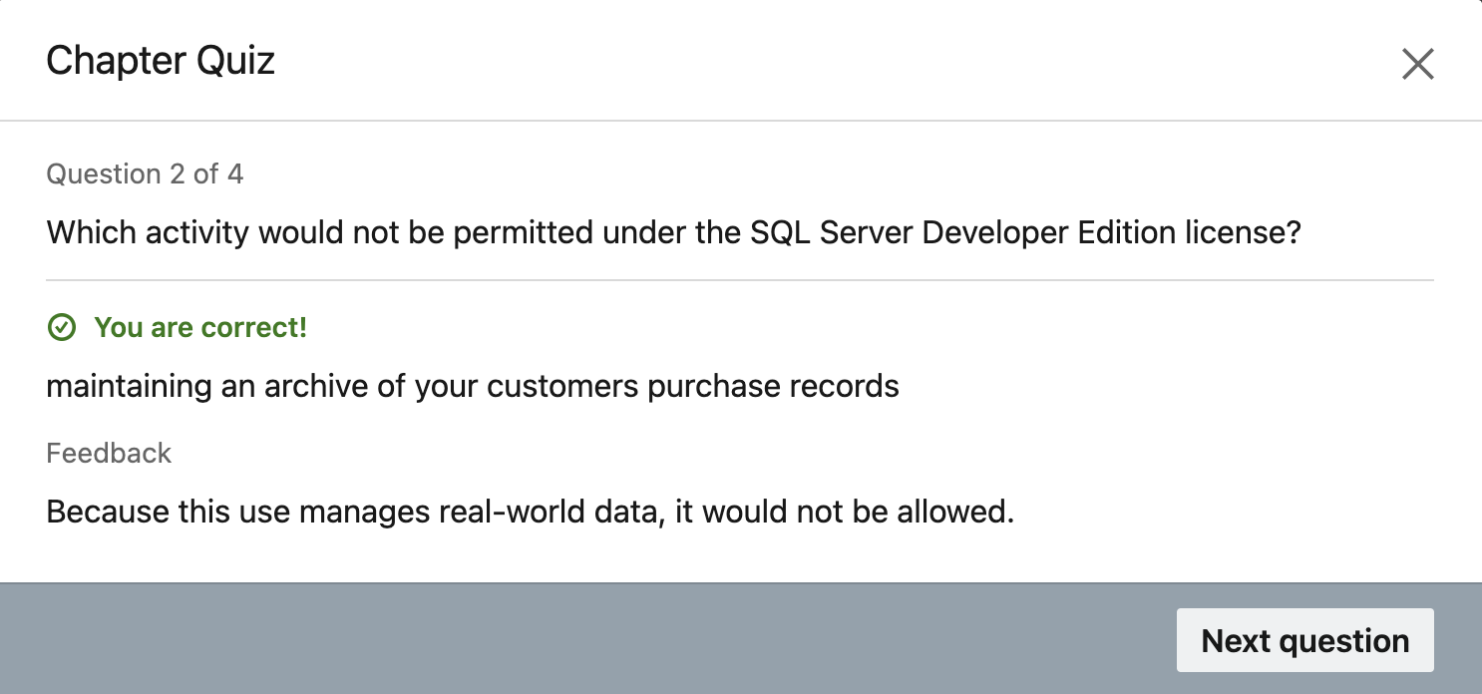
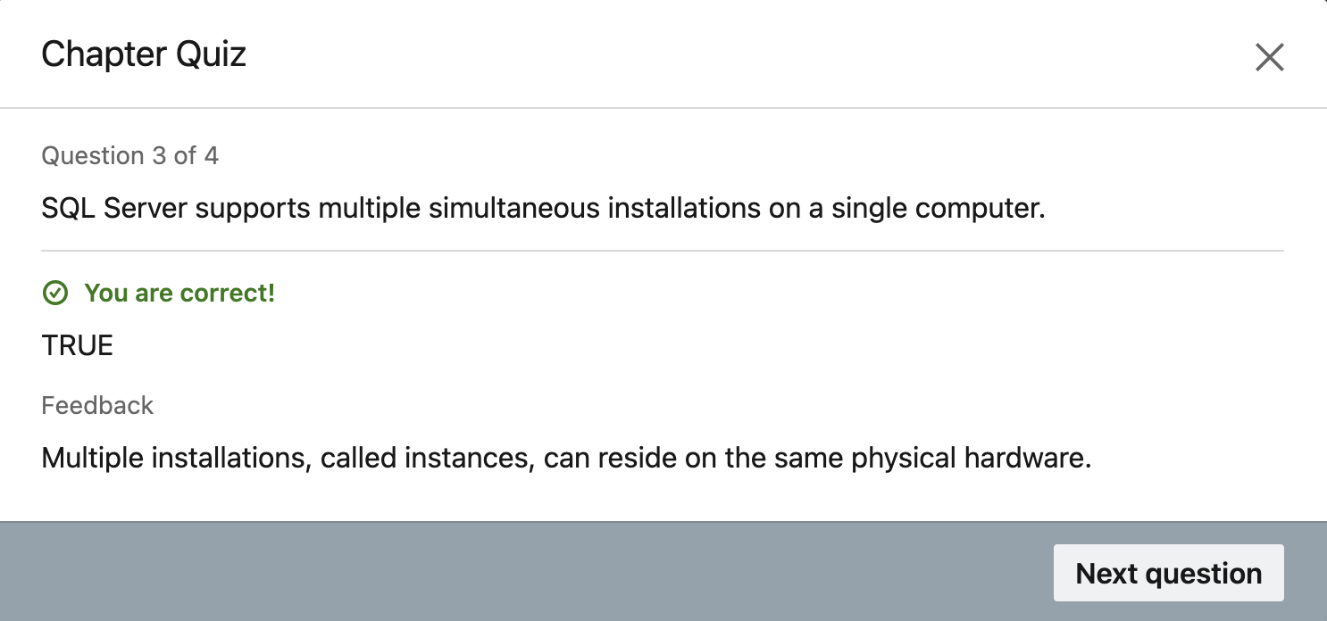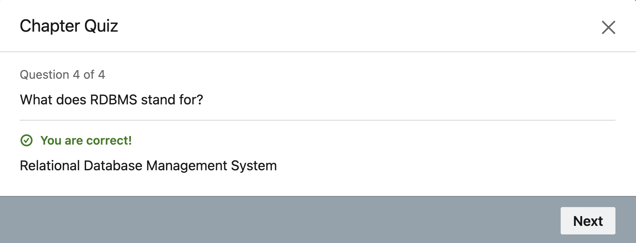
Chapter 2: Work with the server
This chapter elaborates how to arrange the SQL Server. Since the server begins together with the boot up of the system, it is as of now to utilize and waiting for command from the user to be executed. Chapter moreover strolls through empowering ‘sa’ or system administrator account and setting up a SQL password. The clear step by step clarification makes it simpler to arrange the server and begin utilizing the SSMS.
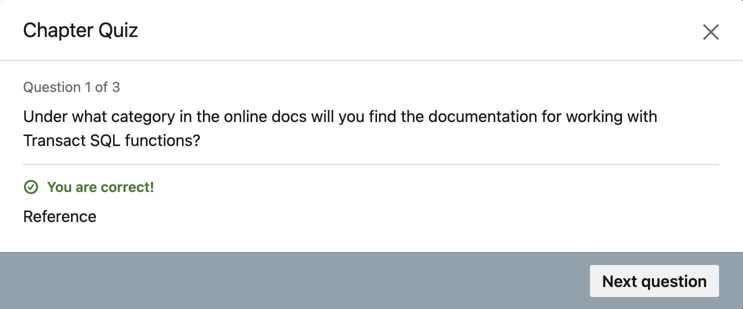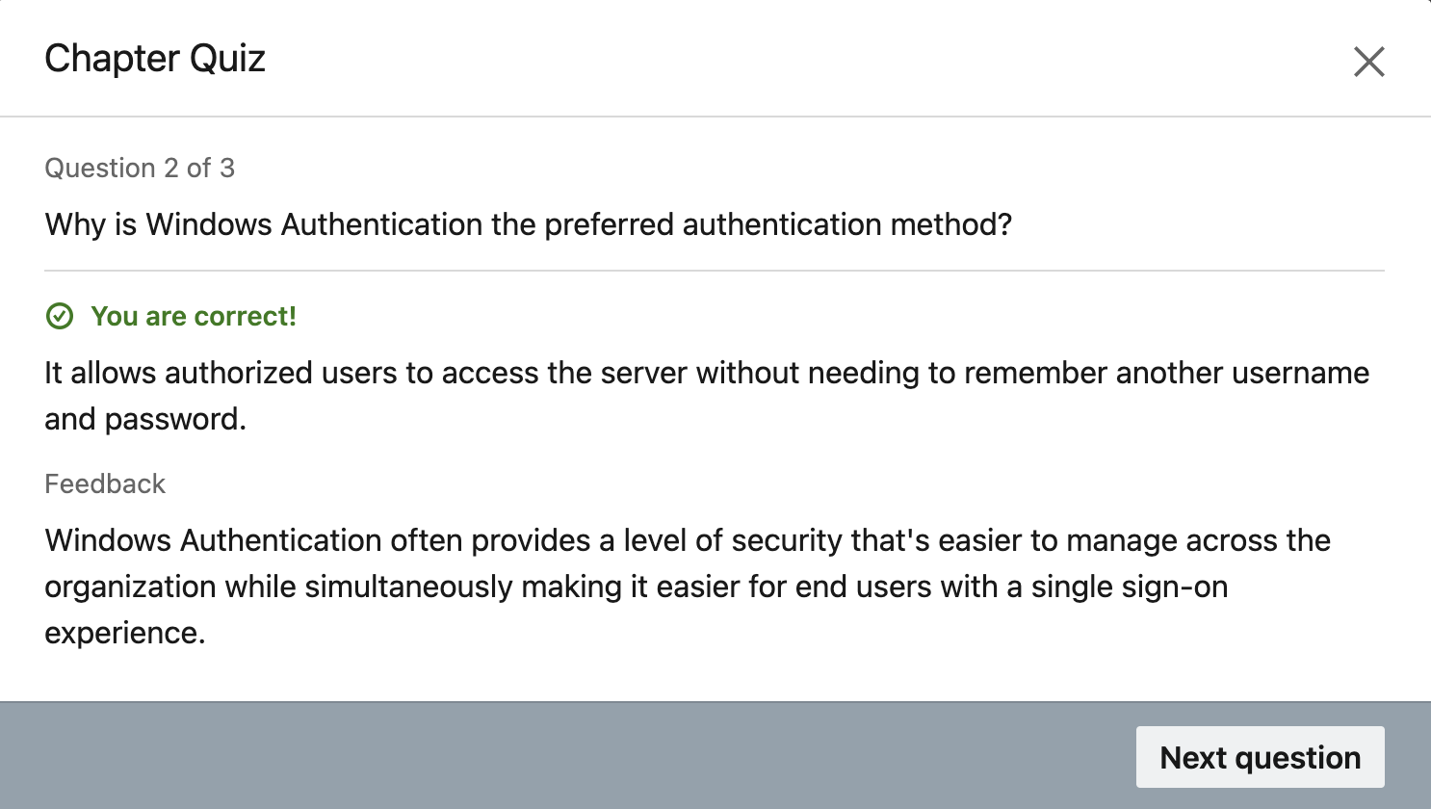
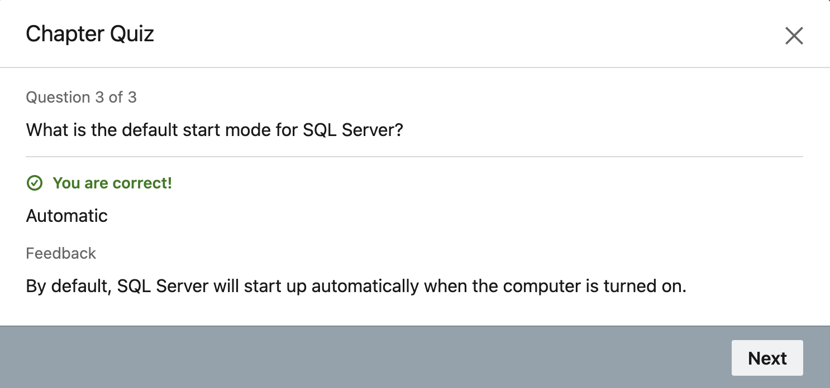
Chapter 3: SQL Server Management Studio
This chapter elaborates the restoring of an already existing database or making our own database and giving limitations such as least and most extreme allocation estimate and a way where database is stored. Another datatypes are talked about and the four fundamental ones are char(), Nchar(), varchar(), Nvarchar(). Numerical datatypes include int, tinyint, decimal and float. Other datatypes are date, currency, geographic coordinates and many more. This is one of the foremost vital chapter of the course since it educates how to make tables, characterize constraints, relationships and enter information into those tables as well as make joins between tables.
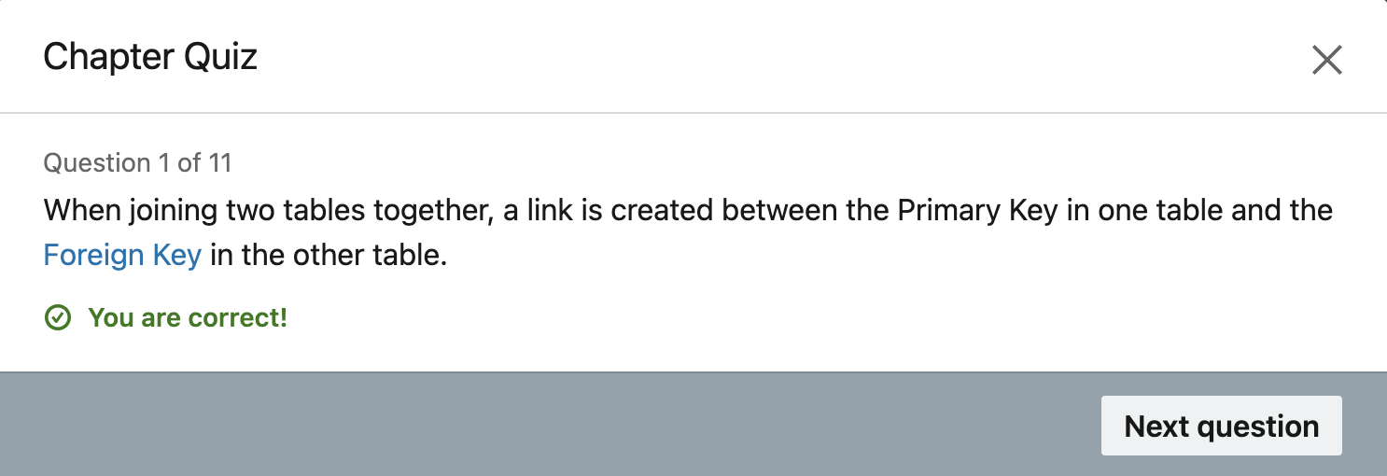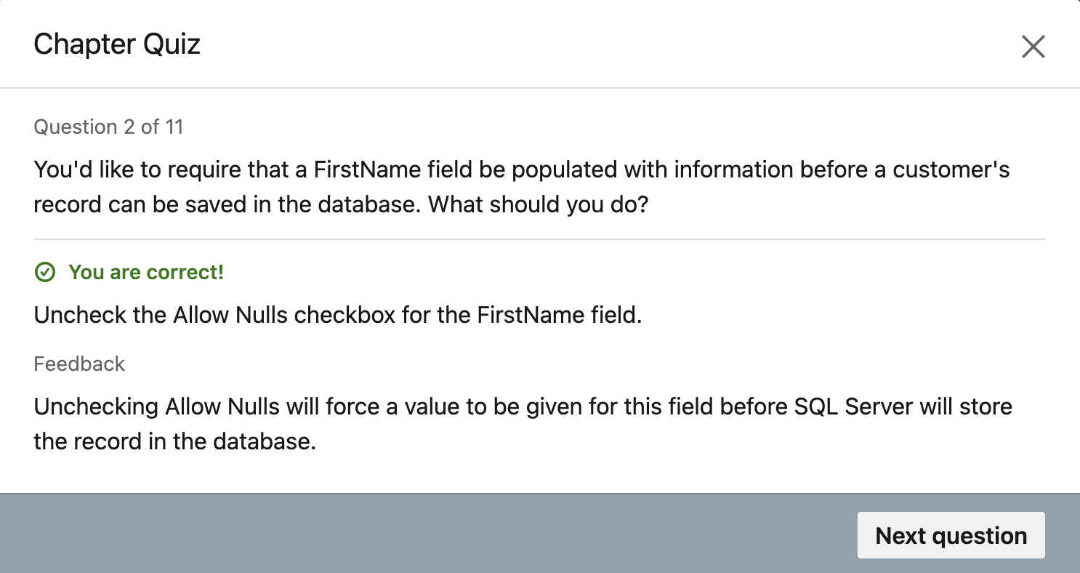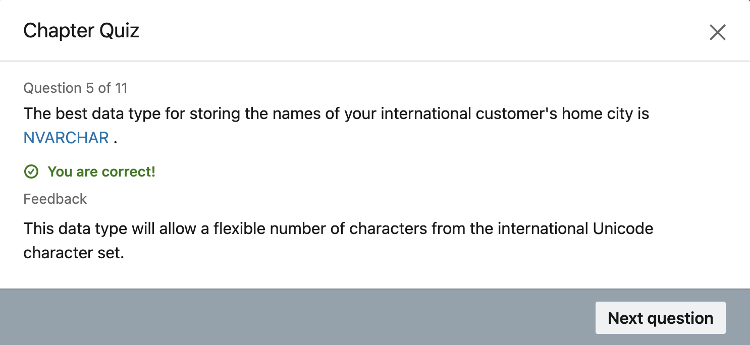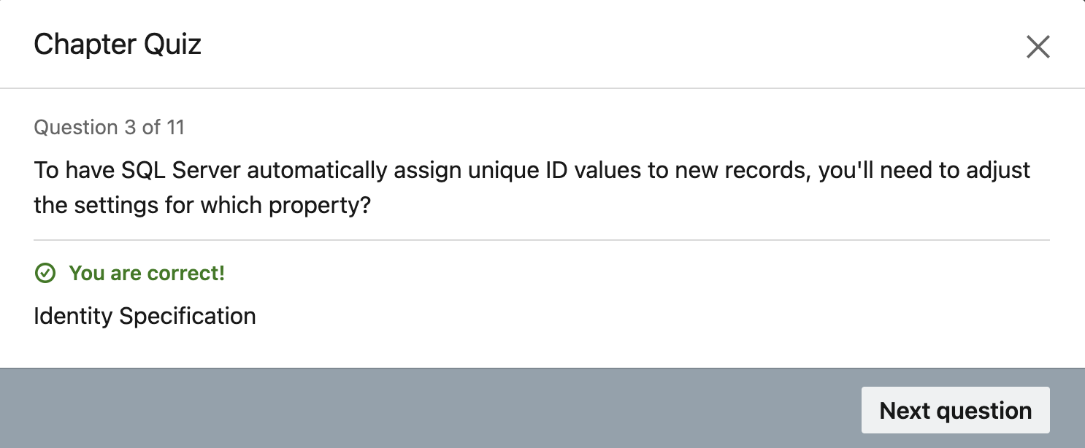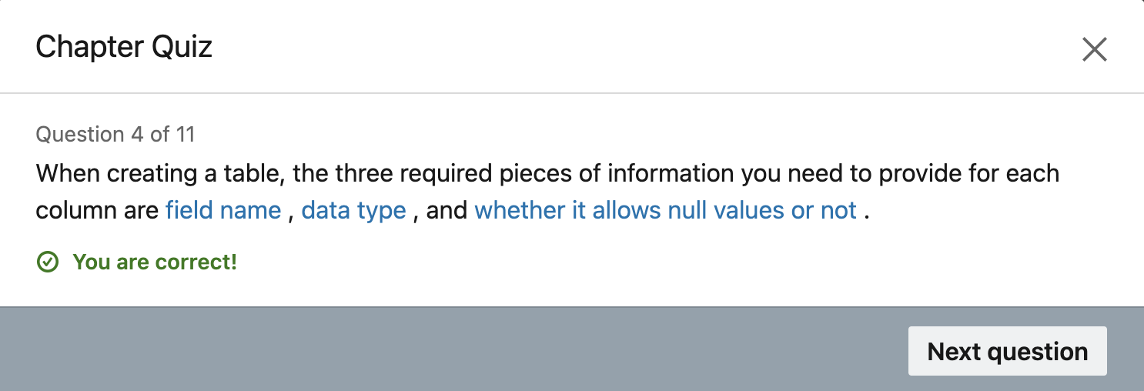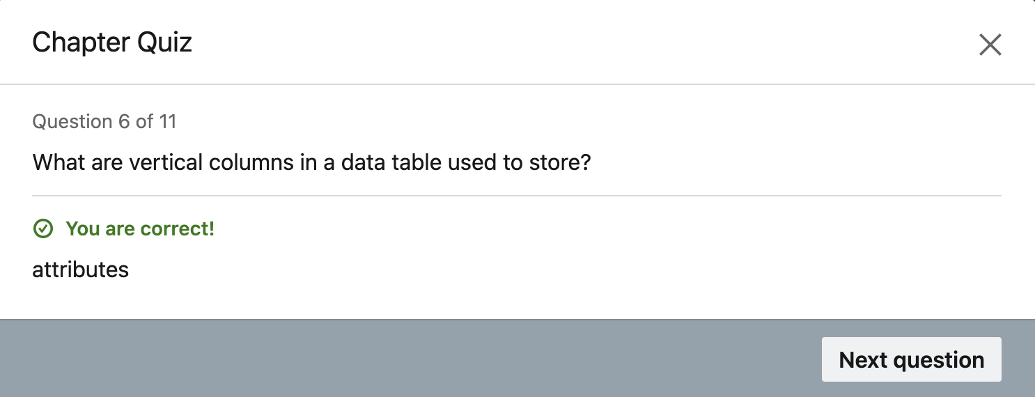
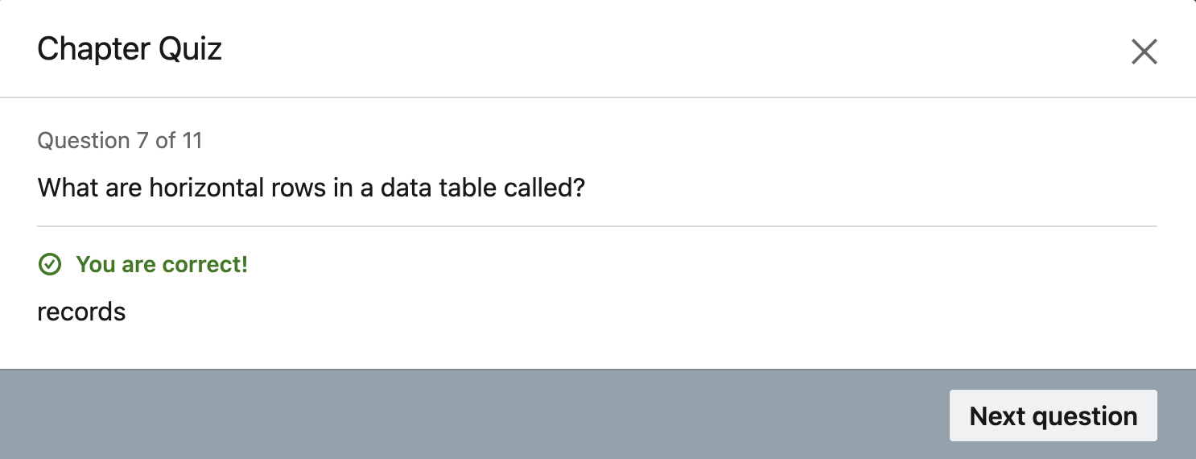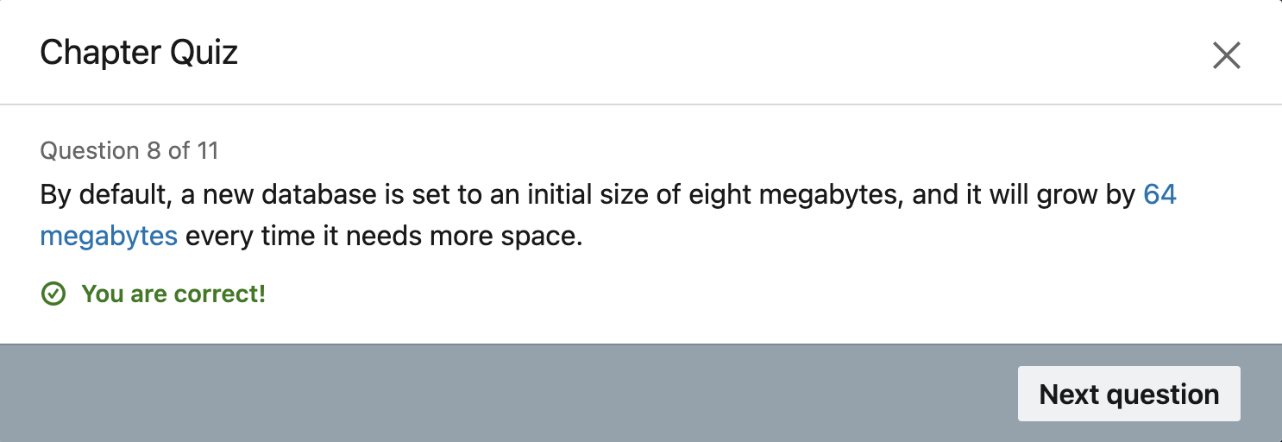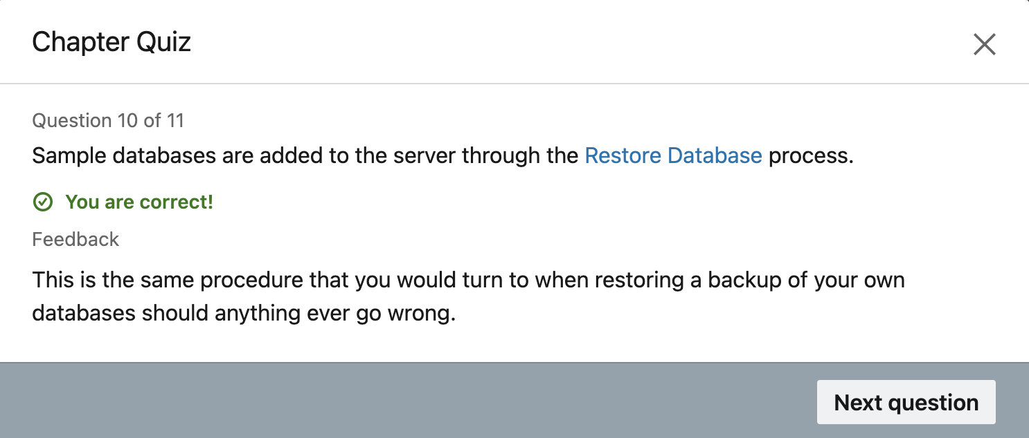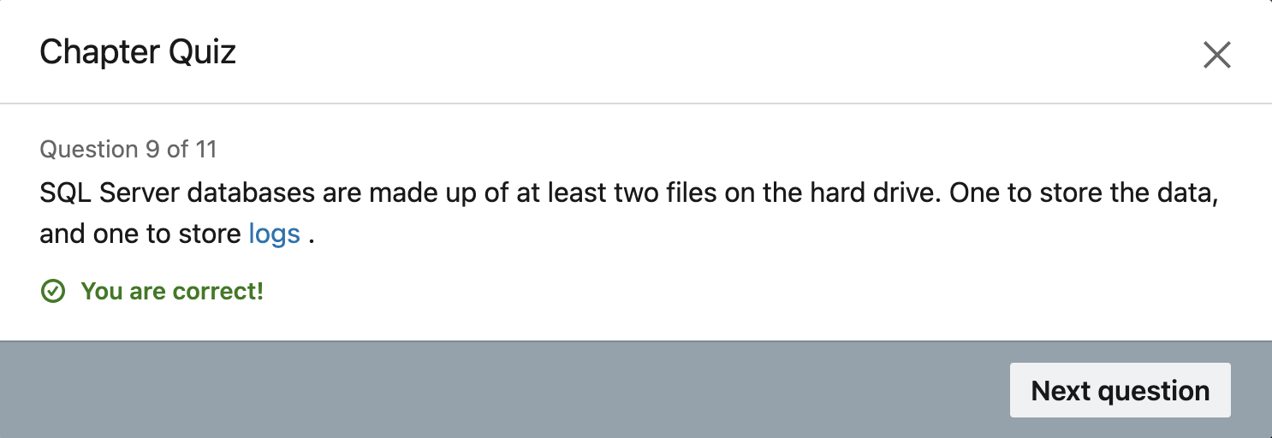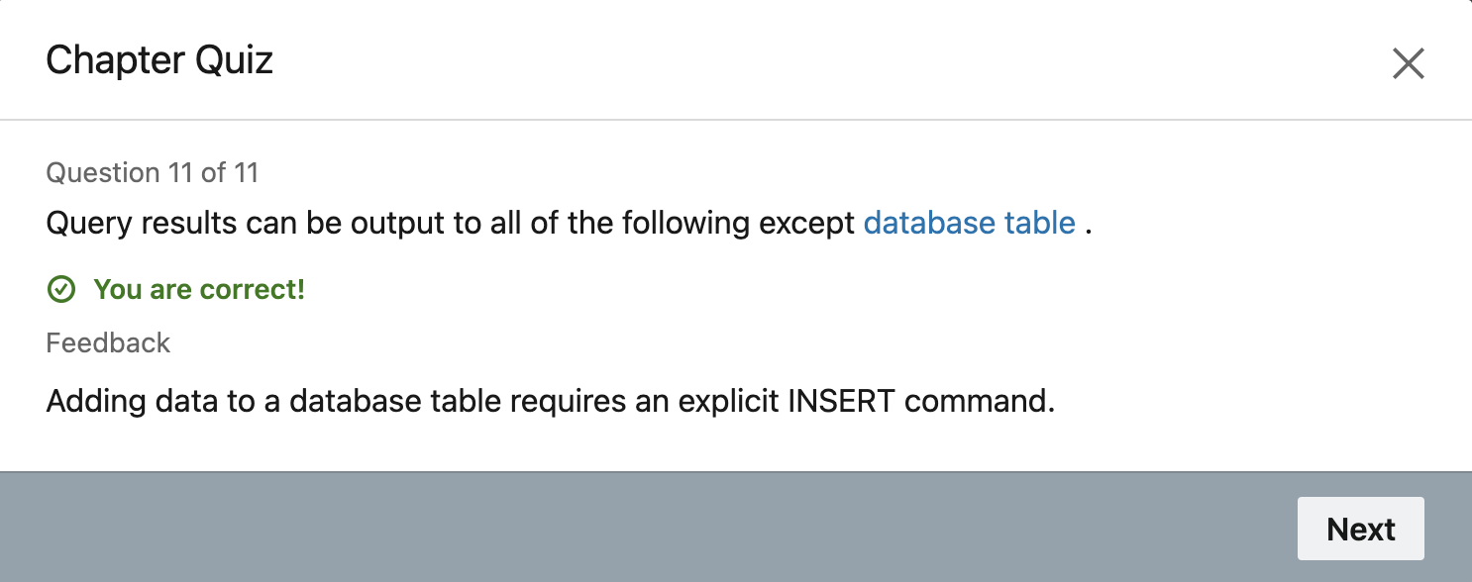

Chapter 4: Write Transact SQL commands
This can also be one of the foremost significant chapter within the course because it educates us how to recover information from a database utilizing T-SQL inquiry. T-SQL query is SQL utilized for Microsoft SQL Server. Here, we learn essential queries such as Select, Where, From, Update and Insert. This chapter moreover appears how to embed informatiomn in the database and tables utilizing Insert. It is exceptionally much fundamental since importing data is the exceptionally another step after a database is made. T-SQL is exceptionally much like SQL and the course here appears as it were essential of it. It would have been nice if the course went into a little more profundity of T-SQL quering with a few advanced query functions. Below given is the screenshot of a basic T-SQL query utilized to recover data almost all the orders places by a specific client and the date of those orders.
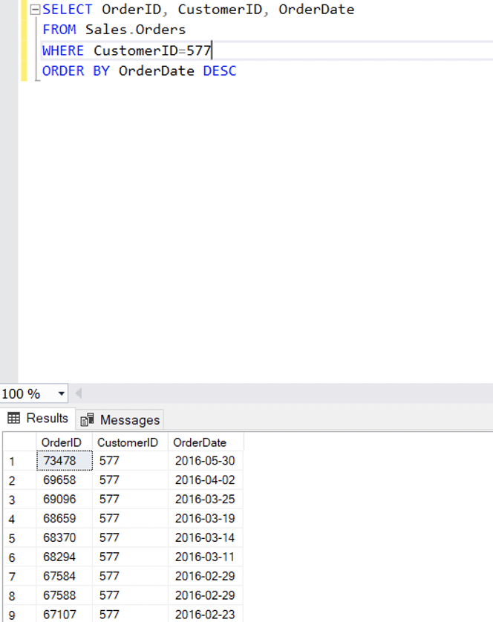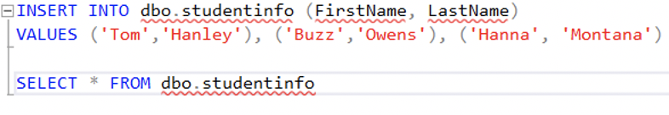
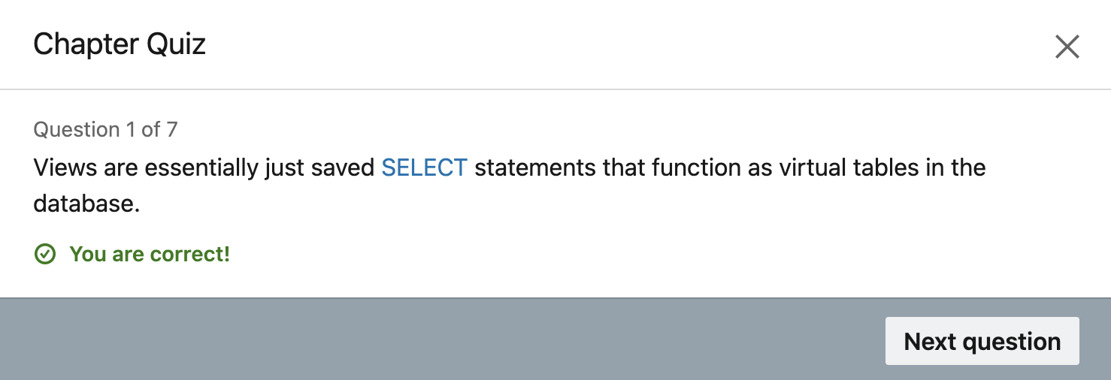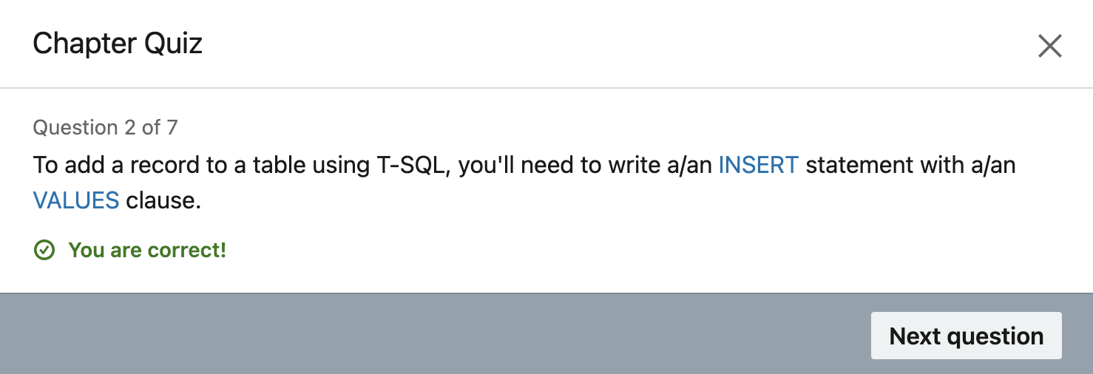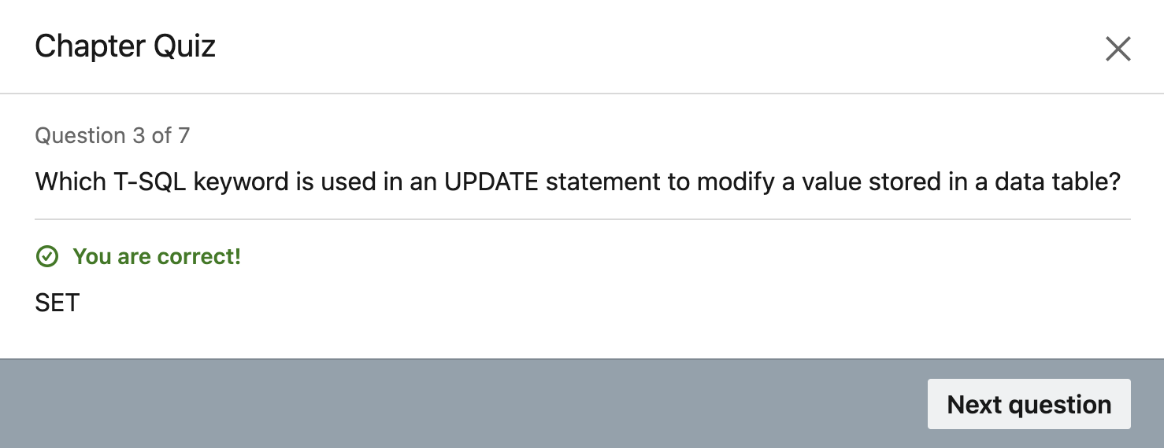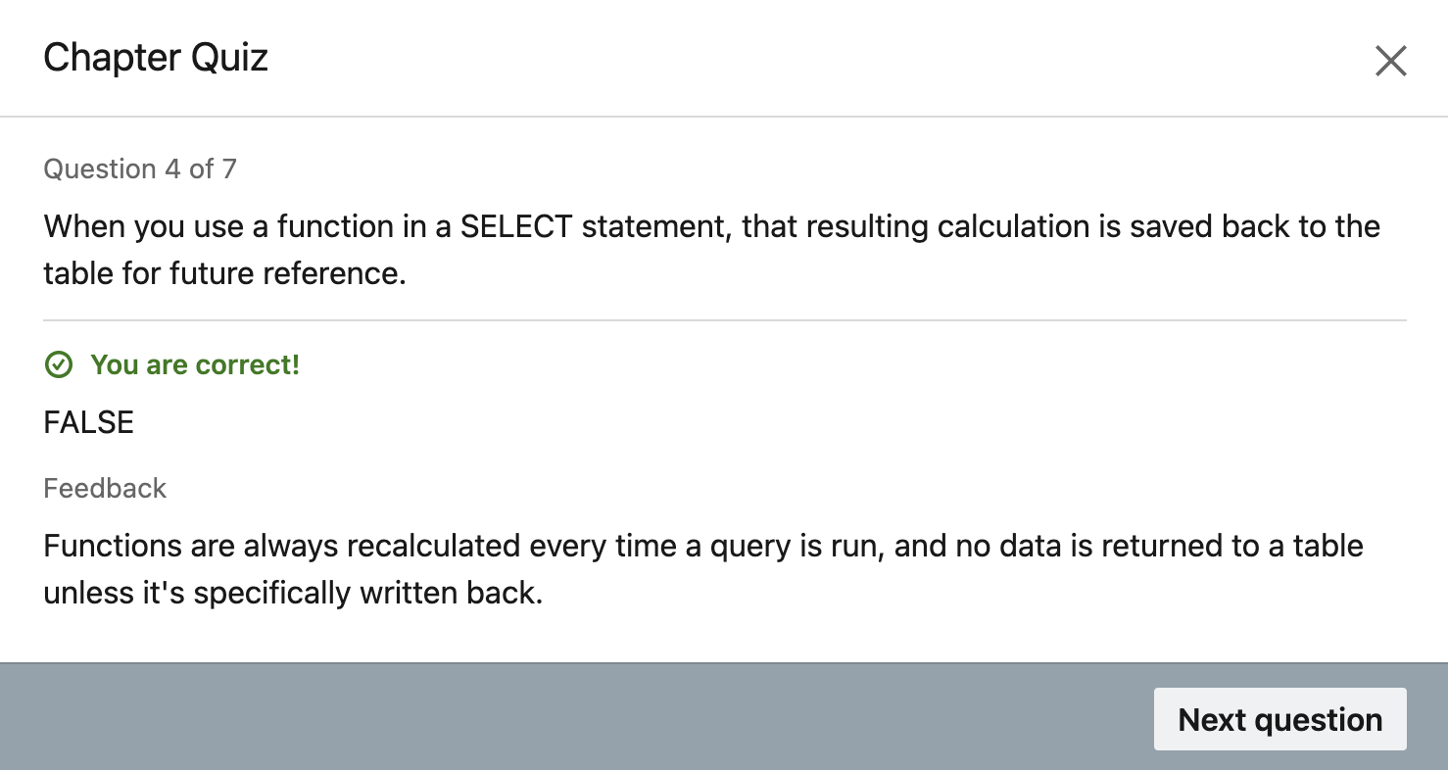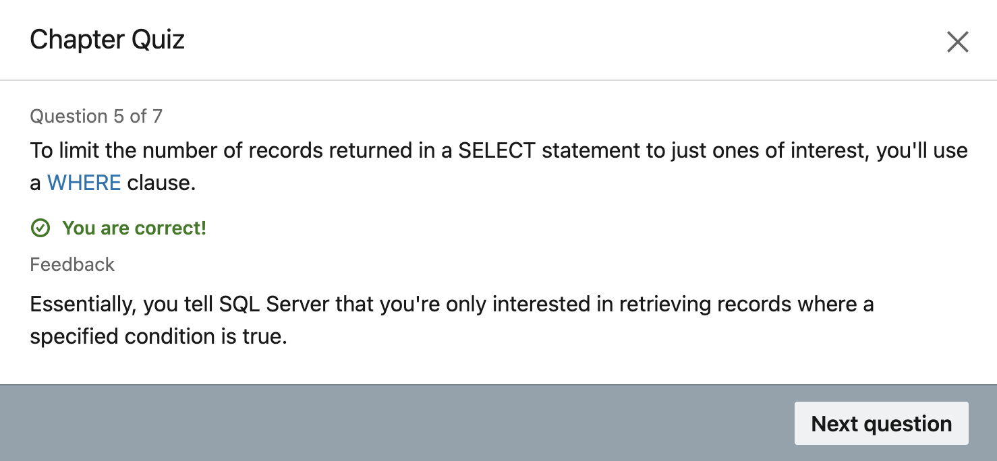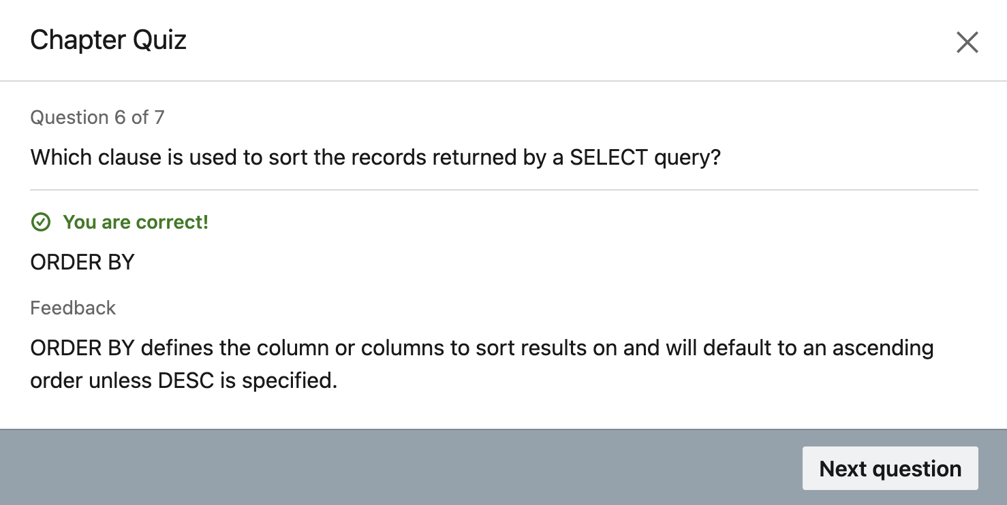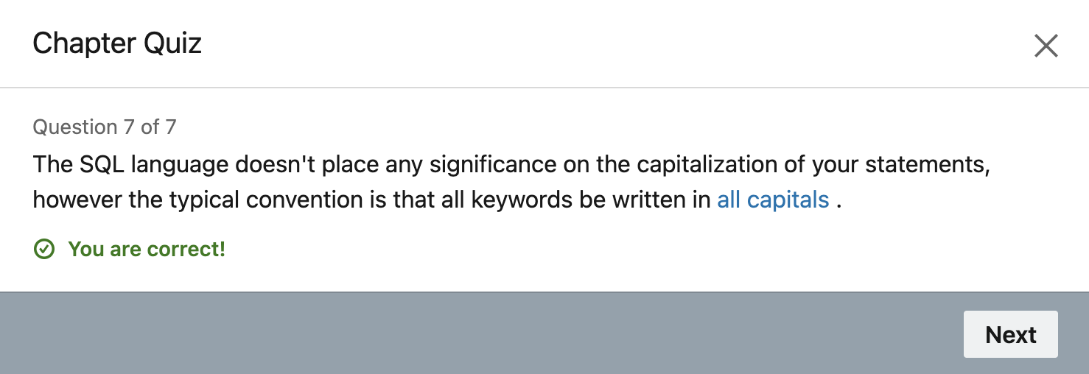
Chapter 6: Conclusion
Finally, this chapter in the end of this course elaborates what is the next step after introducing SQL Server i.e., SQL Server Express.

Certificate of Completion:
Conclusion:
This course truly helped a lot to learn about Microsoft SQL Server and SSMS also. Mac users have to access this server from Azure Virtual Machine but for Windows users they can easily install this on a local computer. Developer version is totally free to use and very user friendly to use.
Reference:
Wilbert, A. (2019, April 18). Next steps - SQL Server Video Tutorial: LinkedIn Learning, formerly Lynda.com. Retrieved December 10, 2020, from
https://www.linkedin.com/learning/learning-microsoft-sql-server-2019/next-steps?resume=false

