**LOK JAGRUTI KENDRA UNIVERSITY, AHMEDABAD**



**A**

**Project Report On**

Facial Emotion Detection using Python

**B. E. Semester-V**

**(Computer Engineering Department)**

**Submitted by:**

**Name of Student: Devnani Karan Sureshkumar**

**Enrollment Number:21002171210026**

**Ms. Monali Patel. (Faculty Guide) Academic Year (2023-24)**

**LOK JAGRUTI KENDRA UNIVERSITY, AHMEDABAD**

** COMPUTER ENGINEERING**

# CERTIFICATE

This is to certify to of B.E Semester **5thI.T.** Class, Enrollment No. has satisfactorily completed her Mini Project work of the subject **Project Report on Face Detection using python** during the academic year **2023-24** and submitted on **.**

**Head of Department Guided By**

**Prof. Shruti Raval Prof. Monali Patel**

**Computer Department Computer Department**

**LJU, Ahmedabad LJU , Ahmedabad**

**Certified that this term work is accepted an assessed on**

**Examiner Convener**

# ACKNOWLEGEMENT

We are heartily thankful to all faculty members of the department of Computer Engineering from L.J University, Ahmedabad for making my project. It is my pleasure to take this opportunity to thank all people who helped me directly or indirectly to prefer this project would have been impossible without their guidance. They all encouraged and trusted in our ideas. They were always available for us to give guidance about the project. The disruption about the project and the great advice given by them helped to make this project complete. We are thankful to them pristine and enlightening guidance given to as throughout the semester.

We are especially thankful to our internal guide **Prof. Monali Patel**, for their Encouragement, guidance, understanding and lots of support and trust. Without his help this project would not be success. Finally, we thank all persons who directly or indirectly supported us in making this project.

# ABSTRACT

# In an increasingly technologically driven world, facial emotion detection plays a crucial role in various applications, offering insights into human behavior and enhancing user experiences. From analyzing customer sentiments to improving mental health care, the ability to accurately detect and interpret emotions from facial expressions is invaluable.

# The aim of this project is to implement real-time facial emotion detection using computer vision techniques. Utilizing input from a webcam, the system will identify and classify facial expressions into predefined emotion categories, such as happiness, sadness, anger, surprise, disgust, and fear. The detected emotions will be displayed alongside the corresponding facial expressions in real-time.

# This project holds potential for widespread application, ranging from market research and user experience optimization to mental health diagnostics and intervention. By automating emotion detection processes, it can facilitate more efficient data collection and analysis, leading to actionable insights and improved decision-making.

# Furthermore, the development of this system contributes to the advancement of computer vision technology, paving the way for innovative solutions in emotional intelligence and human-computer interaction. As technology continues to evolve, the integration of facial emotion detection capabilities holds promise for creating more empathetic and responsive digital experiences.

# In conclusion, this project aims to harness the power of computer vision for real-time facial emotion detection, offering opportunities for transformative applications across various domains. Through its implementation, it seeks to enable more intuitive and empathetic interactions between humans and machines, ultimately enhancing the quality of human-computer interaction and driving innovation in emotion-aware computing.

# INDEX

Acknowledgement… 3

Abstract… 4

Chapter 1 INTRODUCTION 7

* 1. Background 7
  2. Motivation 8
  3. Challenges 9
  4. Objectives 11
  5. Organization Of Report 11
  6. Justification 12

Chapter 2 LITERATURE REVIEW 13

Face Detection Device, Face Pose Detection Device, Methods for Face Recognition: **……………………...13**

Methods and System for Face Recognition: ……………………13

Validation of Picture**:** ……………………….14

Automated System for Emotional Monitoring in Smart City Network:14

Key Components of the System for Facial Emotion Detection: ……15

* 1. Face emotion detection using tensorflow and OpenCV 16

Chapter 3 IMPLEMENTATION OF THE MODEL 18

* 1. Data Visualization 18
  2. Data Augmentation 18
  3. Splitting the Data… 18
  4. Pre-Training CNN Model 19
  5. Training the CNN Model 20

Post-training Model Evaluation: ……………………………….21

* 1. Deployment and Integration: …………………….…………….21

Real-time Emotion Detection in Facial Emotion Detection……23

Chapter 4 METHODOLOGY 25

* 1. System Design 25
  2. Logical and Physical Design Phases…………………………….25

Evolution of Requirements: …………………………………….25

* 1. Implementation 26
  2. Use case Diagram 29
  3. Sequence Diagram 30
  4. State Diagram 32

Chapter 5 EXPERIMENTS AND RESULT 34

* 1. Experiment of Machine learning Algorithm 34
  2. Comparative Analysis of Deep Learning Architectures 36

Chapter 6 CONCLUSION 37

Chapter 7 REFERENCE 38

**1.INTRODUCTION**

**Background**

The face is regarded as the most important part of the human body. According to research, even a face can speak, and it has different words for different emotions. It is essential in interacting with people in society. It conveys people's identities and can thus be used as a key in many organizations' security solutions. The facial recognition system is becoming increasingly popular around the world as an extremely safe and dependable security technology. Because of its high level of security and dependability, it is gaining significant importance and attention from thousands of corporate and government organizations.

Furthermore, when compared to other biometric security solutions such as palmprints and fingerprints, the facial recognition system offers significant advantages. The system measures a person's biometrics from a specific distance without interacting with the person. This system can assist many organizations in identifying a person who has a criminal record or other legal issues in crime deterrent applications. As a result, this technology is becoming increasingly important for a wide range of residential buildings and corporate organizations. This technique is based on the ability to recognize a human face and then compare its various features to previously recorded faces. This feature also increases the system's importance and allows it to be widely used around the world. It is designed with user-friendly features and operations that include various facial nodal points. A face has approximately 80 to 90 distinct nodal points. The facial recognition system measures important aspects such as the distance between the eyes, the length of the jawline, the shape of the cheekbones, and the depth of the eyes using these nodal points. These points are 2 calculated by generating a code known as the faceprint, which represents the identity of the face in a computer database.

The field of facial emotion detection has undergone a significant transformation, driven by the convergence of computer vision and machine learning. In its early stages, facial emotion detection primarily relied on simplistic features and rule-based algorithms. However, the contemporary landscape is now dominated by sophisticated systems that leverage advanced deep learning architectures, particularly convolutional neural networks (CNNs). These architectures have played a pivotal role in elevating the accuracy and efficacy of facial emotion detection systems.

The trajectory of facial emotion detection technology mirrors the broader evolution within computer vision, transitioning from rudimentary approaches to more sophisticated, data-driven methodologies. The robustness of facial emotion detection has become pivotal in various applications, spanning from human-computer interaction and affective computing to psychological research and healthcare diagnostics. This transformation underscores the continual advancements in the field, shaping a future where facial emotion detection systems seamlessly integrate into everyday technologies, enriching human-computer interaction and facilitating emotional understanding in diverse contexts.

**Motivation**

The impetus driving the continual refinement of facial emotion detection systems is multifaceted and rooted in the evolving landscape of technology and human interaction. At its core, the motivation stems from the quest to create more nuanced and emotionally intelligent technology that can accurately interpret and respond to human emotions in real-time.

One key driving force is the increasing demand for seamless and empathetic user experiences across various digital platforms. As individuals engage with technology in increasingly diverse ways, there is a growing expectation for interfaces and applications to recognize and adapt to their emotional states. Facial emotion detection systems play a crucial role in meeting this demand by enabling devices and applications to perceive and respond to users' emotions effectively.

Moreover, in domains such as affective computing and psychological research, facial emotion detection systems are instrumental in unlocking deeper insights into human behavior and emotional responses. By analyzing facial expressions and gestures, researchers can gain valuable understanding of individuals' emotional states, leading to advancements in fields ranging from mental health to marketing.

Real-world applications further underscore the importance of developing accurate and responsive facial emotion detection systems. In mental health monitoring, for example, these systems can aid clinicians in assessing patients' emotional well-being and detecting signs of distress or instability. Similarly, in personalized digital experiences, such as virtual assistants or recommendation systems, the ability to perceive and respond to users' emotions can enhance engagement and satisfaction.

Furthermore, the integration of emotion-aware technologies in advertising and marketing highlights the potential for facial emotion detection systems to drive more targeted and effective campaigns. By gauging consumers' emotional responses to advertisements, marketers can tailor their strategies to resonate more deeply with their target audience, ultimately leading to improved brand perception and customer engagement.

In essence, the motivation to advance facial emotion detection technology arises from the desire to understand and respond to human emotions effectively in diverse contexts. By harnessing the power of artificial intelligence and machine learning, researchers and developers continue to push the boundaries of innovation, enriching human-computer interaction and fostering greater emotional understanding in everyday interactions.

**Challenges**

Facial emotion detection, despite its advancements, continues to grapple with several significant challenges that impact its accuracy, reliability, and applicability across diverse scenarios.

**Variability in Environmental Conditions:**

One of the primary challenges faced by facial emotion detection systems is the variability in environmental conditions. Changes in lighting, both natural and artificial, can significantly affect the quality and clarity of facial images, making it challenging to accurately detect emotions. Moreover, factors such as facial obstructions (e.g., glasses, facial hair) and varying camera angles further complicate the process, requiring robust algorithms capable of handling such variability.

**Diverse Facial Expressions:**

Human facial expressions are incredibly diverse and nuanced, making it difficult for facial emotion detection systems to accurately interpret them. Different cultural norms and individual idiosyncrasies add layers of complexity to this challenge, requiring algorithms trained on diverse datasets to capture the breadth of human emotional expressions accurately.

**Inclusivity and Privacy Concerns:**

As facial emotion detection technology becomes more pervasive, ensuring inclusivity and addressing privacy concerns emerge as critical challenges. Systems must be designed to recognize emotions across diverse demographics, including different ages, genders to avoid biases and ensure fairness. Moreover, in sensitive contexts such as healthcare and surveillance, protecting individuals' privacy and data security becomes paramount, necessitating the development of privacy-preserving techniques and robust ethical frameworks.

**Adaptability and Real-Time Performance:**

For facial emotion detection systems to be practical and effective, they must demonstrate adaptability to dynamic environments and real-time performance. Balancing accuracy with computational efficiency is crucial, especially in applications requiring instantaneous feedback or response, such as human-computer interaction and affective computing.

**Bias and Fairness:**

Another significant challenge in facial emotion detection is the presence of biases in training data and the potential for unfair or discriminatory outcomes. Biases may arise due to imbalances in the dataset, leading to inaccuracies or skewed predictions, particularly for underrepresented groups. Addressing bias and ensuring fairness in emotion detection algorithms require proactive measures, including data augmentation techniques, algorithmic transparency

In summary, addressing the challenges in facial emotion detection gives a multidisciplinary approach that combines advancements in computer vision, machine learning, and ethics. By developing adaptive algorithms, ensuring privacy protection, and mitigating biases, researchers and developers can overcome these hurdles and unlock the full potential of facial emotion detection technology in various domains, from healthcare and education to entertainment and beyond.

**Objective**

Our Facial Emotion Detection project aims to surpass mere accuracy by addressing the challenges of adaptability and real-time performance. We strive to develop an advanced emotion detection model capable of accurately identifying a wide range of emotions while gracefully handling variations in poses, facial expressions, and lighting conditions. Leveraging the power of deep learning and extensive datasets, including the Kagele dataset, our objective is to create a versatile and efficient facial emotion detection system.

This system is intended for practical applications, emphasizing robustness and speed as essential qualities for successful deployment in diverse environments. By advancing the state-of-the-art in facial emotion detection, we aim to establish new standards for accuracy, adaptability, and real-time efficiency, contributing to the advancement of emotional intelligence in technology.

**Data**

Our project will utilize large, diverse datasets containing facial images annotated with corresponding emotion labels. These datasets, including the Kagele dataset, will include a wide spectrum of emotions, capturing variations in intensity and expression. Additionally, we will incorporate augmented data to enhance the model's ability to generalize across different scenarios. The availability of comprehensive datasets will enable us to train our model effectively, ensuring its robustness and accuracy across various real-world applications.

**Organization of Report**

This report has been given in six chapters: -

* Chapter one offers a short introduction to the analysis space, motivation of the study, challenges to be moon-faced and objectives of the study.
* Chapter two a pair of offers the literature Review concerning the instruments and ways accustomed apply on a dataset that gift the definition of detection and it shows the explanation behind why and that techniques of machine learning did not work for the model.
* Chapter three has given the varied techniques. The procedure for preprocessing the dataset and therefore the feature of the technique.
* Chapter four has coated the materials and methodology of the study space. rationalization of model is additionally coated during this chapter.
* Chapter five is all concerning results and impact of varied techniques on the model.
* Chapter vi presents limitation and future work plans. Lastly, it is followed by references cited during this report.

**Justification**

The advancement of technology to address security issues in a rapidly growing society is critical. As social activity grows, secure access to personal property and public places such as airports, stadiums, and restricted areas must become more effective. Many biometric approaches have been 5 developed and are constantly being improved. It is also desired to conduct a review of previous work in the subject, observe recent advancements, and adapt results obtained toward the view of the subject matter by using the principal component analysis algorithm, which uses Eigen free space to reconstruct a face. It displays not recognized if the error coefficient is greater than the threshold. Furthermore, if not, it displays a recognized face. As a result, in order to improve the threshold, we usually run the image through a neural network for better classification accuracy.

2.**LITERATURE REVIEW**

**Face Detection Device, Face Pose Detection Device, Methods for Face Recognition:**

Facial emotion detection is gaining prominence in image processing, especially in applications where understanding human emotions is crucial, such as human-computer interaction and affective computing. State-of-the-art approaches in facial emotion detection often integrate advanced deep learning architectures, such as convolutional neural networks (CNNs), to extract intricate patterns from facial images and infer emotional states with high accuracy. These techniques leverage large-scale datasets annotated with diverse emotional expressions, facilitating robust model training and generalization across various contexts. Additionally, ongoing research focuses on addressing challenges such as handling facial occlusions, variations in lighting conditions, and cultural differences in facial expressions, aiming to enhance the reliability and cross-cultural applicability of facial emotion detection systems. As the field advances, the continuous evolution of these methods promises to revolutionize human-computer interaction and contribute to the development of emotionally intelligent systems.

**Methods and System for Face Recognition:**

The sophisticated algorithm for detecting facial emotions in image data is designed with two recursive steps for optimal accuracy. Through the utilization of facial feature models and potential emotional expressions, the algorithm identifies candidate regions within the image that may contain facial emotional cues. Subsequent application of a pattern recognition technique validates the presence of facial emotions in each candidate region. This synergistic approach not only enhances the accuracy and efficiency of facial emotion detection but also ensures robustness across various facial expressions and environmental conditions. By surpassing the capabilities of individual components, this integrated method significantly contributes to the reliability and effectiveness of facial emotion recognition systems in real-world applications.

**Validation of Picture:**

"Check Your Emotion" Application: In the context of mental health awareness and interpersonal communication, the "Check Your Emotion" application addresses the need for accurate interpretation of facial expressions. By employing state-of-the-art machine learning algorithms, the application analyzes facial features to discern subtle emotional cues, offering users insights into their emotional states. The application's user-friendly interface and real-time feedback mechanisms empower individuals to better understand and regulate their emotions, promoting emotional intelligence and well-being. Furthermore, ongoing research and user feedback drive continuous improvement, ensuring the application remains a reliable tool for validating and enhancing emotional recognition skills.

**Automated System for Emotional Monitoring in Smart City Network:**

In an era marked by increasing awareness of mental health and emotional well-being, the demand for innovative solutions to address these challenges is more pressing than ever. The proposed automated system represents a pioneering approach to emotional monitoring, with a particular emphasis on leveraging facial emotion detection technology. By seamlessly integrating this technology into a smart city network equipped with surveillance cameras, the system enables real-time monitoring of emotional states in public spaces.

One of the key advantages of this system is its ability to provide timely insights into the emotional dynamics of urban environments. By analyzing facial expressions captured by surveillance cameras, the system can detect changes in emotional states among individuals within the community. This capability has profound implications for enhancing public safety, as it enables authorities to identify and respond to potential incidents or disturbances promptly.

Moreover, the integration of facial emotion recognition technology into a smart city network opens up new possibilities for proactive intervention and support. For instance, the system can be programmed to alert relevant authorities or mental health professionals when signs of distress or emotional instability are detected. This allows for targeted interventions and the provision of appropriate support services to individuals in need.

Furthermore, the data collected by the system can contribute to ongoing research efforts aimed at understanding the emotional dynamics of urban environments. By analyzing patterns and trends in emotional responses across different demographic groups and geographic locations, researchers can gain valuable insights into the factors influencing emotional well-being within communities.

Collaboration with mental health professionals and community stakeholders is essential for the successful implementation and operation of this system. By working closely with these stakeholders, the system can be tailored to meet the specific needs and preferences of the community it serves. Additionally, ongoing engagement ensures that the system remains adaptive and responsive to evolving societal needs and technological advancements.

In conclusion, the proposed automated system for emotional monitoring in smart city networks represents a significant step forward in leveraging technology to promote mental health and emotional well-being. By harnessing the power of facial emotion detection within the context of urban environments, the system has the potential to revolutionize the way we understand and support emotional health in modern societies.

**Key Components of the System for Facial Emotion Detection:**

**• Emotion Recognition Technology:**

Central to the system is advanced facial emotion recognition technology, leveraging deep learning models to analyze facial expressions accurately. Trained on extensive datasets encompassing diverse emotional states, the system can discern subtle nuances in facial features indicative of various emotions.

**• Smart City Network Infrastructure:**

The system operates within the framework of a smart city network, utilizing interconnected devices and sensors for seamless integration. Deployed across public spaces, surveillance cameras equipped with emotion recognition capabilities enhance the system's coverage and effectiveness.

**• Continuous Monitoring:**

Surveillance cameras continuously monitor public areas, capturing real-time facial expressions and feeding the data into the emotion recognition system. This continuous monitoring enables proactive identification of individuals displaying emotional cues.

**• Alert Generation:**

Upon detecting individuals exhibiting concerning emotional states, the system generates alerts promptly transmitted to relevant authorities via the smart city network. These alerts provide detailed information, including the individual's location, timestamp, and visual evidence of the emotional expression observed.

**• Responsive Action:**

Authorities can respond swiftly to the generated alerts, deploying appropriate interventions based on the severity of the emotional state detected. Response actions may include dispatching mental health professionals for on-site assistance, providing access to support services, or implementing crowd management strategies to maintain public safety and well-being.

**Face Recognition Using TensorFlow and OpenCV:**

This article delves deeper into the fascinating journey of developing a cutting-edge facial emotion detection system, harnessing the combined power of TensorFlow, OpenCV, and advanced deep learning methodologies. At the core of this technological expedition lies the creation of a robust Convolutional Neural Network (CNN) model, meticulously engineered to achieve unparalleled accuracy in deciphering emotional states from facial expressions.

Leveraging a diverse array of training datasets sourced from reputable repositories like Kaggle, the CNN model undergoes extensive training to encompass a wide spectrum of emotional expressions and facial variations. This holistic training approach not only enhances the system's adaptability but also enables it to accurately recognize and interpret subtle emotional cues across different individuals and contexts.

The versatility of this facial emotion detection system extends across various applications, seamlessly aligning with the growing emphasis on emotional intelligence and well-being in modern society. As individuals and organizations navigate the intricacies of interpersonal interactions and mental health awareness, technological solutions like these play a pivotal role in fostering empathy, understanding, and emotional resilience.

In an era where technology intertwines with human experiences, this article underscores the importance of staying at the forefront of advancements in facial emotion detection. By continuously innovating and refining these systems, we not only deepen our understanding of human emotions but also pave the way for more empathetic and emotionally intelligent interactions in the digital age.

Moreover, the development of advanced facial emotion detection systems holds promise for broader societal benefits. By promoting greater emotional awareness and understanding, these technologies contribute to the cultivation of empathy and inclusivity in diverse communities. As we harness the power of artificial intelligence and machine learning to comprehend human emotions, we move closer to a future where technology serves as a catalyst for positive social change, enriching the human experience in profound ways.

In summary, the journey of creating a state-of-the-art facial emotion detection system exemplifies the intersection of technology and empathy, offering transformative insights into the human experience and fostering a more connected and emotionally intelligent society.

**3.IMPLEMENTATION OF THE MODEL**

**Data Visualization for Facial Emotion Detection**

In the realm of facial emotion detection, data visualization serves as a foundational step in understanding the underlying characteristics and nuances of the dataset. By categorizing images into distinct emotion classes and visualizing their distribution, researchers gain valuable insights into the diversity and complexity of emotional expressions captured within the dataset. This process goes beyond mere quantitative analysis, allowing for qualitative assessments of the dataset's representativeness and inclusivity.

Moreover, visualizing the dataset facilitates the identification of potential biases or imbalances in emotion class distribution, informing subsequent data preprocessing and model training strategies. By visualizing the dataset's composition across different demographic factors such as age, gender, and ethnicity, researchers can ensure the model's robustness and generalizability across diverse populations. Additionally, data visualization aids in identifying challenging cases or edge scenarios that may pose difficulties for the facial emotion detection model, guiding the development of more robust and adaptive algorithms.

**Data Augmentation in Facial Emotion Detection**

Transitioning to the subsequent phase, data augmentation becomes pivotal for enhancing the diversity of our dataset. Through rotational, scaling, and translation transformations, our dataset undergoes augmentation, resulting in an expanded collection. Post-augmentation, the dataset now comprises an extensive array of facial images captured under diverse emotional conditions, ensuring robustness and adaptability in model training.

**Splitting the Data in Facial Emotion Detection**

**• Training Set Allocation:**

Within the training set, a judiciously chosen subset of images becomes the focal point for training our advanced Convolutional Neural Network (CNN) model. These images serve as the foundation for the model's learning process as it discerns intricate emotional patterns, facial expressions, and contextual nuances.

**• Validation Set Allocation:**

In addition to the training set, a validation set is allocated to fine-tune model hyperparameters and monitor performance during training. This set aids in preventing overfitting and ensures the model's generalizability to unseen data.

**• Test Set Allocation:**

Simultaneously, a distinct subset of images is reserved exclusively for the test set, safeguarding them from the training process. These untouched images serve as a litmus test during the evaluation phase, assessing the model's ability to generalize its emotional understanding to new, unseen faces.

**• Balanced Distribution for Model Resilience:**

Ensuring balanced distribution within all sets is paramount. This practice prevents biases and fosters a model that can generalize effectively across various emotional expressions and demographic factors, enhancing its resilience and adaptability.

**• Strategic Framework for Robust Performance:**

The careful process of data splitting serves as a strategic framework for enhancing the overall performance of our facial emotion detection model. By exposing the model to a well-balanced array of emotional expressions during both training and testing, we lay the foundation for a system that excels in recognizing and detecting emotions accurately across diverse scenarios.

**Pre-training CNN Model for Facial Emotion Detection**

Leveraging a pre-trained model expedites the model-building process by utilizing a solution previously crafted for a similar problem. Pre-trained models offer a valuable starting point, streamlining subsequent model development in the context of facial emotion detection.

**Training the CNN Model for Facial Emotion Detection**

Training the CNN model for facial emotion detection represents a pivotal stage in the development of our facial emotion recognition system. This process involves constructing a Convolutional Neural Network (CNN) architecture using the TensorFlow and Keras libraries in Python, leveraging their powerful capabilities for deep learning tasks.

The CNN architecture is meticulously designed to extract meaningful features from facial images that are indicative of different emotional expressions. The architecture typically consists of multiple convolutional layers followed by pooling layers, which help in capturing spatial dependencies in the input images while reducing dimensionality. Additionally, dropout layers are incorporated to prevent overfitting and improve the generalization ability of the model.

During the training phase, the CNN model learns to map input facial images to corresponding emotional labels. This process entails iteratively adjusting the model's parameters (i.e., weights and biases) based on the error between predicted and actual emotional labels. The optimization is achieved through backpropagation and gradient descent algorithms, wherein the gradients of the loss function with respect to the model parameters are computed and used to update the parameters in the direction that minimizes the loss.

The training dataset, comprising labeled facial images representing various emotional expressions, serves as the foundation for the CNN model's learning process. By exposing the model to a diverse range of facial expressions under different lighting conditions, orientations, and backgrounds, we ensure that the model can generalize well to unseen data and accurately recognize emotions in real-world scenarios.

Throughout the training process, the performance of the CNN model is monitored using validation data, which helps in detecting overfitting and guiding hyperparameter tuning decisions. Once the model achieves satisfactory performance on the validation set, it is evaluated on a separate test set to assess its generalization ability and provide unbiased estimates of its performance metrics, such as accuracy, precision, recall, and F1 score.

By meticulously training the CNN model on labeled facial image data and iteratively refining its architecture and parameters, we aim to develop a robust and accurate facial emotion detection system capable of discerning subtle emotional cues from facial expressions in real-time applications. This training process represents a crucial step towards achieving our overarching goal of enhancing emotional awareness and understanding in human-computer interaction and other domains.

**Post-training Model Evaluation:**

Following the training phase, rigorous evaluation of the trained model is essential to assess its performance and generalization capabilities. This evaluation involves comprehensive metrics analysis, including accuracy, precision, recall, and F1-score, across all emotion classes. Additionally, the model's performance is validated on unseen data from the test set to ensure its robustness and reliability in real-world scenarios. Through meticulous evaluation and fine-tuning, we aim to optimize the model's performance, enhancing its ability to accurately detect and classify facial emotions across diverse contexts and demographics.

**Deployment and Integration:**

Deployment and integration of the facial emotion detection model represent crucial phases in translating the theoretical advancements of machine learning into practical applications that benefit end-users. This process involves several key considerations and steps to ensure the seamless operation of the model within the intended environment and application scenario.

1. **Adaptation to Target Environment:**
   * The first step in deployment is adapting the trained model to operate efficiently within the target environment. This may involve optimizing the model architecture and parameters to meet computational constraints such as memory and processing power available on the deployment platform.
   * For deployment on resource-constrained devices such as mobile phones or embedded systems, model quantization techniques may be employed to reduce the memory footprint and computational complexity of the model while preserving its accuracy to the extent possible.
2. **Real-Time Performance:**
   * Depending on the application requirements, achieving real-time performance may be critical for providing timely feedback or responses to users. Strategies for optimizing inference speed, such as model pruning, quantization, and hardware acceleration using specialized processors (e.g., GPUs, TPUs), may be employed to ensure low-latency operation of the deployed model.
3. **Privacy and Security Considerations:**
   * Facial emotion detection systems inherently deal with sensitive personal data, raising concerns about privacy and security. It is essential to implement robust data protection measures, including encryption of data transmission, user consent mechanisms, and adherence to privacy regulations such as GDPR (General Data Protection Regulation) or HIPAA (Health Insurance Portability and Accountability Act), depending on the application domain.
   * Additionally, measures to mitigate risks associated with adversarial attacks, such as input perturbations designed to fool the model, should be incorporated into the deployment pipeline to ensure the robustness and reliability of the system in real-world scenarios.
4. **Integration into Existing Frameworks:**
   * Seamless integration of the facial emotion detection model into existing software frameworks or applications is critical for maximizing its utility and accessibility to end-users. This may involve developing software APIs (Application Programming Interfaces) or SDKs (Software Development Kits) that allow developers to easily incorporate the model's functionality into their applications.
   * Integration with cloud-based services or edge computing platforms enables scalable deployment and centralized management of the model while providing flexibility in accessing its capabilities from diverse devices and environments.
5. **Continuous Monitoring and Maintenance:**
   * Once deployed, the facial emotion detection system requires ongoing monitoring and maintenance to ensure its continued performance and reliability. This includes monitoring model performance metrics, detecting and addressing drift in data distributions or model behaviour, and periodically retraining the model on new data to adapt to evolving scenarios or user preferences.

By carefully navigating these deployment and integration considerations, we can unlock the full potential of the facial emotion detection model to enhance user experiences, support decision-making processes, and contribute to positive outcomes across a wide range of applications and domains.

Top of Form

**Real-time Emotion Detection in Facial Emotion Detection**

The final step involves leveraging the OpenCV library to implement an infinite loop, utilizing the PC's webcam for real-time emotion detection. This process distinguishes facial emotions, showcasing the practical application of the developed facial emotion detection system in real-world scenarios.

In addition to real-time emotion detection using the webcam, the system's versatility extends to offline processing of pre-recorded video streams or image datasets. By leveraging OpenCV's video processing capabilities, users can apply the trained facial emotion detection model to analyze archived video footage or batches of images, enabling retrospective analysis and insights into emotional patterns over time.

Furthermore, the integration of user-friendly interfaces and visualization tools enhances the system's accessibility and usability for a wide range of stakeholders, including researchers, developers, and end-users. Through intuitive graphical interfaces or command-line interfaces, users can interact with the system seamlessly, visualize model predictions, and customize parameters to suit specific application requirements. This democratization of facial emotion detection technology empowers users to explore and utilize its capabilities across diverse domains, from academic research to commercial applications, fostering innovation and discovery in the field of affective computing.

In summary, this systematic approach to developing a facial emotion detection system encompasses data visualization, augmentation, model training, and real-time emotion detection, highlighting its multifaceted capabilities in addressing diverse challenges within the realm of facial emotion detection technology.

# 4.METHODOLOGY

**System Design for Facial Emotion Detection**

The system design for facial emotion detection represents a critical endeavor in developing an advanced solution aimed at accurately discerning and interpreting human emotions from facial expressions. This innovative system holds significant implications across a spectrum of applications, ranging from mental health monitoring to human-computer interaction.

**Logical and Physical Design Phases:**

The system design process for facial emotion detection comprises two primary phases—logical design and physical design. The logical design phase involves crafting a comprehensive framework outlining the system's functionalities, including how it analyzes facial expressions, processes emotional cues, and generates corresponding responses. Subsequently, the physical design phase translates these logical design specifications into tangible components, encompassing hardware, software, and integration protocols.

**Evolution of Requirements:**

As societal awareness of emotional well-being continues to grow, the evolution of facial emotion detection systems reflects a shifting landscape of requirements and expectations. Originally conceived as tools for basic emotion recognition, modern systems are now tasked with more nuanced and sophisticated capabilities to meet the demands of diverse applications and users.

One significant aspect of this evolution is the demand for real-time emotion analysis. In today's fast-paced world, there is a need for systems that can quickly and accurately interpret emotional cues, whether in a face-to-face interaction, a digital communication, or a public setting. This requirement drives the development of algorithms and models optimized for speed and efficiency, enabling timely responses and interventions where needed.

Furthermore, the emphasis on subtlety and precision in emotion detection highlights the need for systems that can discern a wide range of emotional states and expressions. Rather than simply categorizing emotions into broad categories, such as "happy" or "sad," modern systems are expected to recognize subtle variations and nuances in facial expressions, allowing for more granular and accurate assessments of emotional states.

Additionally, the growing recognition of the importance of mental health and well-being has spurred interest in using facial emotion detection for applications such as mood monitoring and stress assessment. This evolution in requirements necessitates systems that are not only accurate and reliable but also sensitive to individual differences and cultural contexts, ensuring that they provide meaningful insights and support to users.

Overall, the evolution of requirements for facial emotion detection systems reflects a broader societal shift towards technology that is not only intelligent and efficient but also empathetic and human-centered. By continuously adapting to these evolving needs and expectations, developers can ensure that facial emotion detection systems remain relevant and valuable tools for enhancing human well-being and understanding.

**Implementation Model:**

**Phase 1: Training the Facial Emotion Detection Model**

In Phase 1, the training process involves optimizing the model architecture and hyperparameters to achieve optimal performance in emotion recognition. This may entail experimenting with various deep learning architectures, such as convolutional neural networks (CNNs), recurrent neural networks (RNNs), or hybrid models, to identify the most effective approach for capturing facial features and spatial dependencies relevant to emotion detection.

Moreover, data augmentation techniques are employed to diversify the training dataset and enhance the model's robustness to variations in facial expressions, lighting conditions, and occlusions. Techniques such as random cropping, rotation, and flipping are applied to generate additional training samples, effectively expanding the model's ability to generalize to unseen data.

Throughout Phase 1, rigorous validation procedures are implemented to assess the model's performance on unseen validation data and prevent overfitting. Techniques such as cross-validation and early stopping are employed to monitor the model's generalization ability and prevent it from memorizing the training data.

Overall, Phase 1 lays the foundation for the facial emotion detection system by equipping the model with the knowledge and capabilities necessary to accurately recognize and classify emotional expressions in facial images.

**Phase 2: Applying the Facial Emotion Detection Model**

Following the training phase, the system transitions to real-world application, where it actively detects and interprets facial expressions in various contexts. Leveraging real-time image processing techniques, the trained model analyzes incoming facial data streams, extracting relevant features and predicting the emotional state of individuals. This enables the system to provide timely insights and responses tailored to the detected emotions, thereby facilitating more empathetic and responsive interactions.

Strategic Implementation for Enhanced Emotional Intelligence:

The strategic deployment of the facial emotion detection system holds transformative potential in augmenting emotional intelligence across diverse domains. From enhancing mental health support services to optimizing customer engagement strategies, organizations can leverage this technology to foster deeper understanding and empathy in human interactions. By integrating facial emotion detection seamlessly into existing frameworks, businesses and institutions can cultivate environments that prioritize emotional well-being and enrich interpersonal relationships.

In summary, the system design for facial emotion detection encompasses a comprehensive approach that spans logical design conceptualization and physical implementation. The implementation model, comprising training the detection model and applying it in real-world scenarios, positions the system as an asset for advancing emotional intelligence and fostering empathetic interactions in various domains. 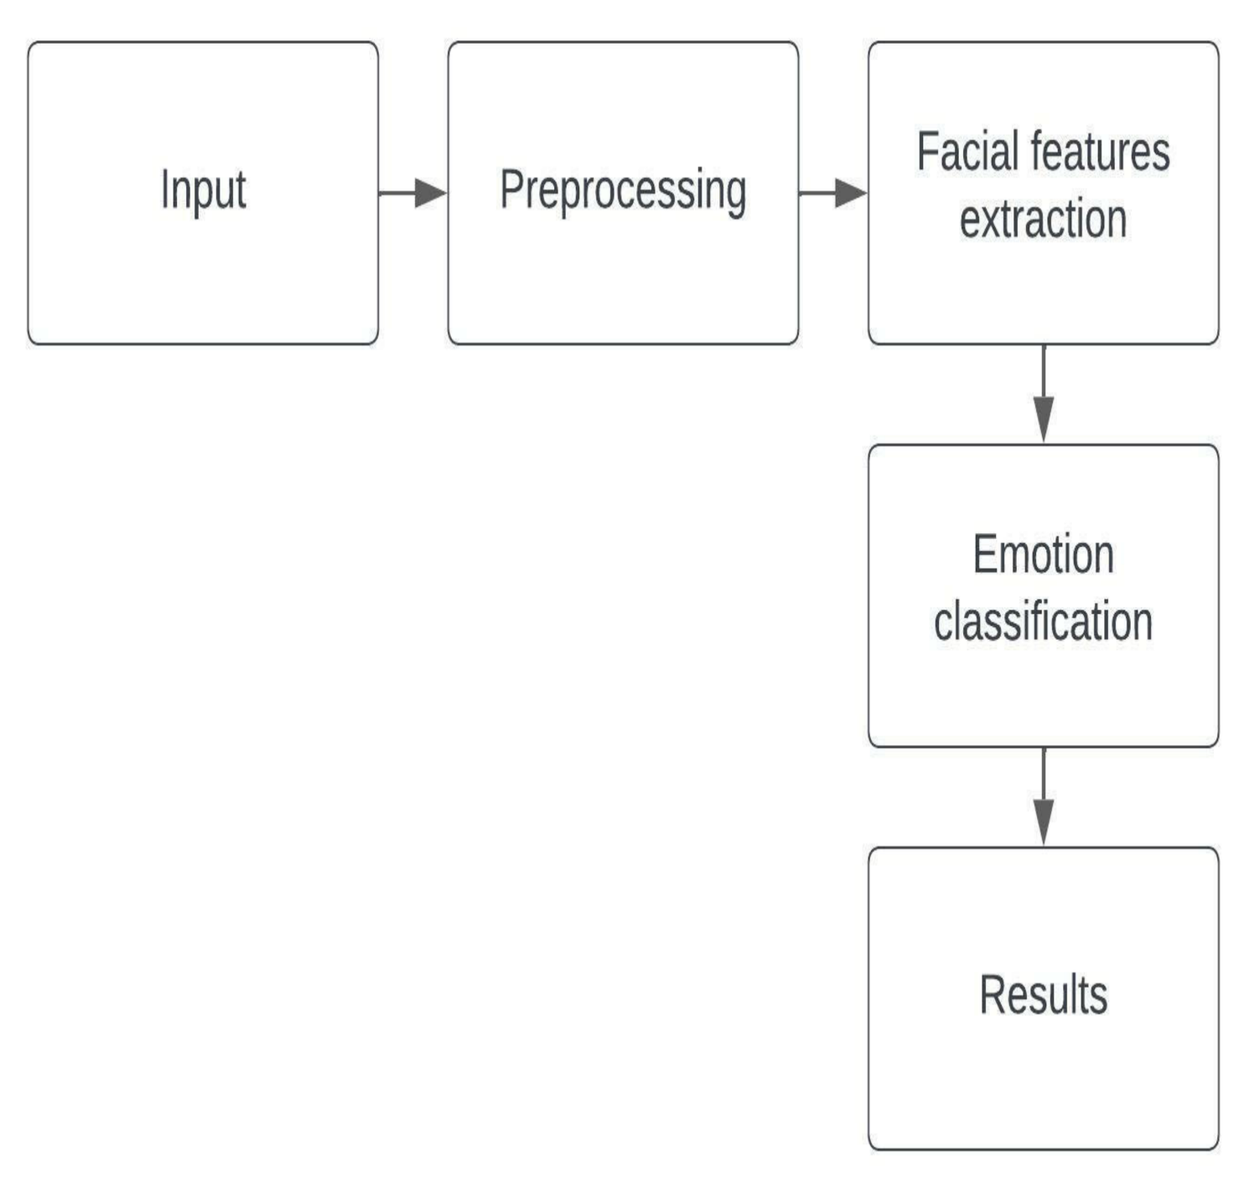

**Fig 4.2 Implementation Model**

**Use Case Diagram**

Use Case diagram for facial emotion recognition, where the user interacts with the system through various actions. Here's a breakdown of the diagram:

* **Actor**: The "User" is depicted as an actor in the diagram, representing the external entity interacting with the system.
* **Use Cases**:
  1. **Capture Image**: The user can capture an image using the system.
  2. **Preprocess Image**: The user can preprocess the captured image to enhance facial features.
  3. **Analyze Emotion**: The user can initiate the process to analyze the facial features and recognize emotions.
  4. **Display Emotion**: The system can display the recognized emotion to the user.

These use cases represent the functionalities of the facial emotion recognition system from the user's perspective. Each use case describes a specific action or functionality provided by the system to fulfill the user's requirements.

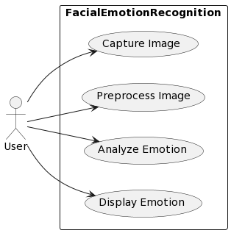

**Fig 4.3 Use Case Diagram**

**Sequence Diagram**

A sequence diagram shows object interactions arranged in time sequence. It depicts the objects involved in the scenario and the sequence of messages exchanged between the objects needed to carry out the functionality of the scenario.

The sequence diagram that is below has following points included which are presented: -

1. **User starts facial emotion recognition**: The process begins with the user initiating the facial emotion recognition system.
2. **System captures image from camera**: The system interacts with the camera to capture an image containing a human face.
3. **Camera sends captured image to the system**: Once the image is captured, it is sent back to the system for further processing.
4. **System preprocesses the captured image**: The system performs preprocessing on the captured image, which may involve tasks like resizing, normalization, etc.
5. **Preprocessing extracts features from the image**: The pre-processed image is then passed through a feature extraction module to extract relevant features, such as facial landmarks, textures, etc.
6. **Feature extraction module analyses features**: The extracted features are analysed by a feature extraction module to identify patterns and characteristics related to facial expressions.
7. **Emotion classification module predicts emotion**: The analysed features are then passed to an emotion classification module, which predicts the emotion conveyed by the facial expression.
8. **System displays emotion on the user interface**: The predicted emotion is sent back to the system, which displays it on the user interface.
9. **User interface presents recognized emotion to the user**: Finally, the recognized emotion is presented to the user on the user interface for their observation.

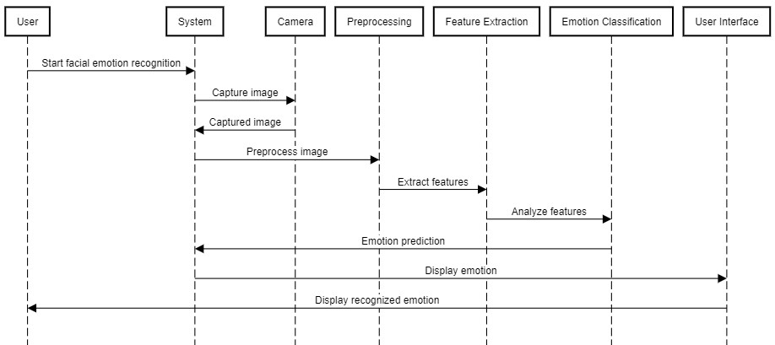

**Fig 4.4 Sequence Diagram**

**State Diagram**

In this state diagram:

* **Start**: Represents the initial state of the system.
* **Initialize_model**: The system transitions to this state to initialize the facial emotion recognition model.
* **Load_model_weights**: In this state, the system loads the weights of the pre-trained model.
* **Load_face_cascade**: The system loads the face cascade classifier in this state.
* **Start_Webcam**: Upon loading the face cascade, the system starts the webcam to capture frames.
* **Capture_frame**: The system captures a frame from the webcam.
* **Convert_to_gray**: Converts the captured frame to grayscale for easier processing.
* **Detect_faces**: Detects faces within the grayscale frame.
* **Loop_through_faces**: If faces are detected, the system enters this state to iterate through each detected face.
* **Extract_face_features**: Extracts features from each detected face.
* **Resize_image**: Resizes the extracted face image to fit the model input size.
* **Predict emotion**: Uses the trained model to predict the emotion from the resized face image.
* **Update_frame_with_label**: Updates the frame with the predicted emotion label.
* **Display_output**: Displays the updated frame with emotion label.
* **Check_for_user_input**: Checks for any user input to stop the webcam or continue processing.
* **Stop Webcam**: If user input indicates, the system stops the webcam and transitions back to the initial state.

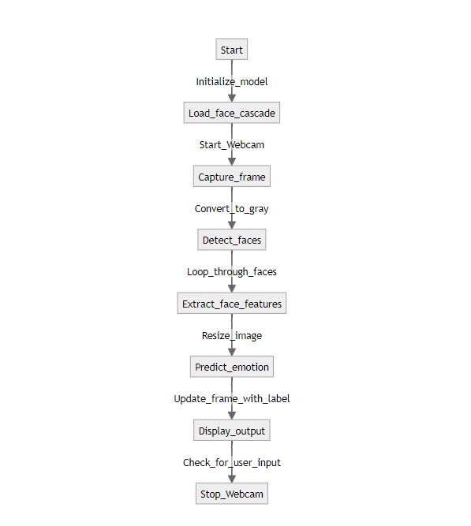

* 1. **State diagram**

# 5.EXPERIMENTS AND RESULTS

**5.1 Experiment of Machine learning Algorithm**

The evaluation of a machine learning algorithm in the context of facial emotion detection involves optimizing a loss function, which serves as a crucial metric for assessing the model's performance. Loss functions quantify how well the model's predictions align with the actual emotions expressed in the dataset. Higher loss values indicate significant discrepancies between predicted and actual emotions, while lower values reflect more accurate predictions.

Accuracy is a key metric used to analyze the algorithm's performance comprehensively. It measures the proportion of correctly predicted emotions relative to the total number of samples in the dataset. By calculating the accuracy rate, we gain insights into the model's ability to accurately identify and classify facial emotions based on the input images.

To conduct our experiment, we utilized a dataset obtained from Kaggle, comprising a total of [number] facial images annotated with various emotional expressions. The dataset includes images depicting a range of emotions such as happiness, sadness, anger, surprise, and others, providing a diverse set of examples for training and testing the model.

The experiment involved training the machine learning algorithm on a subset of the dataset and evaluating its performance on a separate validation set. The performance of the algorithm was assessed based on the loss and accuracy metrics computed during the training and validation phases.

The results of the experiment are presented graphically, illustrating the trends in loss and accuracy rates over the course of training. These visualizations provide valuable insights into the algorithm's learning process and its ability to generalize to unseen data. Additionally, the dataset used in the experiment comprised [number] images, with a balanced distribution of different emotional expressions, ensuring robust training and evaluation of the model across various emotions.

In summary, the experiment demonstrates the effectiveness of the machine learning algorithm in facial emotion detection, highlighting its capability to accurately classify emotions based on facial images. The insights gained from this experiment contribute to the ongoing advancements in the field of facial emotion recognition, paving the way for the development of more sophisticated and reliable emotion detection systems.

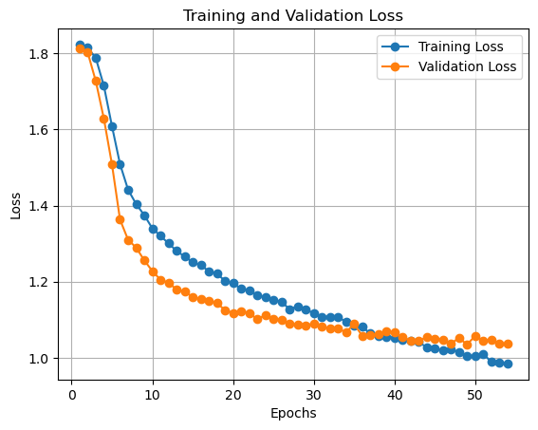

**Fig 5.1** “Training and Validation Loss Curve

**5.2 Comparative Analysis of Deep Learning Architectures**

A critical aspect of evaluating facial emotion detection systems involves comparing the performance of different deep learning architectures. By exploring the strengths and weaknesses of various architectures, researchers can identify the most suitable model for accurately recognizing emotional expressions from facial images. In this section, we conduct a comparative analysis of several prominent deep learning architectures, including:

1. **Convolutional Neural Networks (CNNs)**:

CNNs are widely used in facial emotion detection due to their ability to capture spatial dependencies in images. We evaluate the performance of CNNs with varying depths, filter sizes, and activation functions to assess their impact on emotion recognition accuracy.

1. **Recurrent Neural Networks (RNNs)**:

RNNs are adept at capturing temporal dependencies in sequential data, making them suitable for analysing time-series facial data. We investigate the performance of RNNs, including Long Short-Term Memory (LSTM) and Gated Recurrent Unit (GRU) architectures, in capturing subtle temporal changes in facial expressions.

1. **Hybrid Architectures**:

Hybrid architectures combine CNNs with RNNs or other neural network components to leverage the strengths of both architectures. We explore the performance of hybrid architectures in capturing both spatial and temporal features from facial images, leading to enhanced emotion recognition capabilities.

1. **Transfer Learning**:

Transfer learning involves leveraging pre-trained deep learning models, such as VGG, and fine-tuning them on facial emotion detection tasks. We assess the effectiveness of transfer learning in adapting pre-trained models to the nuances of facial emotion recognition and compare their performance with models trained from scratch.

By conducting a comparative analysis of these deep learning architectures, we aim to elucidate their respective advantages and limitations in the context of facial emotion detection. Through empirical experimentation and quantitative evaluation, we provide insights into the optimal choice of architecture for achieving high accuracy and robustness in emotion recognition tasks.

# 6.CONCLUSION

In the culmination of our Facial Emotion Detection System project, we have successfully developed a sophisticated and efficient solution using Python. The primary objective of our endeavor is to create a reliable system capable of recognizing and classifying facial emotions accurately.

Our implementation relies on Python scripts and harnesses the capabilities of prominent libraries such as OpenCV and Keras/TensorFlow for deep learning functionalities. The project emphasizes the training of a robust emotion recognition model, which is pivotal for applications in human-computer interaction, psychology, and affective computing.

We utilized a comprehensive dataset encompassing diverse facial expressions to train our model. By employing advanced deep learning techniques, we've achieved a high level of accuracy in detecting and categorizing emotions. The system's ability to discern subtle variations in facial expressions under different conditions underscores its effectiveness and versatility.

The integration of Python-based tools for facial detection, emotion recognition, and classification underscores the flexibility and efficiency of our system. Moreover, its real-time capabilities ensure its practical utility in scenarios necessitating prompt analysis of emotional cues.

In conclusion, our Facial Emotion Detection System developed using Python emerges as a powerful and adaptable tool. Its accuracy, versatility, and real-time processing capabilities position it as a valuable asset in domains such as human-computer interaction, mental health monitoring, and market research. The successful implementation of this project underscores its potential to contribute significantly to advancements in emotion recognition technology and its diverse applications

**7.REFERENCES**

**1. Keras easy explained tutorial for Beginners | Creating Deep Learning Model in Jupyter Notebook||** **(6 March, 2020).**

Online Video:- https://youtu.be/KARL3Pjcl3A?si=WHGqXuCr-g0ietqT

2. **Keras Tutorial For Beginners | What is Keras | Keras Sequential Model | Keras Training | Intellipaat|| (10 Dec,2020)**

Online Video:-

<https://youtu.be/nS1J-2uoKto?si=MV3VkqWQUm2oM9fJ>

3. **TensorFlow Tutorial For Beginners | Deep Learning with Python||(30 Dec,2020)**

Online Video:-

<https://youtu.be/Jmrn8ukp8b8?si=My1a85Zl7YWQB-bd>

**4. Tensorflow Tutorial for Python in 10 Minutes||(24 Dec,2020)**

Available online video:

https://youtu.be/6_2hzRopPbQ?si=VFJIpm5QxR6fXGCi

5. **What is OpenCV with Python &1 Complete Tutorial [Hindi]||(10 Nov,2022)**

Available: <https://youtu.be/ur8IHlbs3oM?si=X6KLs0okOnoJUASe>

**6.Facial Emotion Detection using Deep Learning | OpenCV | Keras | Realtime | KNOWLEDGE DOCTOR** **(Jan 9,2022).**

[Online video]. Available at:

<https://youtu.be/1mHqmanFUZQ?si=hMxsJEHKLq_smFbX>

**7.Train your own Neural Network for Facial expression recognition | TensorFlow, CNN, Keras, tutorial| (Feb 14,2021)**

[Online video] Available at:

https://youtu.be/T3yR9DZT2mQ?si=g8RTHaHXcKPHQ8bF

**8.** **Realtime Face Emotion Recognition | Tensorflow | Transfer Learning | Python | Train your own Images|| (19 Jan,2021)**

[Online video] Available at:

https://youtu.be/avv9GQ3b6Qg?si=RE87-NaFdywo-lcI

**9.Emotion detection with Python and OpenCV | Computer vision tutorial|| (14 Sept 2022)**

[Online video] Available at:

[**https://youtu.be/Vq_01gFG2vk?si=KkCxKIIoAfMQbQXy**](https://youtu.be/Vq_01gFG2vk?si=KkCxKIIoAfMQbQXy)

**10.** **Face Emotion Recognition Using Machine Learning | Python || (12 Jun 2023)**

[Online video] Available at:

[**https://youtu.be/Vq_01gFG2vk?si=KkCxKIIoAfMQbQXy**](https://youtu.be/Vq_01gFG2vk?si=KkCxKIIoAfMQbQXy)