Class____ Seat No.____

Roll No.____

VIVEKANAND EDUCATION SOCIETY'S INSTITUTE OF TECHNOLOGY

Hashu Advani Memorial Complex, Collector's Colony, R C Marg, Chembur, Mumbai-400074



**CERTIFICATE**

Certified that Mr./Miss ________________________________ of _______________________ has satisfactorily completed a course of the necessary experiments/assignments in ____________________under my supervision in the Institute of technology in the year 20__-20__

Principal Head of Department

Lab In-charge Subject Teacher

**Subject: Web Programming Academic Year: 2016-2017**

**Index Sheet**

|  |  |  |  |  |  |
| --- | --- | --- | --- | --- | --- |
| **Experiment No** | **Experiment Name** | **Date of Performance** | **Data of Submission** | **Grade** | **Sign** |
| 0 | Case study: pros and cons of any 5 websites |  |  |  |  |
| 1 | HTML page design using basic HTML tags |  |  |  |  |
| 2 | Web page Template creation using HTML and CSS |  |  |  |  |
| 3 | JavaScript Programs |  |  |  |  |
| 4 | Introduction to JQuery and JQuery getting started programs |  |  |  |  |
| 5 | Login and Signup page validation using JQuery from validation plugin |  |  |  |  |
| 6 | Introduction to PHP. Basic PHP programs |  |  |  |  |
| 7 | Event Management using PHP |  |  |  |  |
| 8 | Introduction to JSP / Servlet. Telephone directory using JSP / Servlet |  |  |  |  |
| 9 | Introduction to ASP.NET. ASP.NET server controls |  |  |  |  |
| 10 | Mini Project using any server side scripting language, HTML, CSS and JQuery |  |  |  |  |

**Web Programming Mini Project**



# **STEPUP MUSIC**

Group Members:

***1) Jackie Hinduja -34***

***2) Karan Hotwani-36***

***3)Radhika Karwa-44***

**ABSTRACT**

The design and implementation of music and lyrics website can be used by anyone to listen music of their favourite artists with lyrics easily.

Achieving this objective is difficult using a manual system as the information and lyrics are numerous, but everything is solved using this project. Instead of searching the lyrics everywhere all data is stored including the music and lyrics securely on servers managed by the website manager.

The system makes the user to create the account and then they can have access to the website or can also view and listen if they wish not to have an account right away. There is graphical interface for each cover page to make website more creative.

Streaming is generally taken to refer to cases where a user watches digital video content and/or listens to digital audio content on a computer screen and speakers (ranging from a desktop computer to a smartphone) over the Internet. With strea

ming content, the user does not have to download the entire digital video or digital audio file before they start to watch/listen to it. There are challenges with streaming content on the Internet. If the user does not have enough bandwidth in their Internet connection, they may experience stops in the content and some users may not be able to stream certain content due to not having compatible computer or software systems.

**Introduction to the system:**

The craze of listening music all the time has increased and not every song is available in the phone every time so in order to listen the music anytime this website is made. And sometimes the lyrics are also needed. The main advantage of this website will be it won’t cost any money. You just have to create the account to get access for services.

Streaming is generally taken to refer to cases where a user watches digital video content and/or listens to digital audio content on a computer screen and speakers (ranging from a desktop computer to a smartphone) over the Internet. With streaming content, the user does not have to download the entire digital video or digital audio file before they start to watch/listen to it. A client end-user can use their media player to begin to play the data file (such as a digital file of a movie or song) before the entire file has been transmitted.The user can opt for the premium version if they wish to have an ad free experience.

**Goals and Objectives**

* Provide various types of graphical designs on each artists and song.
* Provide the information about the song.
* Provide music of various artists arranged in alphabetically order.
* Provide registration facility for users to access for our services.
* Free of cost.
* Provide lyrics for every music

**Technology stack used**

In our project we have used Html css and php as the front end. Html as the base and css for the designing and php to unlock some extra features for ease of development. as far as the backend goes Sql is what we have used to store and retrieve data for the users who login to our website etc.

**Functional and nonfunctional requirements**

* We have added songs by artists and have also provided proper lyrics for all those music heads out there.
* With dedicated graphical design on each artist and song that plays.
* Arranged in a systematic and Alphabetic order so that its easy to access
* There are facilities like register and login if they wish to have a account for themselves.
* There’s also a pro version to it if anyone wishes to spend for a way more better experience to our music world.

**SCREENSHOT**

**1.Login Page**

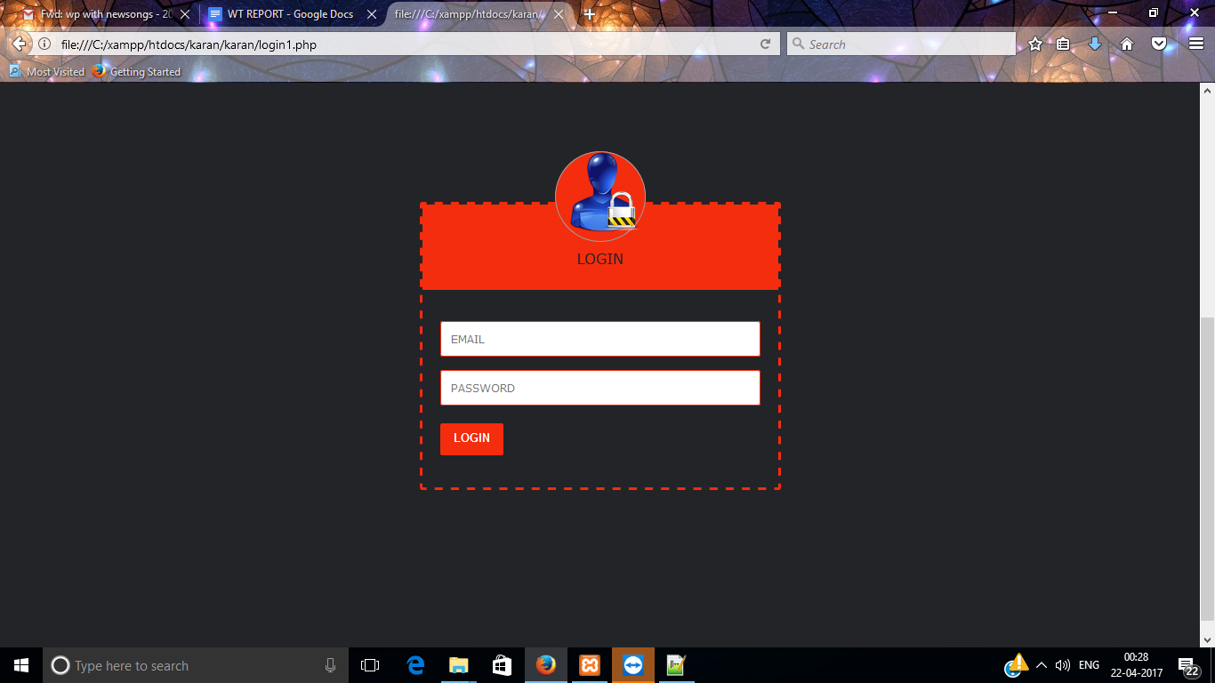

**2.Signup Page**

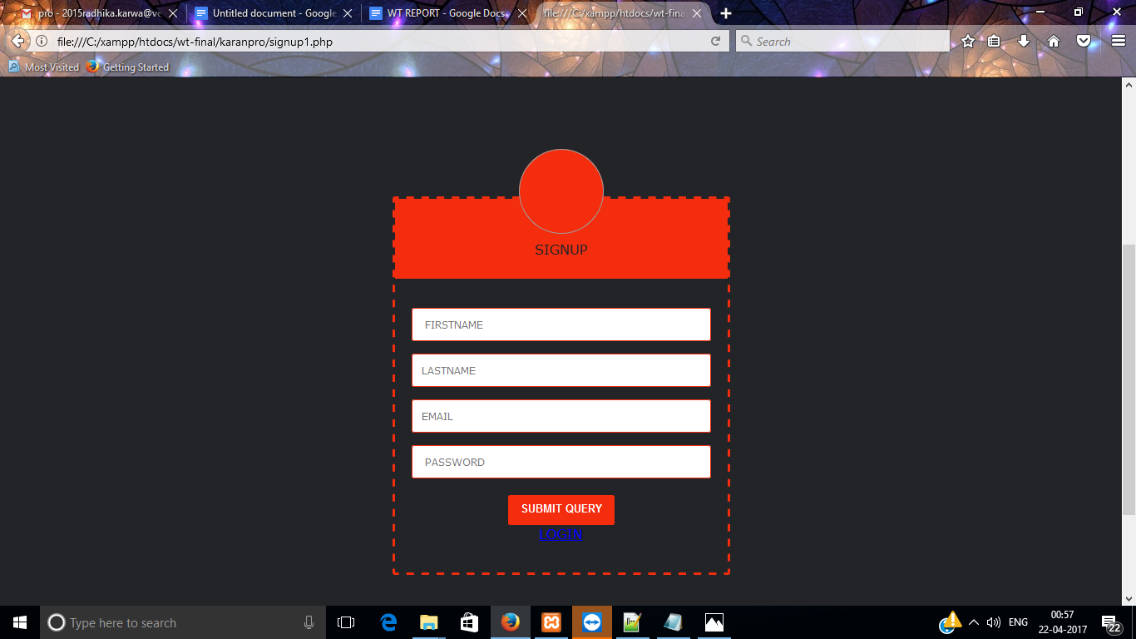

**3.Front Page**

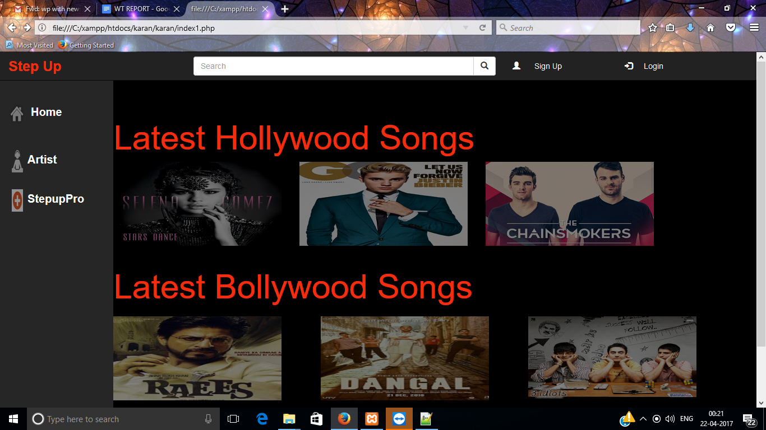

**4.About Artist**

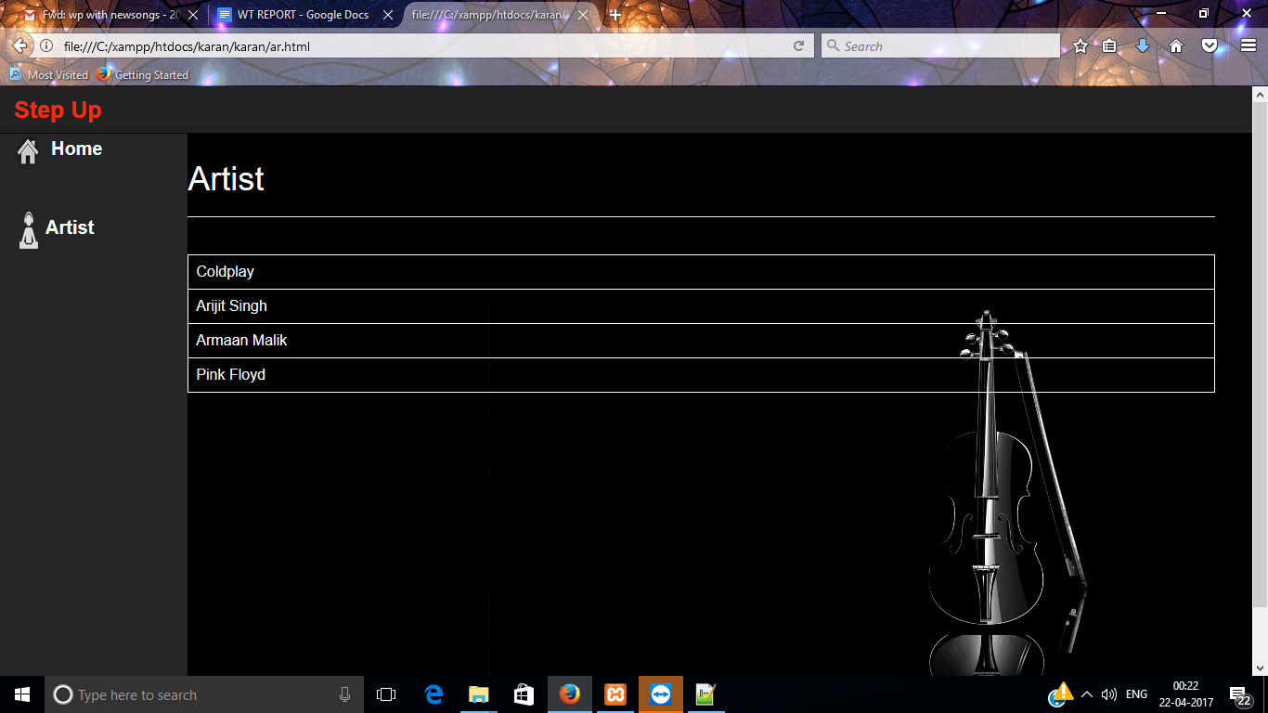

**5.Information**

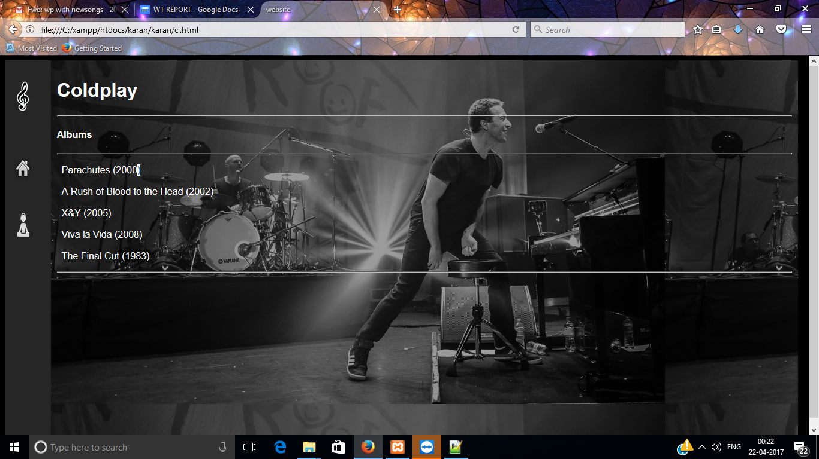

**6.Song Page**

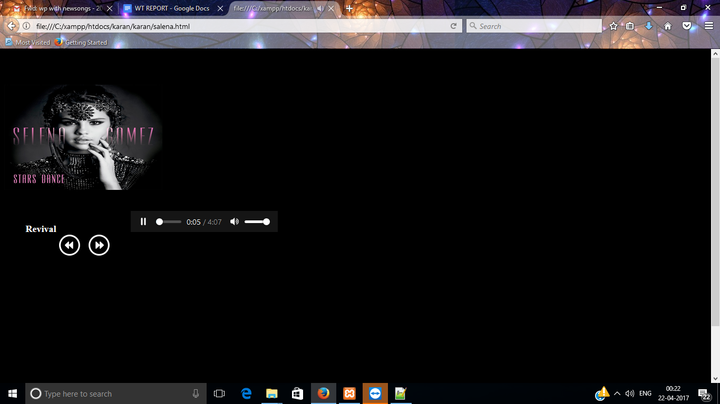

**7. Payment Information**

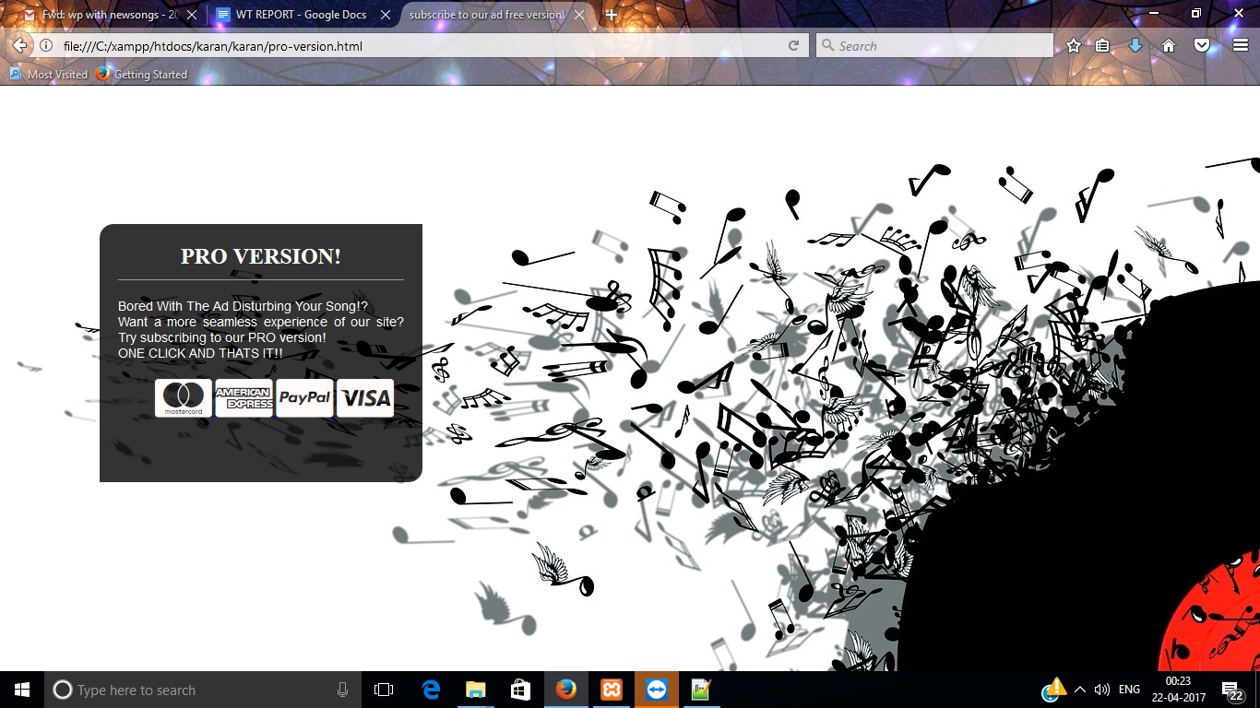

**CONCLUSION**

After making this project we gained a command over some of the basic scripting languages and also got an opportunity to use all those languages to make one project out of it.

This project can be updated regularly with all new albums coming up daily, With some advanced knowledge about the scripting languages used this site can be made more attractive and user friendly.

With today's youth listening to music on such a large extent can make this website more useful for onestep for all latest songs out there.