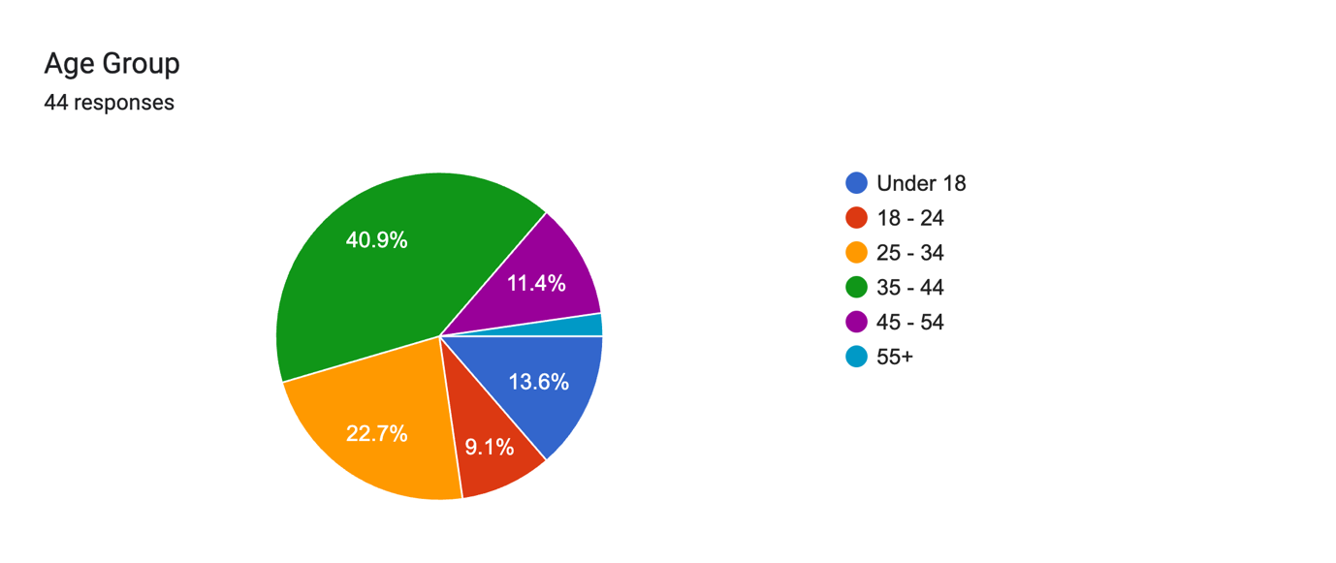

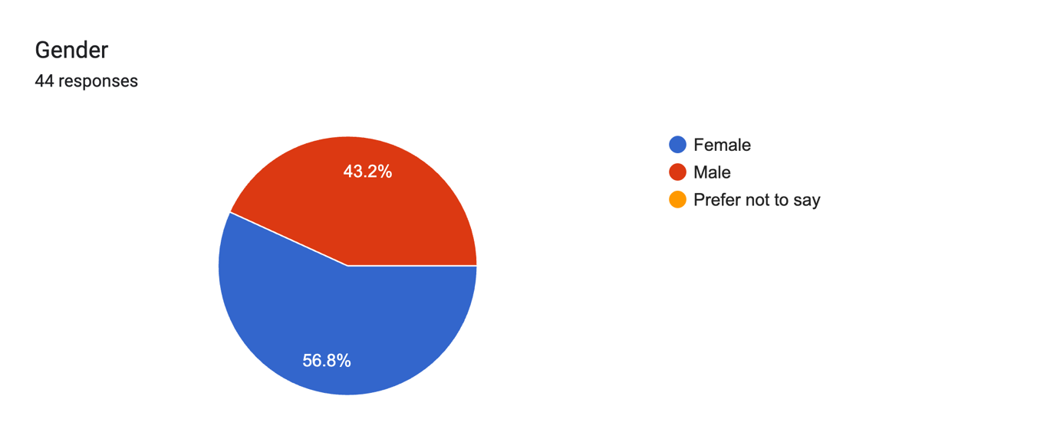

**Participants Education/ background/ job:**

Student

I am a middle schooler

Engineer

post graduate

MBA

I studied General Mathematics at university, and now I work as an Arabic language and Islamic religion teacher.

IT consultant

Software Designer

Masters in CS. Works as a Data Engineer..

Teacher

I have done Mass. Communication and now I am teaching

im a TY student

Graduated from physical education university

MSc - graduate

Masters in chemistry

Full Stack Developer

Arctect

I am a Computer Engineer with experience in software development, application support, and implementing security hardening measures across software and network systems. I am currently pursuing my postgraduate studies in Cybersecurity, further strengthening my expertise in securing digital infrastructures and developing resilient solutions.

Degree and post graduate degree

Level 9 education

I am a licensed pharmacist with a strong educational background and professional experience in providing safe, effective medication therapy and patient-centered care.

Secondary school

PRT from last 12 yesrs

B.E

Third year

I am a secondary TY student

I’m a Physiotherapist by profession

Iam ophthalmologist

University Graduate

Experience in secondary school

I studied Business Administration

Undergraduate degree

Business administration

Finance professional

1st year in college

PhD

Itec level 3 clinical therapist

Physics

Masters in international business

Engineer

I am a masters student

B.S.c Computer engineering, 10+ experience in Software engineering

Bachelor, Electronics and Communication Engineering 1997 - 2002, Oracle DBA

**For Cyclists:**

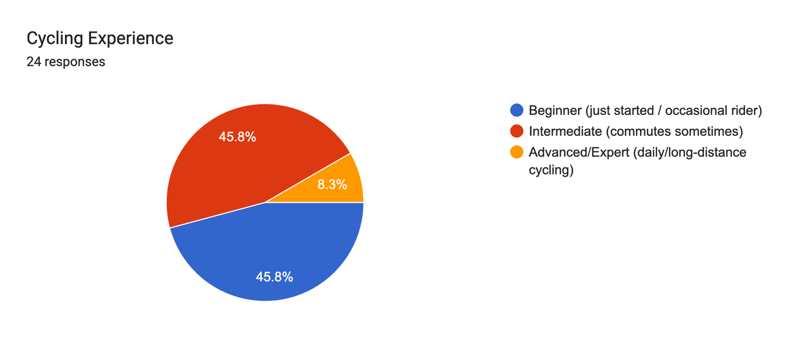

Forms response chart. Question title: What frustrates you about current navigation apps when cycling?

(Choose one or more). Number of responses: 23 responses.

Forms response chart. Question title: Which features do you find most valuable when using current navigation apps for cycling?
(Choose one or more, rate each: Yes / No / Maybe useful). Number of responses: .

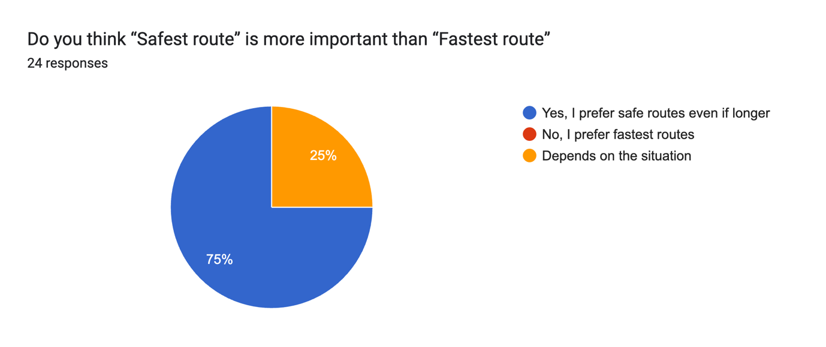

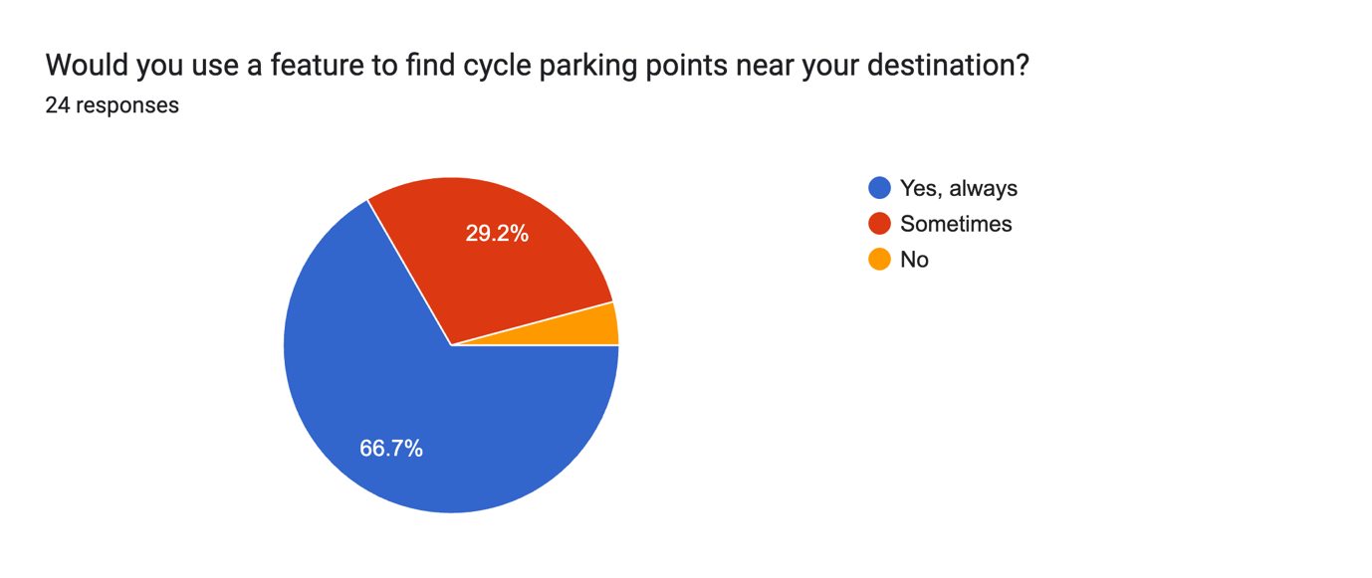

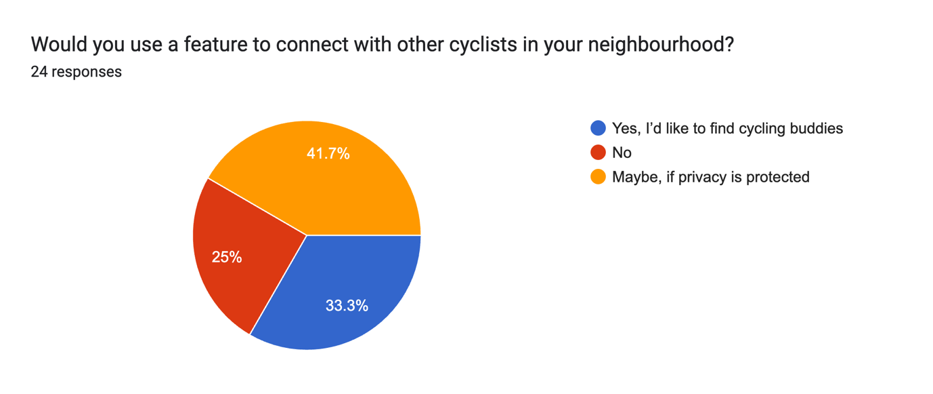

**For Pedestrians:**

Forms response chart. Question title: How often do you walk as part of your daily or weekly routine?

(e.g., to school, work, shops, or transport stops). Number of responses: 39 responses.

Forms response chart. Question title: What frustrates you about current navigation apps when walking?

(Choose one or more). Number of responses: 38 responses.

Forms response chart. Question title: What features would you find most valuable in the SafePath app? 
(Choose one or more). Number of responses: 36 responses.

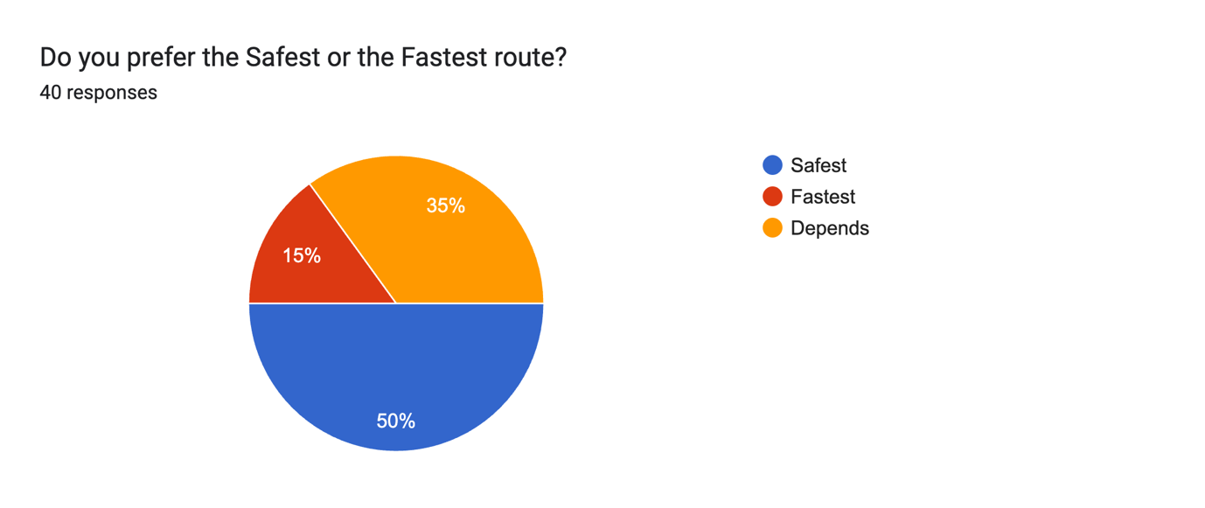

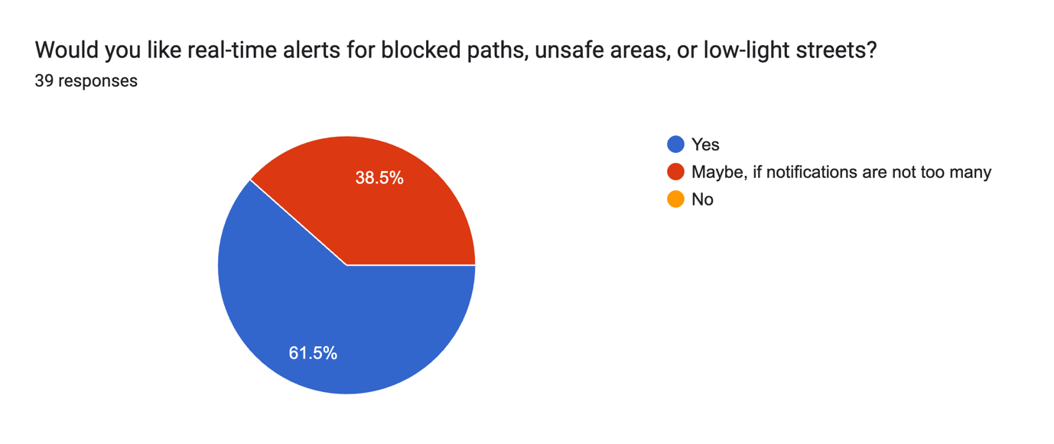

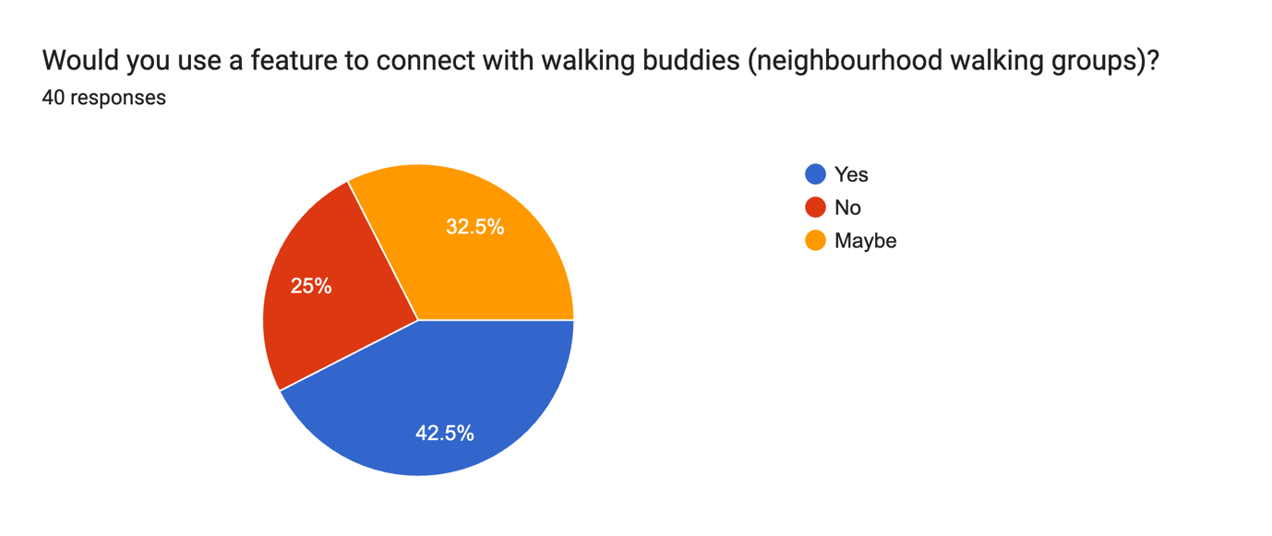

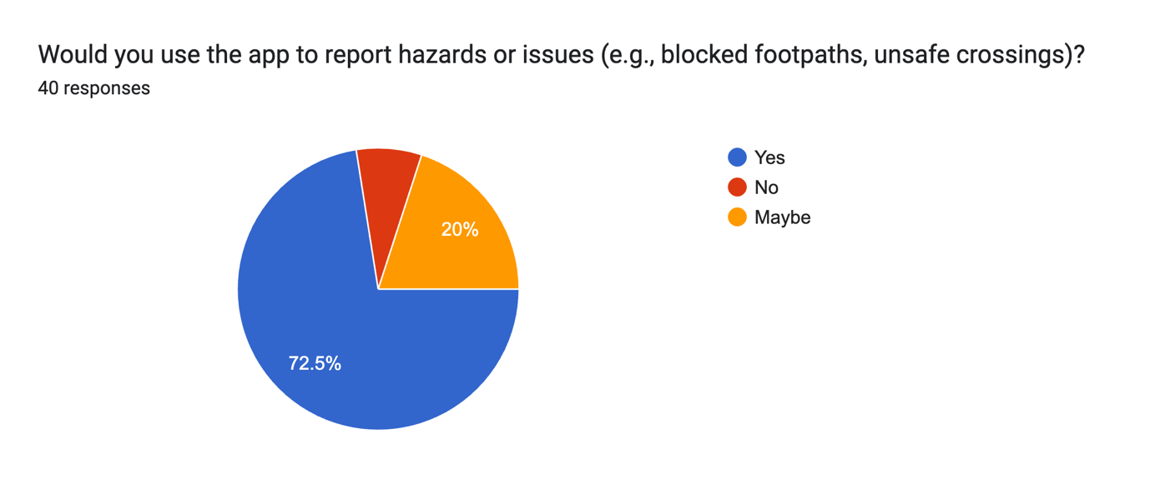

**For all users ( Cyclist and Pedestrians)**

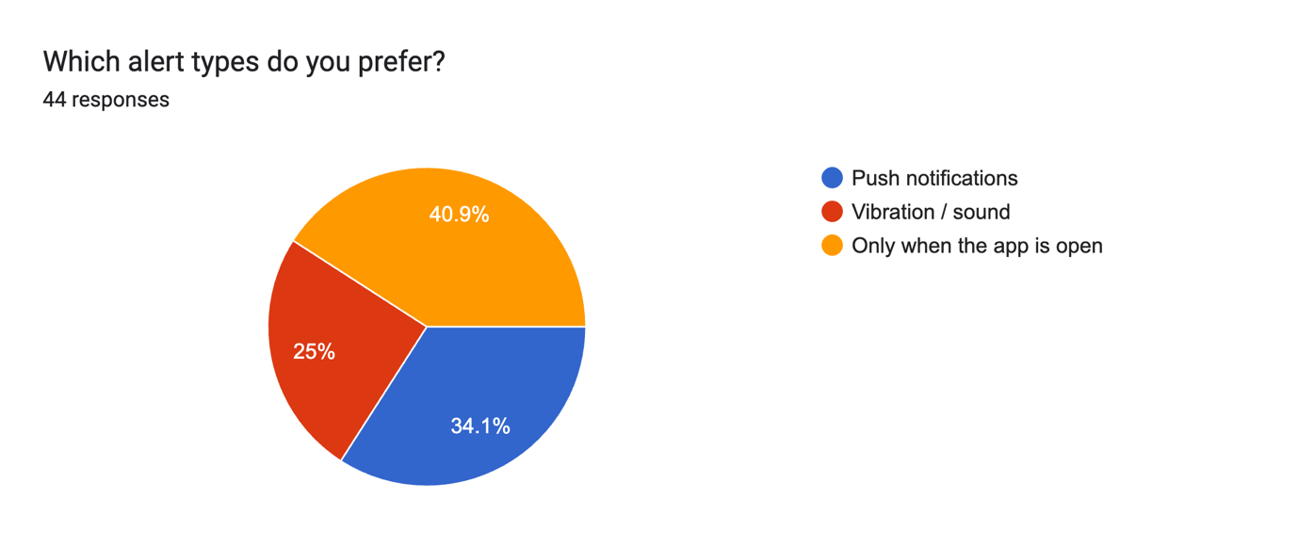

Forms response chart. Question title: How important are these features to you? 

(Rate 1–5: Not Important → Very Important). Number of responses: .

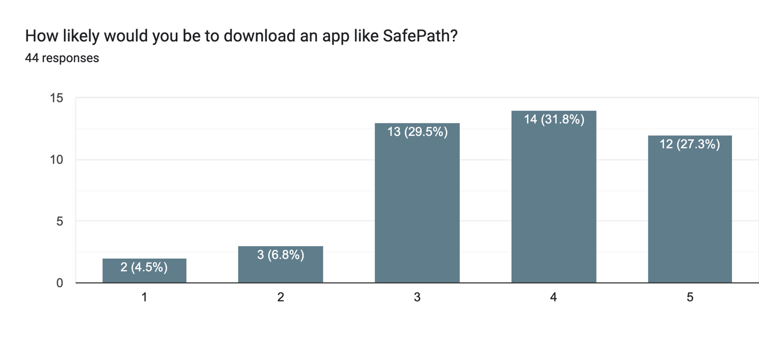

Forms response chart. Question title: What would encourage you most to use this app?

(Choose one or more). Number of responses: 44 responses.

Forms response chart. Question title: Where would you expect to hear about this app?

(Choose one or more). Number of responses: 44 responses.