Project Folder Introduction

1. Quantorix- ProductCatalog\Quantorix-backend\QuantorixProject -> Folder Contains the Actual Backend Container Based on Web API architecture with API endpoints for –

* Fetching Products
* Adding Products
* Fetching Sorted Products

1. Quantorix- ProductCatalog\quantorix-frontend -> Folder Contains the React Frontend Project
2. Quantorix- ProductCatalog\Quantorix-backend\ProjectCommons -> Folder contains a Class Library used for Common modules ex- Logger Service.

Tech Stack Used

1. Back End – ASP.Net Core with Entity Framework to connect with Database
2. Database – Microsoft SQL Server
3. Frontend – React , HTML, CSS

React Packages Used(npm) –

1. Axios
2. React-Router-Version 6
3. React-Select

.Net Core Packages(nuget) –

1. Microsoft.EntityFramework.SQL
2. Microsoft.EntityFramework.Tools

Project Screenshots –

Default Landing Page

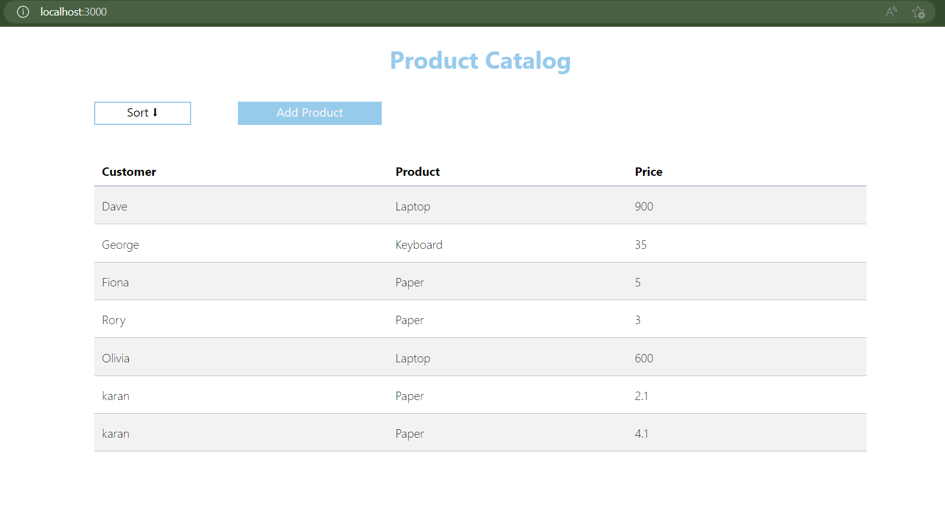

Sorting by Price on Ascending order

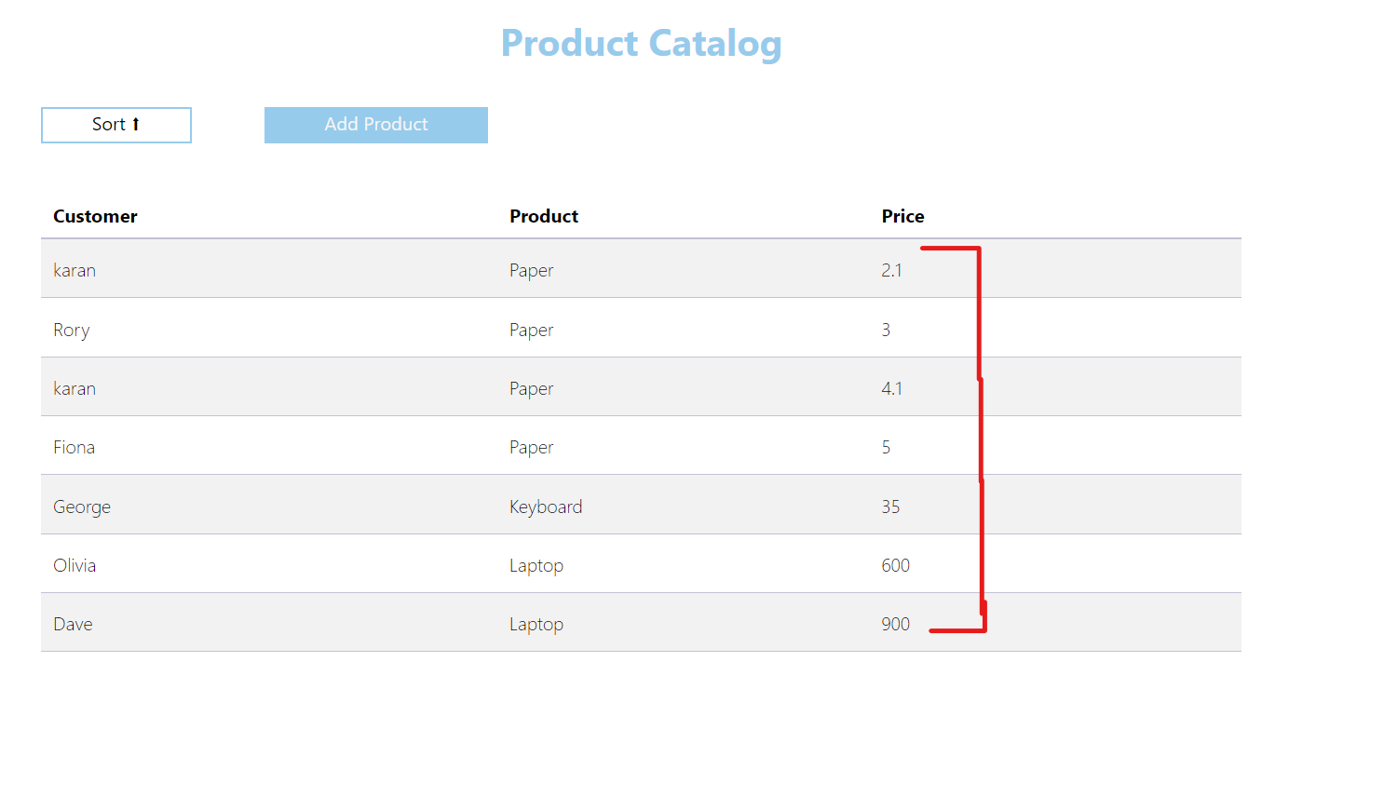

Sorting by Price on Descending order

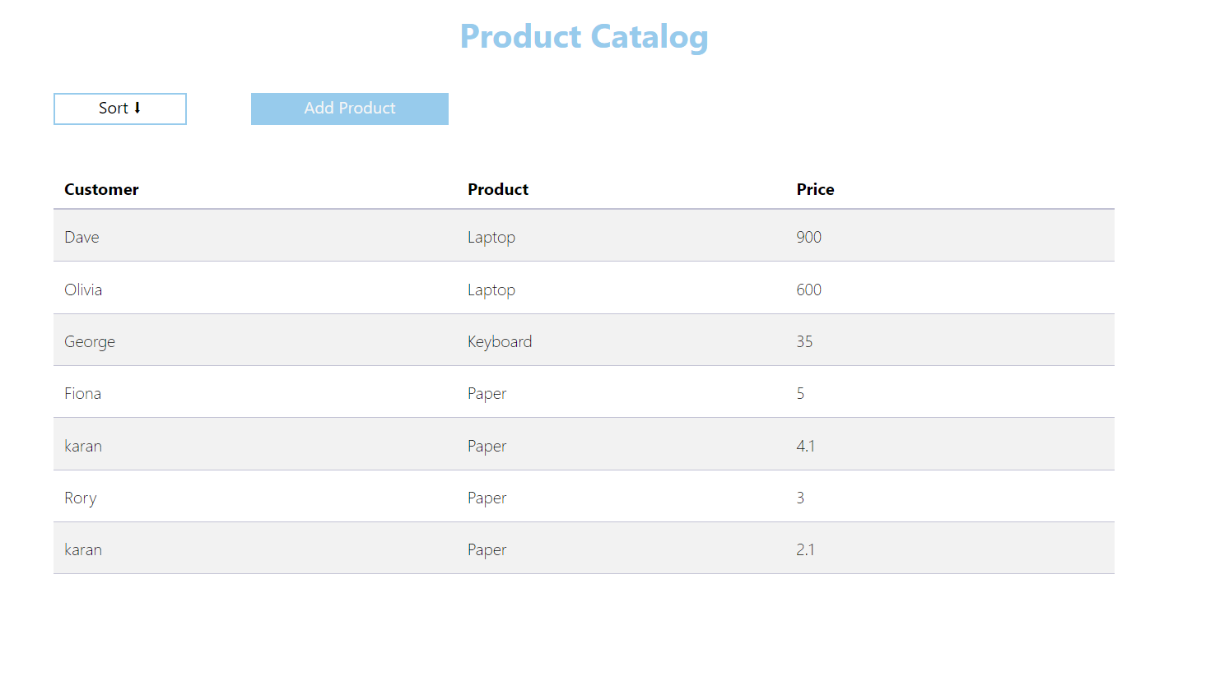

Add Product Screen

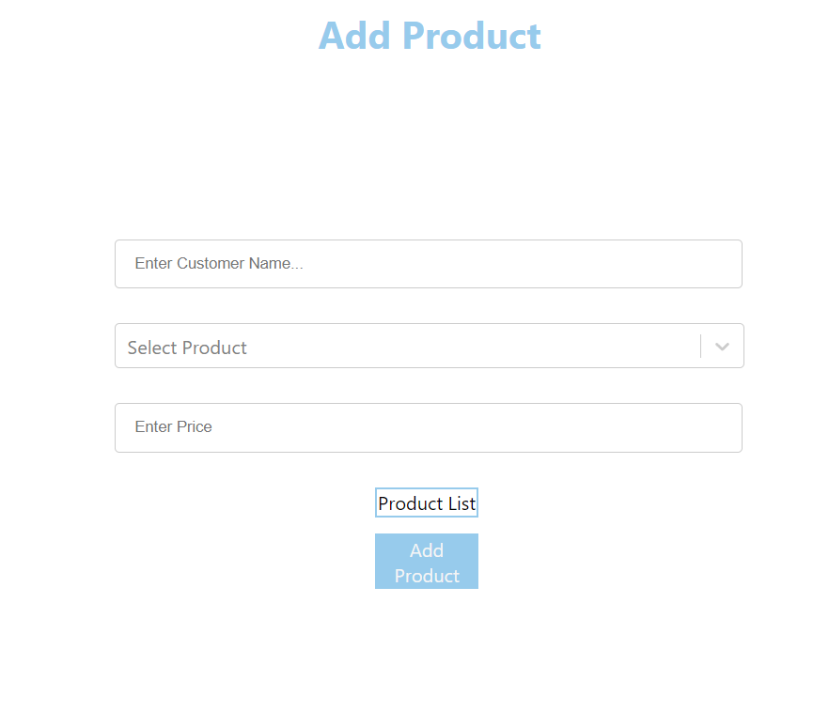

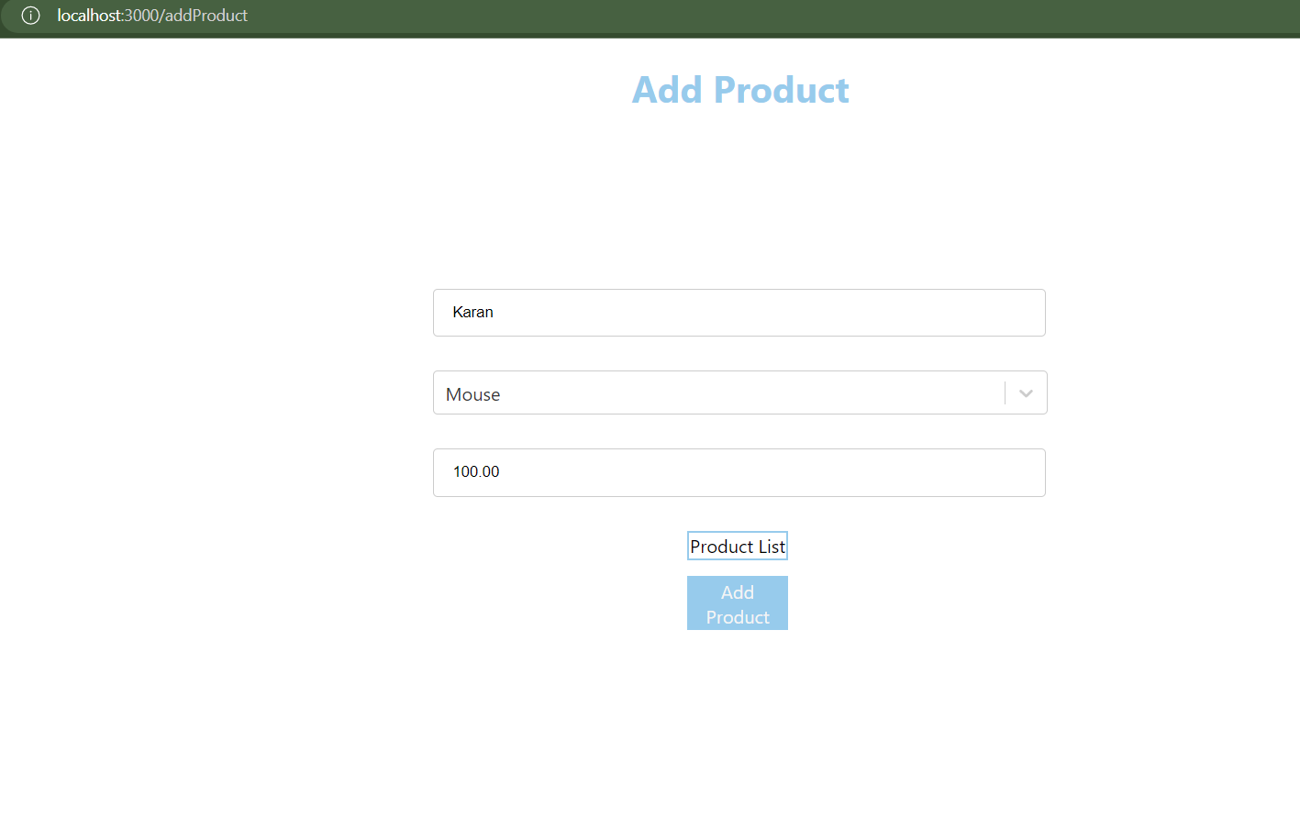

Database Snapshot

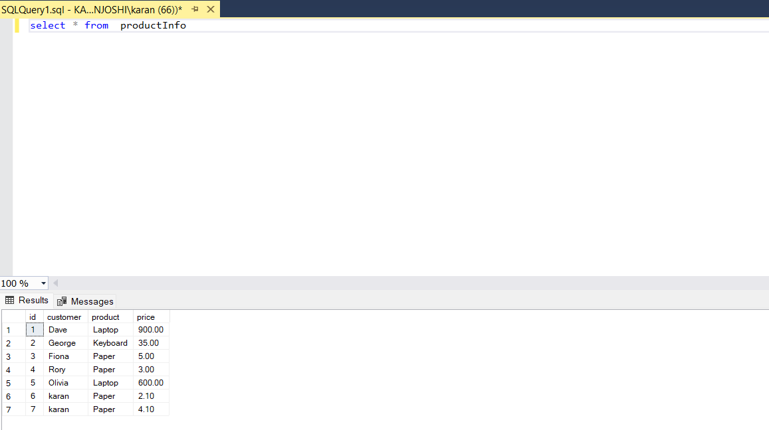

How to Run –

1. Setup Quantorix-backend folder in Visual Studio and build both Quantorix Project and Project Commons .Start the Quantorix Project and API’s will be hosted at the base URL <http://localhost:7531/api/Product> (To change Port Number check launchSettings.json File)
2. Setup Quantorix-frontend folder in Visual Studio / Visual Studio Code . Use the command npm start to start local react hosting server .

Project will be hosted at <http://localhost:3000> to browse.

1. Setup productInfo table In Database .