Compose already included in D Desktop
docker-compose --version
docker compose version

make a
1. compose file .yml
2. python source file (Flask App (Backend))
3. requirements.txt
4. nginx.conf
5. Dockerfile

cd C:\Users\HP\Desktop\INT332\Pcompose

docker-compose up –build
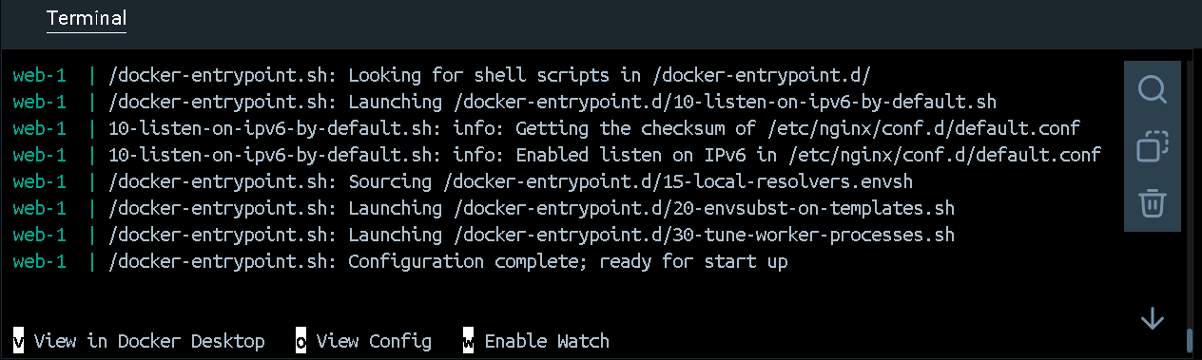

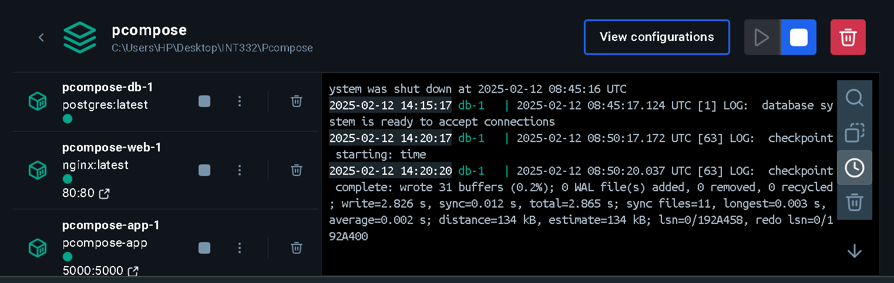

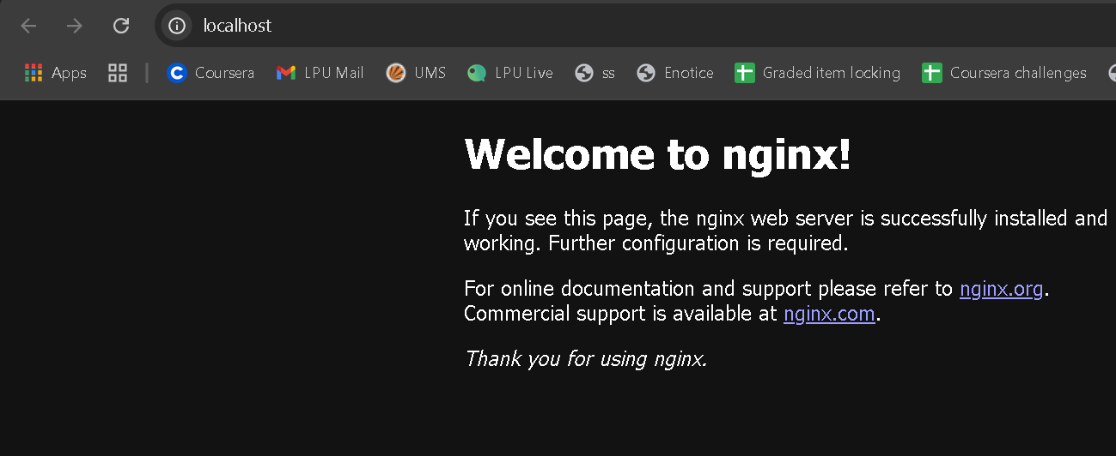



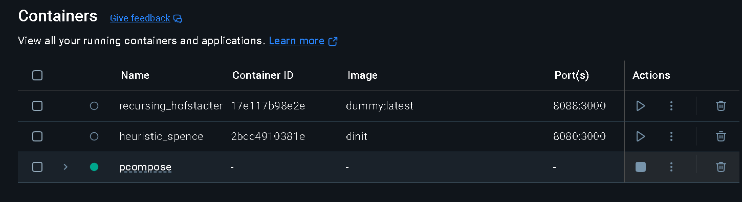
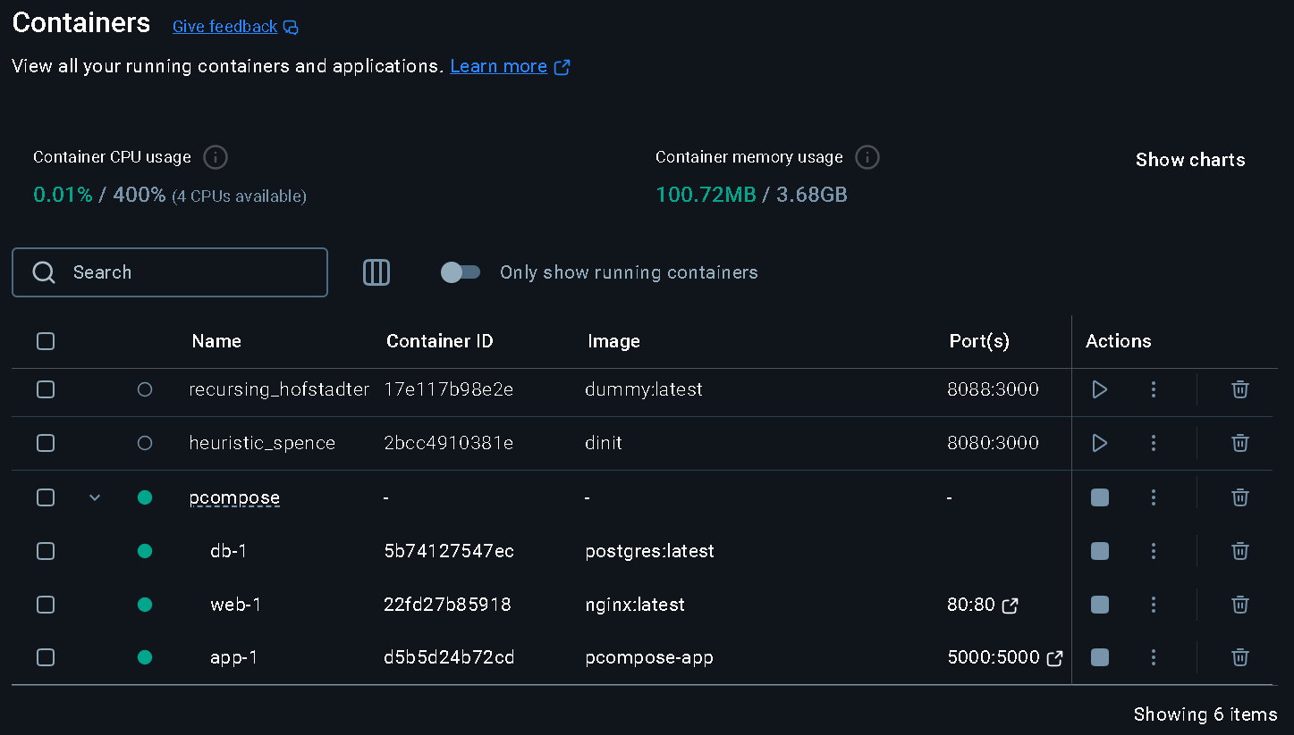
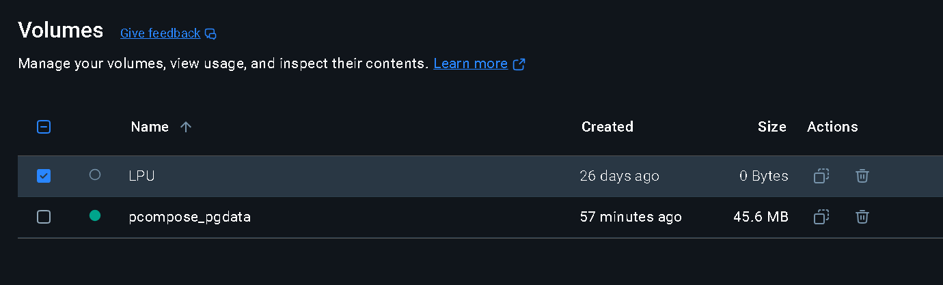

To start all the services defined in your compose.yaml file: docker compose up -d
./run_tests
To stop and remove the running services: docker compose down
If you want to monitor the output of your running containers and debug issues, you can view the logs with: docker compose logs
To lists all the services along with their current status: docker compose ps

https://docs.docker.com/reference/cli/docker/compose/

