**Netflix Database**

CBD_2303_FALL-2019

Database Design

Group no: 1

**OVERVIEW:**

Netflix is a content streaming service provided on internet. It can be accessed via website or the Netflix mobile application. It allows its users to watch different types of movies, tv shows and series.

There are three types of memberships:

* Basic
* Standard
* Premium

Basic plan contains one screen with HD resolution.

Standard plan contains two screens with FHD resolution.

Premium plan contains three screens with UHD resolution.

The Netflix database can be used in following ways:

* To retrieve the data of customer, their subscriptions and payment details.
* To search content available according to certain conditions.
* To retrieve the details of movies, tv shows and series.
* To offer discounts according to the payment cycle of customer.

**DIFFICULTIES FACED:**

* To find the number of tables for the database.
* Designing the ER diagrams and establishing the cardinality between them.
* Designing the queries according to the requirements.
* While designing the number of columns in the tables.

**LESSONS LEARNED:**

* How to create ER diagrams using software such as lucid charts.
* How to apply joins on multiple tables.
* How to fetch data by applying conditions.
* Use of different functions to retrieve data.
* Use of normalization.

**TOOLS USED**

|  |  |
| --- | --- |
| Lucidchart | ER diagrams |
| Mockaroo | Inserting data |
| XAMPP | Launching Mysql |
| MS word | Documentation |
| MS paint | screenshots |

**ENTITY RELATIONSHIP DIAGRAM**

Entity Relationship Diagram is a type of structural diagram for use in database design, also known as ERD, ER Diagram or ER model. An ERD contains various symbols and connectors that display two important information: the major entities within the scope of the system, and the interrelationships between these entities.

Let us have a look at the entity-relationship diagram of Netflix Database and how the different entities relate to each other:

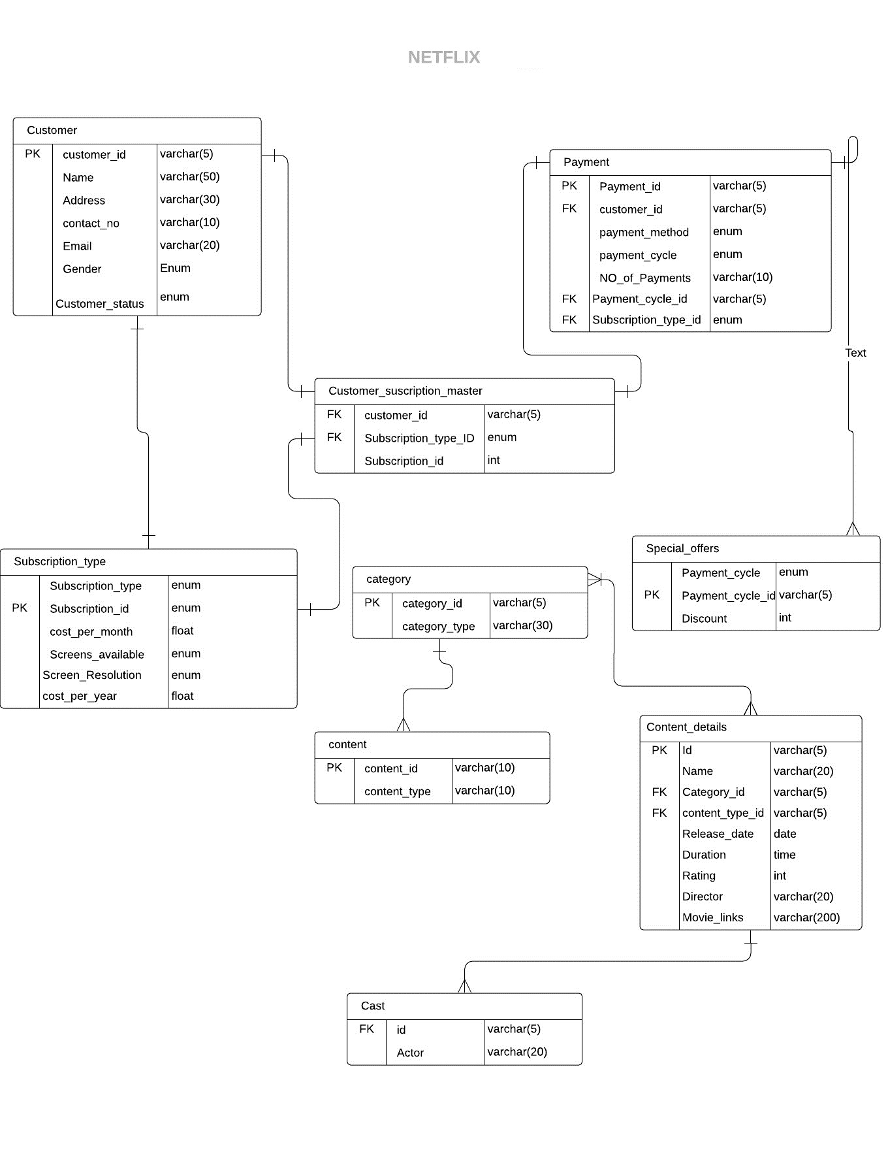

**TABLES**

CUSTOMER TABLE

|  |  |  |
| --- | --- | --- |
| FIELD NAME | DATA TYPE | CONSTRAINT |
| CUSTOMER_ID | VARCHAR | PRIMARY KEY |
| NAME | VARCHAR |  |
| ADDRESS | VARCHAR |  |
| CONTACT_NO | VARCHAR |  |
| EMAIL | VARCHAR |  |
| GENDER | ENUM |  |
| CUSTOMER_STATUS | ENUM |  |

SUBSCRIPTION_TYPE TABLE

|  |  |  |
| --- | --- | --- |
| FIELD NAME | DATA TYPE | CONSTRAINT |
| SUBSCRIPTION_TYPE | ENUM |  |
| SUBSCRIPTION_ID | ENUM | PRIMARY KEY |
| COST_PER_MONTH | FLOAT |  |
| SCREENS_AVAILABLE | ENUM |  |
| SCREEN_RESOLUTION | ENUM |  |
| COST_PER_YEAR | FLAOT |  |

CUSTOMER_SUBSCRIPTION_MASTER TABLE

|  |  |  |
| --- | --- | --- |
| FIELD NAME | DATA TYPE | CONSTRAINT |
| CUSTOMER_ID | VARCHAR | FOREIGN KEY |
| SUBSCRIPTION_TYPE_ID | ENUM | FOREIGN KEY |
| SUBSCRIPTION_ID | INT |  |

CATEGORY TABLE

|  |  |  |
| --- | --- | --- |
| FIELD NAME | DATA TYPE | CONSTRAINT |
| CATEGORY_ID | VARCHAR | PRIMARY KEY |
| CATEGORY_TYPE | VARCHAR |  |

CONTENT TABLE

|  |  |  |
| --- | --- | --- |
| FIELD NAME | DATA TYPE | CONSTRAINT |
| CONTENT_ID | VARCHAR | PRIMARY KEY |
| CONTENT_TYPE | VARCHAR |  |

CONTENT_DETAILS TABLE

|  |  |  |
| --- | --- | --- |
| FIELD NAME | DATA TYPE | CONSTRAINT |
| ID | VARCHAR | PRIMARY KEY |
| NAME | VARCHAR |  |
| CATEGORY_ID | VARCHAR | FOREIGN KEY |
| CONTENT_TYPE_ID | VARCHAR | FOREIGN KEY |
| RELEASE_DATE | DATE |  |
| DURATION | TIME |  |
| RATING | INT |  |
| DIRECTOR | VARCHAR |  |

PAYMENT TABLE

|  |  |  |
| --- | --- | --- |
| FIELD NAME | DATA TYPE | CONSTRAINT |
| PAYMENT_ID | VARCHAR | PRIMARY KEY |
| CUSTOMER_ID | VARCHAR | FOREIGN KEY |
| PAYMENT_METHOD | ENUM |  |
| PAYMENT_CYCLE | ENUM |  |
| NO_OF_PAYMENTS | VARCHAR |  |
| PAYMENT_CYCLE_ID | VARCHAR | FOREIGN KEY |
| SUBSCRIPTION_TYPE_ID | ENUM | FOREIGN KEY |

SPECIAL_OFFERS TABLE

|  |  |  |
| --- | --- | --- |
| FIELD NAME | DATA TYPE | CONSTRAINT |
| PAYMENT_CYCLE_ID | VARCHAR | PRIMARY KEY |
| PAYMENT_CYCLE | ENUM |  |
| DISCOUNT | INT |  |

CAST TABLE

|  |  |  |
| --- | --- | --- |
| FIELD NAME | DATA TYPE | CONSTRAINT |
| ID | VARCHAR | FOREIGN KEY |
| ACTOR | VARCHAR |  |

**Queries**

1. **Create table queries.**

create table category

(category_id varchar(5) primary key,

category_type varchar(20));

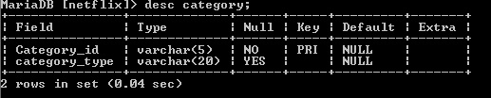

create table content

(content_id varchar(10) primary key,

content_type varchar(10));

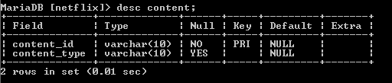

CREATE TABLE content_detail

(id varchar(5) Primary Key, name varchar(20) ,

category_id varchar(5) ,

content_type_id varchar(5) ,

release_date date ,

duration time ,

ratings int ,

director varchar(20) ,

FOREIGN KEY (category_id) REFERENCES category(Category_id),

FOREIGN KEY (content_type_id) REFERENCES content(content_id));

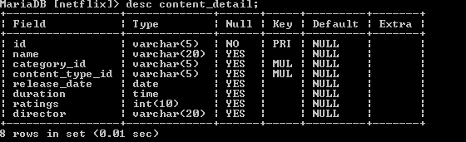

CREATE TABLE customer

(customer_id varchar(5) primary key,

Name varchar(50) ,

address varchar(30) ,

contact_no varchar(10) ,

email varchar(20) ,

gender enum('male','female','others') ,

customer_status enum('active','unactive'));

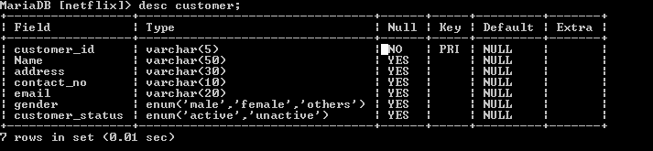

CREATE TABLE customer_subscription_master

( customer_id varchar(5) ,

subscription_id int(11) ,

subscription_type_ID enum('B1','S1','P1') ,

FOREIGN KEY (customer_id) REFERENCES customer (customer_id),

FOREIGN KEY (subscription_type_ID) REFERENCES subscription_type (subscription_id));

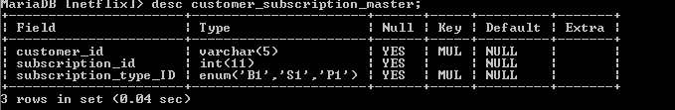

CREATE TABLE payment

( payment_id varchar(5) Primary key, customer_id varchar(5) ,

payment_method enum('debit','credit') ,

payment_cycle enum('monthly','yearly') ,

no_of_payments varchar(10) ,

FOREIGN KEY (customer_id) REFERENCES customer (customer_id));

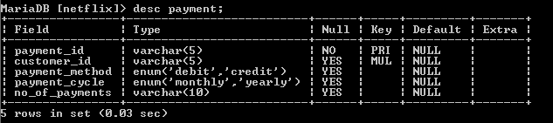

CREATE TABLE special_offers

(payment_cycle enum('monthly','yearly') ,

discount int );

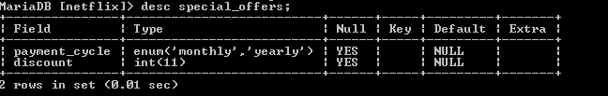

CREATE TABLE subscription_type

( subscription_type enum('Basic','Standard','Premium') ,

subscription_id enum('B1','S1','P1') primary key ,

cost float ,

Screens_available enum('1','3','5') ,

Screen_resolution enum('HD','FHD','UHD') ,

cost_per_year float );

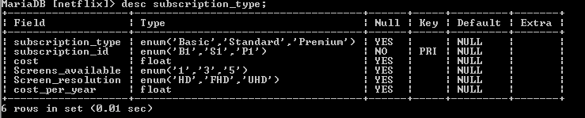

create table cast

(id varchar(5) ,

actor varchar(20),

foreign key(id) references content_detail (id));

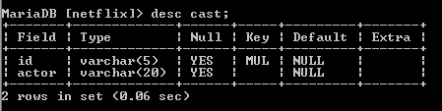

1. **Insert Queries**

insert into cast values ('1', 'Rock');

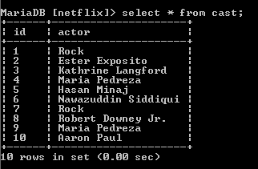

insert into customer

(customer_id, name, address, contact_no, email, gender, customer_status)

values (1, 'Antin', '07 Lake View Court', '911-887-0711', 'hpendrigh0@hugedomains.com', 'Male', 'Active');

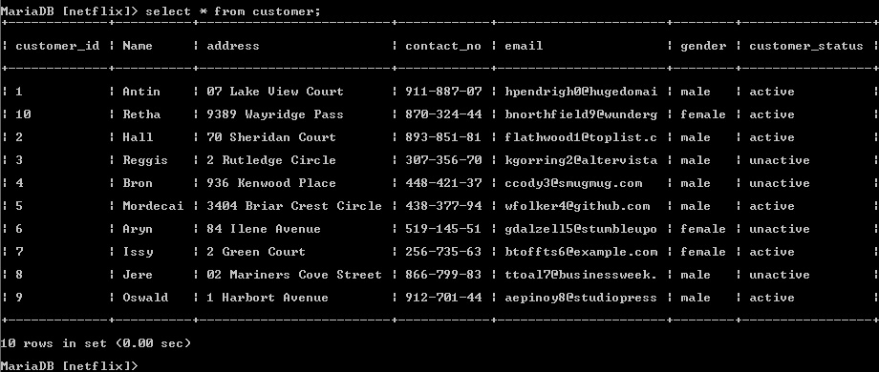

insert into Subscription_type

(subscription_type, subscription_id, cost, Screens_available, Screen_resolution)

values ('Basic', 'B1', '9.99', '1', 'HD');

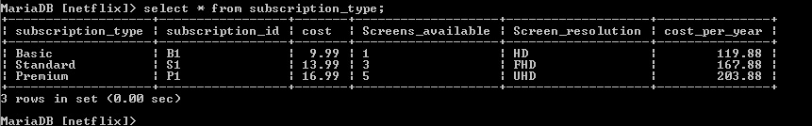

insert into customer_subscription_master

(customer_id, subscription_id, subscription_type_ID)

values (1, 11, 'B1');

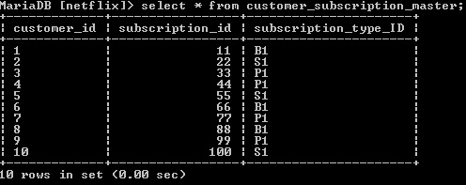

insert into category

(category_id, category_type)

values ('M1', 'Movies');

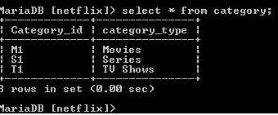

insert into content

(content_id, content_type)

values ('H1', 'Horror');

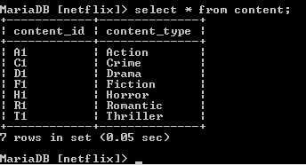

insert into payment

(payment_id, customer_id, payment_method, payment_cycle, no_of_payments)

values ('p1', 1, 'debit','monthly', 2);

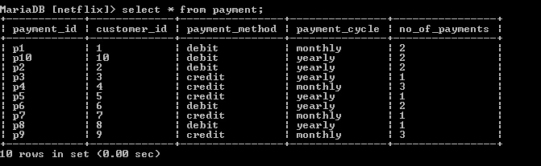

insert into content_detail

(id, name, category_id, Content_type_id, Director , release_date, ratings,duration)

values (1, 'Hobbs And Shaw', 'M1', 'A1', 'Ankita', '2011-09-06', 4,'2:44:00');

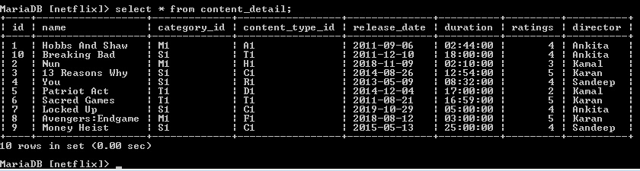

1. **Alter and update queries**

update content_detail

set duration='18:00'

where id=10;

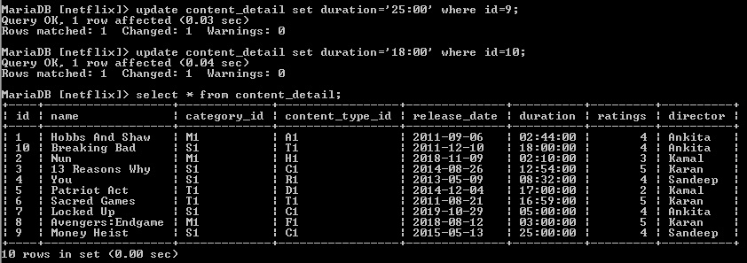

update content_detail

set movie_links='https://www.netflix.com/ca/title/80150243'

where id=1;

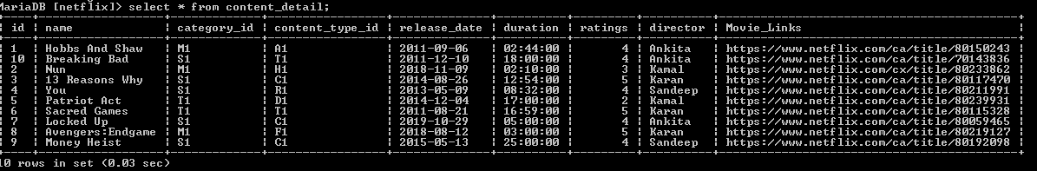

update customer join payment

set customer_status='unactive'

where no_of_payments<2

and customer.customer_id=payment.customer_id;

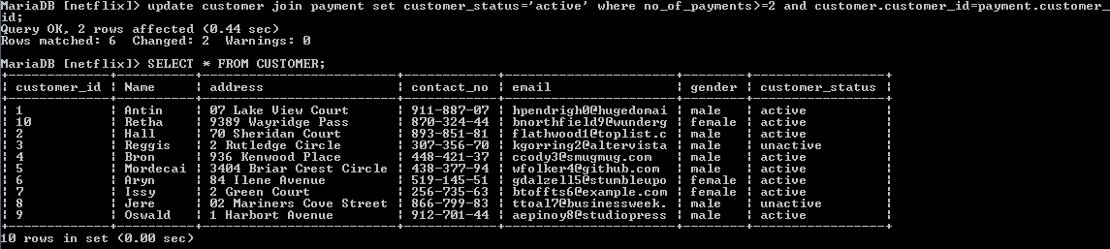

alter table category

modify category_type varchar(30);

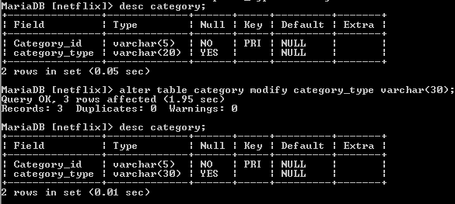

alter table subscription_type

change cost cost_per_month float;

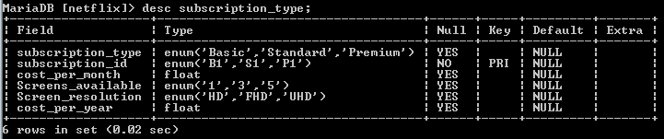

1. **Functions and clauses:**

Order by clause

select name, duration, ratings, director

from content_detail

order by name asc;

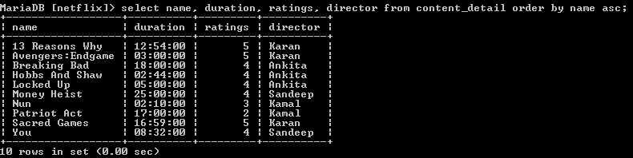

Group by clause

select director, count(*) as Number_of_movies_directed

from content_detail

group by director;

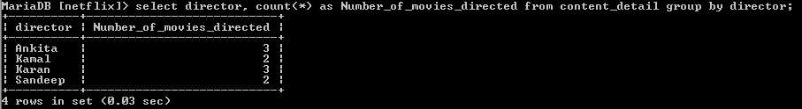

Count()

select count(id) as Movies_in_Netflix

from content_detail

where category_id='M1';

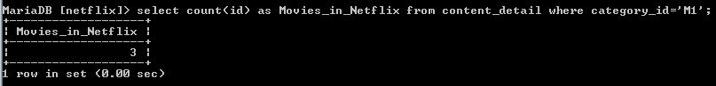

Max()

select max(duration)

from content_detail;

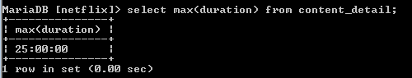

Min()

select min(duration)

from content_detail;

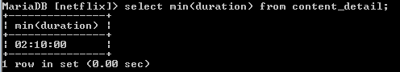

Avg()

select avg(ratings)

from content_detail

where director='kamal';

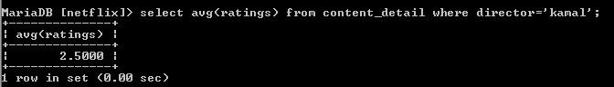

Sum()

select sum(no_of_payments) as total_monthly_payments

from payment

where payment_cycle='monthly';

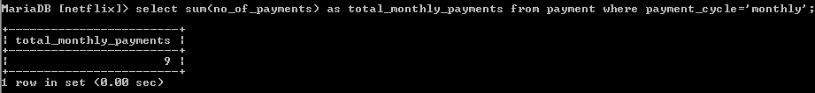

Format()

select name,date_format(release_date,"%D,%M,%Y") as release_date

from content_detail;

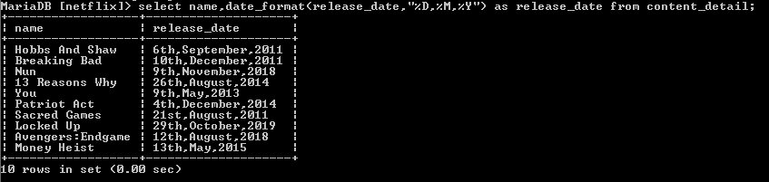

Concat()

select concat('$',format(cost_per_year,3))

from subscription_type;

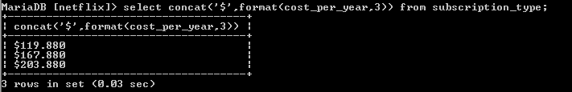

Year()

select name, release_date

from content_detail

where year(release_date) between 2014 and 2018;

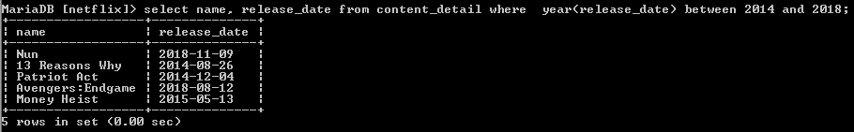

Like

select * from content_detail

where director like 'k%';

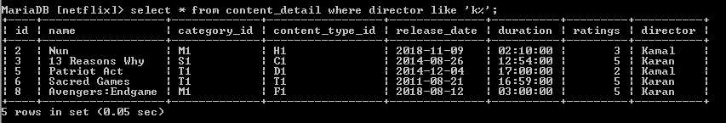

Curdate()

select * from content_detail

where release_date>curdate();

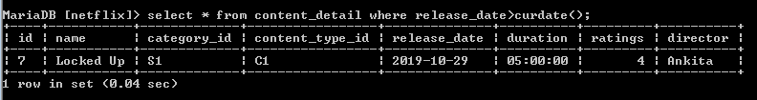

1. **Complex queries**

**Retrieve payment details of customer who made maximum number of payments.**

select * from payment

where payment_method='credit'

and no_of_payments=(select max(no_of_payments) from payment);

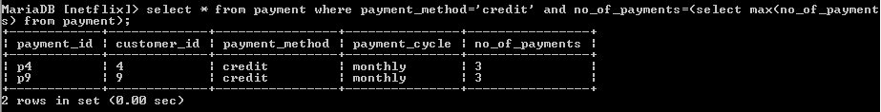

**Retrieve those customers with premium subscription.**

select name, customer.customer_id, subscription_type_ID, subscription_type.subscription_type

from customer

join customer_subscription_master

join subscription_type

on customer.customer_id=customer_subscription_master.customer_id and subscription_type.subscription_id=subscription_type_id

where subscription_type_id='P1'

group by customer.customer_id;

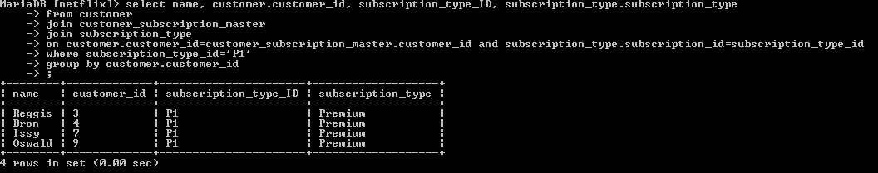

**Retrieve all subscription details of customer including name and id of customer.**

select customer.customer_id, name, subscription_type, cost, screens_available,screen_resolution

from customer

join subscription_type join

customer_subscription_master

on customer.customer_id=customer_subscription_master.customer_id

and subscription_type_ID=subscription_type.subscription_ID ;

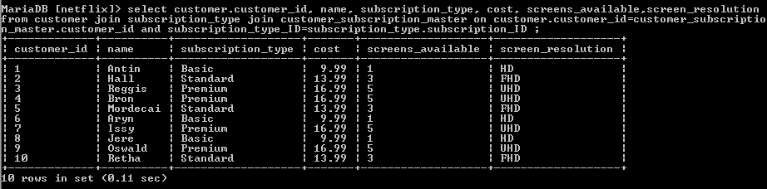

**Retrieve those customers who are paying yearly.**

select customer.customer_id, name, payment_id, payment_cycle

from customer join payment

on customer.customer_id=payment.customer_id

where payment_cycle='yearly';

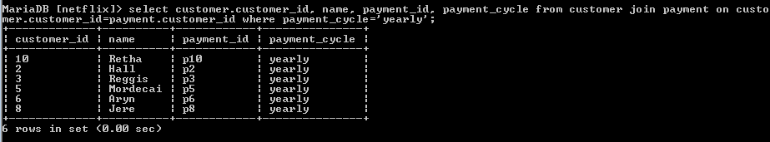

**Retrieve those movies, shows or series whose actor is rock.**

select name, duration, release_date, actor

from cast join content_detail on cast.Id = content_detail.id

where actor='rock';

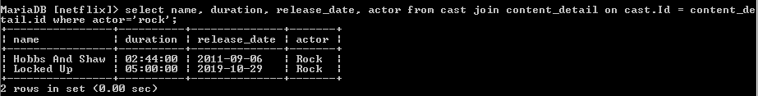

**Retrieve active female customers who watch horror movie.**

select * from customer join content

on customer_status='active' and gender='female'

where content_id=(select content_id from content where content_type='Horror');

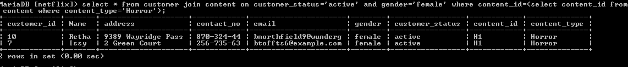

**Discount to those customers who are paying yearly with standard subscription.**

select name,customer.customer_id, subscription_type.subscription_type,special_offers.payment_cycle_id,

(cost_per_year*special_offers.discount/100) as yearly_discount , subscription_type.cost_per_year-(cost_per_year*special_offers.discount/100) as Amount_After_Discount

from customer join customer_subscription_master

join subscription_type

join payment

join special_offers

on customer.customer_id=customer_subscription_master.customer_id

and customer_subscription_master.subscription_type_id=payment.subscription_type_id

and customer_subscription_master.subscription_type_id=subscription_type.subscrition_id

and payment.payment_cycle_id=special_offers.payment_cycle_id

where payment.payment_cycle_id='Y1'

and payment.subscription_type_id='S1'

and special_offers.payment_cycle_id='Y1'

group by customer.customer_id;

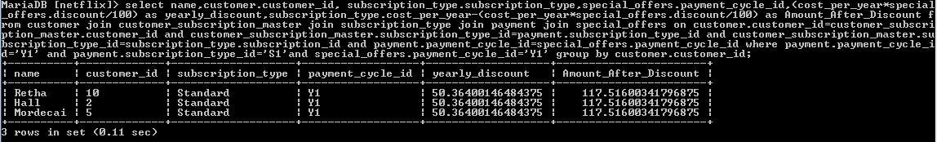

1. **Views**

create view subscriptions_by_customers

as select customer.customer_id, name, subscription_type, cost, screens_available,screen_resolution from customer

join subscription_type join

customer_subscription_master

on customer.customer_id=customer_subscription_master.customer_id

and subscription_type_ID=subscription_type.subscription_ID ;

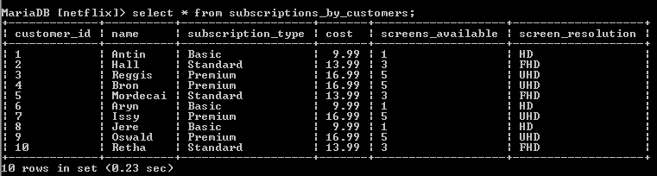

create view actor_name_r

as select name, duration, release_date, actor from cast

join content_detail on cast.Id = content_detail.id

where actor like 'R%';

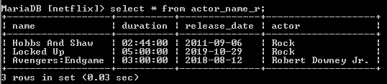

create view discount

as select name,customer.customer_id, subscription_type.subscription_type, special_offers.payment_cycle_id,(cost_per_year*special_offers.discount/100) as yearly_discount,

subscription_type.cost_per_year-(cost_per_year*special_offers.discount/100)

as Amount_After_Discount from customer

join customer_subscription_master

join subscription_type

join payment

join special_offers

on customer.customer_id=customer_subscription_master.customer_id

and customer_subscription_master.subscription_type_id=payment.subscription_type_id

and customer_subscription_master.subscription_type_id=subscription_type.subscription_id

and payment.payment_cycle_id=special_offers.payment_cycle_id

where payment.payment_cycle_id='M1'

and payment.subscription_type_id='B1'

and special_offers.payment_cycle_id='M1'

group by customer.customer_id;

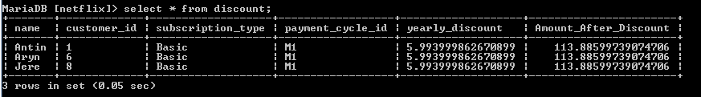

**References:**

1. Netflix - 6/09/2019- <https://www.netflix.com/ca/>
2. Mockaroo - 9/09/2019- <https://mockaroo.com/>
3. Lucidchart - 8/09/2019- [https://www.lucidchart.com](https://www.lucidchart.com/)
4. Mysql tutorials - 10/09/2019- <http://www.mysqltutorial.org/>
5. W3schools - 10/09/2019- <https://www.w3schools.com/>