**Stress Management through AR VR**

**By**

**Karan Mungra (19BCE137)**

**Nikhil Makwana(19BCE107)**



**DEPARTMENT OF COMPUTER SCIENCE & ENGINEERING**

**Ahmedabad 382481**

**Stress Management through AR VR**

**Report**

Submitted in partial fulfilment of the requirements

For the degree of

**Bachelor of Technology in Computer Science & Engineering**

By

**Karan Mungra (19BCE137) ,Nikhil Makwana(19BCE107)**

Guided By

**Dr Mohd Zuhair**



**DEPARTMENT OF COMPUTER SCIENCE & ENGINEERING**

**Ahmedabad 382481**

**CERTIFICATE**

This is to certify that the Minor Project entitled “Stress Management through AR VR” submitted by **Karna Mungra (19BCE137), and Nikhil Makwana(19BCE107)** towards the partial fulfilment of the requirements for the degree of Bachelor of Technology inComputer Science and Engineering of Nirma University is the record of work carried out by him/her under my supervision and guidance. In my opinion, the submitted work has reached the level required for being accepted for examination.

**Dr Mohd Zuhair** **Dr Madhuri Bhavsar**

Assistant Professor, Professor and HOD

Computer Science and Engineering Dept Computer Science and Engineering dept

Institute of Technology, Institute of Technology,

Nirma University. Nirma University.

**Acknowledgement**

I have taken efforts in this project work. However, it would not have been possible without the kind support and help of many individuals. I would like to extend my sincere thanks to all of them. I am highly indebted to Dr Mohd Zuhair for his guidance and constant supervision as well as for providing necessary information regarding the project work. I would like to express my gratitude towards my parents and member of the family for their kind cooperation and encouragement which help me in the completion of this project. My thanks and appreciations also go to people who have willingly helped me out with their abilities.

Karan Mungra & Nikhil Makwana

#### ABSTRACT

#### This report provides a description and methodology of the AR/VR THREEJS model for terrain rendering. The model is also applied to use case of stress management using AR/VR Natural Forest Rendering. The model is designed to be flexible, scalable and easily enhanced to meet the requirements. It provides features like View rendering relative camera focus (which enables) to provide the illusion of infinite terrain, and basic building blocks for rendering forest in the model like Ground, Grass Objects, Tree Objects, etc. It builds upon the THREEJS framework, WEBGL Engine and WebXR API.

The main objective of the model is to provide a basic framework to be used for building better AR/VR nature rendering projects for stress management. A comprehensive list of framework components is RelativeViewWorld, RelativeCamera, TerrainModel, TreeModel, RockModel, HillModel, BushesModel, etc.

#### CONTENTS

# Certificate I

**Acknowledgement** Ii

**Abstract** Ii

**Chapter 1 Introduction**

**Chapter 2 Literature overview**

**Chapter 3 Methodology**

**Chapter 4 Results**

**Chapter F Summary conclusion and Future work**

**Reference**

**Introduction**

Stress management means controlling stress and reducing stress gradually through a period through a habit of activities. One such activity in current times has come to be VR/AR technology. The technology can provide a virtual rendered world and also capable the user to interact with the world. A recent example of this technology used in real life is of US Airforce, which has created a virtual funeral ceremony for Iraq War, so the veterans can re-experience the funeral of their lost comrades. The activity can reduce the stress and anxiety of the war by relieving the experience of pain. And enhance the veterans to deal with the trauma.

Experience in the natural world can also reduce stress over time in particular cases. But not always possible for people dealing with diseases or disabilities to travel to such places. Also in this fast-pacing world, for people to deal with their daily work and at the same time go on a mini vacation regularly is not possible. Hence, an VR/AR model can give a similar experience to the user. Hence, we have developed a basic modular framework or a collection of tools to easily developed such worlds using THREEJS and WebGL.

The framework is created to provide the basic elements necessary for such virtual world rendering. It also provides enough flexibility, that a user can quickly come up with a virtual world.

It does not provide any highly complex tool which is not easily modifiable. One can always make tweaks in the source code according to the use case and can get better performance. Still, the model can easily deal with advanced usage for rendering. It provides features like View rendering relative to the camera for better performance.

The main objective of the framework is to provide flexibility, and simplicity in usage and performance.

**Literature overview**

[1] Bhargava, Deepti & Trivedi, Hemant. (2018). A Study of Causes of Stress and Stress Management among Youth. IRA-International Journal of Management & Social Sciences (ISSN 2455-2267). 11. 108. 10.21013/jmss.v11.n3.p1.

The paper discusses the causes and effects of stress in youth and provides how to combat stress during the period of life from childhood to adolescence. It gives various suggestions such as a positive environment, creating a hostile learning environment by minimizing the negative impact of stressors for stress management. The paper also emphasizes the success of the development stage of a child into adolescence.

[2] Alborzkouh P, Nabati M, Zainal M, Abed Y, Shahgholy Ghahfarokhi F. A review of the effectiveness of stress management skills training on academic vitality and psychological well-being of college students. J Med Life. 2015;8(Spec Iss 4):39-44. PMID: 28316704; PMCID: PMC5319270.

The paper reviews the effectiveness of stress management training on the academic life and mental well-being of the students of Shaded University. The researchers sample a total of 40 students through the convenience sampling method and were organized into two groups: experimental and control groups. Then both groups were pretested by using an academic vitality inventory and an 84 – questions psychological well-being inventory. Then, the experimental group received stress management skills training for ten sessions, and the control group did not receive any intervention. Next, both groups were post-tested, and the data were analysed with SPSS-21 software by using descriptive and inferential statistical methods. The findings showed that stress management skills training significantly contributed to promoting the academic vitality and psychological well-being of students (p < 0.001). Hence, from the paper one can conclude through proper stress management activities can lead to stress reduction.

[3] AUTHOR=Kim Hyewon, Kim Dong Jun, Kim Seonwoo, Chung Won Ho, Park Kyung-Ah, Kim James D. K., Kim Dowan, Kim Min Ji, Kim Kiwon, Jeon Hong Jin

TITLE=Effect of Virtual Reality on Stress Reduction and Change of Physiological Parameters Including Heart Rate Variability in People With High Stress: An Open Randomized Crossover Trial

JOURNAL=Frontiers in Psychiatry

VOLUME=12YEAR=2021URL=https://www.frontiersin.org/articles/10.3389/fpsyt.2021.614539 DOI=10.3389/fpsyt.2021.614539 ISSN=1664-0640

This paper focuses on measuring the effectiveness of VR technology in stress management. The researchers tested stress management through VR on a group of participants. Participants consisted of 83 healthy adult volunteers with high stress, which was defined as a score of 20 or more on the Perceived Stress Scale-10 (PSS-10). This study used an open, randomized, crossover design with baseline, stress, and relaxation phases. During the stress phase, participants experienced an intentionally generated shaking VR and serial-7 subtraction. For the relaxation phase, participants underwent a randomly assigned relaxation session on day 1 among VR relaxation and biofeedback, and the other type of relaxation session was applied on day 2. We compared the State-Trait Anxiety Inventory-X1 (STAI-X1), STAI-X2, the Numeric Rating Scale (NRS), and physiological parameters including heart rate variability (HRV) indexes in the stress and relaxation phases.

**Results [referenced from the paper]:** A total of 74 participants were included in the analyses. The median age of participants was 39 years, STAI-X1 was 47.27 (SD = 9.92), and NRS was 55.51 (SD = 24.48) at baseline. VR and biofeedback significantly decreased STAI-X1 and NRS from the stress phase to the relaxation phase, while the difference in effect between VR and biofeedback was not significant. However, there was a significant difference in electromyography, LF/HF ratio, LF total, and NN50 between VR relaxation and biofeedback.

In conclusion, they found VR technology is quite effective for stress management.

**Methodology**

**Technologies Used:**

* WEBGL 3

WebGL (Web Graphics Library) is a JavaScript API for rendering high-performance interactive 3D and 2D graphics within any compatible web browser without the use of plug-ins. WebGL does so by introducing an API that closely conforms to OpenGL ES 2.0 that can be used in HTML <canvas> elements. This conformance makes it possible for the API to take advantage of hardware graphics acceleration provided by the user's device.

* THREEJS

Three.js is often confused with WebGL since more often than not, but not always, three.js uses WebGL to draw 3D. WebGL is a very low-level system that only draws points, lines, and triangles. To do anything useful with WebGL generally requires quite a bit of code and that is where three.js comes in. It handles stuff like scenes, lights, shadows, materials, textures, 3d math, all things that you'd have to write yourself if you were to use WebGL directly.

* WEBXR API

WebXR is a group of standards which are used together to support rendering 3D scenes to hardware designed for presenting virtual worlds (virtual reality, or VR), or for adding graphical imagery to the real world, (augmented reality, or AR). The WebXR Device API implements the core of the WebXR feature set, managing the selection of output devices, rendering the 3D scene to the chosen device at the appropriate frame rate, and managing motion vectors created using input controllers.

**Initial Research:**

The initial research showed that a VR experience of a virtual world with realistic looks can help a patient to reduce stress. The paper on the effectiveness of VR technology on patients showed that technology is useful. Hence, we designed a basic framework for rendering realistic nature in VR. The following few pages talk about Terrain JS and how we developed it.

**Terrain JS Basic Architecture:**

The main aim of the framework is to be as modular and flexible as possible. The framework consists of individual 3D Objects with defaults. One can just use the default objects and can create easily a virtual world. The below Object tree shows the modular architecture of the framework.

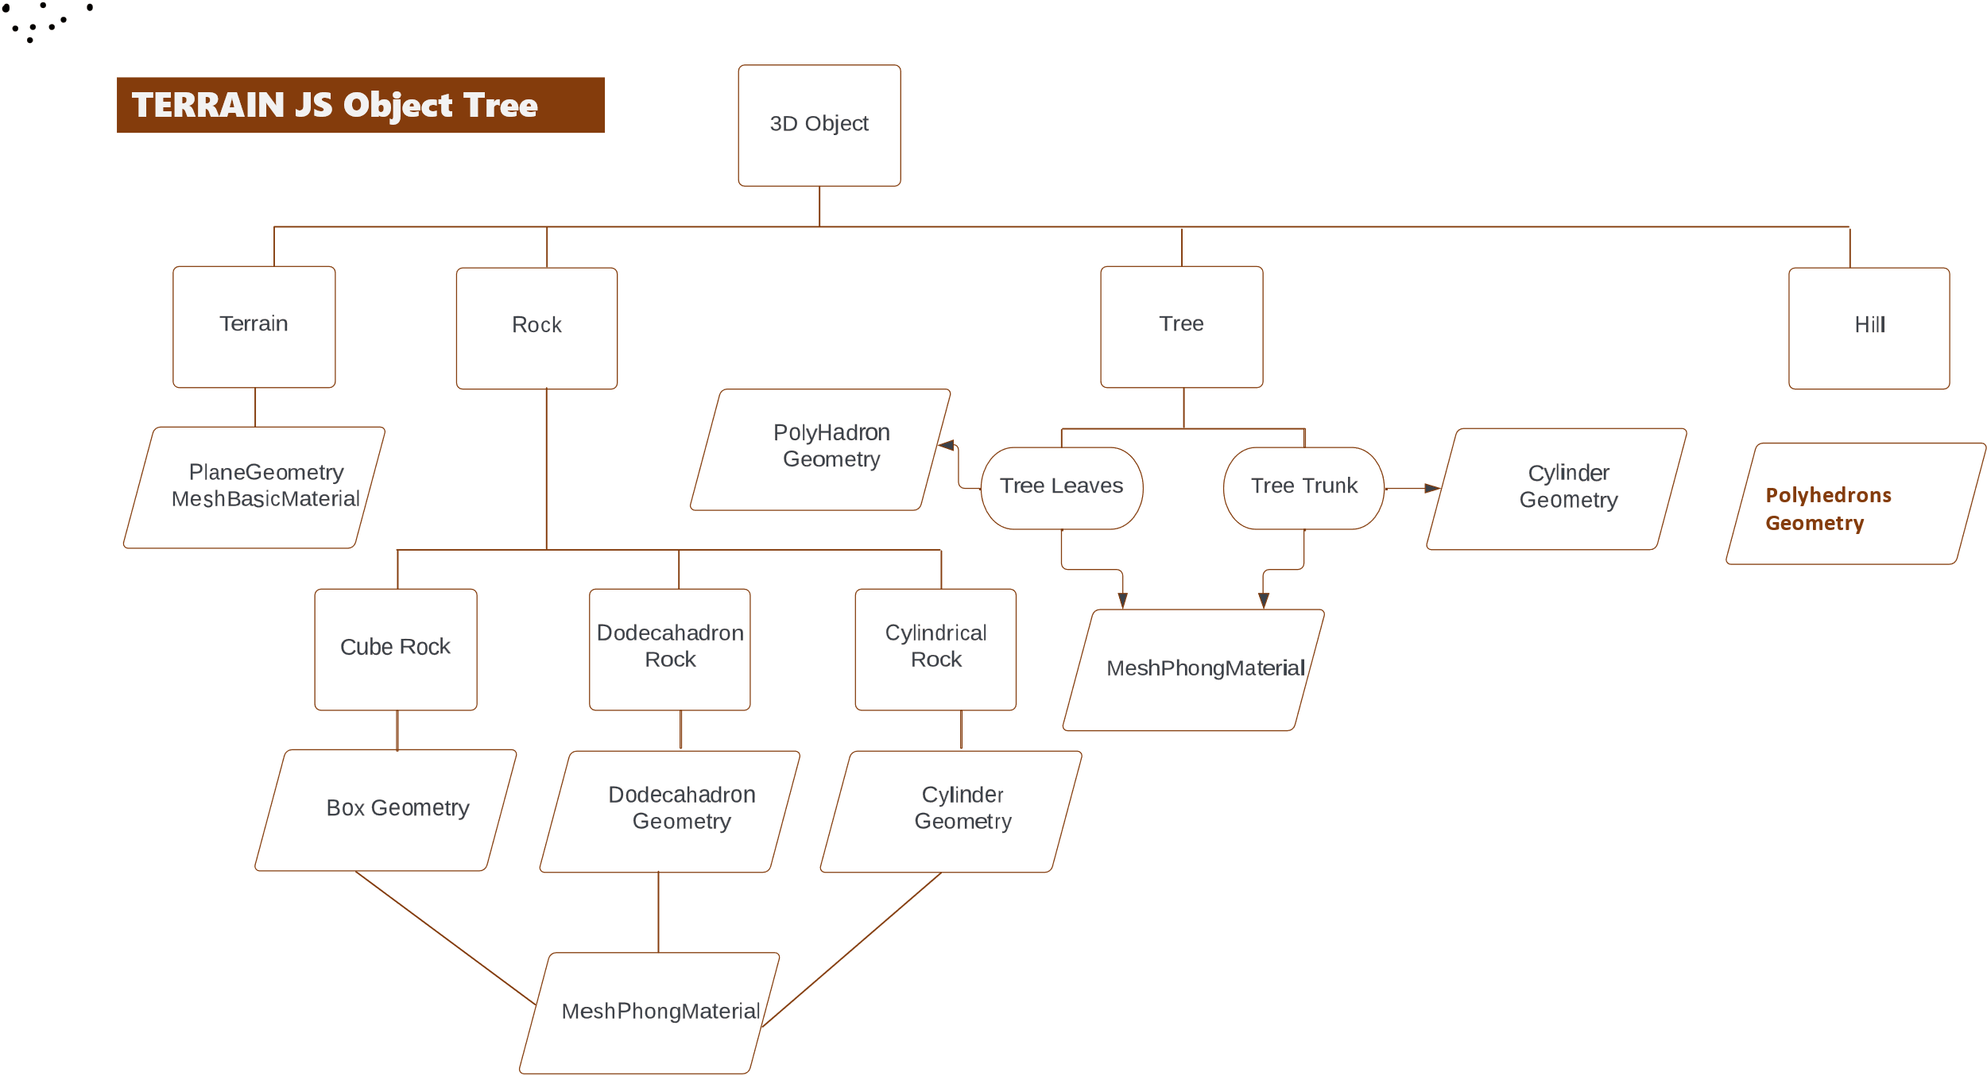

Figure – Terrain JS Object Tree

The emphasis is the simplicity of usage. Users can use concepts like Polymorphism and inheritance for more power usage. But it is not usually required.

The framework provides the following features,

* + Modularity
  + Relative to camera rendering
  + Built-in shadow, light and textures.
  + Built-in Motion controls.
  + Can be easily integrated with WebXR.

**Components of Terrain JS:**

1. **Terrain**

The terrain provides basic ground with grass textures to emulate grass fields in the virtual world. Its build opens the Plane Geometry and MeshBasicMaterial. Any type of advanced texture can be applied to the object.

1. **Rock**

Rock provides three different types of shapes with the same texture. Its build opens the Dodecahedron Geometry, Box Geometry, Cylinder Geometry and MeshPhongMaterial. Advanced texture can be easily applied to the object.

1. Cube Rock
2. Dodecahedron Rock
3. Cylinder Rock

All three types of rocks inherit from base abstract Rock which has a default texture.

1. **Tree**

A tree is made up of two components namely, Tree Leaves and Tree trunks. Tree Leaves are made up of Polyhedron Geometry and MeshPhongMaterial. And Tree Trunk is made up of Cylinder Geometry and MeshPhongMaterial. Both the components are easily changeable and are provided with defaults.

1. **Hill**

Hill is a Polyhedron Geometry and has MeshPhongMaterial applied to it. Its height and average radius can be easily modified as they are abstracted out.

**Setting up the world:**

We randomly added objects at different positions and in different shapes and sizes in the world for the experiment. We also added light and a camera to the world. And keyboard control movements for travelling in the world.

The test was how much GPU performance the world took up for rendering. And seeing the number of objects in total 92,341, the performance recorded was quite satisfactory.

List of different objects added within the range of -5000 to 5000:

* Tree – 30,000 with dimensions (leaves radius = 2-12, trunk height = 4-14, trunk radius = 1-4).
* Cube Rock – 40000 with dimensions (length = 1-8)
* Dodecahedron Rock – 20000 with dimensions (radius = 1 - 31)
* Hill – 2000 with dimensions (radius = 1 – 155, height = 256)

**Adding WebXR to the world:**

Adding VR controllers to the THREE JS model is very easy because the framework provides a WebXR component which is portable and can easily be integrated. We added basic VR which just looks around and does not do much. But the capabilities can be easily advanced.

**Results** **Analysis**

Our result analysis consists of two parts, Performance evaluation and usefulness of the work in stress management. In a recent study, researchers have found that due to an increase in work and stress in life people, have gotten away from the natural world. And exposure to the natural world can lead to stress reduction. Hence, a VR world which can give a similar experience is always good.

Our work here is very preliminary but with advanced textures and better models, one can make a more realistic emulation.

Our virtual world looks more like an animated world, without any textures applied. But it can be easily applied.

Virtual World Output:

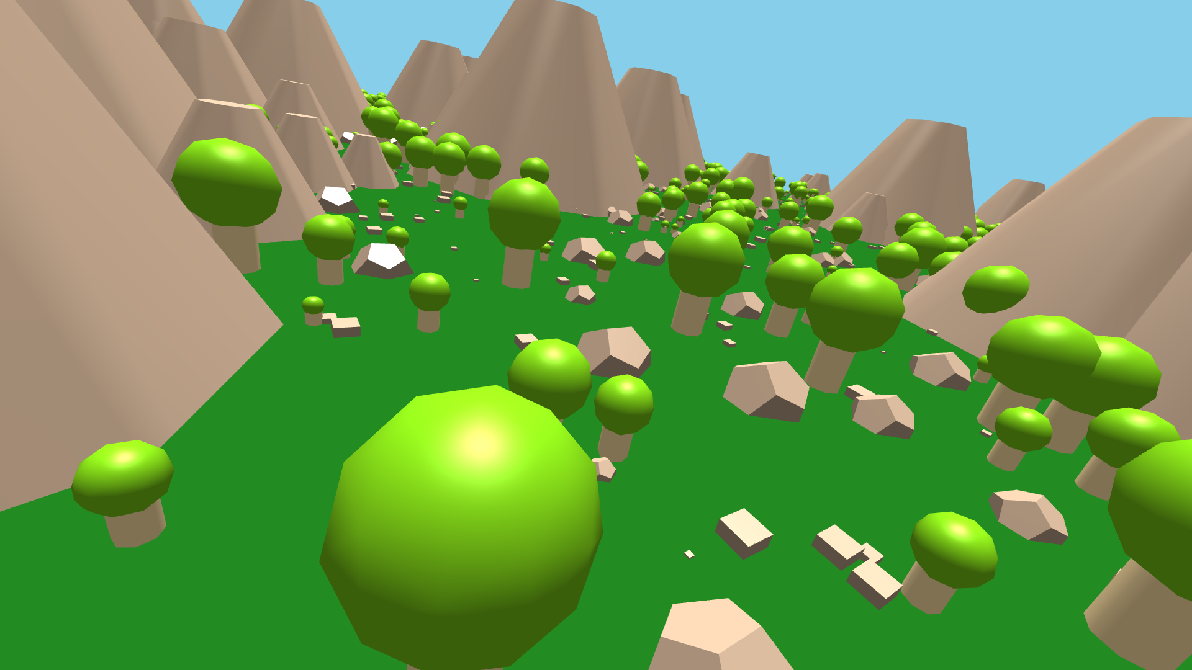

Figure – A sample output image of the rendered world from the test

The performance of the world rendering on the GPU and CPU was satisfactory.

|  |  |  |
| --- | --- | --- |
|  | Performance Table |  |
| Build Time | 10 seconds | Time required for bundling JS files into a webpack |
| Start-Up Time | 7 seconds | Time from initial document load in browser to rendering |
| GPU Memory | 0.7 GB | GPU – Nvidia GeForce GTX |
| GPU Utilization | 15% |  |
| CPU Utilization | 12% | CPU – 11th Gen Intel i5 – 3.10 GHz |

Table – Performance on the different parameters for test world rendering

**Conclusion**

Many things are possible in this range of technology. It all depends on the creativity and performance of the rendering devices. One can create a whole 3d forest experience and create a stress-reducing tool for a specified group of people. Our TERRAIN JS framework is very primitive in terms of handling realistic graphics. But it can be easily enhanced to get a better feel and look.

For stress management using VR, one can easily create a world with realistic graphics, sound and feel with shaking VR and other such stuff.

In conclusion, in this hard work life, technology like VR can enable experiences of faraway places sitting at home and help in reducing stress.

**Future Scope of Work**

Terrain JS is still a very basic framework with very few components. One can easily extend it to have more components. At the same time, performance can also be improved using things like WebGL Attributes, static projection Matrix and other such techniques. More utility can be created around the framework which can enable better-looking and realistic texture mapping. Hence, improvements and enhancements are very much possible.

**References**

[1] Carson, Daniel. (2020). Research-Paper-WebGL. 10.13140/RG.2.2.18538.95683.

[2] Three JS official documentation: <https://threejs.org/docs/>

[3] Kim H, Kim DJ, Kim S, Chung WH, Park KA, Kim JDK, Kim D, Kim MJ, Kim K, Jeon HJ. Effect of Virtual Reality on Stress Reduction and Change of Physiological Parameters Including Heart Rate Variability in People With High Stress: An Open Randomized Crossover Trial. Front Psychiatry. 2021 Aug 10;12:614539. doi: 10.3389/fpsyt.2021.614539. PMID: 34447320; PMCID: PMC8384255.