**5. Flowchart/ Prototypes**

5.1 Flowchart

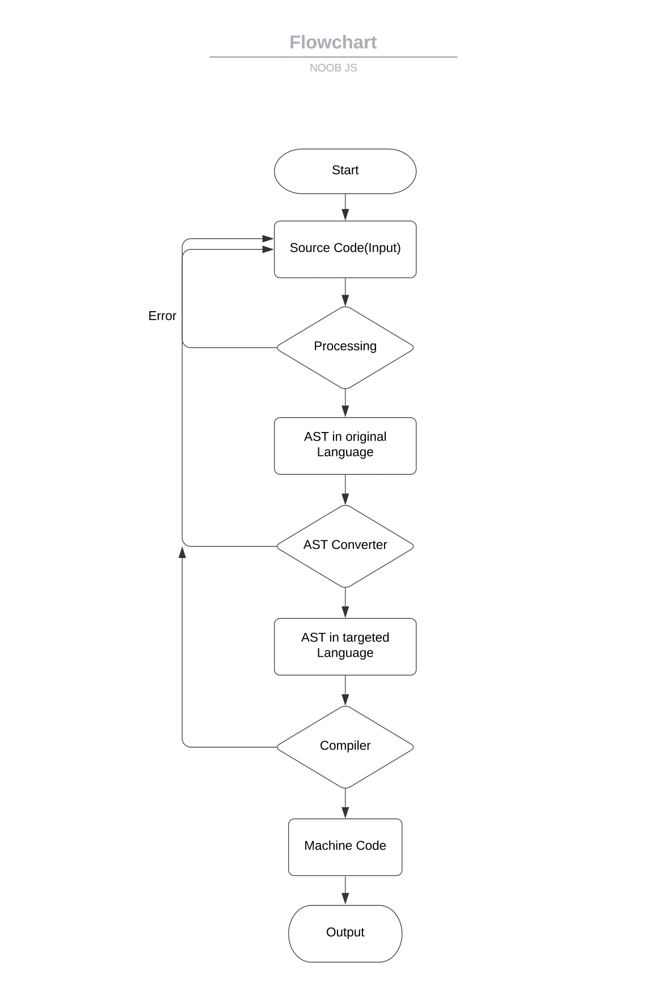

5.2 Prototypes

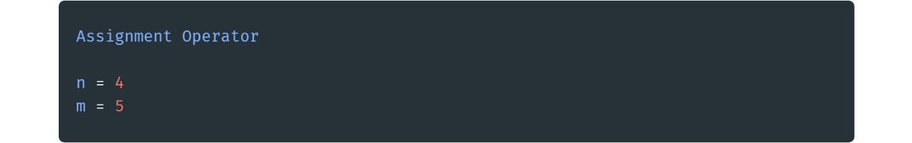

Fig 5.2.1 Assignment Operator

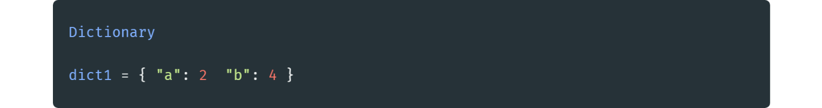

Fig 5.2.2 Data Dictionary

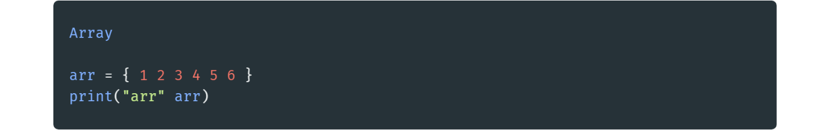

Fig 5.2.3 Array

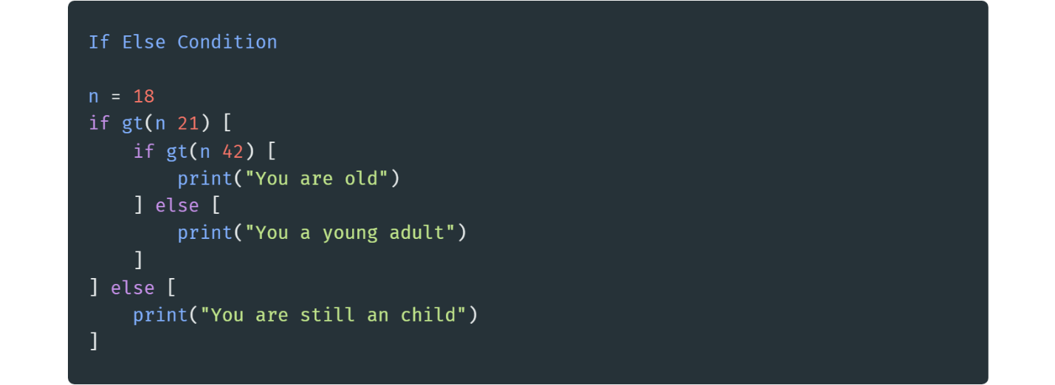

Fig 5.2.4 If Else Condition

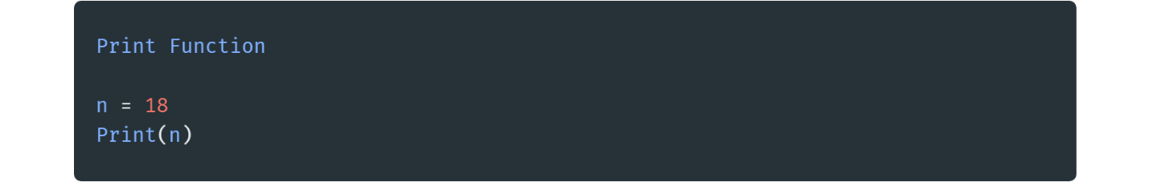

Fig 5.2 3 Print Function

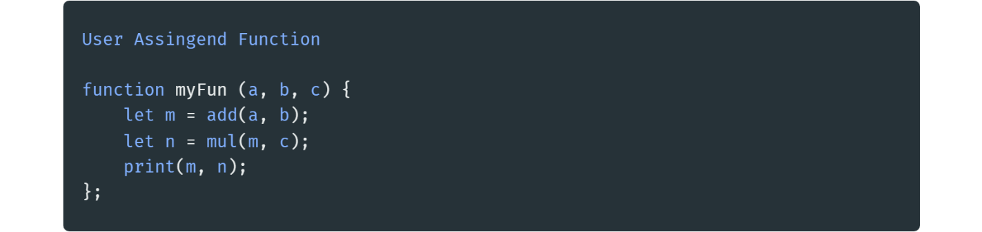

Fig 5.2.6 User Assigned Function

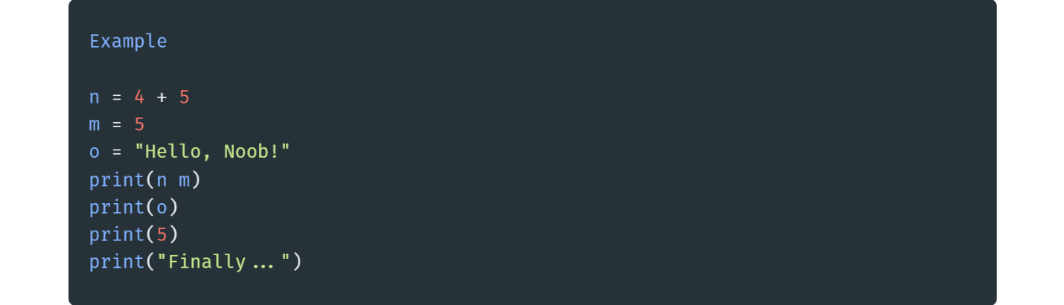

Fig 5.2.7 Basic Example