Database Design and Structure

Entity Relationship (ER) Diagram

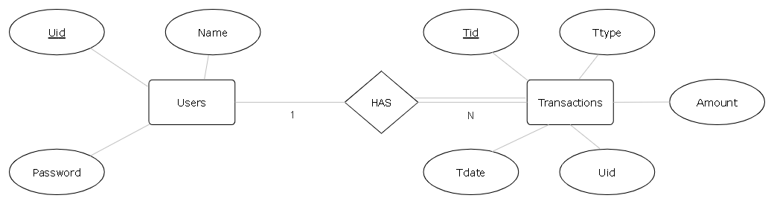

Financial Management Database

Database Tables:-

1. USERS

|  |  |  |  |  |  |
| --- | --- | --- | --- | --- | --- |
| **Field** | **Type** | **Null** | **Key** | **Default** | **Extra** |
| UID | varchar(50) | NO | PRI | NULL |  |
| NAME | varchar(100) | NO |  | NULL |  |
| PASSWORD | varchar(20) | NO |  | NULL |  |

SQL Command:- CREATE TABLE USERS (UID VARCHAR(50) NOT NULL PRIMARY KEY,NAME VARCHAR(100) NOT NULL,PASSWORD VARCHAR(20) NOT NULL);

1. TRANSACTIONS

|  |  |  |  |  |  |
| --- | --- | --- | --- | --- | --- |
| **Field** | **Type** | **Null** | **Key** | **Default** | **Extra** |
| TID | int | NO | PRI | NULL | auto_increment |
| TTYPE | char(8) | NO |  | NULL |  |
| AMOUNT | int | NO |  | 0 |  |
| TDATE | date | NO |  | NULL |  |
| UID | varchar(50) | NO | MUL | NULL |  |

SQL Command:- CREATE TABLE TRANSACTIONS (TID INT NOT NULL PRIMARY KEY AUTO_INCREMENT,TTYPE CHAR(8) NOT NULL,AMOUNT INT NOT NULL,TDATE DATE NOT NULL,UID VARCHAR(50) NOT NULL,FOREIGN KEY (UID) REFERENCES USERS(UID));