**NAME - KARAN MISHRA  
DIV - D15B  
ROLL NO - 36  
ADV DEVOPS 11**Function Creation:-  
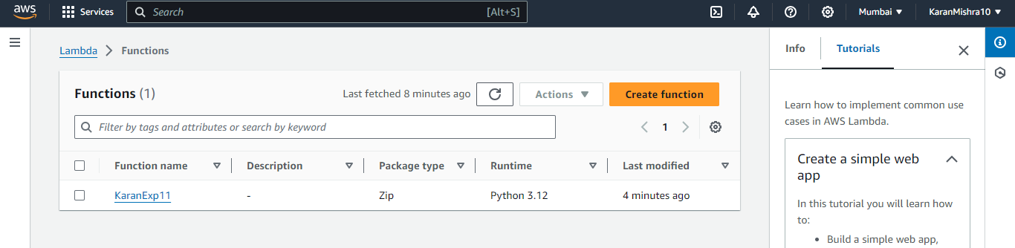  
Configuration Changing:-

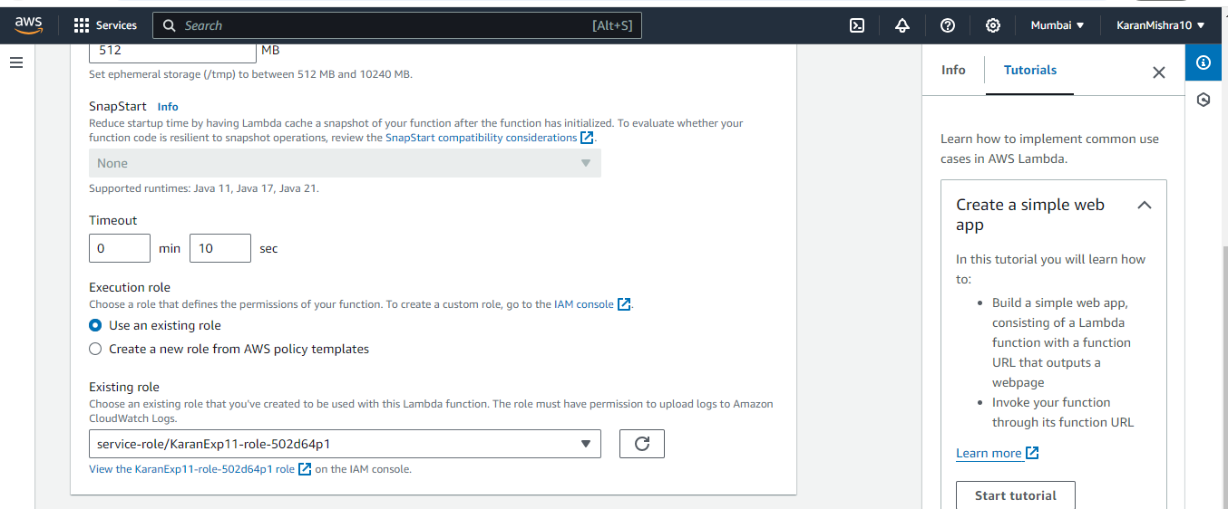  
  
Code Changing:-

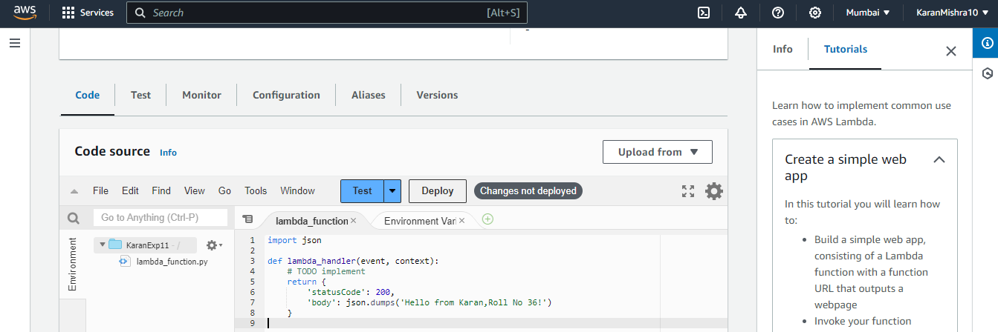

Deploying:-

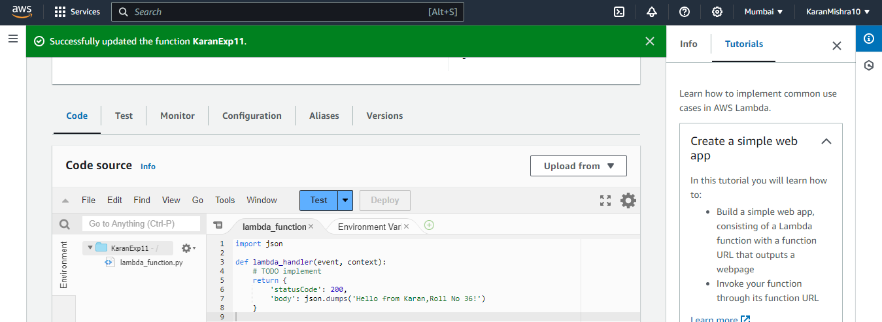  
  
Final Testing:-

