
Software Requirements Specification
for
Image Encryption System
Version 1.0.0

Prepared by
Group Name: Tech_noobs
Karan Pittie | 13BCE0360 | karan.pittie@yahoo.com
Balaji Shanmugam | 13BCE0821 | balajishanmugam@gmail.com

Instructor: | Prof Manjula R.
Course: | Software Engineering
Lab Section: | L 5+6
Teaching Assistant: | -
Date: | 24 - 01 - 2016
Contents
Revisions iii
1 Introduction 1
1.1 Document Purpose 1
1.2 Product Scope 1
1.3 Intended Audience and Document Overview 1
1.4 Definitions, Acronyms and Abbreviations 1
1.5 Document Conventions 1
1.6 References and Acknowledgments 2
2 Overall Description 3
2.1 Product Perspective 3
2.2 Product Functionality 3
2.3 Users and Characteristics 3
2.4 Operating Environment 3
2.5 Design and Implementation Constraints 4
2.6 User Documentation 4
2.7 Assumptions and Dependencies 4
3 Specific Requirements 5
3.1 External Interface Requirements 5
3.2 Functional Requirements 6
3.3 Behaviour Requirements 6
4 Other Non-functional Requirements 7
4.1 Performance Requirements 7
4.2 Safety and Security Requirements 7
4.3 Software Quality Attributes 7
5 Other Requirements 8
Appendix A – Data Dictionary 9
Appendix B - Group Log 10

Revisions
Version | Primary Author(s) | Description of Version | Date Completed
Final 1 | Karan Pittie, Balaji Shanmugam | This will be the production version of the system. | N/A

Introduction

Document Purpose
To design a system that can keep up with the security measures required to transmit files in the form of digital images securely over the internet.
With the growing trend of digital services like internet communication, medical and military imaging systems, multimedia system requires a reliable security in storage and transmission of digital images. Due to faster growth in multimedia technology, internet and cell phones, there is a need for security in digital images. Therefore there is a need for image encryption techniques in order to hide images from such attacks. In this system we try to encrypt the image such that any kind of security threat that the image may be exposed to can be avoided and the secure transmission of the image over the internet can be done smoothly.

Product Scope
The need of exchanging messages and images secretly over unsecure networks promoted the creation of cryptosystems to enable receivers to interpret the exchanged information. The EL Gamal cryptographic algorithm will be used to encrypt the images. The EL Gamal algorithm is currently being used to transfer text files securely over the internet. In this system we are trying to implement the algorithm for the gray scale images. We will be applying the algorithm to the matrix of the image currently being observed. To implement the algorithm on the image we will be using MATLAB for manipulating the matrix values or the pixel intensity values of the image. This system gives one of the best image encryptions that have been used since the encryption procedure over any image goes smoothly and transfers the original image to completely undefined image which makes this system a really secure and successful system for image encryption. With the growing trend of transferring important information with the help of digital images it is clearly important that we develop a secure way of transferring the image securely over an unsecure line such that only the person for whom the image is intended for can be able to access the image with the help of the key which only he/she has access to. This system can make of images more immune against some future attacks since breaking this system depends on solving the discrete logarithm problem which is really impossible with large prime numbers and would take exponentially long time even if done with the help of computers with large computation power.

Intended Audience and Document Overview
This document is mainly intended to be read by the professor and the clients that will be using our system in order to transfer the images over the internet in a more secure and a better encrypted way. We intend our system to be used by anyone and everyone who works with the internet on a daily basis and is going to transfer digital images over the internet.
The rest of this SRS contains the details of the software and the hardware requirements for the system to work properly as well as it contains the step by step procedure which has been used to encrypt the images using the EL Gamal encryption algorithm. It also contains the details about the functionality of the system and the user requirements as well as the software requirements which are intended to be known so that the user can use the system without facing any difficulties or issues. As a professor the sections 1 and 2 will be of prime importance and theory and if a user is reading this document then for him the section 3 and 4 can be of prime importance and even section 2 can be used as a reference.

Document Conventions
The document has been typed in the font Arial with the font size of 12 throughout the document for text. The headings or the important sections are marked with a bold text of size 14 with arial as their font.

References and Acknowledgments
[1] Haraty, R.A., A.N. El-Kassar and B. Shibaro, 2006. A comparative study of rsa based digital signature algorithms. J. Math. Stat., 2: 354-359.
[2] Schnorr, C. P. and Jakobsson, M., 2000. Security of signed ElGamal encryption. Springer Berlin Heidelberg.
[3] Gonzalez R. C. , Woods R. E. and Eddins S. L. , 2009 . Digital Image processing Using MATLAB. Gatesmark PublishingA Division of Gatesmark, LLC.

Overall Description

Product Perspective
In today’s world transmission of data securely over the internet is of prime importance. It means that we need to have a reliable and secure way with which data and information can be transmitted securely over the internet such that, only the person for whom the data is meant to be seen for can only the data and any attacker cannot attack and steal valuable information.
Today almost all digital services like internet communication, medical and military imaging
System’s, multimedia system requires reliable security in storage and transmission of digital images. Due to faster growth in multimedia technology, internet and cell phones, there is a need for security in digital images. Therefore there is a need for image encryption techniques in order to hide images from such attacks. In this system we use El Gamal Encryption algorithm in order to hide image. Such Encryption technique helps to avoid intrusion attacks.
The image encryption system that we are developing is a self-contained product and it has never been used in the industry before. It uses the latest encryption algorithm scheme in order to encrypt the data so that it can be transmitted over the internet successfully without any attacker being able to manipulate the information that is being passed.

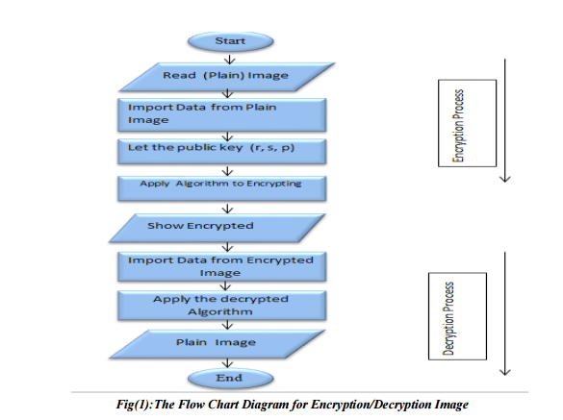

Product Functionality
The system will be able to provide the following functionalities:
- It can be used to encrypt the image with the help of El Gamal encryption scheme.
- It can be used to decrypt the image with the help of the El Gamal decryption scheme.
In cryptography, the ElGamal encryption system is an asymmetric key encryption algorithm for public-key cryptography which is based on the Diffie–Hellman key exchange. It was described by Taher Elgamal in 1985. ElGamal encryption is used in the free GNU Privacy Guard software, recent versions of PGP, and other cryptosystems. The DSA (Digital Signature Algorithm) is a variant of the ElGamal signature scheme, which should not be confused with ElGamal encryption. ElGamal encryption can be defined over any cyclic group . Its security depends upon the difficulty of a certain problem in related to computing discrete logarithms.
ElGamal encryption consists of three components: the key generator, the encryption algorithm, and the decryption algorithm.

Key generation
The key generator works as follows:
- Alice generates an efficient description of a cyclic group of order with generator . See below for a discussion on the required properties of this group.
- Alice chooses an randomly from.
- Alice computes.
- Alice publishes, along with the description of , as her public key. Alice retains as her private key, which must be kept secret.

Encryption
The encryption algorithm works as follows: to encrypt a message to Alice under her public key ,
- Bob chooses a random from , then calculates .
- Bob calculates the shared secret .
- Bob maps his secret message onto an element of .
- Bob calculates.
- Bob sends the cipher text to Alice.
Note that one can easily find if one knows . Therefore, a new is generated for every message to improve security. For this reason, is also called an ephemeral key.

Decryption
The decryption algorithm works as follows: to decrypt a cipher text with her private key ,
- Alice calculates the shared secret
- and then computes which she then converts back into the plaintext message , where is the inverse of in the group . (E.g. modular multiplicative inverse if is a subgroup of a multiplicative group of integers modulo n).
The decryption algorithm produces the intended message, since

Practical use
The ElGamal cryptosystem is usually used in a hybrid cryptosystem. I.e., the message itself is encrypted using a symmetric cryptosystem and ElGamal is then used to encrypt the key used for the symmetric cryptosystem. This is because asymmetric cryptosystems like Elgamal are usually slower than symmetric ones for the same level of security, so it is faster to encrypt the symmetric key (which most of the time is quite small if compared to the size of the message) with Elgamal and the message (which can be arbitrarily large) with a symmetric cypher.

Security
The security of the ElGamal scheme depends on the properties of the underlying group as well as any padding scheme used on the messages.
If the computational Diffie–Hellman assumption (CDH) holds in the underlying cyclic group, then the encryption function is one-way.
If the decisional Diffie–Hellman assumption (DDH) holds in , then ElGamal achieves semantic security. Semantic security is not implied by the computational Diffie–Hellman assumption alone. See decisional Diffie–Hellman assumption for a discussion of groups where the assumption is believed to hold.
ElGamal encryption is unconditionally malleable, and therefore is not secure under chosen cipher text attack. For example, given an encryption of some (possibly unknown) message , one can easily construct a valid encryption of the message .
To achieve chosen-cipher text security, the scheme must be further modified, or an appropriate padding scheme must be used. Depending on the modification, the DDH assumption may or may not be necessary.
Other schemes related to ElGamal which achieve security against chosen ciphertext attacks have also been proposed. The Cramer–Shoup cryptosystem is secure under chosen ciphertext attack assuming DDH holds for. Its proof does not use the random oracle model. Another proposed scheme is DHAES, whose proof requires an assumption that is weaker than the DDH assumption.

Efficiency
ElGamal encryption is probabilistic, meaning that a single plaintext can be encrypted to many possible cipher texts, with the consequence that a general ElGamal encryption produces a 2:1 expansion in size from plaintext to cipher text.
Encryption under ElGamal requires two exponentiations; however, these exponentiations are independent of the message and can be computed ahead of time if need be. Decryption only requires one exponentiation:

Decryption
The division by can be avoided by using an alternative method for decryption. To decrypt a cipher text with Alice's private key ,
- Alice calculates.
is the inverse of . This is a consequence of Lagrange's theorem, because
where is the identity element of .
- Alice then computes, which she then converts back into the plaintext message.
The decryption algorithm produces the intended message, since

Users and Characteristics
The various users that can be using the system that we have developed can be anyone ranging from a normal college going student to an organisation as big as Norton. We aim at providing one of the most efficient encryption algorithms as the algorithm that is being implemented in the system and we strongly believe that it can be used to solve many issues that are related with security in today world. We aim at a large population to be our potential users. They can use our system and can transmit images over the internet in a secure fashion.

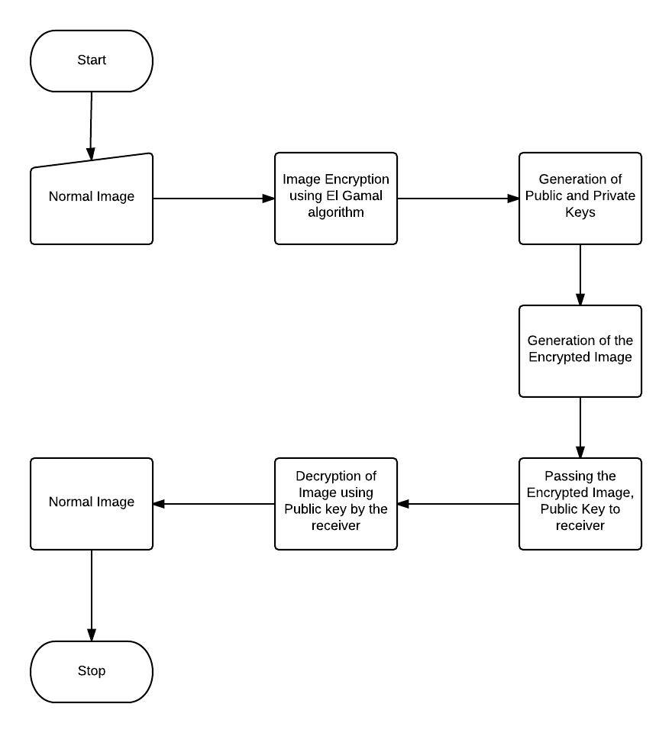

Operating Environment
Our system requirements include a normal working operating system which can support the software MATLAB by mathworks. The OS can be anything but it should be able to support the software mentioned above. MATLAB is the high-level language and interactive environment used by millions of engineers and scientists worldwide. It lets you explore and visualize ideas and collaborate across disciplines including signal and image processing, communications, control systems, and computational finance. Apart from the requirements mentioned above the system should have a minimum of 512 MB of RAM along with a processor of at least 1.5 GHz of processing speed, and a image reading software that has to be installed into the system.

Design and Implementation Constraints
There may be a few constraints which will limit the functionality of the system design –
- Video files may not be able to be processed because of the large number of frames that will be generated per second if the video file is processed individually as each frame per second.
- The color images may not be fully encrypted as they are a three dimensional matrix and our algorithm will work perfectly fine for mainly two dimensional images but may or may not work the three dimensional ones.
- Only one image at a time may be processed by the system and if the user has to process or encrypt more than one image file then he or she will have to re run the whole system again each time a image is being processed.
- The whole system is based on MATLAB and if the software MATLAB is not supported by the system on which the user is currently working then the system cannot be used at all by the user.
- The processing of large image files may require a little more of computation power.

User Documentation
For developing the system that we are currently making, the help of online tutorials on how the MATLAB software works and the detailed description and explanation on the usage of the EL Gamal encryption algorithm may be needed.

Assumptions and Dependencies
The whole system is dependent on the external third party software called MATLAB and hence if this dependency is not met then the whole system will crash.

Specific Requirements

External Interface Requirements

User Interfaces

Logical Characteristics:
- High-level language for numerical computation, visualization, and application development
- Interactive environment for iterative exploration, design, and problem solving
- Mathematical functions for linear algebra, statistics, Fourier analysis, filtering, optimization, numerical integration, and solving ordinary differential equations
- Built-in graphics for visualizing data and tools for creating custom plots
- Development tools for improving code quality and maintainability and maximizing performance
- Tools for building applications with custom graphical interfaces

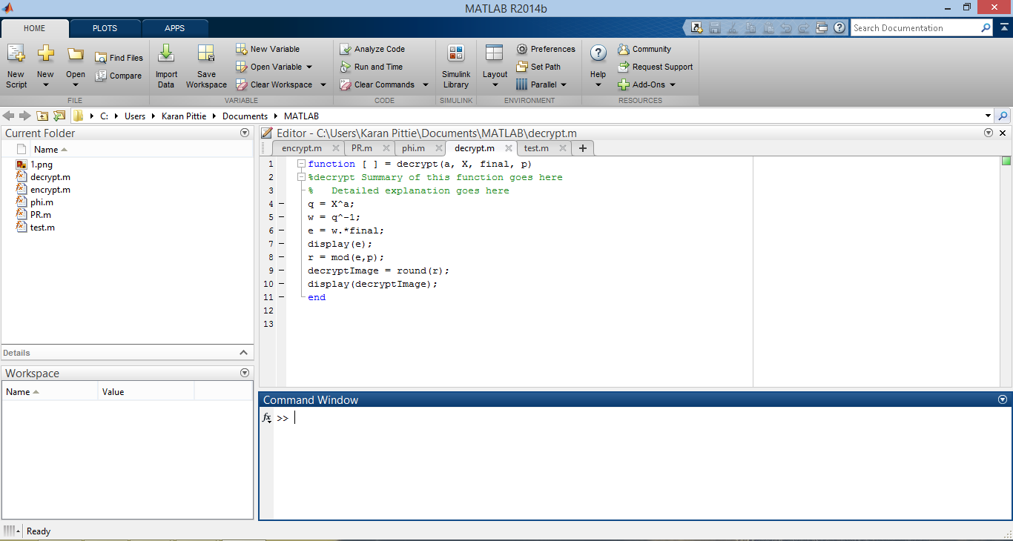
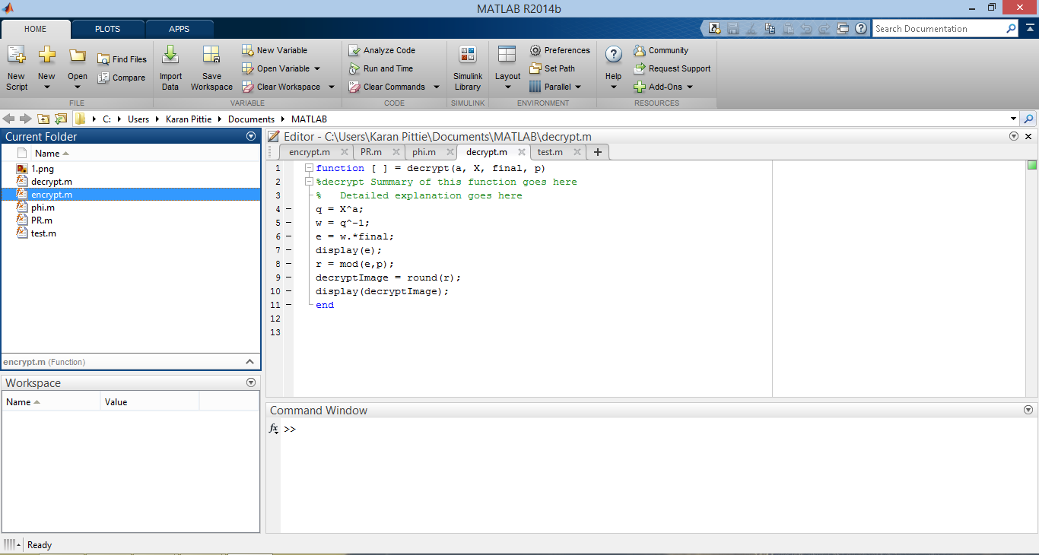

Hardware Interfaces
The image encryption software accesses the hard drive to locate the image files to be uploaded for encryption. The encrypted data will need a password to access.

Software Interfaces

This product is made using the following tools:

- MATLAB 8.2.0.29 (R2013b).
- Windows 8.1.
- Dev C++.

Communications Interfaces

Access the internet using HTTP Protocol to send the image to be encrypted to the Server.

Access the image files (uploads/downloads) using FTP Protocol.

Image encryption.

Functional Requirements

Ability to get the pixels of the original image.

Create a strong encryption image such that it cannot be hacked easily.

Faster Encryption time such that the encrypted image in transferred faster to the person.

Perfection in the original image we obtain after decrypting it.

Behaviour Requirements

Use Case View
The system will have a CLI interface wherein the user will be having a specific folder in which he would paste the image file which he wants to encrypt by using the EL Gamal’s encryption algorithm. The user will then, encrypt the image using the system and will generate the public key and the encrypted image which will then be passed on to the receiver. On the receivers end, the receiver will be decrypting the image using the system and will be generating the final unencrypted image and seeing the result.

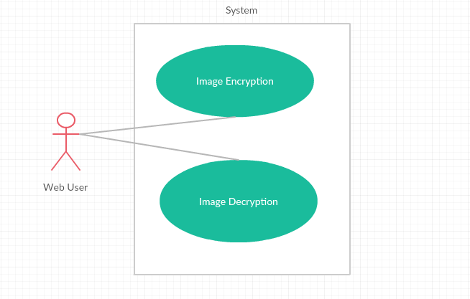
Use case view for a Web User

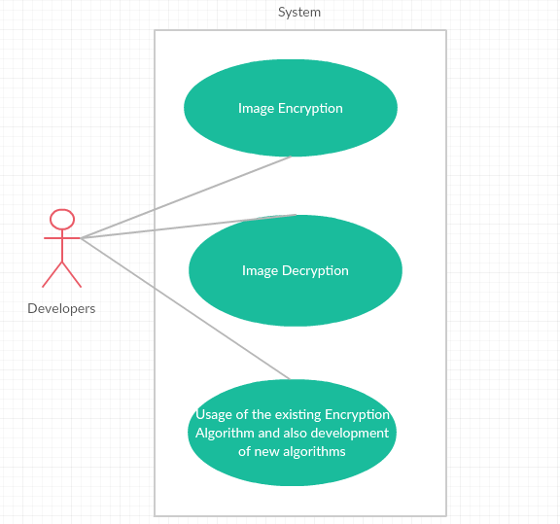

\

Use case view for professors and developers

Other Non-functional Requirements

Performance Requirements
4.1.1 [Visual acceptance]
Part of information may be visible but the encrypted image should look noisy
4.1.2 [Selective encryption]
Encryption occurs after compression and leaves parts of the bit stream unencrypted
4.1.3 [Constant bit rate]
Encryption should preserve the size of the bit stream
4.1.4 [Bit stream compliance]
The encryption step should produce a compliant bit stream according to the chosen format definition.

Safety and Security Requirements

The image will be encrypted and will require a passkey to decrypt.

The images will the 256 bit encrypted and hard to crack.

Software Quality Attributes

Portability

Very small file size, can be easily carried in a chip/USB.
The system is designed using MATLAB functions and hence the file size should not be very large (approx. in KB’s) so the system can be carried easily in a USB.

This software can be accessed from anywhere in the world through the internet.
The system can be hosted online with the help of MATLAB servers and hence any user across the globe having internet access can access the system and use it.

Maintainability

This software can be easily maintained and updated online.
The software has majorly MATLAB operations. The MATLAB operations can be regularly updated and changed with respect to recent trends in technology and the system can then be appropriately maintained.

Adaptability

This software is adaptable across all major platforms.
Our system can work on virtually any system that supports MATLAB designed my Math Works and hence it can be run on any system without any compatibility issues.

Availability

This software is available online and 24/7 all 365 days.
Once the system is live on the internet using the MATLAB servers it can be accessed by anyone at any time of the day or night the only condition being that the person trying to access the system should have a working internet connection and should have MATLAB installed in his system.

Appendix A – Data Dictionary
- Encryption – In cryptography, encryption is the process of encoding messages or information in such a way that only authorized parties can read it. Encryption does not of itself prevent interception, but denies the message content to the interceptor. In an encryption scheme, the intended communication information or message, referred to as plaintext, is encrypted using an encryption algorithm, generating cipher text that can only be read if decrypted. For technical reasons, an encryption scheme usually uses a pseudo-random encryption key generated by an algorithm. It is in principle possible to decrypt the message without possessing the key, but, for a well-designed encryption scheme, large computational resources and skill are required. An authorized recipient can easily decrypt the message with the key provided by the originator to recipients, but not to unauthorized interceptors.
- Cryptography – Cryptography or cryptology; from Greek κρυπτός kryptós, "hidden, secret"; and γράφειν graphein, "writing", or -λογία -logia, "study", respectively is the practice and study of techniques for secure communication in the presence of third parties called adversaries. These adversaries are often referred to as Eve in cryptography, while the sender and recipient of messages are called Alice and Bob respectively. More generally, cryptography is about constructing and analyzing protocols that prevent third parties or the public from reading private messages; various aspects in information security such as data confidentiality, data integrity, authentication, and non-repudiation are central to modern cryptography. Modern cryptography exists at the intersection of the disciplines of mathematics, computer science, and electrical engineering. Applications of cryptography include ATM cards, computer passwords, and electronic commerce.
- El Gamal – In cryptography, the ElGamal encryption system is an asymmetric key encryption algorithm for public-key cryptography which is based on the Diffie–Hellman key exchange. It was described by Taher Elgamal in 1985. ElGamal encryption is used in the free GNU Privacy Guard software, recent versions of PGP, and other cryptosystems. The DSA (Digital Signature Algorithm) is a variant of the ElGamal signature scheme, which should not be confused with ElGamal encryption. ElGamal encryption can be defined over any cyclic group . Its security depends upon the difficulty of a certain problem in related to computing discrete logarithms
- MATLAB – MATLAB (matrix laboratory) is a multi-paradigm numerical computing environment and fourth-generation programming language. A proprietary programming language developed by MathWorks, MATLAB allows matrix manipulations, plotting of functions and data, implementation of algorithms, creation of user interfaces, and interfacing with programs written in other languages, including C, C++, Java, Fortran and Python.

- Image – An image (from Latin: imago) is an artifact that depicts or records visual perception, for example a two-dimensional picture, that has a similar appearance to some subject—usually a physical object or a person, thus providing a depiction of it.
- Primitive Root – In modular arithmetic, a branch of number theory, a number g is a primitive root modulo n if every number coprime to n is congruent to a power of g modulo n. That is, for every integer a coprime to n, there is an integer k such that g^{k} ≡ a (mod n). Such k is called the index or discrete logarithm of a to the base g modulo n. In other words, g is a generator of the multiplicative group of integers modulo n. Gauss defined primitive roots in Article 57 of the Disquisitiones Arithmeticae (1801), where he credited Euler with coining the term. In Article 56 he stated that Lambert and Euler knew of them, but he was the first to rigorously demonstrate that primitive roots exist for a prime n. In fact, the Disquisitiones contains two proofs: the one in Article 54 is a nonconstructive existence proof, while the other in Article 55 is constructive

Appendix B - Group Log
Apart from the meeting that were conducted during the lab hours there were several other meetings that were conducted both over the phone and in person where the abstract and the design of the project was finalised.

