**STATS202A HW 9**

**Bhargav Parsi (804945591)**

1. Result of SVM:

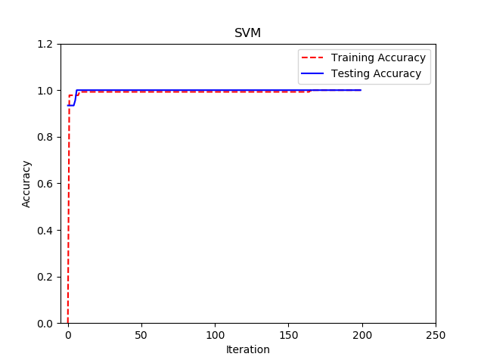

Since SVM has a regularization parameter we can say that it does not overfit the data. It is clearly visible from the graph.

1. Result of Adaboost:

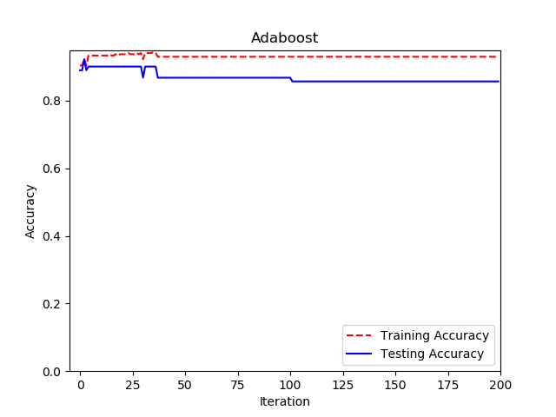

We can see that Adaboost can be sensitive to noisy data and outliers because, after reaching a maximum accuracy, it decreases due to outliers unlike SVM. We can also conclude that Adaboost overfits the data if lot of weak classifiers are used.