**STAT202A**

**Assignment 6**

**BHARGAV PARSI**

**(804945591)**

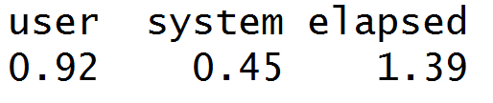

**QR for n = 20 and p = 500 in RCPP**

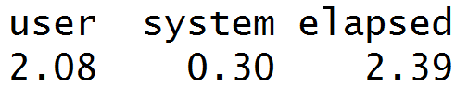

**QR for n = 20 and p = 500 in R**

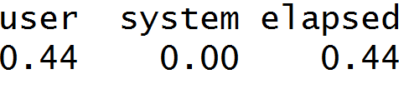

**Sweep for n = 20 and p = 500 in Rcpp**

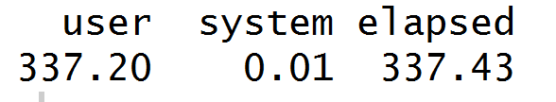

**Sweep for n = 20 for p = 500 in R**

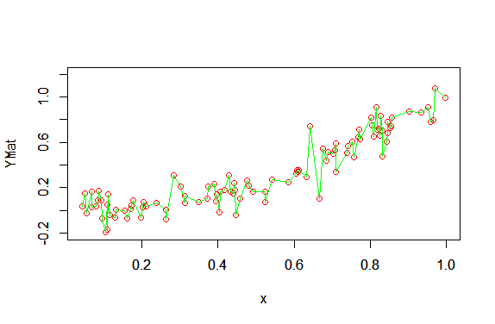

**N = 100, P = 500, lambda = 0**

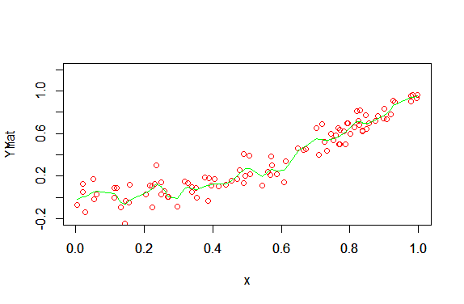

**N = 100, P = 500, lambda = 0.001**

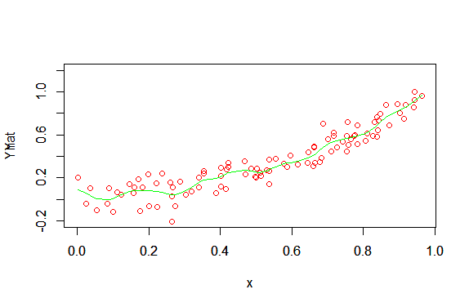

**Lambda = 0.01**

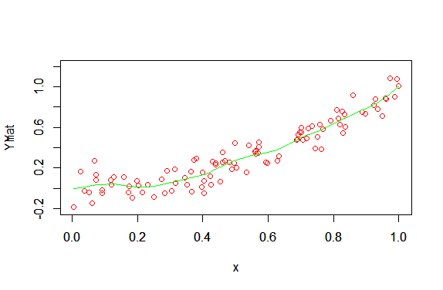

**Lambda = 0.1**

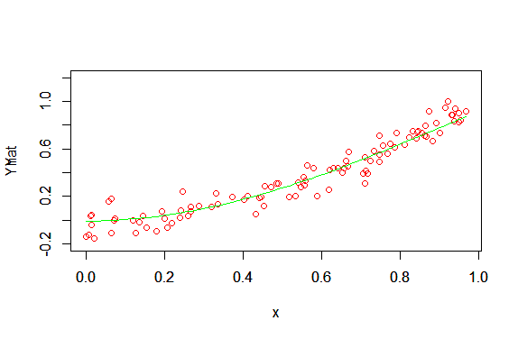

**Lambda = 100**

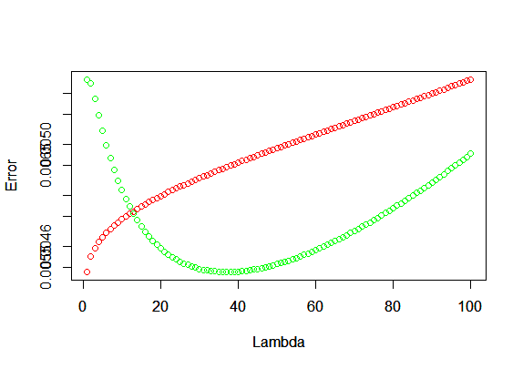

**Green – Test Error, Red – Train Error**

**N = 50, P = 1000**

As lambda is low, training error is low and testing error is high, as the model is overfitting, as lambda increases, Training error and testing error increase due to under fitting.

Ridge Regression:

We can observe the similar results in ridge regression also. As lambda increases, the curve overfits when lambda is small and under fits when lambda is large.

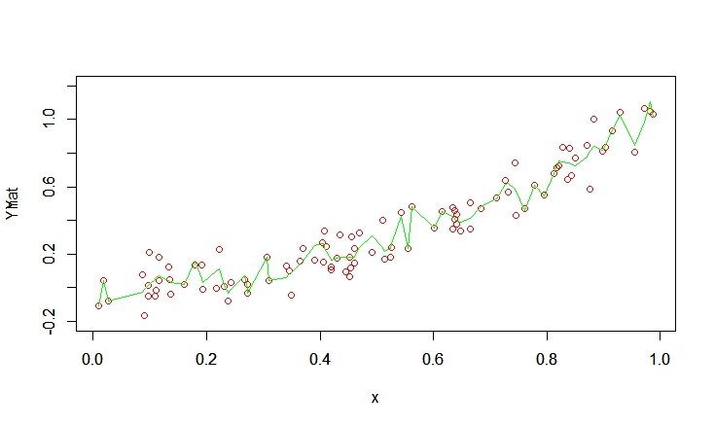

**Lambda = 0**

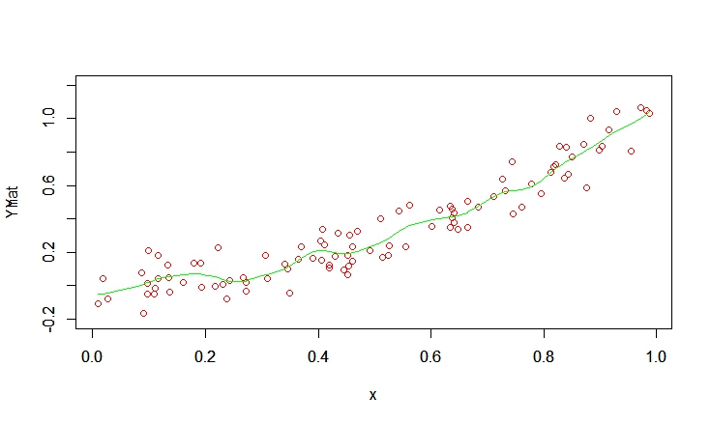

**Lambda = 0.001**

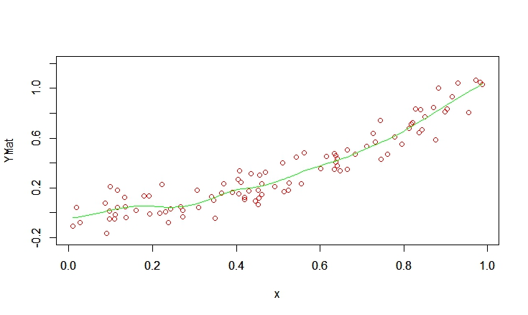

**Lambda = 0.01**

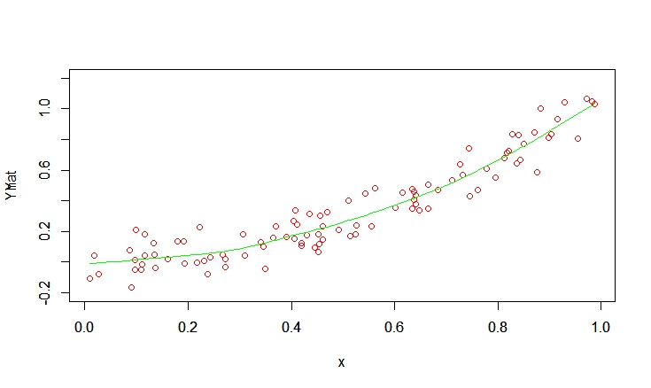

**Lambda = 0.1**

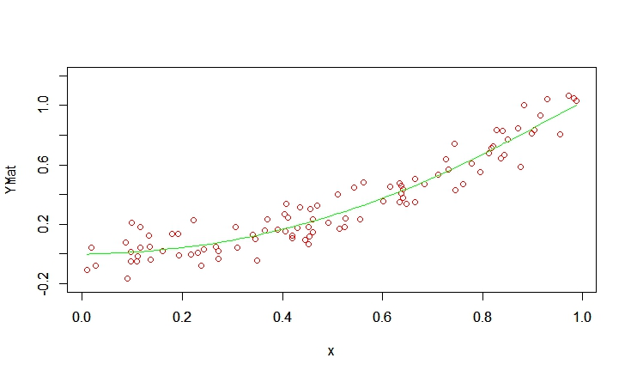

**Lambda = 1**

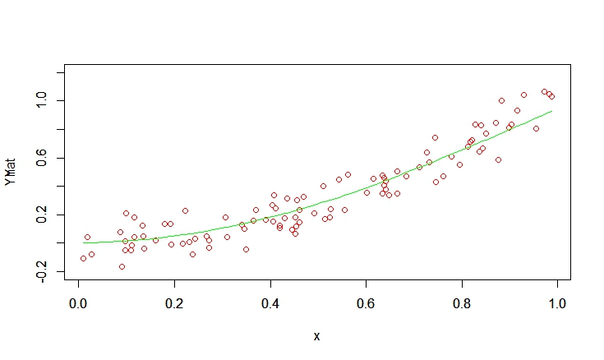

**Lambda = 10**

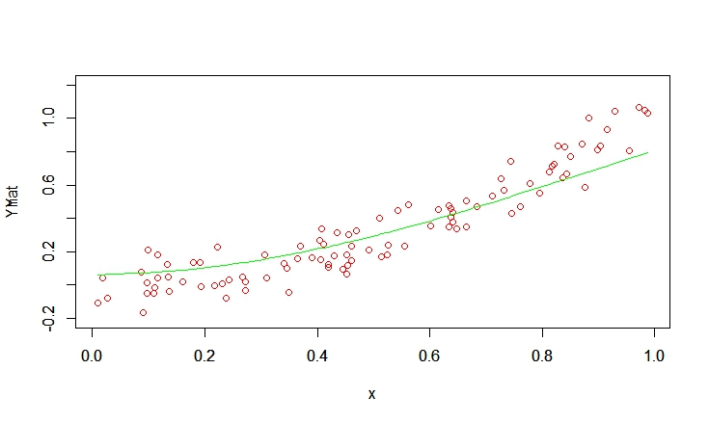

**Lambda = 50**

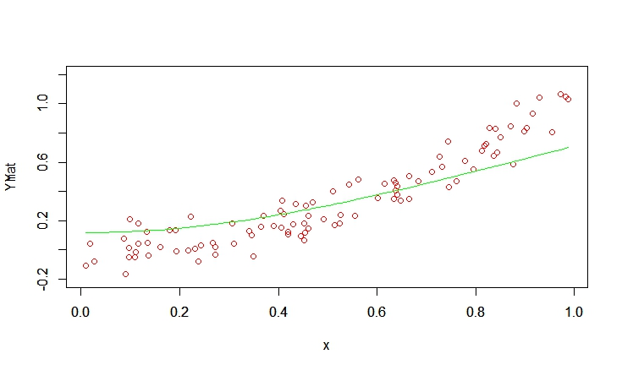

**Lambda = 100**

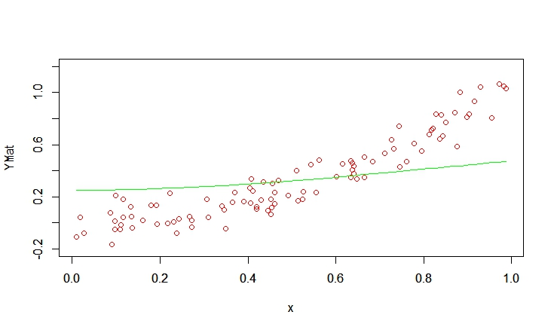

**Lambda = 500**

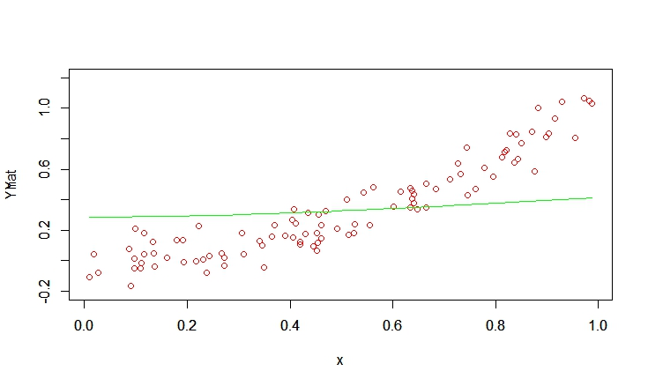

**Lambda = 1000**