**Stats202A - HW 7**

**BHARGAV PARSI (804945591)**

1. Error plot for Lasso for various Lambda values

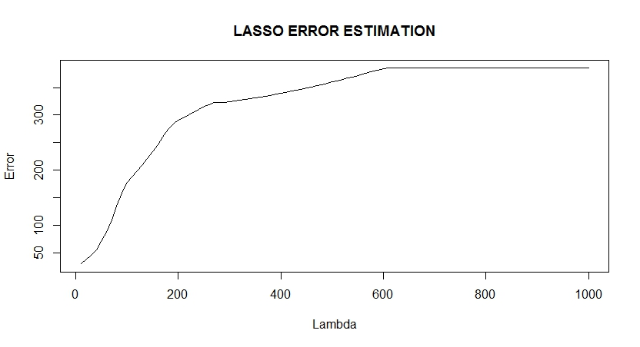

**Fig 1: Error Vs Lambda**

1. Analysis of Real World Data sets:

I have used the Swiss Data set for Linear Regression and Ridge Regression.

Below I have plotted a few variables vs the y value.

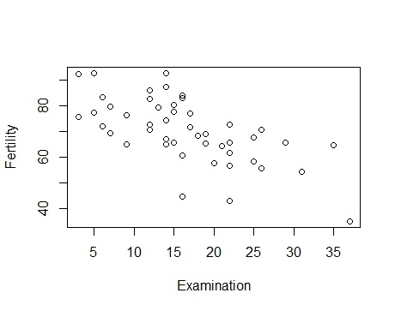

**Fig 2 Fertility Vs Examination**

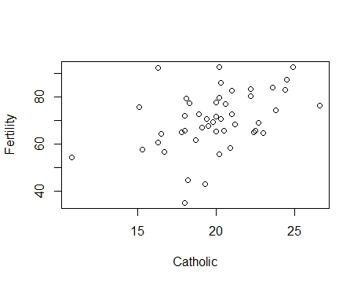

**Fig 3 Fertility Vs Catholic**

1. **Logistic Regression:**

I have used the binary dataset from the IDRE website("https://stats.idre.ucla.edu/stat/data/binary.csv"). This dataset has the independent variables as GRE, GPA and Rank. The dependent variable is whether that particular person got an Admit or not.

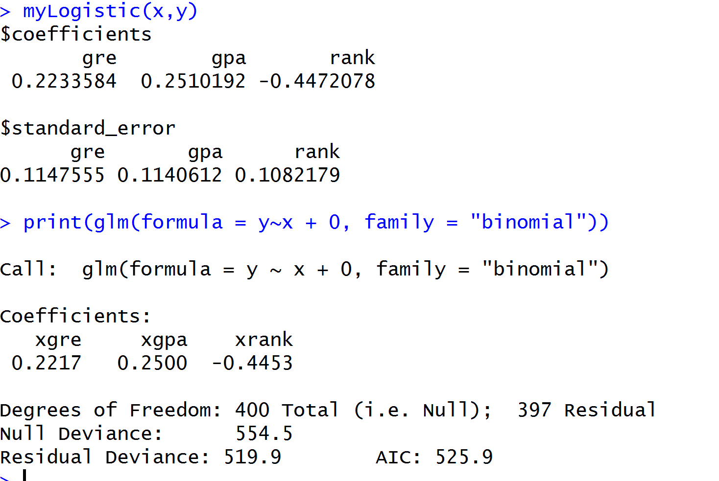

**Fig 4: Logistic Regression**

1. **Ridge Regression:**

Swiss dataset was used to compare results. It gives us the Standardized fertility measure and socio-economic indicators for each of 47 French-speaking provinces of Switzerland at about 1888.

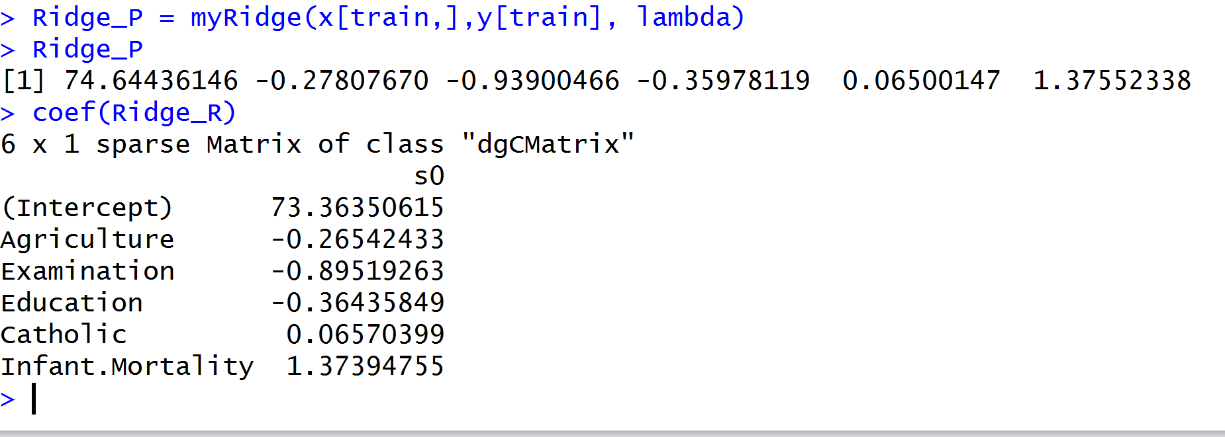

**Fig 5: Results of Ridge Regression**

The myRidge result was compared with lambda = 0.1 with the glmnet library in R. We can see that the result is quite similar to the output of the R function.

1. **PCA**

Iris Dataset was used to analyse PCA. This famous (Fisher's or Anderson's) iris data set gives the measurements in centimeters of the variables sepal length and width and petal length and width, respectively, for 50 flowers from each of 3 species of iris. The species are *Iris setosa*, *versicolor*, and *virginica*.

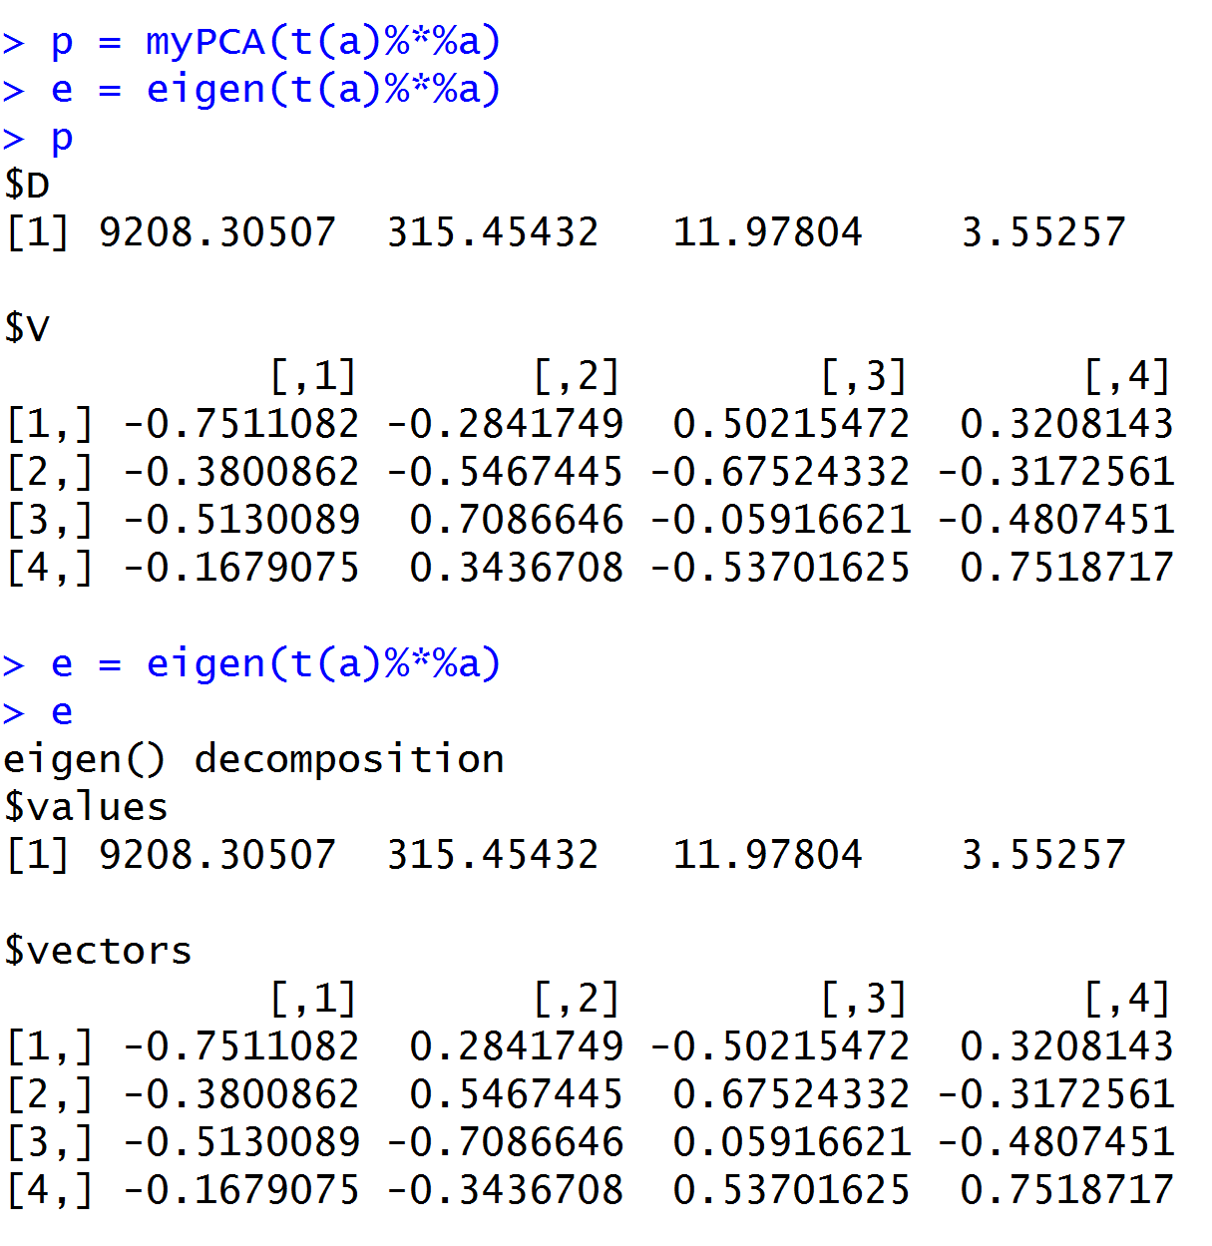

**Fig 6: Analysis of PCA**

1. **Linear Regression**

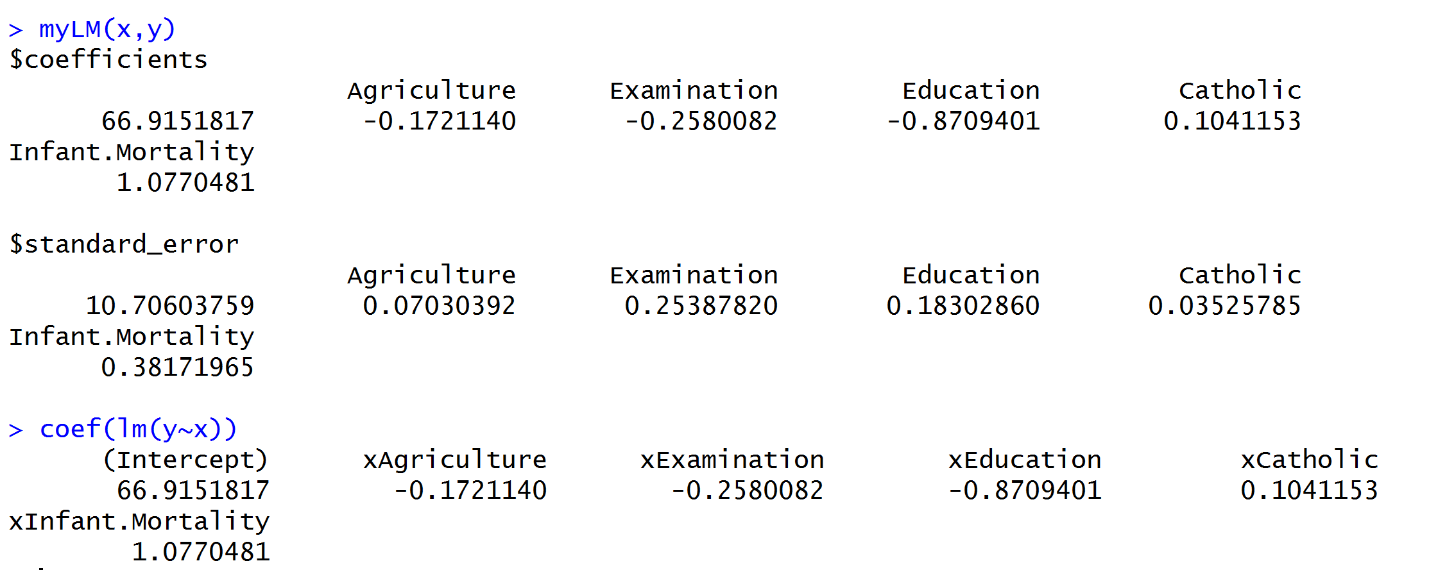

**Fig 7: Linear Regression**

We can see the negative correlation between Examination and Fertility and positive correlation between Catholic and Fertility. This can be also observed from the coefficient values which are -ve and +ve.

1. **Lasso Regression**

I used the Swiss data set with Lambda = 10^seq(10,-2,length = 100). Below are the lasso solution paths for in built function(glmnet) and my function.

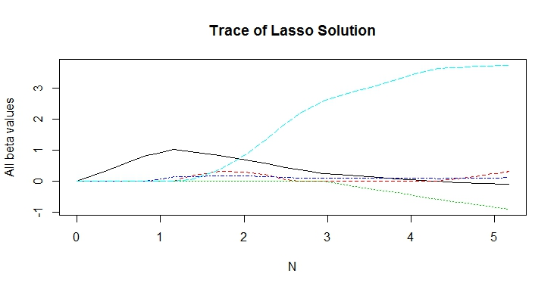

**Fig 8: Lasso Solution for myLasso Function**

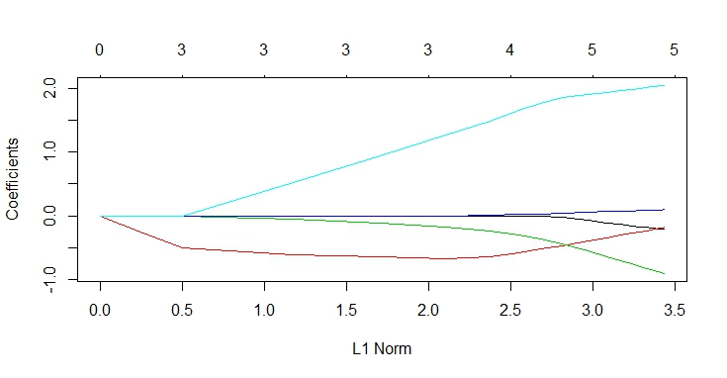

**Fig 9: Lasso Solution for Inbuilt Lasso Function**