**Linux Commands**

**Stats 202A**

**BHARGAV PARSI(804945591)**

1. Mkdir – Makes a new directory

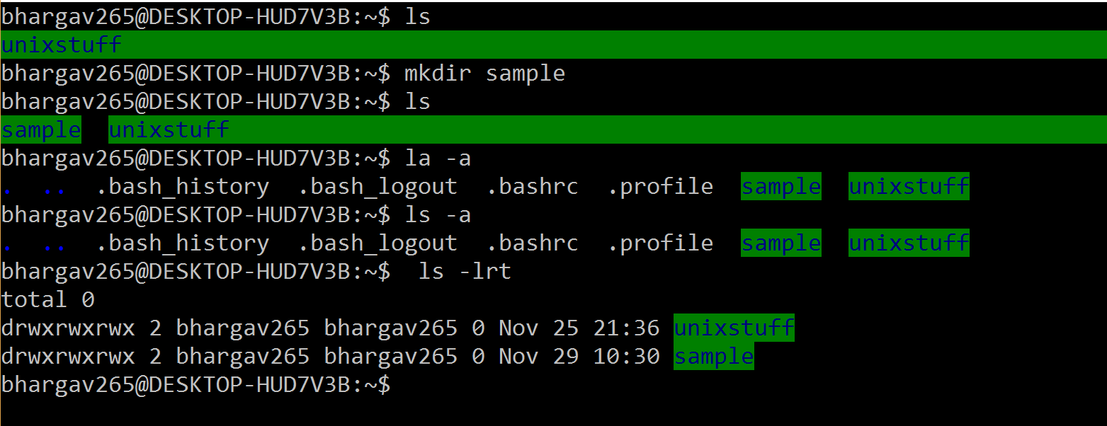

1. Cd – Changes the directory

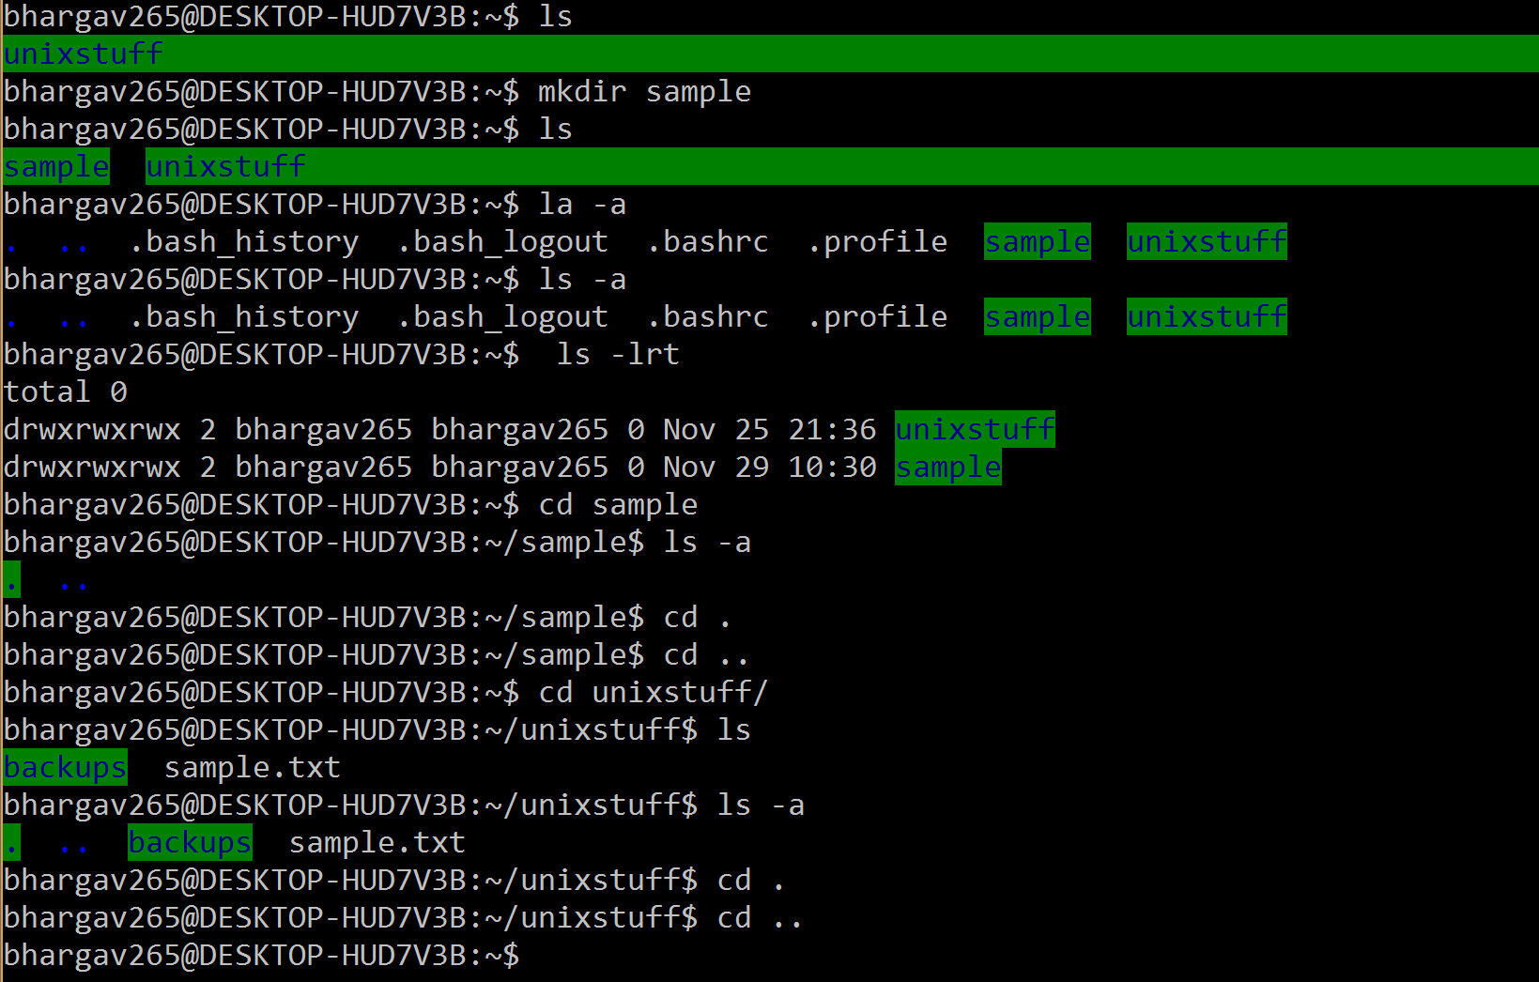

1. ls path – lists the items in the path specified

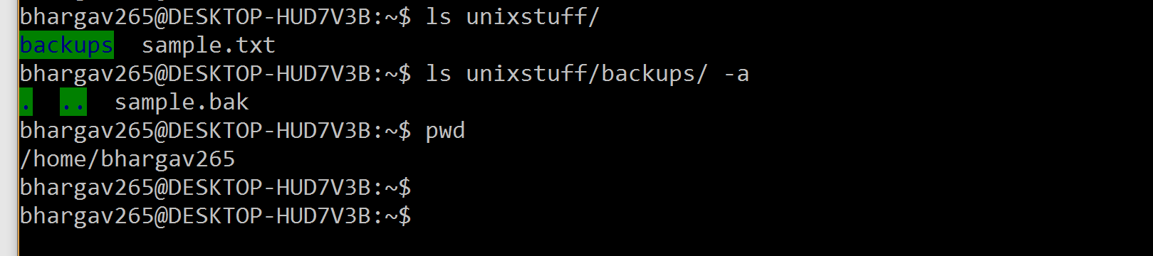

1. copy, move, rmdir – removes specified directory

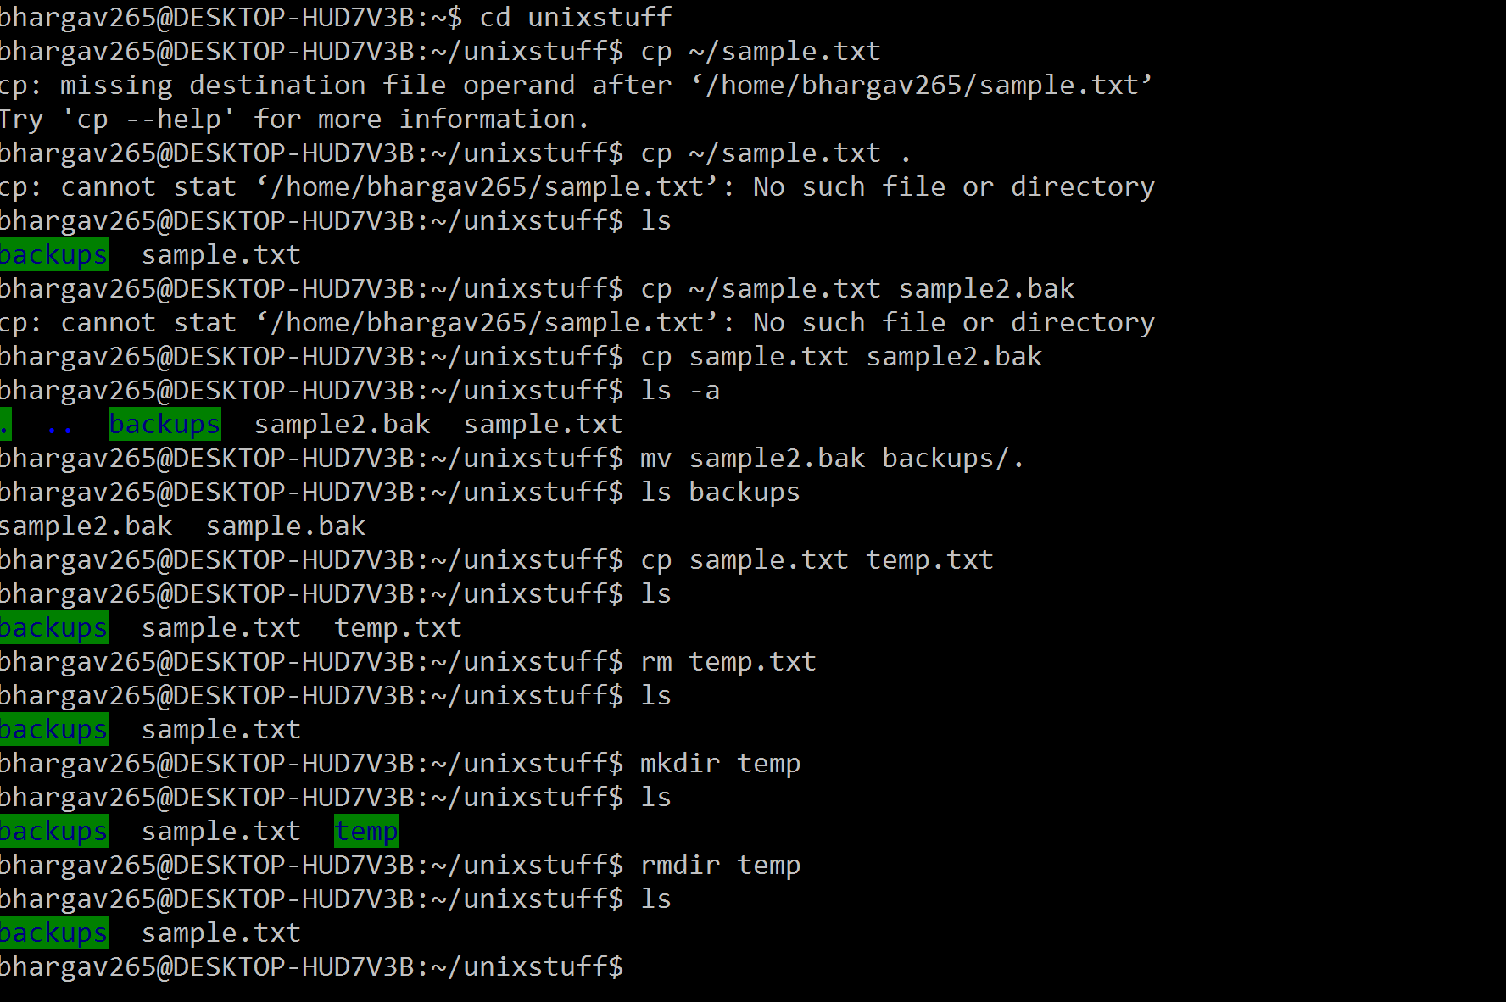



1. cat – concats text to file, less, head, tail – show limited description of file

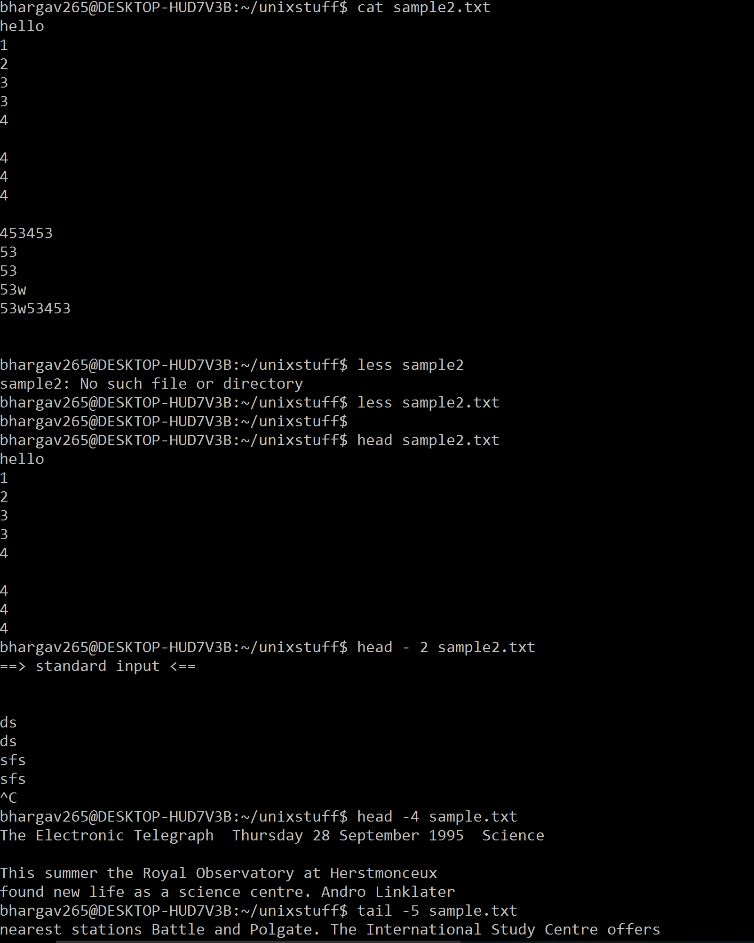

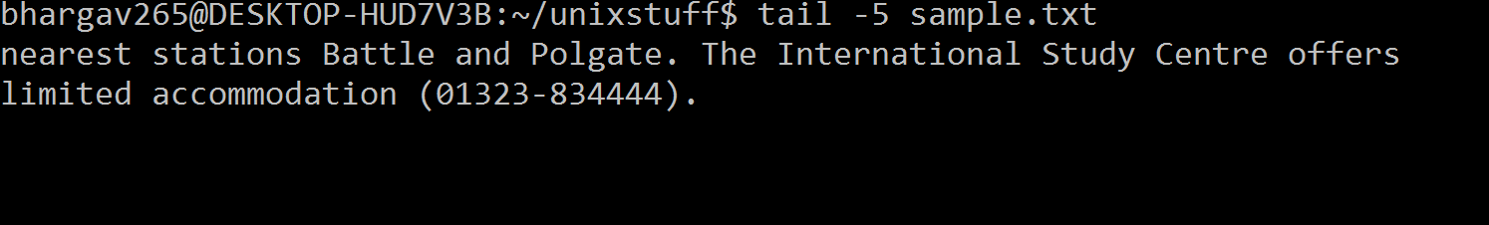

1. grep – searches term in a file

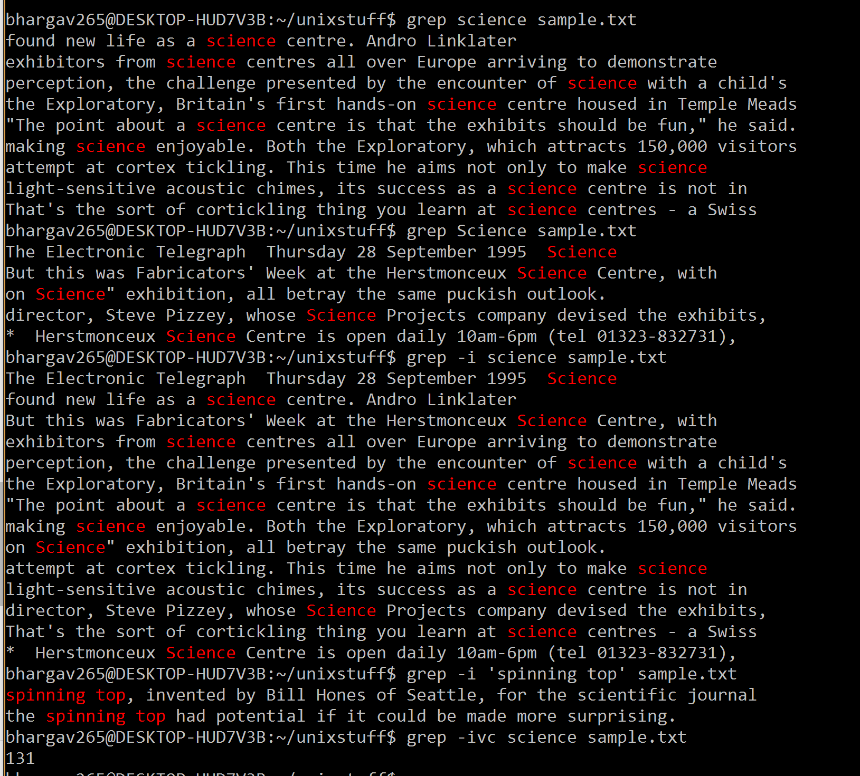

1. word count

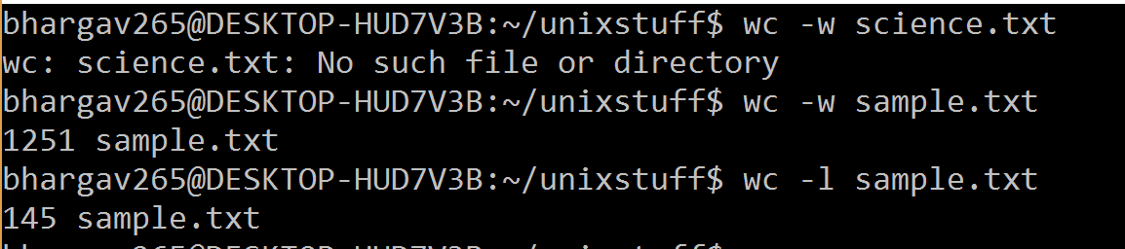

1. concatenate to list – writes input text to list

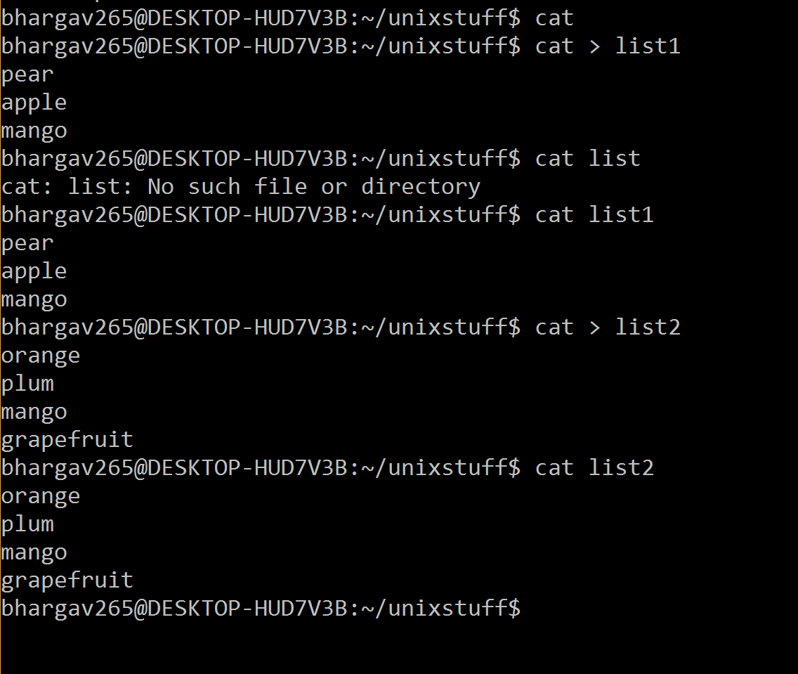

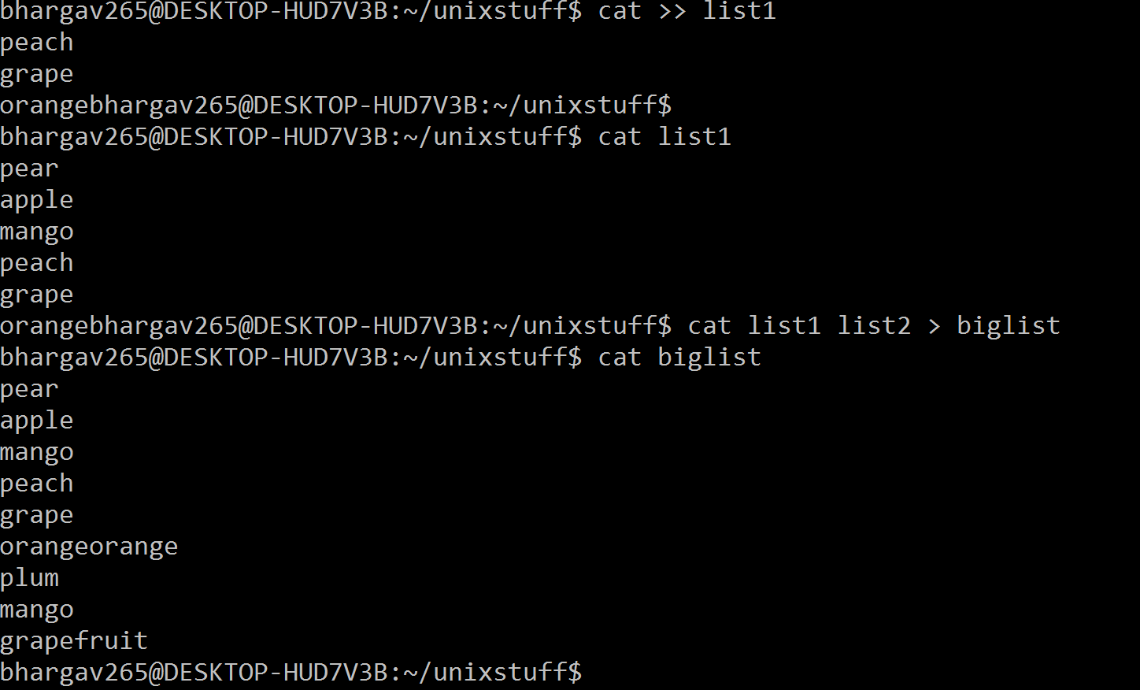

1. sort – sorts the input given

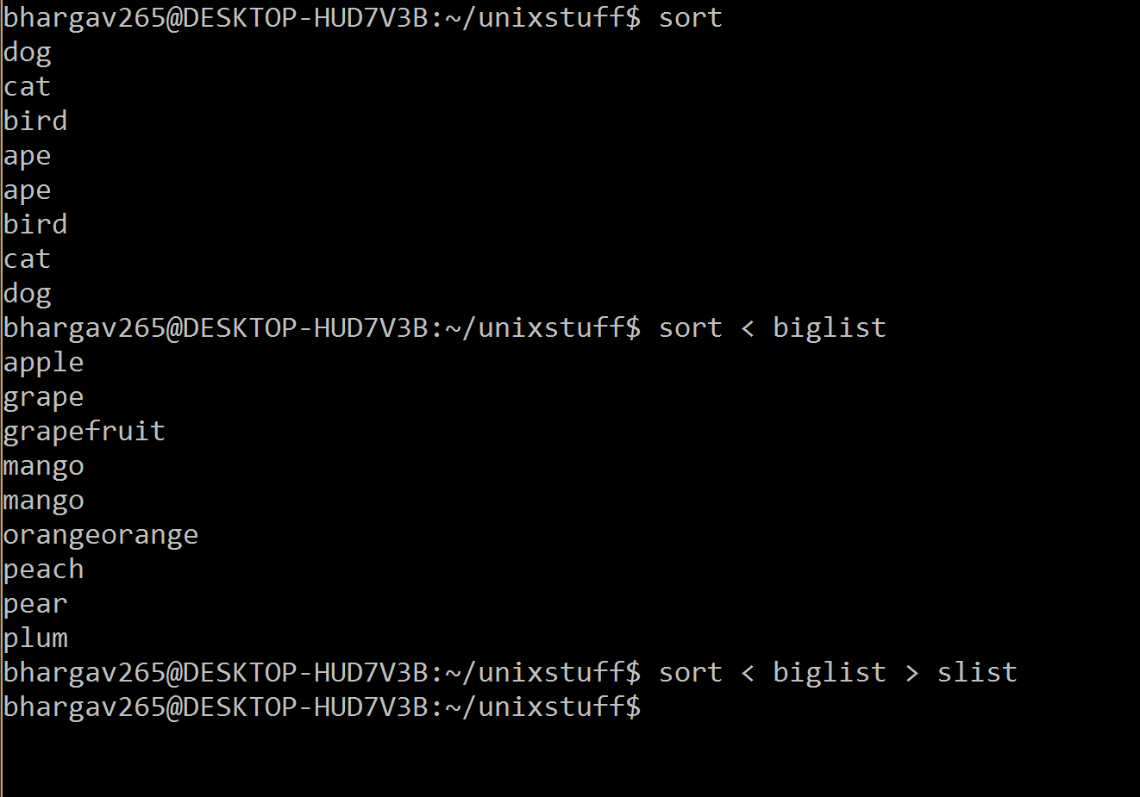

1. ) who, cat + grep

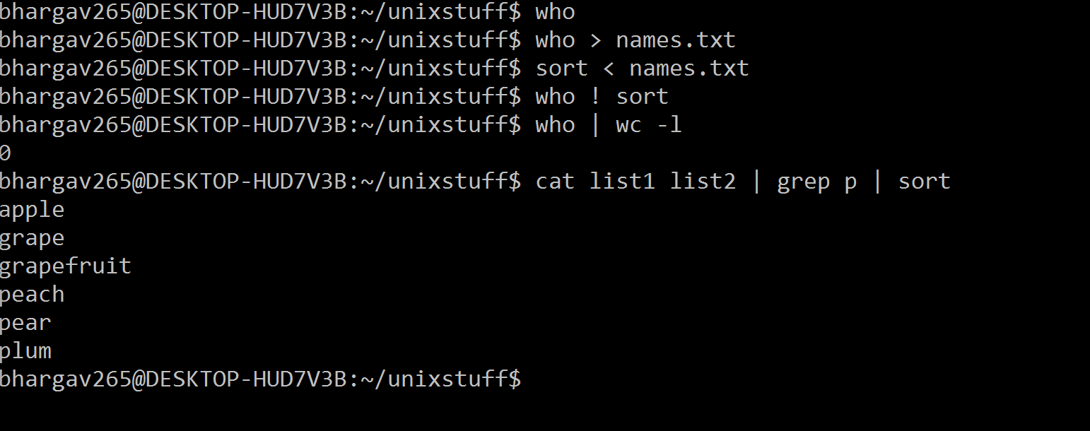

1. )wildcard – Searching mechanisms. * -> 0 or many characters, ? -> exactly 1 character

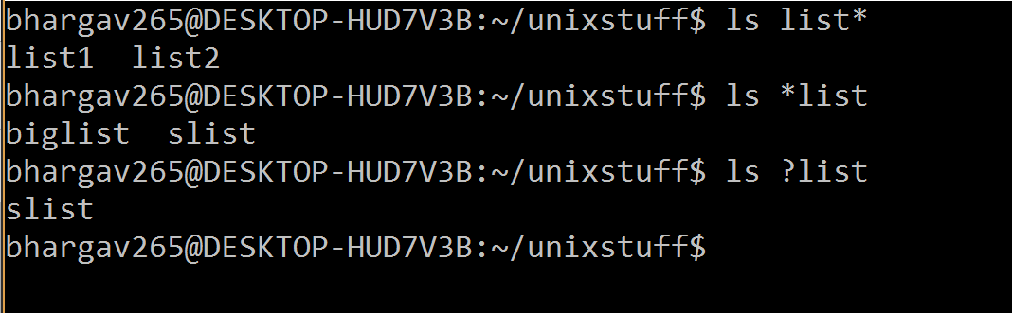

1. ) man – user manual of command, aprpos – searches approximate commands near to given input.

