Project 3 - Aircraft Classification
Group - 4
Student1: Karan Rooprai Student 1 ID: N12498122
Student2: Nhu Hieu Nguyen Student 2 ID: N12194778

A pretrained ResNet-18 (ImageNet weights) was adapted through transfer learning to classify the 20-class FGVC-Aircraft subset. The trainval folder of 1,331 images was divided 80/20 with a stratified split into 1,064 training and 267 validation images, while the 669 test images were held out and used only once, for the final evaluation. Every image was resized to 224×224 and normalised with the ImageNet mean and standard deviation to match the pretrained backbone, and the 1000-way ImageNet head was replaced with a fresh 20-way linear layer. The three experiments follow a controlled design: each alters a single variable relative to a common baseline and is trained for 12 epochs, so any change in validation accuracy is attributable to that one factor.
A. Baseline model
The baseline uses ResNet-18 as a fixed feature extractor: the convolutional backbone is frozen and only the new classification head is trained, with plain SGD (learning rate 0.001, momentum 0.9) on un-augmented images. This establishes the performance floor that every experiment must beat. It reached a best validation accuracy of 0.5094 (Table 1; blue curve, Figure 1). The frozen ImageNet features separate the twenty aircraft types moderately well, but because the backbone cannot adapt, the head alone cannot capture the fine-grained differences between visually similar variants.
B. Experiment 1 - Data augmentation
Hypothesis: randomly flipping, rotating (±15°) and colour-jittering the training images exposes the frozen extractor to more varied views, reducing over-fitting and improving validation accuracy. Result: not supported. Augmentation lowered best validation accuracy to 0.4082, a drop of 0.1011 below the baseline (orange curve, Figure 1). With the backbone frozen, the network cannot adapt its features to the distorted inputs, so the augmented images push the fixed ImageNet features into regions the linear head has not learned, and twelve epochs are too few to compensate. Augmentation therefore hurts a pure feature-extraction setup on this dataset.
C. Experiment 2 - Fine-tuning the backbone
Hypothesis: ImageNet features are generic, so unfreezing the backbone and letting every layer adapt to aircraft should capture fine-grained variant differences and lift accuracy well above the frozen baseline. Result: strongly supported. Unfreezing the backbone — the only change from the baseline, keeping the identical SGD optimiser and 0.001 learning rate — raised best validation accuracy to 0.7678, a gain of 0.2584 (green curve, Figure 1). This is by far the largest single improvement, confirming that adapting the convolutional features, not just the classifier, is essential for fine-grained aircraft recognition.
D. Experiment 3 - AdamW optimiser + Cosine-Annealing schedule
Hypothesis: replacing plain SGD with AdamW (adaptive updates plus weight decay) and decaying the learning rate on a cosine schedule should give faster, more stable convergence of the frozen head and a modest accuracy gain. Result: supported, modestly. With the backbone frozen and images un-augmented, changing only the optimiser and schedule raised best validation accuracy to 0.5468, a gain of 0.0375 over the baseline (red curve, Figure 1). AdamW converges faster and to a slightly better optimum than SGD, but with the backbone still frozen the ceiling is limited, so the gain is real but small next to fine-tuning.
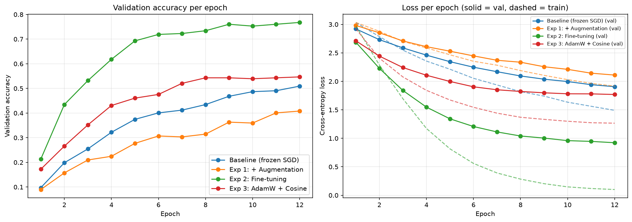
Figure 1. Validation accuracy (left) and training/validation loss (right) per epoch for the baseline and the three experiments.
Model | Best validation accuracy | Δ vs baseline
Baseline (frozen, SGD) | 0.5094 | —
Exp 1: + Data augmentation | 0.4082 | −0.1011
Exp 2: Fine-tuning | 0.7678 | +0.2584
Exp 3: AdamW + Cosine | 0.5468 | +0.0375
Table 1. Best validation accuracy of the baseline and each single-variable experiment.
E. Best model
Rationale. The final model combines only the changes that improved validation accuracy over the baseline. Fine-tuning (+0.2584) and AdamW + Cosine-Annealing (+0.0375) both helped and are retained; augmentation is excluded because it reduced accuracy and is therefore not a winning ingredient. The best model is thus an unfrozen ResNet-18 trained with AdamW and Cosine-Annealing on un-augmented images. As required, it was retrained on the entire trainval set (all 1,331 images, no validation split) for 15 epochs, using a smaller learning rate of 0.0001 suited to fine-tuning the whole network with AdamW, before a single evaluation on the test set.
Result. On the 669 held-out test images the model achieves an average per-class accuracy of 0.8148, an overall accuracy of 0.8146, and a macro-averaged F1 of 0.8152, comfortably exceeding the required 0.75 target. Average per-class accuracy — the mean of the twenty per-class recall values — is reported rather than overall accuracy because it weights every aircraft type equally and is not dominated by the larger or easier classes; the near-identical macro-F1 confirms performance is balanced across classes. The test confusion matrix is shown in Figure 2.
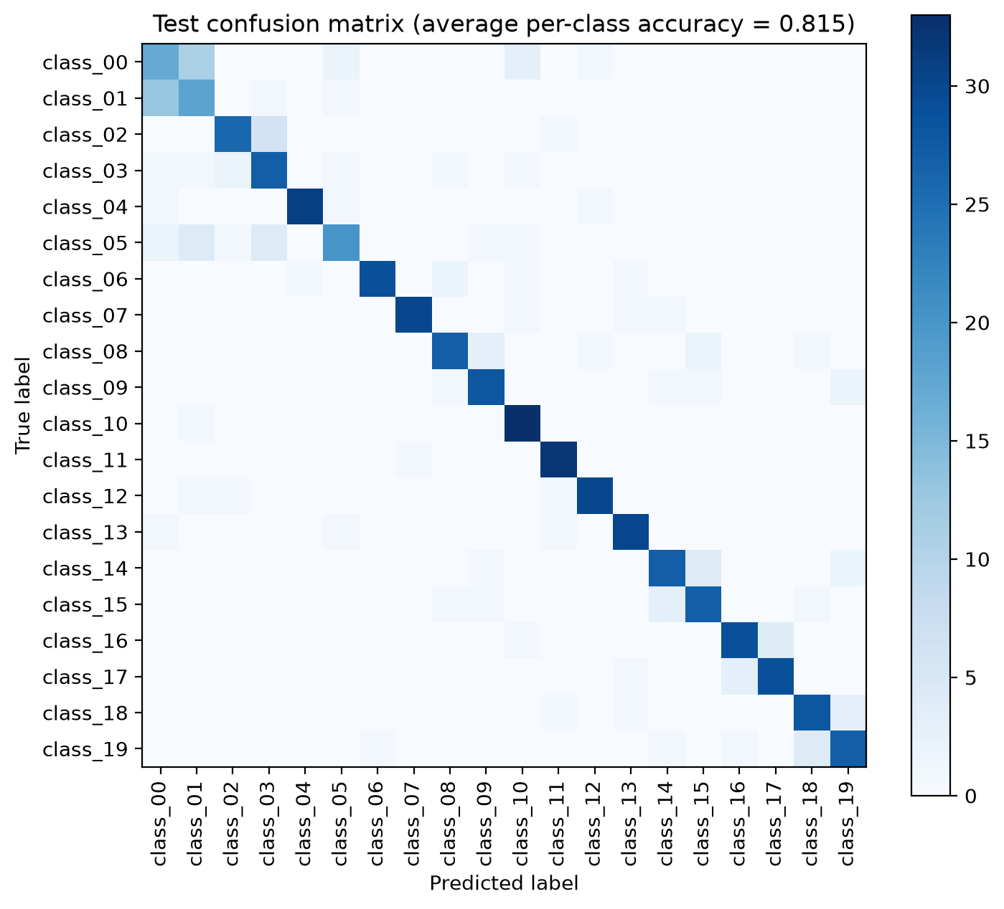
Figure 2. Confusion matrix of the best model on the 669 test images (average per-class accuracy = 0.815).
F. Potential and limitations
The strong diagonal in Figure 2 shows most classes are recognised reliably, with the best (class_10 and class_11) reaching about 0.97. Performance is dragged down by a small cluster of visually near-identical variants: class_00 is the weakest at 0.500 and is heavily confused with class_01 (13 class_01 images are predicted as class_00 and 11 class_00 images as class_01), while class_05 (0.606) and class_02 are spread across similar look-alike types. The fine-tuned model also reaches 100% training accuracy within a few epochs, so the roughly 0.19 gap between training and test performance reflects moderate over-fitting on the small training set. Within the same transfer-learning framework, results could be improved by reintroducing light augmentation now that the backbone is trainable (augmentation regularises a fine-tuned network differently from a frozen one), tuning weight decay or adding modest dropout, or using early stopping to close the train–test gap; a deeper backbone such as ResNet-34 could also raise the ceiling on the hardest look-alike classes.

