Project 7: Improving DDPM — Cosine vs Linear Noise Schedules
Group 4
Student 1: Karan Rooprai Student 1 ID: n12498122
Student 2: Nhu Hieu Nguyen Student 2 ID: n12194778
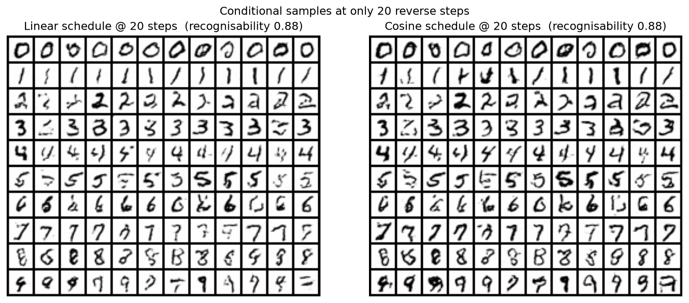
Figure 1. Conditional samples (12 per digit, 120 per model) generated with only 20 DDIM reverse steps from the linear (left) and cosine (right) models. Both show within-class variety (no mode collapse), but the cosine digits have bolder, higher-contrast strokes closer to the real ink weight, while the linear digits are thinner and washed out.

Introduction
Denoising diffusion probabilistic models (DDPMs; Ho et al., 2020) generate an image by reversing a fixed noising process over T steps, which makes sampling slow. Nichol & Dhariwal (2021) observed that the original linear variance schedule destroys information too quickly on low-resolution images: the image is almost pure noise well before t = T, so many steps are wasted. They proposed a cosine schedule that adds noise more gently in the middle of the process and reported better likelihoods and, importantly, near-full sample quality with far fewer sampling steps (tens rather than thousands). We test their claim that a cosine schedule allows a DDPM to generate high-quality samples using fewer time steps than a linear schedule, on 20x20 custom MNIST with class-conditional generation.
Methodology
Baseline. We follow Tutorial 9.3: a small conditional U-Net (two pooling levels, 20→10→5) predicts the noise ε added at a random timestep, with summed timestep and class embeddings injected at every stage. Images are scaled to [-1, 1]; T = 1000, linear β from 1e-4 to 0.02, MSE loss, Adam (lr 2e-4), batch 256, 100 epochs. The whole training set is kept on the GPU to avoid data-loading bottlenecks.
Cosine schedule. The second model is identical except for the schedule, which we implement from Nichol & Dhariwal (2021): ᾱ(t) = cos²(((t/T)+s)/(1+s)·π/2) with s = 0.008, normalised so ᾱ(0) = 1, and β_t = 1 − ᾱ(t)/ᾱ(t−1) clipped at 0.999. Architecture, T, optimiser, epochs and seed are shared, so the schedule is the only variable.
Fewer-step sampling. To sample in K < T steps we take an evenly spaced subsequence of timesteps and apply deterministic DDIM updates (Song et al., 2021), clipping the predicted x₀ to [-1, 1] and re-deriving ε from it. An initial attempt with naive ancestral re-spacing was numerically unstable for the cosine schedule (its sharp fall in ᾱ near t = T makes the re-spaced β approach 1), which is why DDIM — the standard reduced-step sampler — was used for all reported results.
Experiments
Both models generate the required 12x10 grids (Fig. 1 and main_report.ipynb). To test the hypothesis we sample 500 images per model (50 per digit, fixed seed) at K = 10, 20, 50, 100, 250 and 1000 steps and score them with two metrics built on an independent CNN classifier trained on the real digits (97.5% test accuracy). Recognisability is the fraction of samples classified as their conditioned digit. Fréchet feature distance (FD) fits Gaussians to the classifier’s 128-d penultimate features of 2,000 real test digits and of the samples, and measures the distance between them (an FID analogue; we use in-domain features because Inception-v3 expects 299x299 natural photographs). We also record wall-clock training time for each schedule.

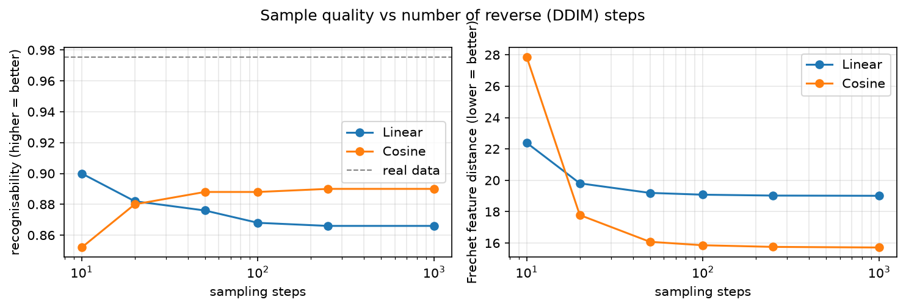
Figure 2. Recognisability (left, higher is better) and Fréchet feature distance to the real data (right, lower is better) versus the number of DDIM reverse steps, log scale.

Discussion
Steps | 10 | 20 | 50 | 100 | 250 | 1000
FD linear | 22.4 | 19.8 | 19.2 | 19.1 | 19.0 | 19.0
FD cosine | 27.9 | 17.8 | 16.1 | 15.9 | 15.8 | 15.7
Rec. linear | 0.900 | 0.882 | 0.876 | 0.868 | 0.866 | 0.866
Rec. cosine | 0.852 | 0.880 | 0.888 | 0.888 | 0.890 | 0.890
Table 1. Quality vs sampling steps (bold = cosine better).
Fewer steps. The Fréchet distance shows a clear advantage for the cosine schedule. With only 20 steps the cosine model reaches FD = 17.8, already lower than the linear model at the full 1000 steps (19.0), a 50x reduction in sampling steps for better quality. The cosine curve is within 3% of its plateau by 50 steps (16.1 vs 15.7), and from 20 steps upward it is better than linear at every budget, ending about 17% lower. This supports the hypothesis. Fig. 1 shows why: at 20 steps the linear digits are thin and faint, whereas the cosine digits keep realistic stroke weight.
Limits of the effect. At an extreme 10 steps the ordering reverses (FD 27.9 cosine vs 22.4 linear; recognisability 0.852 vs 0.900). The cosine schedule concentrates much of its change in ᾱ near the end of the process, so a very coarse 10-step grid skips that region badly. Recognisability barely separates the models (0.866–0.890 at 1000 steps): it saturates once a digit is legible, which is why a distributional metric was needed.
Training time and quality. Training time was identical (801 s vs 801 s): the schedule only changes the noise levels drawn during training, not the cost of each step. The final training losses are not comparable (0.032 vs 0.054), because the cosine schedule samples more mid-noise timesteps where predicting ε is harder. The benefit therefore appears entirely at inference time.
Limitations. Results use one seed, 500 samples per point and a single small U-Net on a simple, high-contrast dataset; FD from 500 samples has noticeable variance, so small gaps (e.g. at 250 vs 1000 steps) are not meaningful. A learned reverse variance (Nichol & Dhariwal, 2021) or several seeds would strengthen the conclusion.
Conclusion
With identical training cost, the cosine schedule produced samples that were distributionally closer to real digits than the linear schedule at every budget of 20 steps or more, and at 20 steps it already beat the linear model at 1000 steps. The evidence supports the hypothesis, with the caveat that at 10 steps the linear schedule was better. Future work: repeat over several seeds, add a learned reverse variance, and test at higher resolution.
References
Ho, J., Jain, A., & Abbeel, P. (2020). Denoising diffusion probabilistic models. NeurIPS 33, 6840–6851.
Nichol, A. Q., & Dhariwal, P. (2021). Improved denoising diffusion probabilistic models. ICML, PMLR 139, 8162–8171.
Song, J., Meng, C., & Ermon, S. (2021). Denoising diffusion implicit models. ICLR.

