Project 8: Extending Tiny NeRF with View Dependence and Hierarchical Sampling
Group 4
Student 1: Karan Rooprai Student 1 ID: n12498122
Student 2: Nhu Hieu Nguyen Student 2 ID: n12194778
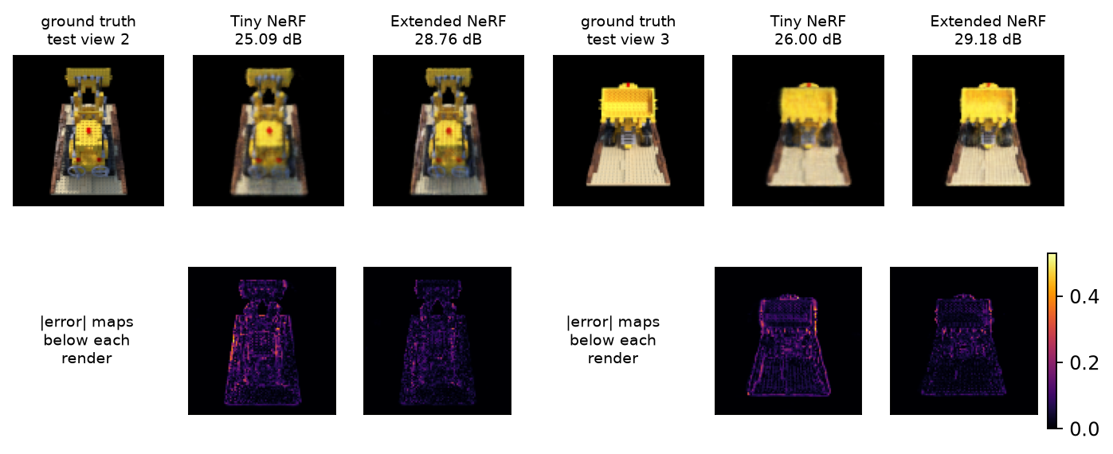
Figure 1. Held-out test views 2 (largest gain) and 3 (median gain): ground truth, Tiny NeRF and Extended NeRF with PSNR, and absolute-error maps on a shared scale. Tiny NeRF blurs the bucket, studs and tracks of the Lego bulldozer; Extended NeRF recovers sharper silhouettes and detail, and its remaining error is fainter and confined to thin edges.

Introduction
A Neural Radiance Field (NeRF; Mildenhall et al., 2020) represents a scene as an MLP that maps a 3D point to a density σ and a colour c, and renders a pixel by volume rendering along its camera ray. The Tutorial 10.4 Tiny NeRF simplifies this in two ways: colour depends on position only, so every surface is matte, and each ray is sampled at 64 evenly spaced depths, most of which fall in empty space. We restore the two components the full NeRF uses, view-dependent colour (Task 1) and coarse-to-fine hierarchical sampling (Task 2), and measure their effect on the six held-out views of the tutorial scene (Task 3).
Implemented changes
Task 1: view-dependent colour. The position x is encoded with L = 6 frequencies and passed through two 128-unit ReLU layers. A density head reads only this trunk, so σ(x) is the same from every direction and the geometry stays consistent. A feature layer is then concatenated with the encoded unit view direction γ(d) (L_dir = 4, 27 values) and a 64-unit colour head outputs RGB through a sigmoid. A sanity cell confirms σ is identical for different directions while RGB changes.
Task 2: hierarchical sampling. A coarse network (same architecture) is evaluated at N_c = 32 stratified depths in [2, 6]. Its weights w_i = T_iα_i, normalised to a PDF over the bin midpoints, are passed to the provided sample_pdf, which draws N_f = 64 depths by inverse-transform sampling; these are detached so no gradient flows through the sampling. The fine network evaluates all 96 sorted depths and gives the final image. Both outputs are supervised, L = ‖Ĉ_c − C‖² + ‖Ĉ_f − C‖², so the coarse network keeps learning where the surface is.
Fair protocol and ablations. Every model uses the same seed, rays, batch of 1,024 and 100 epochs, with Adam and the learning rate decaying from 5e-4 to 5e-5 as in the NeRF paper. Tiny NeRF keeps the tutorial architecture; its only changes are this budget, chunked test rendering and saving weights. To separate the two contributions we also trained A, the Extended model with the direction input zeroed (hierarchical, no view dependence), and B, a single view-dependent network with 96 uniform samples (same samples per ray as the fine pass, no coarse network). PSNR and SSIM (Wang et al., 2004) are averaged over test views 100–105; main_report.ipynb reproduces every number from the saved weights.
Results
Model | PSNR (dB) | SSIM | Coarse PSNR | s / image | Params
Tiny NeRF (64 unif.) | 25.41 ± 1.00 | 0.893 | – | 0.033 | 22,148
Extended NeRF | 28.44 ± 1.09 | 0.940 | 25.95 | 0.142 | 96,904
A: no view dirs | 26.41 ± 1.14 | 0.916 | 24.33 | 0.137 | 96,904
B: VD, 96 unif. | 28.34 ± 1.27 | 0.936 | – | 0.101 | 48,452
Table 1. Held-out test views (mean ± sd over 6 views). Render time on a shared NVIDIA A16 GPU.
Quality. Extended NeRF reaches 28.44 dB and SSIM 0.940, meeting the 28 dB target and improving on Tiny NeRF (25.41 dB, 0.893) by 3.03 dB. It is better on all six views (gains 2.35–3.67 dB), so the improvement is not driven by one easy view. Fig. 1 shows where it comes from: Tiny NeRF smears the edges and the shading between faces, while Extended NeRF keeps sharp silhouettes and the error that remains sits on one-pixel edges. Fig. 3 shows Tiny NeRF plateauing near 25.5 dB while every view-dependent model passes 28 dB.
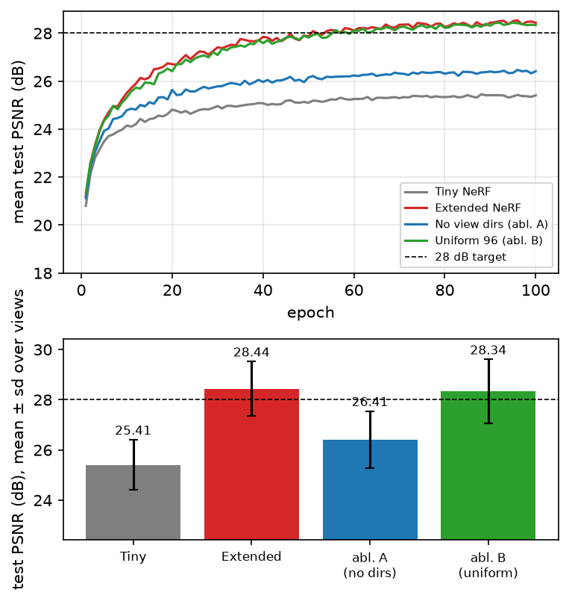
Figure 3. Test PSNR during training (top) and final test PSNR per model (bottom); identical budgets.

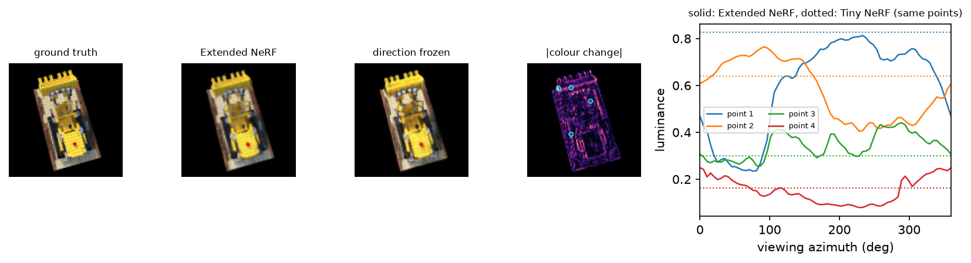
Figure 2. View dependence on test view 0. Re-rendering with the colour network's direction frozen to another view's direction changes colour by 0.028 on average (map), concentrated on the lit faces (ablation A: exactly 0). Right: luminance of four surface points (circles) seen from 360° of azimuth; Extended NeRF varies by 0.323 on average, Tiny NeRF (dotted) is constant by construction.

Discussion
Which change matters? Removing view dependence (A) costs 2.03 dB, whereas removing hierarchical sampling at the same 96 samples (B) costs only 0.10 dB. View dependence is therefore the main source of the gain: the scene's faces change brightness with viewpoint, and a direction-blind model can only average them. Fig. 2 confirms the model really uses the direction: freezing it drops view 0 from 26.42 to 21.38 dB, while the same test leaves ablation A unchanged. Shading is learned rather than specular highlights, as expected for a diffuse scene.
Hierarchical sampling. The fine pass does what it is designed to: 84.7% of the importance samples land near the surface, against 14.3% of uniform samples (Fig. 4). Its PSNR benefit is small here because the object fills a tight [2, 6] depth range, so 96 uniform samples already resolve it at 100×100 pixels. The cost is real: twice the parameters and 40% more render time than B. The NeRF paper shows the same ordering (Table 2: −3.35 dB without view dependence, −0.95 dB without hierarchy).
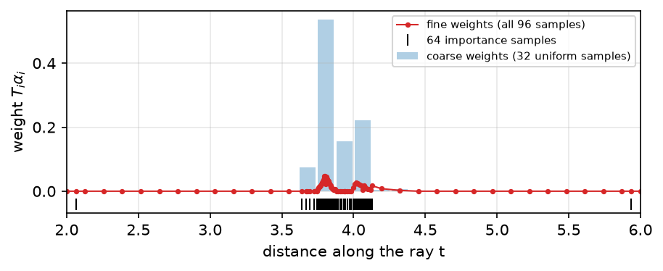
Figure 4. One object ray: coarse weights (bars), the 64 importance samples drawn from them (ticks) and the fine weights.
Strengths and limitations. The evaluation is controlled (same data, seed, budget) and the ablations isolate each change. However, it uses one seed and only six test views, a 128-unit MLP on 100×100 images, and shared-GPU timings, so differences of about 0.1 dB (Extended vs B) are within noise. Hierarchical sampling should matter more for larger scenes, wider depth bounds or fewer samples.
Recommendations. Use view-dependent colour by default; it is cheap and gives most of the gain. Keep hierarchical sampling for scenes with large empty space or when reducing samples per ray, and test it with several seeds, wider bounds and higher resolution before paying its cost on small scenes.
Conclusion
Adding view-dependent colour and hierarchical sampling raised test PSNR from 25.41 to 28.44 dB (above the 28 dB target) with visibly sharper novel views (Fig. 5). The ablations show view dependence provides most of the gain, while hierarchical sampling places samples far more efficiently but adds little accuracy for this compact scene.
References
Mildenhall, B., Srinivasan, P. P., Tancik, M., Barron, J. T., Ramamoorthi, R., & Ng, R. (2020). NeRF: Representing scenes as neural radiance fields for view synthesis. ECCV, 405–421.
Wang, Z., Bovik, A. C., Sheikh, H. R., & Simoncelli, E. P. (2004). Image quality assessment: From error visibility to structural similarity. IEEE Trans. Image Processing, 13(4), 600–612.

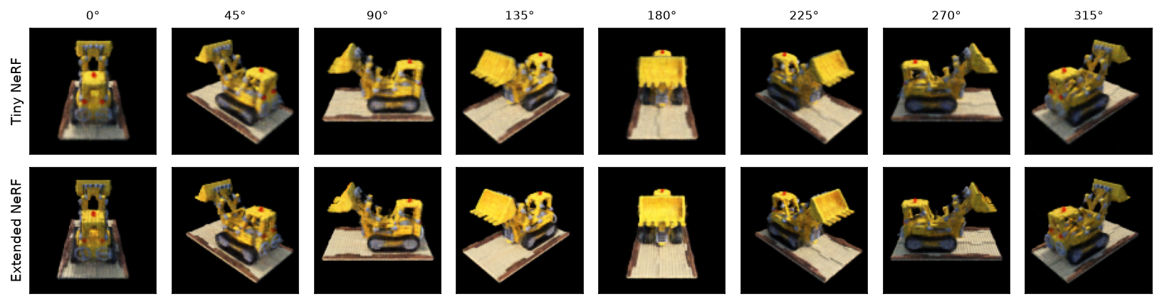
Figure 5. Novel views on a 360° turntable (elevation 30°, radius 4) that no training camera matches; Tiny NeRF (top) vs Extended NeRF (bottom). Extended NeRF is sharper at every angle (e.g. bucket teeth, tracks, base plate); the full 40-frame side-by-side "3D movie" is nerf_turntable.gif.

