Project 5: Extending an Addition LLM to Subtraction and Reverse-Order Prediction
Group 4
Student 1: Karan Rooprai Student 1 ID: n12498122
Student 2: Nhu Hieu Nguyen Student 2 ID: n12194778
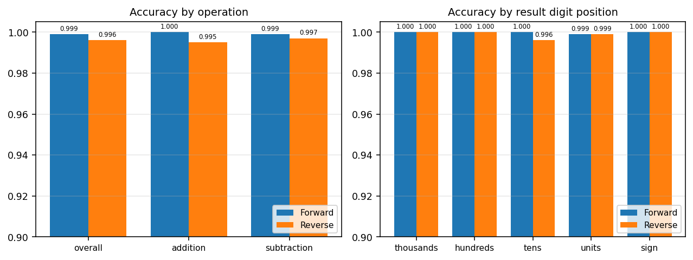
Figure 1. Test accuracy of the Forward and Reverse models. Left: overall and per-operation. Right: per result-digit position (with a separate check on the sign of the answer). Note the y-axis starts at 0.90 to make the small differences visible; every value is ≥ 0.995.

The Week 7 workshop trains a small causal Transformer to perform addition by next-token prediction, completing a prompt such as "23+1=" with "24". We extend it in two ways: Task 1 adds subtraction, including negative results; Task 2 trains a second model that predicts the answer digits right-to-left (Reverse mode) instead of left-to-right (Forward mode). We then compare the two paradigms on a single balanced held-out test set. The model, tokeniser structure, causal-masked next-token objective and training loop follow the workshop; only the changes below differ.
1. Task 1 — Handling subtraction
Two conceptual changes were required. First, the vocabulary gains a single "−" token that plays a dual role: the subtraction operator in a prompt ("50−73=") and the negative sign in a result ("−23"). Reusing one token keeps the vocabulary minimal and lets the model learn that the same symbol means "operator here, sign there" from position. Second, the data generator samples an operation as well as the two non-negative ≤ 3-digit operands; for subtraction the Python string of a−b already produces the signed answer. The training set is a balanced 50/50 mix of addition and subtraction, with unique, non-overlapping train / validation / test splits. Nothing else changes: the same network learns the longer, sign-bearing targets. Because borrows and negatives make subtraction harder than addition, more epochs and a validation set (to watch convergence) were used, exactly as the brief anticipates.
2. Task 2 — Reverse-mode prediction
Only the target answer is reversed; the prompt is untouched, so the two models see identical inputs and differ solely in output ordering. We reverse the whole answer string literally, so the units digit is emitted first — "31" becomes "13" and the model predicts 1 then 3, matching manual right-to-left arithmetic (2+9, then 1+1+carry). The brief does not define how to reverse a negative result, so we adopt the same literal rule: "−123" becomes "321−", i.e. the sign is predicted last, which is consistent with right-to-left computation (the sign is known only after the magnitude). At evaluation the generated string is simply un-reversed before being parsed to an integer. Keeping the tokeniser, architecture and training identical to Forward makes prediction direction the only variable in the comparison.
3. Results and analysis
Set-up. Both models are evaluated on one shared held-out set of 10,000 examples, balanced between addition and subtraction (sub fraction 0.49) and disjoint from training. Overall accuracy is the fraction of exact numeric matches. Both paradigms clear the target comfortably: Forward 0.999 and Reverse 0.996 overall (Fig. 1, left) — far above the 0.78 expectation.
Operation robustness. Forward is essentially perfect on addition (1.000) and near-perfect on subtraction (0.999). Reverse scores 0.995 on addition and 0.997 on subtraction — marginally better at subtraction than addition. This small asymmetry is consistent with the motivation for reverse order: emitting the units digit first aligns the output with the direction in which borrows (and carries) actually propagate.
Digit-level performance. Accuracy is near-perfect at every result position for both models (Fig. 1, right). Thousands, hundreds and the answer sign are exact (1.000) in both modes; the only visible dips are Reverse’s tens position (0.996) and the units position (0.999 for both). Errors are therefore rare and shallow — at most a single wrong digit — rather than structural.

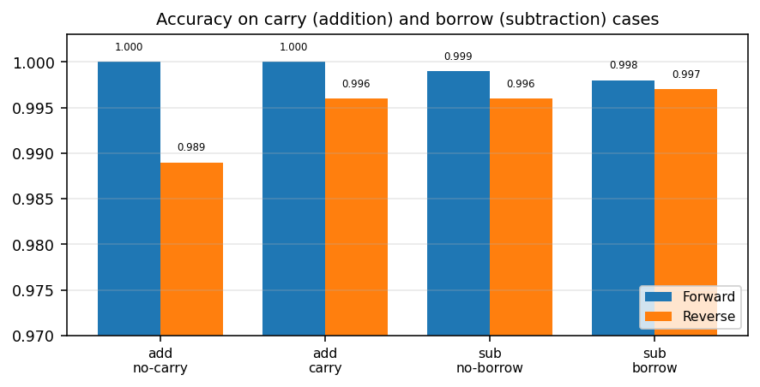
Figure 2. Accuracy split by whether a carry (addition) or borrow (subtraction) is involved. Forward is near-perfect throughout. Reverse’s residual errors sit mainly in additions — and, against intuition, more in no-carry than in carry additions — while on subtraction it handles borrows (0.997) as well as non-borrows. Reverse ordering does not hurt the borrow cases it was meant to help.

Carry and borrow cases. Figure 2 isolates the hard columns. Forward handles carries and borrows essentially perfectly. Reverse’s few errors concentrate in addition, and specifically in no-carry additions (0.989) rather than carry ones (0.996); on subtraction it is equally strong with and without borrows (0.997 / 0.996). So the reverse ordering is, if anything, most reliable exactly on the borrow/carry columns, and its weak spot is the ordinary no-carry additions — the opposite of what a "carries are hard" story would predict.
Direction effects — the main finding. The largest difference between the paradigms is not final accuracy but learnability. With 80,000 training examples the Reverse model plateaued near 0.10 sequence accuracy and never fit the task, whereas the identical Forward model reached 0.98 on the same data. Only after increasing the training set to 150,000 did Reverse converge to 0.996. Under the workshop’s absolute positional encoding, reversing the output makes the mapping substantially harder to optimise: the model must determine the answer’s length and its higher digits while committing to the least-significant digits first, and it needs roughly twice the data to do so. Once enough data is supplied both paradigms reach comparable, near-perfect accuracy, but Forward is clearly the easier and more data-efficient direction to train.
Error patterns and conclusion. The residual errors in both models are single-digit slips on the longest results and at the units position; they are not concentrated on carries, borrows or negatives (sign accuracy is 1.000 for both), indicating both learned the arithmetic algorithm and generalise across operations and magnitudes rather than memorising. In summary, both Forward and Reverse LLMs learn addition and subtraction to ≈ 99.6–99.9% on unseen data; prediction direction barely affects final accuracy but strongly affects training — reverse-order output is markedly harder to learn under absolute positional encoding, yet once trained it is at least as accurate as, and slightly better than, Forward on subtraction.

