Project 4: Auditing Three Pretrained CelebA Binary Classifiers
Group 4
Student 1: Karan Rooprai Student 1 ID: n12498122
Student 2: Nhu Hieu Nguyen Student 2 ID: n12194778
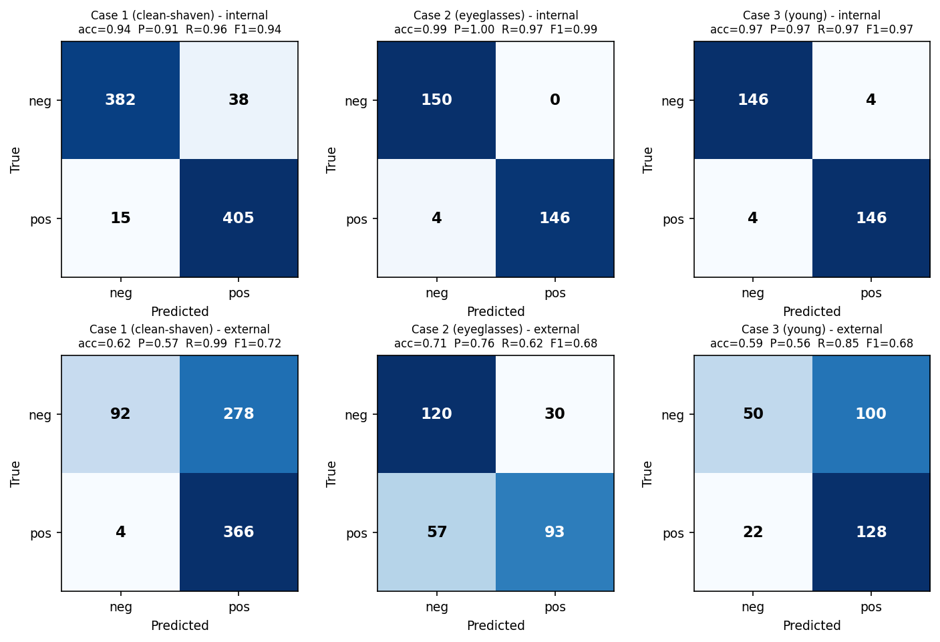
Figure 1. Confusion matrices on the internal (top row) and external (bottom row) test splits for the three frozen classifiers. All three are strong internally; externally Case 1 floods false positives (278), Case 2 misses true positives (57 FN), and Case 3 errs on both sides — three different failure shapes.

Three ResNet-18 classifiers, each pretrained and frozen for a different CelebA binary attribute, pass internal testing yet fail after deployment. Acting as auditors we reload each model unchanged and evaluate it on the supplied test_internal and test_external splits — no retraining, no fine-tuning. For every split we compute the confusion matrix, precision, recall and F1, the ROC curve with AUC (discrimination) and a 10-bin reliability diagram with expected calibration error, ECE, plus the accuracy of the model’s high-confidence predictions (probability quality); the notebooks additionally render class-activation maps (CAM). Comparing internal against external behaviour on these axes separates three distinct failure modes — an input-distribution shift, a spurious subgroup shortcut, and over-confidence — even though all three look similar at the level of raw accuracy (Table 1).
The test splits are roughly class-balanced (Case 1 has 840 internal and 740 external images; Cases 2 and 3 have 300 each), so accuracy is directly interpretable and a shift in the confusion matrix reflects a real change in behaviour rather than a change in class priors. Each model is evaluated exactly as delivered — the frozen ResNet-18 backbone with its trained two-way head, images resized to 224×224 and normalised with the ImageNet statistics — so any internal-to-external gap is a property of the model and the data, not of the evaluation pipeline.
1. Case 1 — clean-shaven (studio → mobile)
Diagnosis: covariate / input-distribution shift. The model was trained on studio-quality images and is evaluated on mobile photos whose distribution differs, so its learned decision boundary no longer fits the deployed inputs.
Evidence. On the internal studio set the model is strong and well-calibrated: acc 0.937, AUC 0.985, ECE 0.013 (Fig. 1 top-left; Fig. 2 left, blue). On the external mobile set every axis degrades together — accuracy 0.937→0.619, AUC 0.985→0.846, ECE 0.013→0.250 — and the errors are strongly one-sided: false positives jump from 38 to 278 so precision falls 0.914→0.568 while recall stays high (Fig. 1 bottom-left). The model now labels almost every mobile image “positive”, and its reliability curve drops well below the diagonal. Simultaneous loss of discrimination and calibration, with the mass shifting toward one class, is the signature of the input distribution changing rather than the labels or the head: the clean features the network relies on (sharp edges, even studio lighting) are weakened by mobile resolution, noise and lighting, pushing borderline faces across the boundary.
Recommendation. Close the gap between training and deployment inputs. Best: collect labelled mobile images and fine-tune / domain-adapt the model to that domain (beyond the no-retrain audit). Immediately deployable without retraining: apply matched pre-processing to mobile photos, add a distribution-shift monitor that flags inputs whose feature statistics fall outside the studio range for human review, and recalibrate plus raise the threshold on a small mobile sample to curb the false-positive flood.

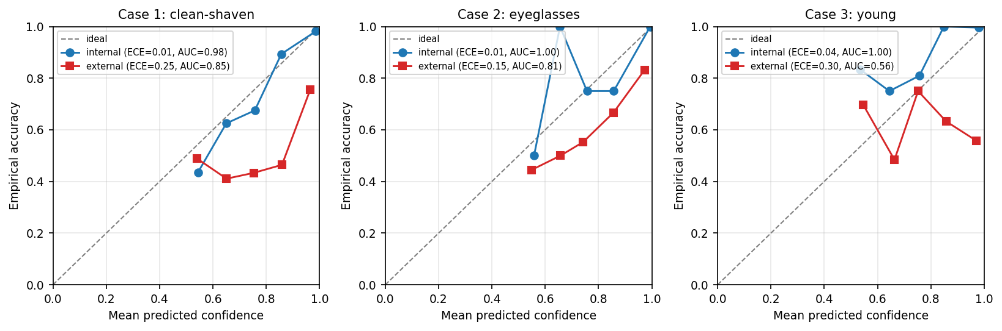
Figure 2. Reliability diagrams (10 bins). Internal curves (blue) track the diagonal; external curves (red) fall below it, showing over-confident probabilities. The effect is most extreme for Case 3, whose ≥0.9-confidence predictions are correct only ≈56% of the time — directly undermining its high-confidence auto-publish bypass.
Case (positive) | Split | Acc | P | R | F1 | AUC | ECE
1 (clean-shaven) | internal | 0.937 | 0.914 | 0.964 | 0.939 | 0.985 | 0.013
1 (clean-shaven) | external | 0.619 | 0.568 | 0.989 | 0.722 | 0.846 | 0.250
2 (eyeglasses) | internal | 0.987 | 1.000 | 0.973 | 0.987 | 1.000 | 0.013
2 (eyeglasses) | external | 0.710 | 0.756 | 0.620 | 0.681 | 0.812 | 0.152
3 (young) | internal | 0.973 | 0.973 | 0.973 | 0.973 | 0.996 | 0.036
3 (young) | external | 0.593 | 0.561 | 0.853 | 0.677 | 0.564 | 0.296
Table 1. Per-case metrics on the internal and external splits. Accuracy alone hides the differences; AUC (discrimination) and ECE (calibration) separate the three failure modes.

2. Case 2 — eyeglasses
Diagnosis: a spurious correlation / shortcut feature causing a subgroup failure — the model works for some users and fails for others on clear, well-lit images, because it never learned the eyeglasses themselves.
Evidence. Internally the model is essentially perfect — acc 0.987, AUC 0.9997, precision 1.000, ECE 0.013 (Fig. 1 top-middle) — which is itself a warning. Externally accuracy is 0.710, but the damage is asymmetric and confined to positives: recall collapses 0.973→0.620 while precision holds at 0.756. The matrix (Fig. 1 bottom-middle) shows 57 eyeglasses images missed (false negatives) against only 30 false positives. Near-perfect internal separation that does not transfer to new positives is the fingerprint of a shortcut: the network latched onto a cue that co-occurs with glasses internally (frame style, capture conditions) rather than the glasses themselves, so external positives lacking that cue are missed. The CAM maps in case2.ipynb confirm attention drifting off the eye region on the missed images.
Recommendation. This is a data / representation fault, not a calibration one — recalibration cannot recover the lost recall. Use saliency to identify the shortcut, then broaden the positive set with diverse eyewear and matched negatives before any retraining (outside the no-retrain audit). Until then restrict deployment to the subgroup the model actually handles and flag positive predictions for review.
3. Case 3 — young (high-confidence bypass)
Diagnosis: model over-confidence / miscalibration. The predicted probabilities are not trustworthy externally, so the “auto-publish at ≥90% confidence” bypass releases wrong tags while reporting near-certainty.
Evidence. Internally the model is accurate and reasonably calibrated (acc 0.973, AUC 0.996, ECE 0.036, Fig. 1 top-right), so in the lab the bypass looked safe. Externally calibration collapses: ECE rises 0.036→0.296 and the reliability curve sits far below the diagonal (Fig. 2 right, red). The decisive test targets the bypass threshold itself — of predictions issued at ≥0.90 confidence, only 55.8% are correct externally (and at ≥0.99, 51.7%), versus ≈100% internally. The system is therefore auto-publishing near-coin-flip predictions labelled as near-certain. That the external AUC is only 0.564 (≈ chance) explains why: the scores carry little real signal on this data, yet the softmax still emits extreme probabilities — the definition of over-confidence.
Recommendation. Stop trusting raw model confidence for the bypass. Recalibrate the probabilities (temperature / Platt scaling) on a held-out external sample and re-derive the auto-publish threshold from the calibrated confidence, so that “≥90%” corresponds to genuine ≈90% accuracy; verify with a reliability diagram and ECE before re-enabling. Given how weak the external signal is, restore human review for this population and continuously monitor ECE and high-confidence accuracy in production.
4. Summary
At the accuracy level the three failures look alike (all fall to 0.59–0.71 externally), but their mechanisms differ. Case 1 is an input-distribution shift from studio to mobile photos: discrimination and calibration degrade together and the model floods false positives, so the fix is to match or adapt to the deployment domain. Case 2 is a spurious shortcut that fails a subgroup — near-perfect internal separation but collapsed recall on external positives — so the fix is better positive data, not recalibration. Case 3 is over-confidence: predictions issued at the ≥90% auto-publish threshold are correct only ≈56% externally, so the fix is to recalibrate the probabilities and restore human review rather than trust raw confidence. Matching each remedy to the right fault is the whole point of the audit.

