XAI-DRIVEN ALTERNATIVE CREDIT SCORING AND DEFAULT RISK PREDICTION FOR GIG WORKERS  Domain / Area: Artificial Intelligence | Machine Learning | FinTech | Explainable AI  Semester / Year: 6th Semester / 2026 | Ramaiah Institute of Technology  Team No: 11  Guide: Dr. Dayananda R. B.  Team: Karan Jamkhandi – 1MS23CS083  Nagesh Bhagelli – 1MS23CS118  Prarthana B K – 1MS23CS134  Vikas Choudhari – 1MS23CS216

1 PROBLEM STATEMENT & RESEARCH GAP | 2 SYSTEM FLOW — INPUT · PROCESS · OUTPUT | 3 OUTCOMES & SCOPE

RESEARCH GAP  Existing credit scoring systems mainly rely on salary records, banking history, and CIBIL scores, making them ineffective for evaluating gig workers who possess irregular income patterns and limited formal financial documentation.  PROBLEM STATEMENT  The rapid growth of the gig economy has created employment opportunities for millions of workers through platforms such as Uber, Swiggy, Zomato, and Upwork.  However, gig workers often face difficulties in accessing loans and financial services because traditional credit scoring systems depend heavily on salary slips, tax records, and banking history.  Existing systems fail to consider alternative financial indicators such as gig-platform earnings, transaction history, work consistency, payment behavior, and customer ratings. As a result, financially capable gig workers are often denied access to credit facilities.  The proposed system aims to develop an AI-driven alternative credit scoring platform using Machine Learning and Explainable AI techniques to generate transparent and reliable credit scores and default risk predictions for gig workers. | INPUT ▶ PROCESS ▶ OUTPUT  • Gig-worker financial data • Transaction history • Platform earnings • Customer ratings • Payment behavior • Income consistency • CSV uploads and user forms • Data preprocessing and cleaning • Feature engineering • ML model training using Logistic Regression, Random Forest, and XGBoost • Default risk prediction • Explainability generation using SHAP and LIME • Dashboard generation… • Alternative credit score • Default risk probability • SHAP feature importance graph • LIME explanation report • Loan approval insights • Risk analysis dashboard | OUTCOMES  • AI-driven alternative credit scoring system  • Default risk prediction model  • Explainable AI dashboard  • Web-based lender and gig-worker platform  • Performance comparison of ML models  • Transparent lending insights  SCOPE & FUTURE EXTENSIONS  Current Scope  - Prototype-level web application  - Synthetic gig-worker dataset  - Credit scoring using ML algorithms  - Explainability using SHAP and LIME  - Dashboard visualization  Future Extensions  - Real-time API integration with gig platforms  - Mobile application development  - Cloud deployment  - Fraud detection  - Federated learning  - Integration with banks and fintech systems

4 NOVELTY — EXISTING SYSTEM VS OUR APPROACH

ASPECT | EXISTING SYSTEM + LIMITATION | OUR APPROACH | NOVELTY / WHY BETTER
Algorithm / Model | Uses traditional scoring methods | Uses XGBoost, Random Forest, Logistic Regression | Better prediction accuracy
Accuracy / Metric | Lower accuracy for gig workers | ML-based alternative scoring | Improved prediction reliability
Data / Dataset | Depends on banking records | Uses gig-platform and behavioral data | Better financial inclusion
Scalability | Limited adaptability | Modular AI-driven architecture | Easy future integration
User Interaction | No explainability | SHAP and LIME explanations | Transparent AI decisions

5 ARCHITECTURE DIAGRAMS — SYSTEM ARCHITECTURE · DFD · ER · USE CASE

SYSTEM ARCHITECTURE DIAGRAM  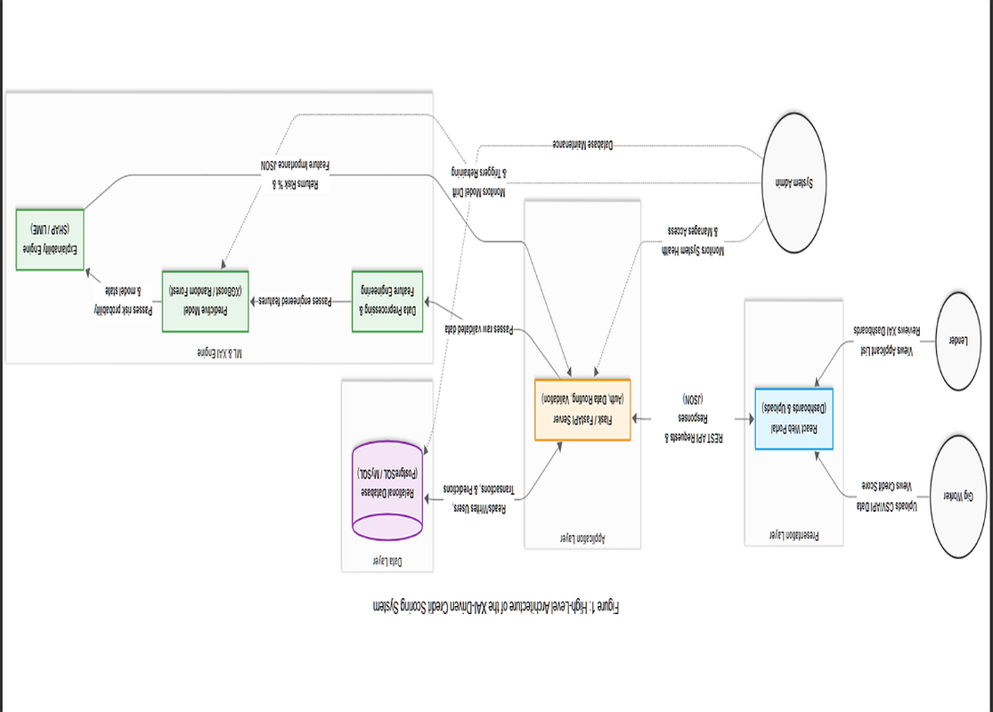 | ER DIAGRAM / FLOWCHART / CLASS DIAGRAM  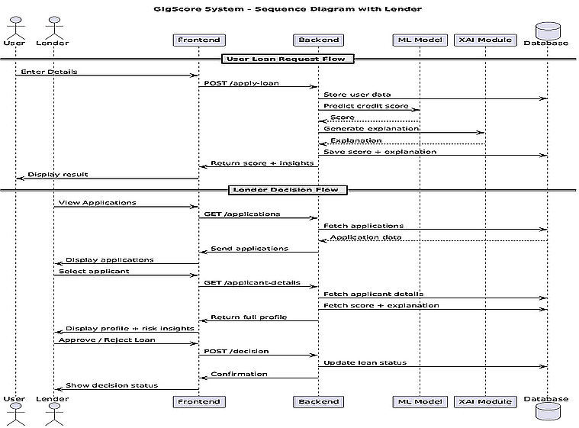

6 ALGORITHM & PROCESS STEPS | 7 TECHNOLOGY STACK

1 Step 1 — Data Collection Input: Gig-worker financial data Output: Structured dataset Tools: CSV, Pandas  2 Step 2 — Data Preprocessing Input: Raw dataset Output: Cleaned and normalized data Tools: Pandas, NumPy  3 Step 3 — Feature Engineering Input: Financial attributes Output: ML-ready feature vectors Tools: Scikit-learn  4 Step 4 — ML Model Training Input: Processed dataset Output: Trained ML models Algorithms: Logistic Regression, Random Forest, XGBoost  5 Step 5 — Prediction Generation Input: User financial data Output: Credit score and default risk Tools: XGBoost  6 Step 6 — Explainability Generation Input: ML predictions Output: SHAP and LIME explanations Tools: SHAP, LIME | LAYER TECHNOLOGY / TOOL — WHY CHOSEN  Frontend React.js — Interactive dashboard  Backend Flask / FastAPI — REST API development  Database PostgreSQL / MySQL — Secure data storage  ML / AI Scikit-learn, XGBoost — Prediction models  Deployment GitHub, Google Colab — Development and testing  Explainable AI SHAP, LIME — Transparent predictions

8 PERFORMANCE METRICS — COMPARISON WITH EXISTING SYSTEM

METRIC | EXISTING SYSTEM | OUR SYSTEM | IMPROVEMENT % | HOW MEASURED
Accuracy | 78% | xx% / xx sec | +xx% | Confusion matrix
Precision | 75% | xx% / xx sec | +xx% | Classification Report
Recall | 73% | xx% / xx sec | +xx% | Evaluation Metrics
F1-Score | 74% | xx% / xx sec | +xx% | ML Evaluation
Transparency | Low | xx% / xx sec | +xx% | SHAP/LIME Analysis

9 RESULTS — GRAPHS & VISUAL EVIDENCE

Graph / Chart 1 — e.g. Accuracy vs Epochs  [ Paste chart / screenshot / result image here ]  Add a 1-2 line caption explaining what this graph shows and what the key insight is. | Graph / Chart 2 — e.g. Precision–Recall Curve  [ Paste chart / screenshot / result image here ]  Add a 1-2 line caption explaining what this graph shows and what the key insight is. | Graph / Chart 3 — e.g. Confusion Matrix / Bar Chart  [ Paste chart / screenshot / result image here ]  Add a 1-2 line caption explaining what this graph shows and what the key insight is.

10 RESEARCH GAP RESOLUTION | 12 CONCLUSION & FUTURE SCOPE

GAP RESOLUTION  How our output closes it:  The proposed GigScore system addresses the limitations of traditional credit scoring systems by using alternative gig-worker financial and behavioral data instead of relying solely on salary records and banking history.  Machine Learning models improve prediction accuracy, while Explainable AI techniques such as SHAP and LIME provide transparent explanations for predictions. The system improves financial inclusion by enabling fair and interpretable credit assessment for gig workers. | CONCLUSION & FUTURE SCOPE  Conclusion:  The proposed GigScore system successfully demonstrates the use of Machine Learning and Explainable AI techniques for alternative credit scoring and default risk prediction for gig workers. The system improves transparency, prediction accuracy, and financial inclusion by using alternative financial and behavioral data.  Future Scope:  • Real-time integration with gig-platform APIs  • Mobile application support  • Cloud deployment  • Fraud detection systems  • Federated learning implementation  • Multilingual dashboard support.

Guide Signature

