Employment Offer Letter

# Employee Information

Candidate Name: Candidate 3

Position Offered: Software Engineer Level 3

Start Date: 2025-08-03

Location: Office 3, Tech Park

Reporting Time: 11:00 AM

Company name : Tech Solutions Pvt Ltd

# Job Description & Responsibilities

Lorem ipsum dolor sit amet, consectetur adipiscing elit. Integer nec odio. Praesent libero. Sed cursus ante dapibus diam.

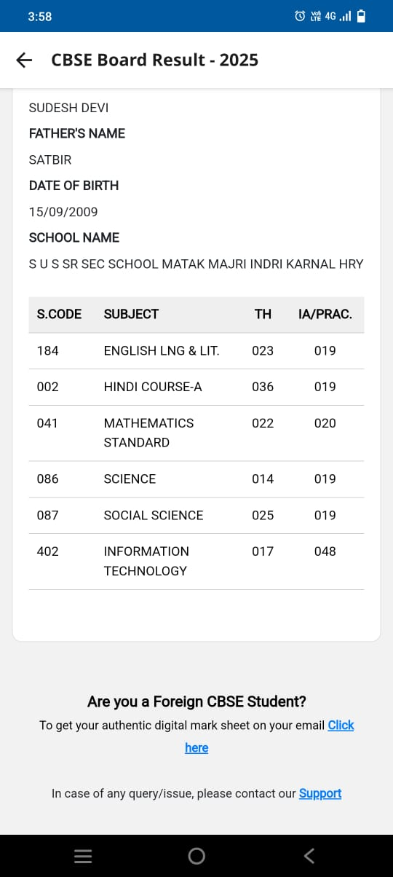

Authorized Signatory