Experiment 3

Aim - To Perform various GIT operations on local and Remote repositories

Theory:

The command `mkdir git` creates a new directory (folder) named "git" in the current working directory. This command is used to make a new directory in a Unix-like operating system.
The command `cd git` is used to change the current working directory to the directory named "git." After executing this command, any subsequent commands or file operations will occur within the "git" directory. "cd" stands for "change directory."

The `git config--global user.name` and `git config--global user.email` commands are used to set your global Git username and email address, respectively. They are part of the configuration settings in Git and are associated with the commits you make.
If you want to check your configuration settings, you can use the git config--list command to list all the settings Git can find at that point

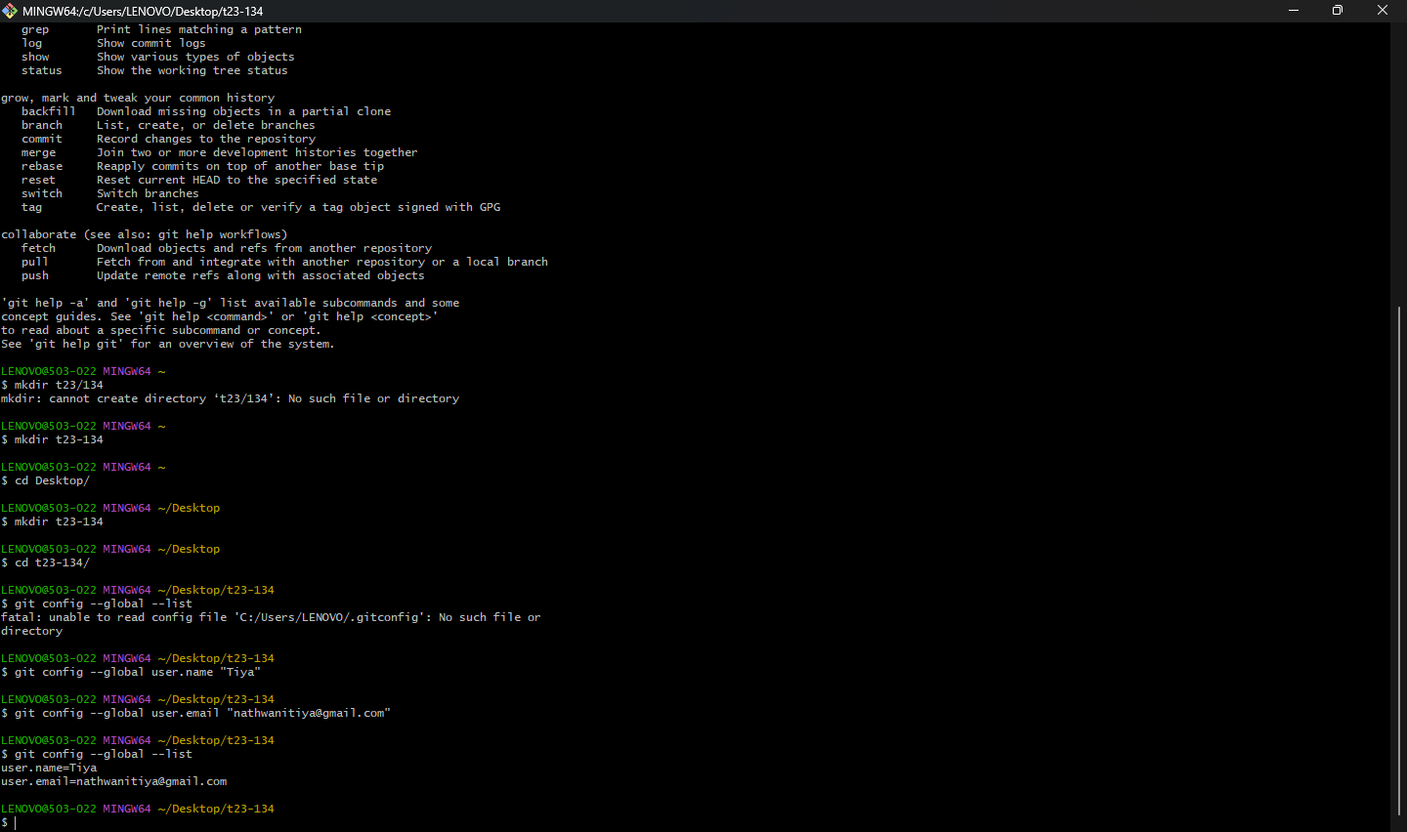

git commit-am "commit message"` stages and commits all changes in tracked files with a commit message in a single command.
The command `nano index.html` opens the Nano text editor for the file named "index.html." Nano is a simple command-line text editor that allows you to view and edit files directly in the terminal.

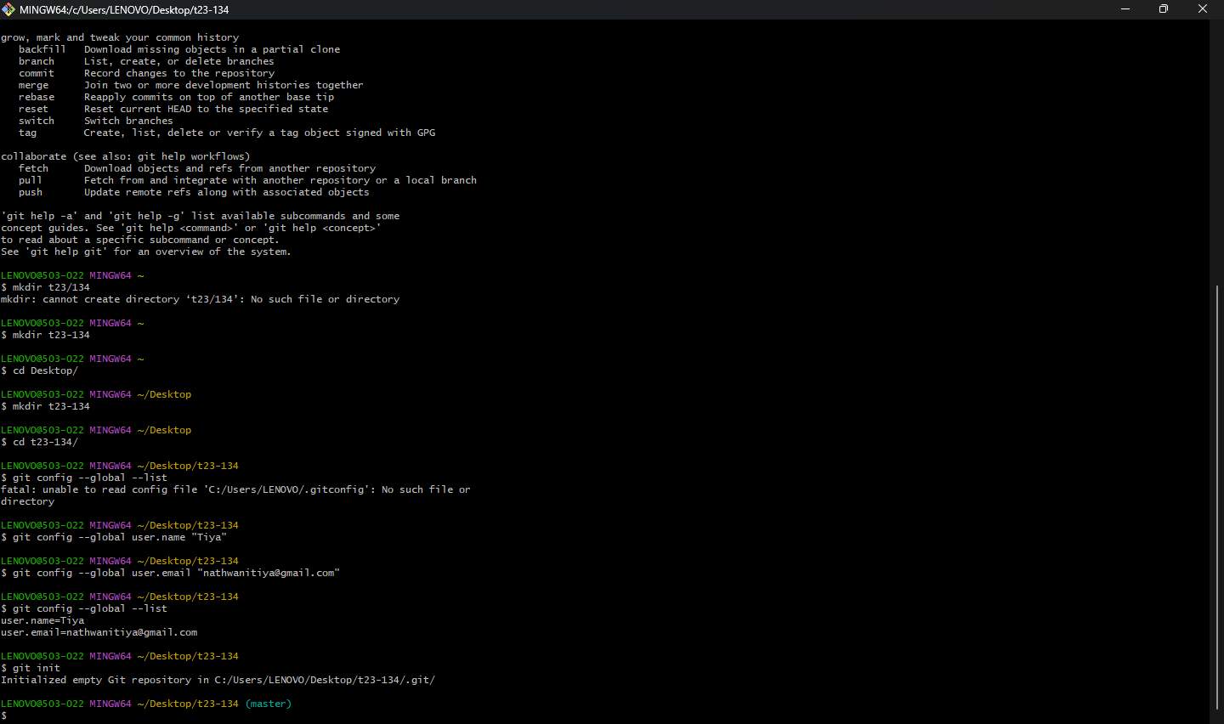

The command `touch teststatus` creates an empty file named "teststatus" in the current
directory. The `touch` command is commonly used to update the timestamps of a file or
create an empty file if it doesn't exist.
git checkout-- teststatus: Discards changes to the file "teststatus" in the working directory. This reverts the file to the state it has in the last commit.
The `git add` command is used to stage changes in the working directory for the next commit in Git. It prepares modifications, additions, or deletions to be included in the upcoming commit.

The `git log` command is used to display the commit history of a Git repository. It shows a chronological list of commits, including commit hashes, author information, timestamps, and commit messages.
The command `git log--oneline` displays a simplified and concise one-line representation of the commit history in a Git repository, showing only the commit SHA-1 hash and the commit message.
The `git clone` command is used to create a copy of a Git repository. When you run this command, it duplicates the entire repository, including its files, commit history, and branches, and downloads it to your local machine. This is often the initial step when you want to work with a project hosted on a remote Git repository.
The `git pull` command is used to fetch and integrate changes from a remote repository into the current branch of your local repository. It combines two actions: it fetches the changes from the remote repository, and then it automatically merges those changes into your local branch. This is a convenient way to update your local repository with the latest changes from the remote repository.
The `git push` command is used to upload or push the local changes in your Git repository to remote repository. It updates the remote repository with the latest changes made in your local branch, making them accessible to others who share the same remote repository.
The `git fetch` command is used to retrieve changes from a remote repository. It fetches any new branches or changes made in the remote repository since your last interaction.
However, it does not automatically merge these changes into your local branches. After using `git fetch`, you can inspect the changes and decide whether to integrate them using `git merge` or `git rebase`.

