Name- Karan Shejwal Roll number- 109 Batch- T22
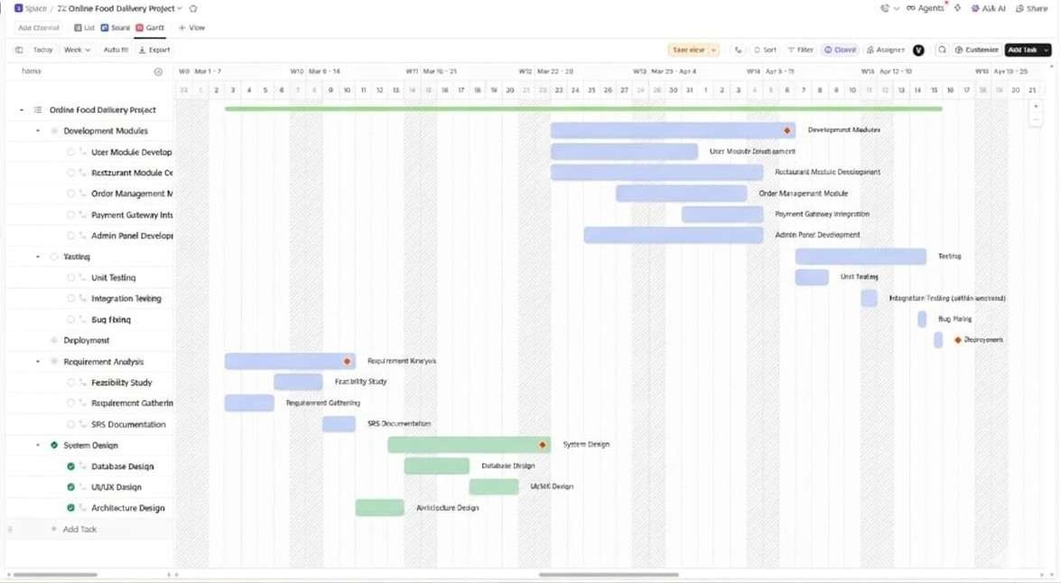
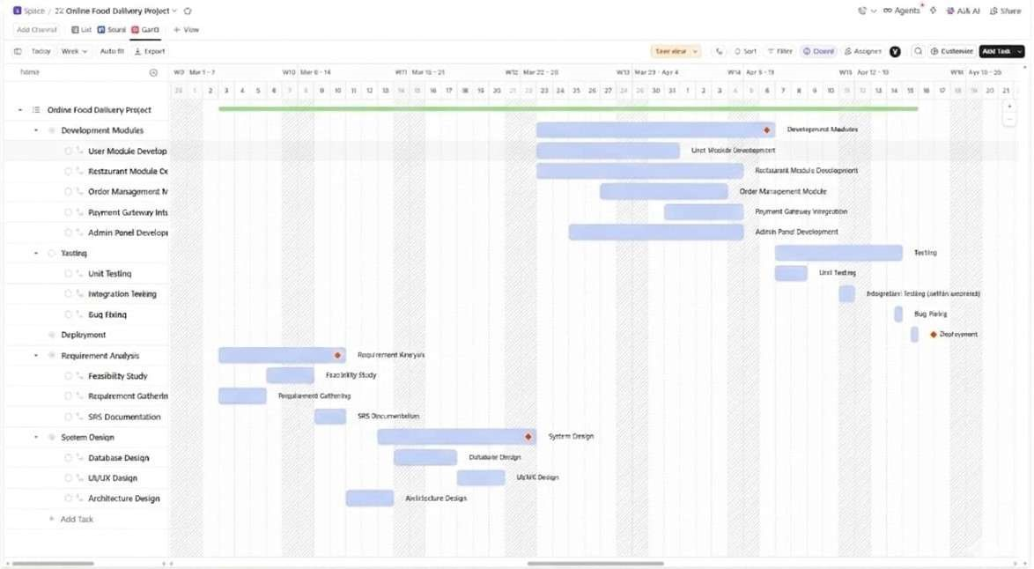
Software Engineering and Project Management

Name- Karan Shejwal Roll number- 109 Batch- T22
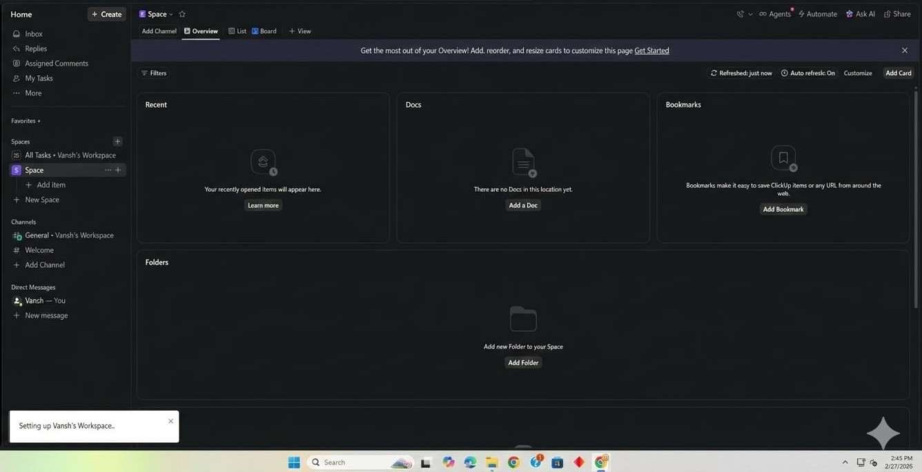
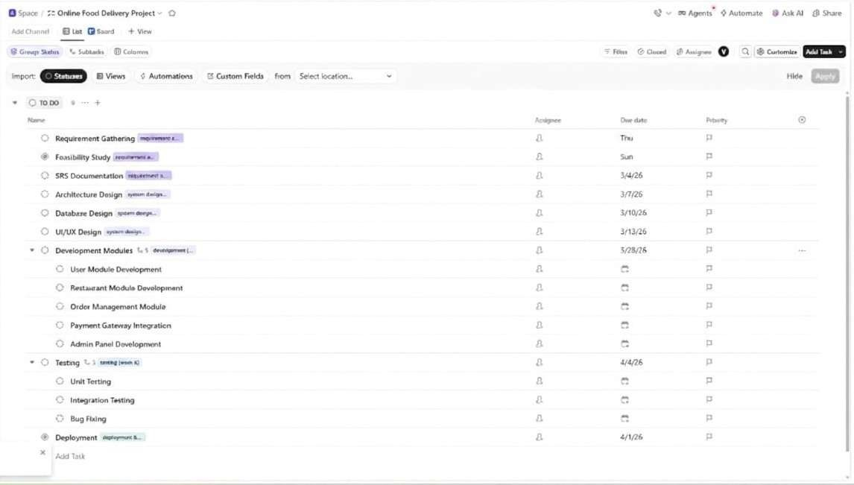
Software Engineering and Project Management

