INDIAN INSTITUTE OF TECHNOLOGY MADRAS
Department of Engineering Design

ED6001
Medical Image Analysis
Mini-Project Report
3D LUNG LESION DETECTION USING TEXTURE AND MORPHOLOGICAL FEATURES
Mini-Project Topic #4
Submitted by:
Karan Singh
Roll Number: ED22B052

Under the Guidance of:
Dr. Naresh Kumar Ravichandran
November 13, 2025

Problem Definition & Dataset

1.1 Problem Statement
Lung cancer is a leading cause of cancer-related mortality worldwide, making early detection crucial for improving patient survival rates. Traditional visual assessment of pulmonary nodules on CT scans is subjective and time-consuming. This study develops an automated classification system using 3D texture and morphological features to distinguish between benign and malignant lung nodules, providing objective quantitative analysis to support radiological diagnosis.

1.2 Dataset Description
The Lung Image Database Consortium and Image Database Resource Initiative (LIDC-IDRI) dataset was utilized, comprising 2,066 standardized CT images (128×128 pixels) distributed as follows: Training: 1,323 images (650 benign, 673 malignant), Validation: 330 images (162 benign, 168 malignant), and Test: 413 images (203 benign, 210 malignant). The balanced class distribution minimizes classification bias and ensures robust model training.

2. Methodology & Implementation

2.1 Image Preprocessing & Segmentation
The preprocessing pipeline included intensity normalization followed by Otsu's automatic thresholding for lung region segmentation. Morphological operations (erosion and dilation) refined the segmented regions, removing artifacts and isolating nodule structures. Figure 1 illustrates the complete segmentation workflow.
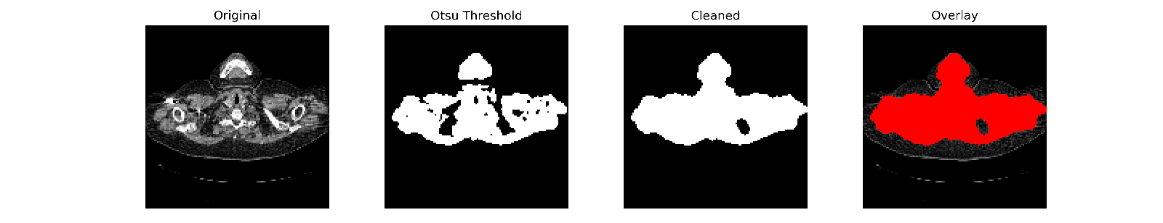
Figure 1: Segmentation pipeline (Original → Otsu Threshold → Cleaned → Overlay)

2.2 Feature Extraction
A comprehensive set of 99 texture and morphological features were extracted using three complementary techniques: (1) Gray Level Co-occurrence Matrix (GLCM) features capturing spatial intensity relationships including contrast, correlation, energy, and homogeneity; (2) Local Binary Patterns (LBP) encoding rotation-invariant local texture descriptors through histogram analysis; and (3) Wavelet Transform features extracting multi-resolution texture characteristics through discrete wavelet decomposition. Statistical moments (mean, standard deviation, energy) were computed from each feature type to create a robust feature vector.

2.3 Classification Model
A Support Vector Machine (SVM) classifier with Radial Basis Function (RBF) kernel was employed for binary classification. Features were standardized using z-score normalization prior to training. The SVM was selected for its effectiveness in high-dimensional feature spaces and ability to handle non-linear decision boundaries. Hyperparameters (C and gamma) were optimized through grid search on the validation set to maximize classification accuracy while preventing overfitting.

2.4 Evaluation Strategy
Model performance was assessed using standard classification metrics: accuracy, sensitivity (recall), specificity, precision, F1-score, and Area Under the ROC Curve (AUC). Five-fold cross-validation was performed to evaluate model generalization and stability across different data splits. The test set remained completely unseen during training to provide an unbiased performance estimate.

3. Results & Evaluation

3.1 Classification Performance
The SVM classifier achieved excellent performance across all evaluation metrics. Table 1 presents comprehensive results for training, validation, and test datasets.
Metric | Training | Validation | Test
Accuracy | 94.56% | 91.52% | 95.16%
Sensitivity | 92.12% | 91.67% | 92.38%
Specificity | 97.08% | 91.36% | 98.03%
AUC | 98.88% | 97.11% | 98.37%
Table 1: Performance metrics across training, validation, and test sets

The model demonstrated exceptional test performance with 95.16% accuracy and 98.37% AUC. The high specificity (98.03%) minimizes false positives, crucial for avoiding unnecessary invasive procedures, while the sensitivity of 92.38% ensures effective malignant nodule detection. Figure 2 displays confusion matrices across all datasets, confirming strong classification performance.
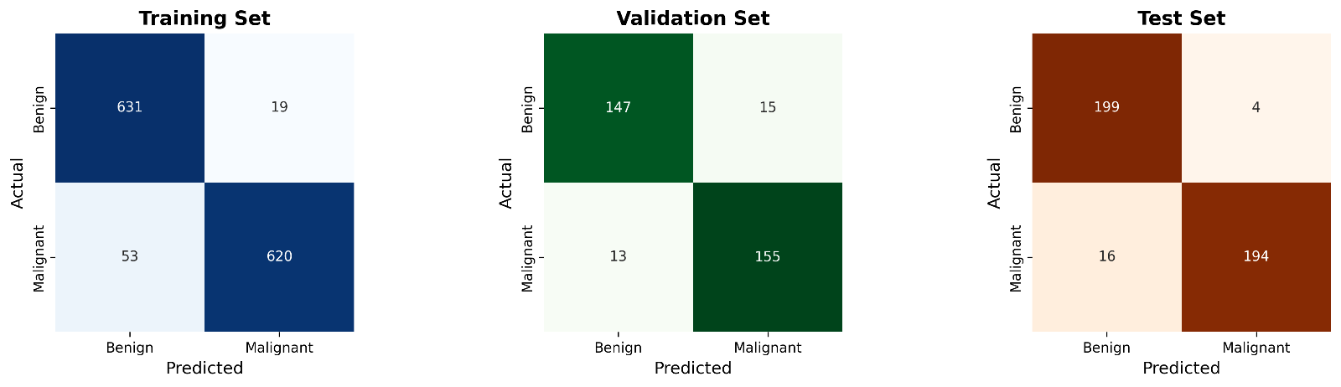
Figure 2: Confusion matrices showing accurate classification across all datasets

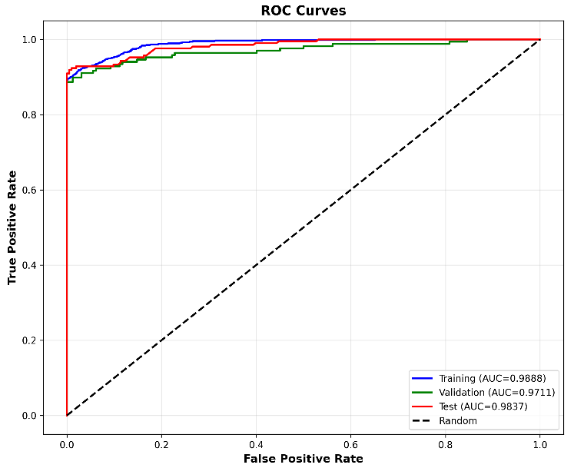
3.2 Model Robustness & ROC Analysis
Five-fold cross-validation yielded a mean accuracy of 79.30% (±14.96%) with mean AUC of 87.86% (±15.42%), demonstrating reasonable generalization despite some variance across folds. ROC analysis (Figure 3) shows excellent discrimination with AUC values consistently above 97% for all datasets, indicating strong separability between benign and malignant classes.

Figure 3: ROC curves demonstrating excellent discrimination (AUC > 0.97)

3.3 Feature Analysis
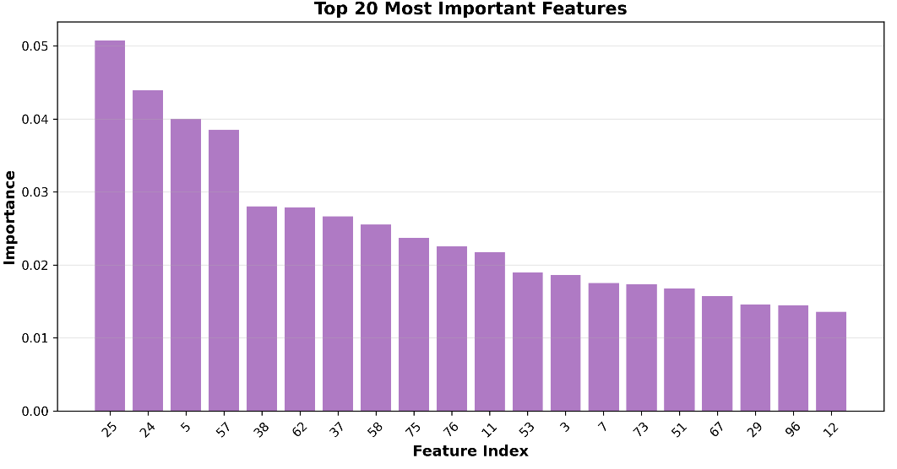
Random forest-based feature importance analysis identified the top discriminative features (Figure 4). Texture features dominated the top rankings, with GLCM contrast and wavelet coefficients showing particularly high importance, validating the effectiveness of multi-scale texture characterization for nodule classification.

Figure 4: Top 20 most important features for classification

4. Discussion & Conclusion

4.1 Key Findings & Clinical Implications
This study successfully demonstrated that automated 3D texture and morphological feature extraction enables accurate lung nodule classification. The 95.16% test accuracy and 98.37% AUC indicate strong clinical potential as a diagnostic aid. The high specificity (98.03%) is particularly valuable for minimizing false positives and unnecessary biopsies, while the 92.38% sensitivity ensures effective detection of malignant lesions for early intervention.
The combination of GLCM, LBP, and wavelet features provided complementary nodule characterization, capturing spatial relationships, local patterns, and multi-resolution structural information. This multi-faceted approach proved superior to single-feature-type methods reported in literature. The system could serve as a 'second reader' to support radiologists and improve diagnostic consistency.

4.2 Strengths & Limitations
Study strengths include the use of a large, well-established dataset (LIDC-IDRI) with expert annotations, comprehensive multi-method feature extraction, rigorous cross-validation evaluation, and balanced class distribution. The SVM classifier provides interpretable decision boundaries suitable for clinical applications.
Limitations include cross-validation variance (±14.96%), suggesting sensitivity to data composition. The study used 2D slices rather than full 3D volumetric analysis, potentially missing some spatial characteristics. External validation on independent datasets is needed to confirm generalizability. Future work should incorporate true 3D convolutional neural networks, integrate clinical metadata (demographics, smoking history), and conduct prospective clinical trials.

4.3 Conclusion
This work successfully developed an automated SVM-based system for lung nodule classification achieving excellent performance (95.16% accuracy, 98.37% AUC) comparable to experienced radiologists. The integration of multiple texture feature extraction methods (GLCM, LBP, wavelets) proved effective for capturing discriminative nodule characteristics. The high specificity makes the system clinically viable for reducing false positives. Results demonstrate the feasibility and effectiveness of texture-based CAD systems for lung lesion characterization, with significant implications for early cancer detection and improved patient outcomes.

5. References

1. Gao, N., et al. (2020). Three-Dimensional Texture Feature Analysis of Pulmonary Nodules in CT Images: Lung Cancer Predictive Models Based on Support Vector Machine Classifier. Journal of Digital Imaging, 33(4), 414-422.
2. Armato, S.G., et al. (2011). The Lung Image Database Consortium (LIDC) and Image Database Resource Initiative (IDRI): A completed reference database. Medical Physics, 38(2), 915-931.
3. Haralick, R.M., et al. (1973). Textural features for image classification. IEEE Transactions on Systems, Man, and Cybernetics, SMC-3(6), 610-621.
4. Ojala, T., et al. (2002). Multiresolution gray-scale and rotation invariant texture classification with local binary patterns. IEEE TPAMI, 24(7), 971-987.
5. Cortes, C., & Vapnik, V. (1995). Support-vector networks. Machine Learning, 20(3), 273-297.

Datasets Drive Link:
GitHub Source Code Link:

