The NGINX Server

1. Introduction

NGINX is a free, open-source, high-performance HTTP server and reverse proxy, as well as an IMAP/POP3 proxy server. NGINX is known for its high performance, stability, rich feature set, simple configuration, and low resource consumption.
NGINX is one of a handful of servers written to address the C10K problem. Unlike traditional servers, NGINX doesn’t rely on threads to handle requests. Instead it uses a much more scalable event-driven (asynchronous) architecture. This architecture uses small, but more importantly, predictable amounts of memory under load. Even if you don’t expect to handle thousands of simultaneous requests, you can still benefit from NGINX’s high-performance and small memory footprint. NGINX scales in all directions: from the smallest VPS all the way up to large clusters of servers.
NGINX powers several high-visibility sites, such as Netflix, Hulu, Pinterest, CloudFlare, Airbnb, WordPress.com, GitHub, SoundCloud, Zynga, Eventbrite, Zappos, Media Temple, Heroku, RightScale, Engine Yard, MaxCDN and many others.

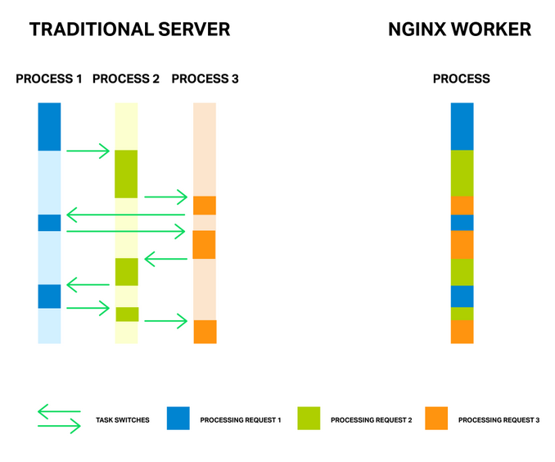

2. NGINX vs Apache

“Apache is like Microsoft Word. It has a million options but you only need six. NGINX does those six things, and it does five of them 50 times faster than Apache.”

2. Installation

1) NGINX Server Installation

Run the following set of commands on terminal:-

sudo apt-get install nginx
sudo service nginx start

After running this command you may get an error like this :-
Starting nginx: nginx: [emerg] bind() to 0.0.0.0:80 failed (98: Address already in use)
This is because port 80 is being used by Apache or some other resource. To get rid of this error, run the command below:-
sudo fuser -k 80/tcp

Restart the nginx server :
sudo service nginx start

Now run http://localhost in your browser, you will see nginx welcome page.

NGINX Web Root is set as : /usr/share/nginx/www

2) Install php on NGINX

Run the following set of commands on terminal:-

sudo apt-get install php5-fpm

Edit the php.ini file :
gedit /etc/php5/fpm/php.ini
Find the line, cgi.fix_pathinfo=1, and change the 1 to 0.

Edit the www.conf file :
/etc/php5/fpm/pool.d/www.conf
Find the line, listen = 127.0.0.1:9000, and change the 127.0.0.1:9000 to /var/run/php5-fpm.sock.

Restart php-fpm :
sudo service php5-fpm restart

Edit the default virtual host file :
gedit /etc/nginx/sites-available/default
Update the file with following:
[...]
server {
listen 80;

root /usr/share/nginx/www;
index index.php index.html index.htm;

server_name example.com;

location / {
try_files $uri $uri/ /index.html;
}

error_page 404 /404.html;

error_page 500 502 503 504 /50x.html;
location = /50x.html {
root /usr/share/nginx/www;
}

# pass the PHP scripts to FastCGI server listening on the php-fpm socket
location ~ \.php$ {
try_files $uri =404;
fastcgi_pass unix:/var/run/php5-fpm.sock;
fastcgi_index index.php;
fastcgi_param SCRIPT_FILENAME $document_root$fastcgi_script_name;
include fastcgi_params;

}

}
[...]

Restart the NGINX Server
sudo service nginx restart

3. Run Apache and NGINX both on Same Server Simultaneously

To run both the web server on same machine, we will change the port being used by Apache :-

Edit /etc/apache2/ports.conf and add in:
NameVirtualHost *:8090
Listen 8090
Edit the sites-available settings in /etc/apache2/sites-available
Replace
<VirtualHost *:80> with <VirtualHost *:8090>
Finally, restart the Apache Server
sudo service apache2 restart

Now you can run both server in your browser as :
- Apache : http://localhost:8090/
- NGINX : http://localhost/

3. Setup a Secure Application (https://)

Step One—Create a Directory for the Certificate
The SSL certificate has 2 parts main parts: the certificate itself and the public key. To make all of the relevant files easy to access, we should create a directory to store them in:
sudo mkdir /etc/nginx/ssl
We will perform the next few steps within the directory:
cd /etc/nginx/ssl

Step Two—Create the Server Key and Certificate Signing Request
Start by creating the private server key. During this process, you will be asked to enter a specific passphrase. Be sure to note this phrase carefully, if you forget it or lose it, you will not be able to access the certificate.
sudo openssl genrsa -des3 -out server.key 2048
Follow up by creating a certificate signing request:
sudo openssl req -new -key server.key -out server.csr
This command will prompt terminal to display a lists of fields that need to be filled in.
The most important line is "Common Name". Enter your official domain name here or, if you don't have one yet, your site's IP address. Leave the challenge password and optional company name blank.
You are about to be asked to enter information that will be incorporated
into your certificate request.
What you are about to enter is what is called a Distinguished Name or a DN.
There are quite a few fields but you can leave some blank
For some fields there will be a default value,
If you enter '.', the field will be left blank.
-----
Country Name (2 letter code) [AU]:US
State or Province Name (full name) [Some-State]:New York
Locality Name (eg, city) []:NYC
Organization Name (eg, company) [Internet Widgits Pty Ltd]:Awesome Inc
Organizational Unit Name (eg, section) []:Dept of Merriment
Common Name (e.g. server FQDN or YOUR name) []:example.com
Email Address []:webmaster@awesomeinc.com

Step Three—Remove the Passphrase
We are almost finished creating the certificate. However, it would serve us to remove the passphrase. Although having the passphrase in place does provide heightened security, the issue starts when one tries to reload nginx. In the event that nginx crashes or needs to reboot, you will always have to re-enter your passphrase to get your entire web server back online.
Use this command to remove the password:
sudo cp server.key server.key.org
sudo openssl rsa -in server.key.org -out server.key

Step Four— Sign your SSL Certificate
Your certificate is all but done, and you just have to sign it. Keep in mind that you can specify how long the certificate should remain valid by changing the 365 to the number of days you prefer. As it stands this certificate will expire after one year.
sudo openssl x509 -req -days 365 -in server.csr -signkey server.key -out server.crt
You are now done making your certificate.

Step Five—Set Up the Certificate
Now we have all of the required components of the finished certificate.The next thing to do is to set up the virtual hosts to display the new certificate.
Let's create new file with the same default text and layout as the standard virtual host file. You can replace "example" in the command with whatever name you prefer:
sudo cp /etc/nginx/sites-available/default /etc/nginx/sites-available/example
Then go ahead and open up that new file:
sudo nano /etc/nginx/sites-available/example
Scroll down to the bottom of the file and find the section that begins with this:
# HTTPS server

server {
listen 443;
server_name example.com;

root /usr/share/nginx/www;
index index.html index.htm;

ssl on;
ssl_certificate /etc/nginx/ssl/server.crt;
ssl_certificate_key /etc/nginx/ssl/server.key;
}
Uncomment within the section under the line HTTPS Server. Match your config to the information above, replacing the example.com in the "server_name" line with your domain name or IP address. Subsequently, add in the correct directory for your site (the above configuration includes the default nginx page).
Additionally, make sure that both of these lines are commented out in the line toward the beginning of the file that says:
# Make site accessible from http://localhost/
# server_name localhost;

Step Six—Activate the Virtual Host
The last step is to activate the host by creating a symbolic link between the sites-available directory and the sites-enabled directory.
sudo ln -s /etc/nginx/sites-available/example /etc/nginx/sites-enabled/example
Then restart nginx:
sudo service nginx restart
Visit https://youraddress
You will see your self-signed certificate on that page!

